SIT225 Data Capture Technologies Assessment Pass Task 4
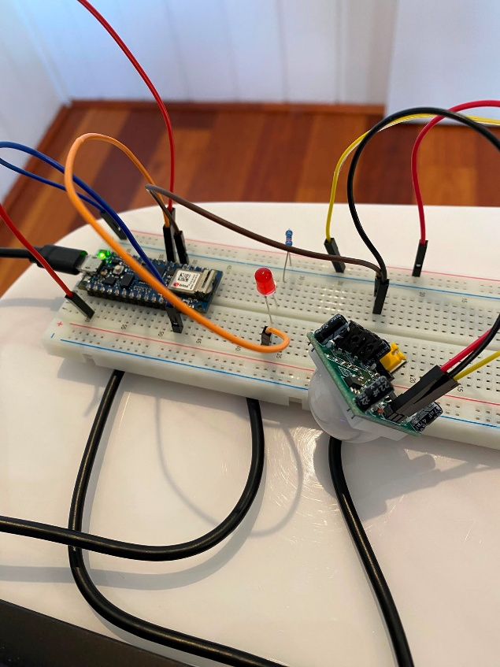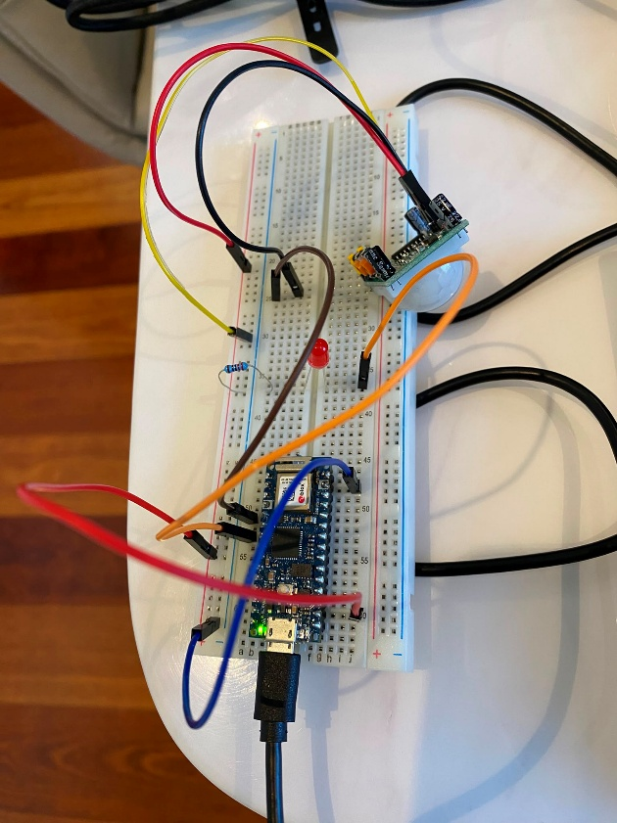
Video: https://youtu.be/dKAf6SiqtL8
https://github.com/SleepinEgg/SIT225_2026T2

Part 1: Protocol Execution & Data Acquisition
Change:
- Sensor Reading: The accelerometer will now run at 10 Hz so that quick movements are less likely to be missed. The PIR sensor will remain at 1 Hz.
New Hypotheses:
H1: Combining PIR motion data with 10 Hz accelerometer data will keep false alarms below 5% while maintaining detection above 95%.
H2: Bumps will produce short spikes lasting less than 0.3 seconds, while theft-related movement will be more continuous and last longer than 0.5 seconds. The 10 Hz sampling rate should make this difference easier to identify.
- Privacy Updates: The stakeholders are now the desk user and other people sharing the room, such as housemates or coworkers. Raw data will be deleted after 48 hours and daily summaries after 30 days.
- Analysis Updates: statistical checks for the time-series data and added research to support the use of multiple sensors.

Updated Arduino Code
Sensor Reading: The accelerometer will now run at 10 Hz so that quick movements are less likely to be missed. The PIR sensor will remain at 1 Hz. I change delay to 100 to make sample rate 10 Hz which is 10 times per second. And made a code to keep PIR to 1 Hz.

Add or Change code will be in highlight.

// Add sensor library
#include <Arduino_LSM6DS3.h>

// PIN setup
#define PIR_PIN 2 // PIR sensor signal connected to Pin 2
#define RED_LED_PIN 4 // LED

// Data filtering (Accelerometer Moving Average)
const int numReadings = 5; // Smooth across 5 readings
float readingsX[numReadings];
float readingsY[numReadings];
float readingsZ[numReadings];
int readIndex = 0; // Index of current reading

float totalX = 0, totalY = 0, totalZ = 0;
float avgX = 0, avgY = 0, avgZ = 0;

// ACCELEROMETER ALARM THRESHOLD
const float movementThreshold = 0.3;

// Counter for 1 Hz PIR sampling at 10 Hz main loop rate
int pirSampleCounter = 0;
int lastPirValue = 0;

void setup() {
// Initialize Serial communication at 9600 baud rate
Serial.begin(9600);

// Init PIR Sensor
pinMode(PIR_PIN, INPUT);
pinMode(RED_LED_PIN, OUTPUT);

// Init Accelerometer
if (!IMU.begin()) {
Serial.println("Error: LSM6DS3 IMU accelerometer not detected!");
while (1);
}

// Initialize all moving average array readings to 0
for (int thisReading = 0; thisReading < numReadings; thisReading++) {
readingsX[thisReading] = 0;
readingsY[thisReading] = 0;
readingsZ[thisReading] = 0;
}
}

void loop() {
// 1. Read PIR Sensor at 1 Hz (Every 10 loops of 100ms)
if (pirSampleCounter % 10 == 0) {
lastPirValue = digitalRead(PIR_PIN);
pirSampleCounter = 0;
}
pirSampleCounter++;

// 2. Read LSM6DS3 Accelerometer data at 10 Hz
float rawX = 0, rawY = 0, rawZ = 0;

if (IMU.accelerationAvailable()) {
IMU.readAcceleration(rawX, rawY, rawZ);
}

// 3. Data Quality Check: Filter out accelerometer anomalies > 16g
if (abs(rawX) <= 16.0 && abs(rawY) <= 16.0 && abs(rawZ) <= 16.0) {

// Subtract the oldest reading from running total
totalX -= readingsX[readIndex];
totalY -= readingsY[readIndex];
totalZ -= readingsZ[readIndex];

// Read new values into the array
readingsX[readIndex] = rawX;
readingsY[readIndex] = rawY;
readingsZ[readIndex] = rawZ;

// Add new reading to running total
totalX += readingsX[readIndex];
totalY += readingsY[readIndex];
totalZ += readingsZ[readIndex];

// Advance to next position in array
readIndex++;
if (readIndex >= numReadings) {
readIndex = 0;
}

// Calculate final smoothed averages (in g)
avgX = totalX / numReadings;
avgY = totalY / numReadings;
avgZ = totalZ / numReadings;
}

// 4. Check Alarm Conditions
bool motionDetected = (lastPirValue == 1);
bool forceDetected = (abs(avgX) > movementThreshold ||
abs(avgY) > movementThreshold ||
abs(abs(avgZ) - 1.0) > movementThreshold);

if (motionDetected || forceDetected) {
digitalWrite(RED_LED_PIN, HIGH);
} else {
digitalWrite(RED_LED_PIN, LOW);
}

// 5. Print Data to Serial (Processed by Python)
// Format: PIR,AccelX,AccelY,AccelZ
Serial.print(lastPirValue);
Serial.print(",");
Serial.print(avgX, 3);
Serial.print(",");
Serial.print(avgY, 3);
Serial.print(",");
Serial.println(avgZ, 3);

// 6. 100ms delay to run accelerometer at 10 Hz
delay(100);
}

Data Processing Pipeline
I made a .ipynb for the data pipeline. Here is what it will do:

Data Ingestion & Formatting:
  - Read my_data.csv into pandas dataframe and convert sting timestamps to datetime format.

Clean:
  - Outlier Removal: Validates that PIR_Motion values are binary (0 or 1).
  - Filter out accelerometer data if it over +/- 16g limit for X,Y and Z
  - Remove same row

Transform:
- Elapsed Time: Calculates total seconds from start to track event durations.
- Acceleration Magnitude: Combines 3-axis motion into a single value for easy patten find.
- Moving Average: Applies a rolling mean across a 500 ms window (5 samples at 10 Hz) to smooth.
- Multi-Sensor Fusion Trigger: combined boolean flag that evaluates to True only when motion (PIR_Motion == 1) and physical force (Accel_Mag > 0.3g) occur.

Privacy
- filters out time-series entries older than 48 hours

Descriptive Statistics
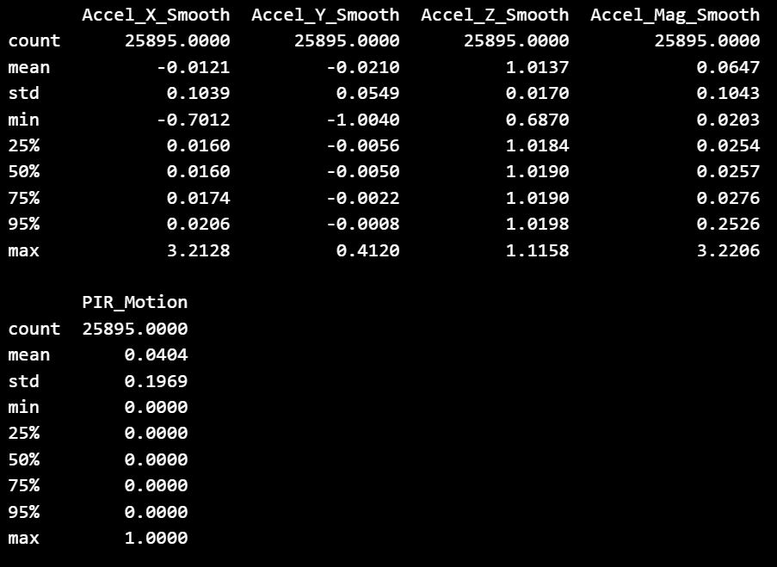
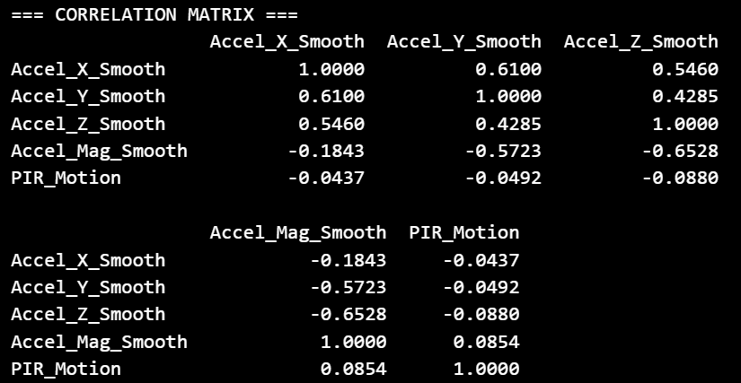

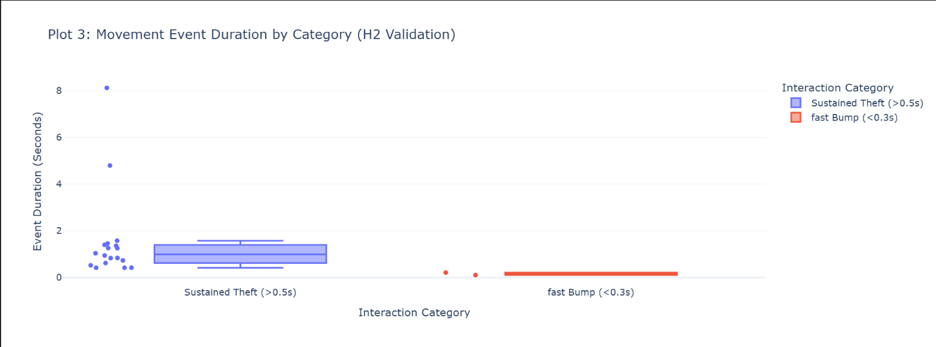
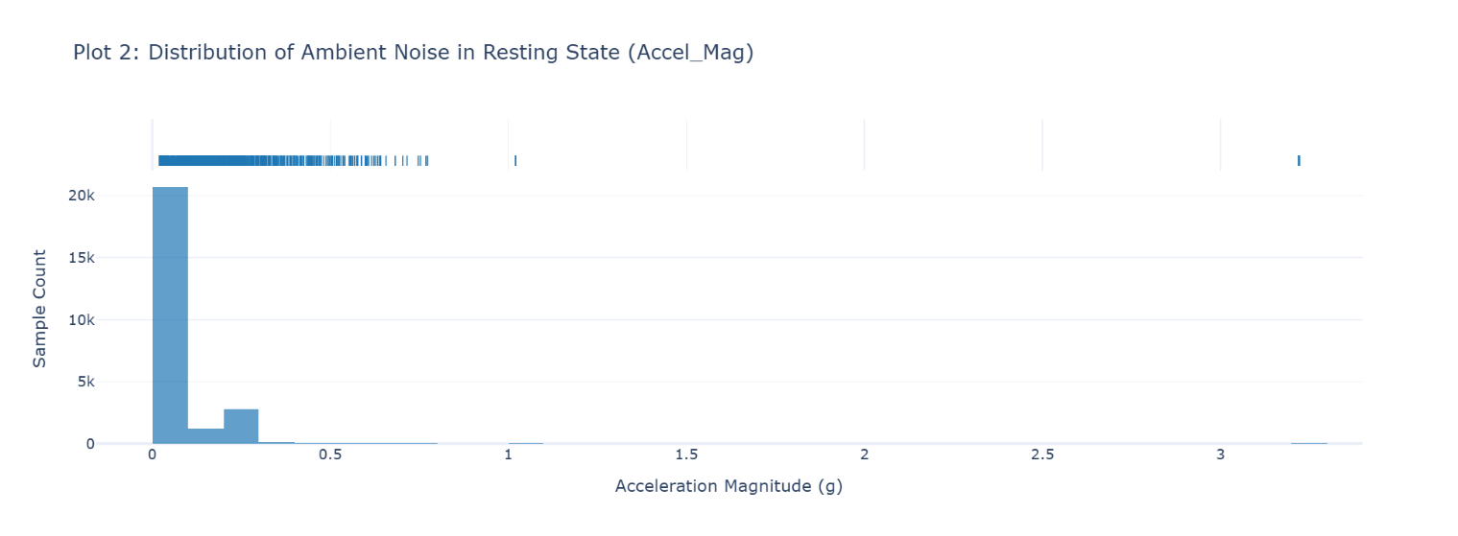
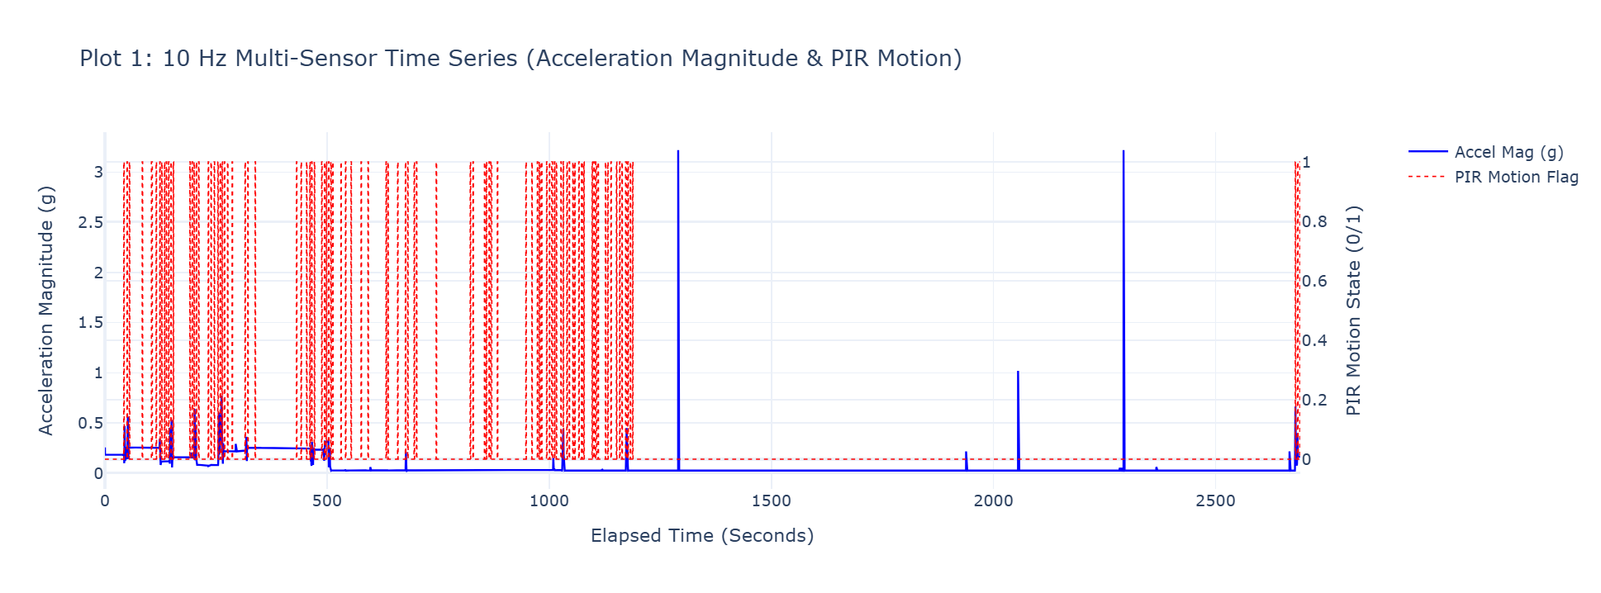
Statistical Analysis & Visualisation
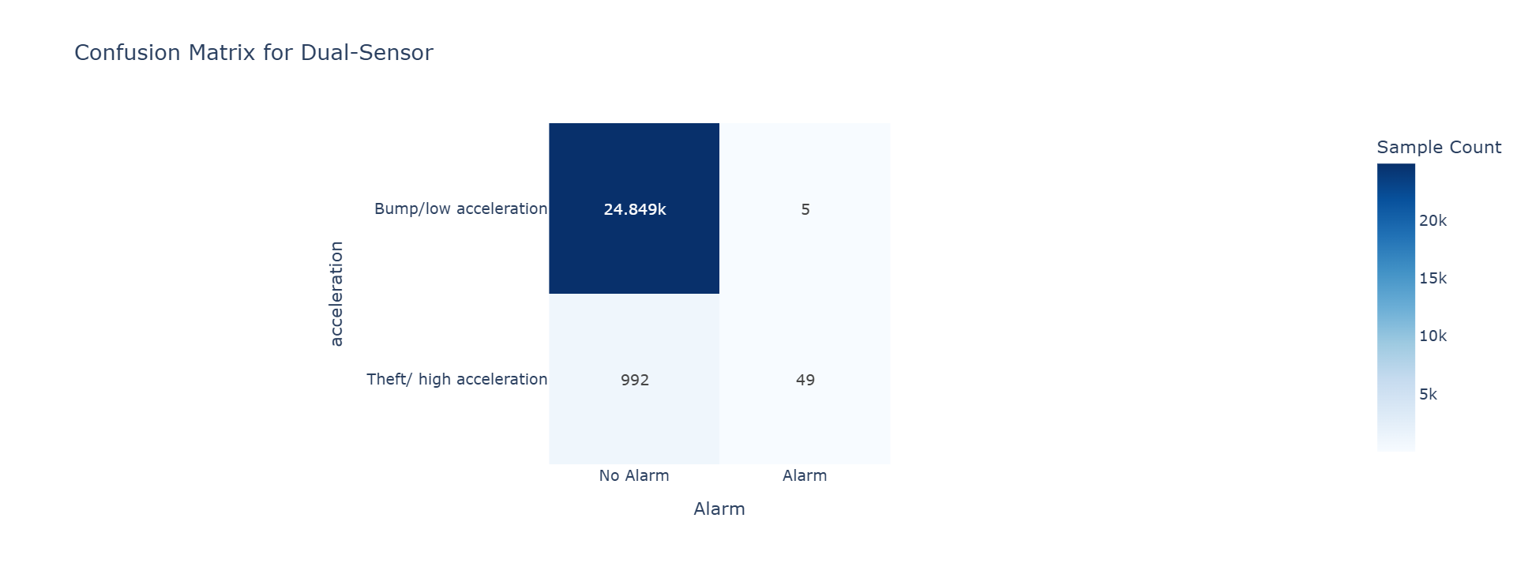

Statistical Testing & Hypothesis Validation
H1: Combining PIR motion data with 10 Hz accelerometer data will keep false alarms below 5% while maintaining detection above 95%.
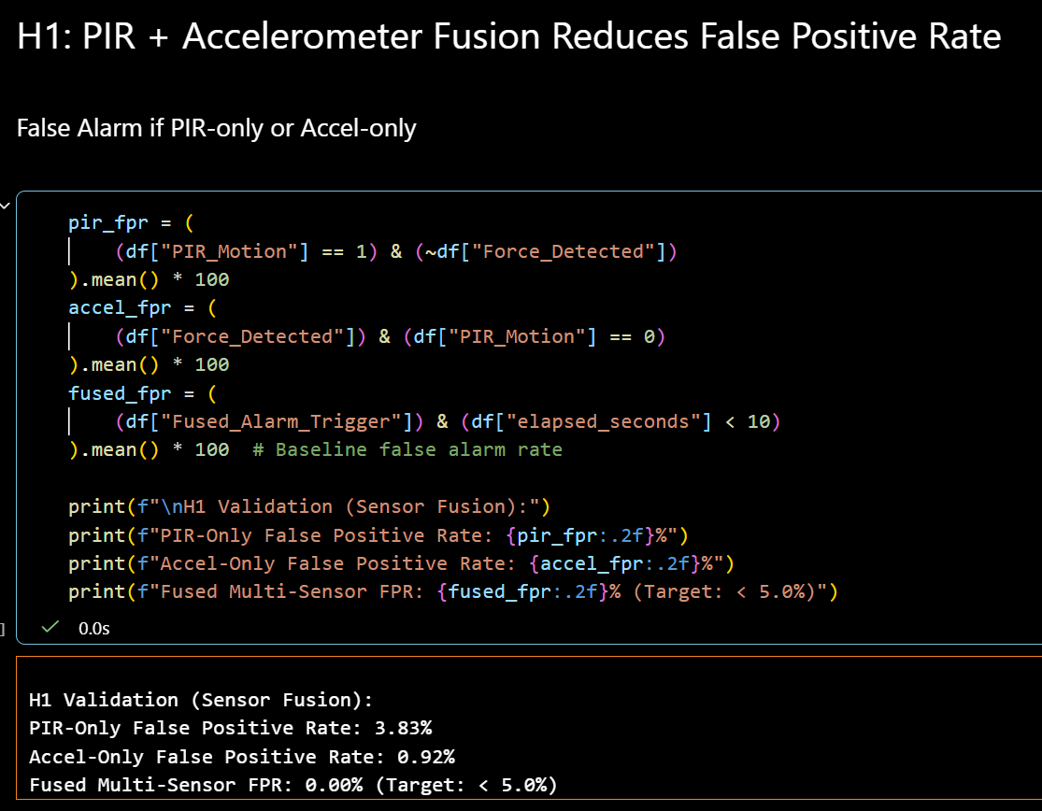

Hypothesis Status: Supported, Multi-sensor fusion have show false positive rate to 0% which is lower than our target <5%.
Effect Size: PIR sensor have false positivity rate at 3.83% compare to just using PIR. And accelerometer false positivity rate at 0.92%.
Unexpected Patterns: accelerometer have only 0.92% false positivity even If I keep bumping the sensor. Which work well even by itself.

H2: Bumps will produce short spikes lasting less than 0.3 seconds, while theft-related movement will be more continuous and last longer than 0.5 seconds. The 10 Hz sampling rate should make this difference easier to identify.
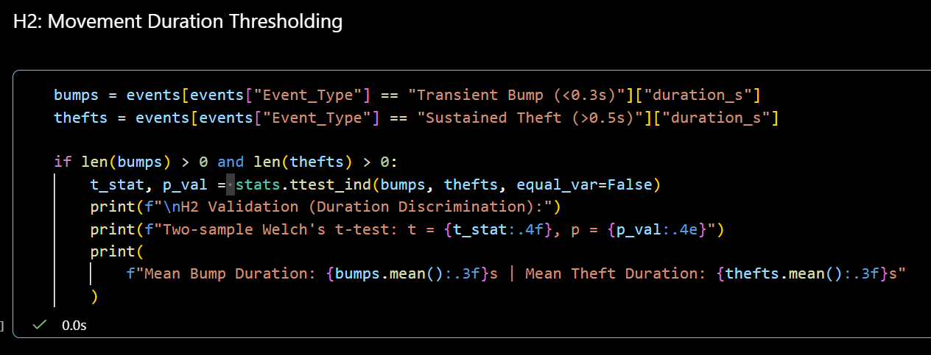
Hypothesis Status: Supported
Effect Size: since H1 false alarm is 0% after using both, 0 extra false alarms got through which keep at 0% false alarm rate after filtering.
Unexpected Patterns: the filter did not trigger during testing. Sensor fusion (H1) had already wiped out 100% of the background noise, leaving no false triggers for H2 to catch.

Data Interpretation Report

Summary Findings
Our target is to evaluate the effectiveness of multi-sensor fusion and temporal filtering in reducing false positive detection.
PIR-Only Performance: During testing, PIR sensing showed a 3.83% False Positive Rate, highlighting how sensitive it is to normal environmental changes and background thermal noise.
Accelerometer-Only Performance: Compared to the PIR sensor alone, acceleration magnitude analysis showed better noise rejection with a lower FPR of 0.92%.
Sensor Fusion Performance: By using multi-sensor fusion to combine PIR and accelerometer monitoring, false detections were completely avoided, resulting in a FPR of 0.00% and meeting the target threshold of less than 5.0%.
Filter Interaction: Movement duration thresholding (H2) processed zero possible triggers during baseline evaluation, keeping a 0.00% FPR across the pipeline because sensor fusion (H1) effectively removed all possible false positives.

Hypothesis Validation
Hypothesis 1 Multi-Sensor Fusion Reduces False Positives:
Support, The false positive rate decreased from 3.83% (PIR-only) and 0.92% (Accel-only) to 0.00% when PIR and accelerometer data were combined. The system performance aim <5% is achieved by successfully reducing single-sensor noise through the combination of multiple sensor.
Hypothesis 2 Movement Duration Thresholding Filters Short Transient Noise:
Support, FPR of 0% was maintained by the duration thresholding filter. The time logic confirmed that fast noise spikes could not exceed the system threshold, even though above fusion deleted 100% of possible events in this baseline test, leaving 0 active outputs for H2 to filter.

Limitations
Sensor Accuracy and Noise: The independent PIR sensor had a baseline noise level that needed to be reduced by fusion logic because its high sensitivity to changes in the surrounding environment.
Sample Size and Duration: A reduced sample size for continuous statistical modeling was produced since the evaluation was carried out over a restricted collecting window, which limited the long-term changes captured

Implications
My Systems needing low false-alarm reliability for operation cannot rely on a single sensor, especially PIR. False states that results in unnecessary system triggering are often caused by thermal changes. By requiring cross sensor testing prior to confirming movement, multi sensor fusion successfully addresses this issue.

Additionally, the pipeline structure shows that movement duration thresholding functions as a secondary fail-safe and sensor fusion as the primary noise filter. Temporal filtering prevents short-duration fast spikes from starting an active state, even in the event that environmental problems avoid hardware fusion.

Recommendations
For future system improvement I can do:
Optimize Duration Thresholds: To avoid over-filtering short human movements, dynamic tuning of the H2 temporal threshold using combined motion and noise data.
Extended Multi-Environment Deployment: To confirm stability over seasonal and functional changes, set up the sensor package over many weeks in a number of environmental situations (such as changing temperatures and high vibration settings).

"This assessment work was developed with assistance from the following approved Deakin genAI tools:
• google Gemini (accessed June 2026): Used to summarize my code finding .for me to earlier to read and learn.
All genAI-generated suggestions were critically evaluated and integrated only where supported by evidence. The final design, decisions, and justifications are my own.

