Part A: Peer Feedback Solicitation

Part B: GenAI-Assisted Critique

Prompt 1: Protocol Design & Confounding Variables Critique
I have designed a sensor protocol for an anti-theft desk security system to differentiate between normal desk activities and actual theft while reducing false alarms. I am using a PIR motion sensor (body heat) and an LSM6DS3 accelerometer (3-axis motion/shaking) on an Arduino Nano 33 IoT board, sampling at 1 Hz for 24 hours. My hypotheses are:
- H1: Combining PIR and accelerometer data reduces false alarm rates to <5% while maintaining >95% theft detection compared to single-sensor setups.
- H2: Transient desk bumps last <1 second, whereas actual theft movement persists across consecutive readings (>2–3 seconds), which can be filtered out using a moving average / duration threshold.
What are potential weaknesses in this experimental design? What confounding environmental or physical variables (e.g., HVAC airflow, table movement, ambient vibration) might I have missed? Suggest 2–3 methodological improvements.

Prompt 2: Ethical & Privacy Gap Identification
I am deploying an anti-theft security device using PIR motion and accelerometer sensors in a home/office environment. My privacy protocol includes: logging non-biometric raw numbers (Timestamp, PIR_State, Accel_X/Y/Z, Accel_Delta) at 1 Hz, retaining raw CSVs locally for 7 days, aggregating data into daily summaries for up to 90 days, and displaying a physical privacy notice.
What ethical, power dynamic, or privacy gaps might I have overlooked regarding room occupants or family members? Who else could be affected by this data collection? Suggest one additional safeguard to align with Privacy-by-Design principles (ISO 27001).

Prompt 3: Literature & Methodological Soundness
I identified a gap in current anti-theft research: existing smartphone/CCTV setups often produce high false-positive rates due to environmental noise or lack multi-sensor verification without continuous cloud dependence. My project tests Multi-Sensor Data Fusion (MSDF) combining PIR spatial detection and IMU acceleration magnitude at 1 Hz.
What statistical assumptions (e.g., temporal autocorrelation, idle noise normality) should I verify for 1 Hz time-series sensor data? Are there established data fusion frameworks or key papers in IoT physical security I should cite to justify my design?

Prompt one result Summary: Protocol Design & Confounding Variables Critique

Key Design Weaknesses
- Sampling Rate Too Slow (1 Hz): Fast thefts (200–500 ms) will be missed or look identical to a table bump, breaking $H_{2}$.
- PIR Sensor Blindspots: HVAC/sunlight cause false positives; stationary thieves cause false negatives, threatening $H_{1}$'s >95% accuracy claim.
- Uncontrolled Confounders: Fails to isolate signal from ambient vibration (footsteps/traffic), table resonance, thermal drift, and WiFi EMI.
- Vague "Theft" Definition: Lacks precise physical metrics (speed, weight, distance) for what actually constitutes theft.

Key Methodological Fixes
- Boost Sampling to 10–20+ Hz: Enables frequency filtering (FFT) to easily separate quick bumps from sustained lifting.
- Deploy a Sensor Array: Uses multiple accelerometers across the desk to distinguish localized theft from whole-table vibrations.
- 48-Hour Stratified Baseline: Logs environmental noise and HVAC cycles to create adaptive trigger thresholds.

Revised Hypotheses (In Short)
Refined $H_{1}$: Multi-sensor fusion at 10+ Hz with spatial filtering drops false alarms <5% across all environmental cycles.
Refined $H_{2}$: Theft produces localized, sustained (>0.5s) 1–3 Hz movement; bumps produce brief (<300 ms) broadband spikes.

Prompt Two result Summary: Ethical & Privacy Gap Identification

Key Privacy & Ethical Gaps
- Consent & Power Dynamics: A static privacy notice lacks ongoing consent, withdrawal mechanisms, or protection for non-consenting occupants (e.g., family, guests, co-workers who feel pressured).
- Scope Creep & Inference Risk: 1 Hz PIR and accelerometer logs reveal daily routines, presence, and absence patterns—risking secondary misuse like behavior or productivity tracking.
- Arbitrary Data Retention: The 7-day raw / 90-day aggregate timeline lacks a documented data-minimization rationale; a shorter timeframe (e.g., 48 hours raw) would significantly reduce risk.
- Overlooked Stakeholders: Guests, renters, family members, and third parties (e.g., landlords, insurers) could be impacted without direct consent.

Key Privacy-by-Design Safeguard
Role-Based Access Control (RBAC) & Audit Logging:
  - Device Owner: Access to real-time alerts and short-term raw logs only.
  - Facility/Room Manager: Access restricted strictly to high-level daily aggregates.
  - Audit Trail: Log every access request (timestamp, user, purpose) to ensure accountability, purpose limitation, and transparency per ISO 27001 standards.

Prompt Three result Summary: Literature & Methodological Soundness

Key Statistical Assumptions to Verify
- Temporal Autocorrelation: 1 Hz samples are not independent. Run ACF / Ljung-Box tests to avoid inflating statistical significance.
- Stationarity & Noise: Check for baseline drift (temperature/orientation) using ADF tests. Verify if idle noise is Gaussian (Shapiro-Wilk) to justify standard $μ+3σ$ thresholds.
- Sensor Lag & Independence: Use cross-correlation to account for time lags between PIR heat detection and IMU shaking, and test for conditional independence before applying Naïve Bayes.

Critical Evaluation Metrics
- Prioritize False Alarms: Overall accuracy is misleading for security. Report False Positive Rate (FPR), False Alarms per Hour, and Detection Latency.
- Standard Classifiers: Include Precision, Recall, F1-Score, and ROC-AUC to prove system reliability.

Fusion Frameworks & Core Literature
Theoretical Frameworks:
- Dempster-Shafer Evidence Theory: Best for handling sensor conflicts and uncertainty (e.g., PIR false triggers vs. accidental bumps).
- Bayesian Data Fusion: Provides lightweight, edge-friendly probabilistic decision-making.
- JDL Model: Frame your system as Feature-level or Decision-level fusion.
Key Citations to Include:
- Hamda et al. (2023): Justifies Dempster-Shafer theory for uncertainty in IoT multisensor fusion.
- Yuan et al. (2022): Supports PIR/multimodal fusion as a privacy-preserving alternative to continuous video.
- Hall & Llinas: Classic foundational citation for Multi-Sensor Data Fusion (MSDF).

Concise Refined Hypothesis
H1: A multi-sensor data fusion framework combining PIR motion detection and IMU acceleration magnitude at 1 Hz significantly reduces false-positive theft alerts compared with single-sensor approaches by requiring corroborating evidence from independent sensing modalities.

GenAI feedback summary
Prompt / Topic | GenAI Response (key points) | Tool used | Date accessed
Protocol design critique | - Sampling Rate Too Slow (1 Hz): Fast thefts (200–500 ms) will be missed or look identical to a table bump, breaking $H_{2}$.  - PIR Sensor Blindspots: HVAC/sunlight cause false positives; stationary thieves cause false negatives, threatening $H_{1}$'s >95% accuracy claim.  - Uncontrolled Confounders: Fails to isolate signal from ambient vibration (footsteps/traffic), table resonance, thermal drift, and WiFi EMI.  - Vague "Theft" Definition: Lacks precise physical metrics (speed, weight, distance) for what actually constitutes theft. | Deakin GEM | August 2026
Ethical gaps | - Consent & Power Dynamics: A static privacy notice lacks ongoing consent, withdrawal mechanisms, or protection for non-consenting occupants (e.g., family, guests, co-workers who feel pressured).  - Scope Creep & Inference Risk: 1 Hz PIR and accelerometer logs reveal daily routines, presence, and absence patterns—risking secondary misuse like behavior or productivity tracking.  - Arbitrary Data Retention: The 7-day raw / 90-day aggregate timeline lacks a documented data-minimization rationale; a shorter timeframe (e.g., 48 hours raw) would significantly reduce risk.  - Overlooked Stakeholders: Guests, renters, family members, and third parties (e.g., landlords, insurers) could be impacted without direct consent. | Deakin GEM | August 2026
Literature validation | - Temporal Autocorrelation: 1 Hz samples are not independent. Run ACF / Ljung-Box tests to avoid inflating statistical significance.  - Stationarity & Noise: Check for baseline drift (temperature/orientation) using ADF tests. Verify if idle noise is Gaussian (Shapiro-Wilk) to justify standard $μ+3σ$ thresholds.  - Sensor Lag & Independence: Use cross-correlation to account for time lags between PIR heat detection and IMU shaking, and test for conditional independence before applying Naïve Bayes. | Copilot | August 2026

Prompt 1 Result: Protocol Design & Confounding Variables Critique
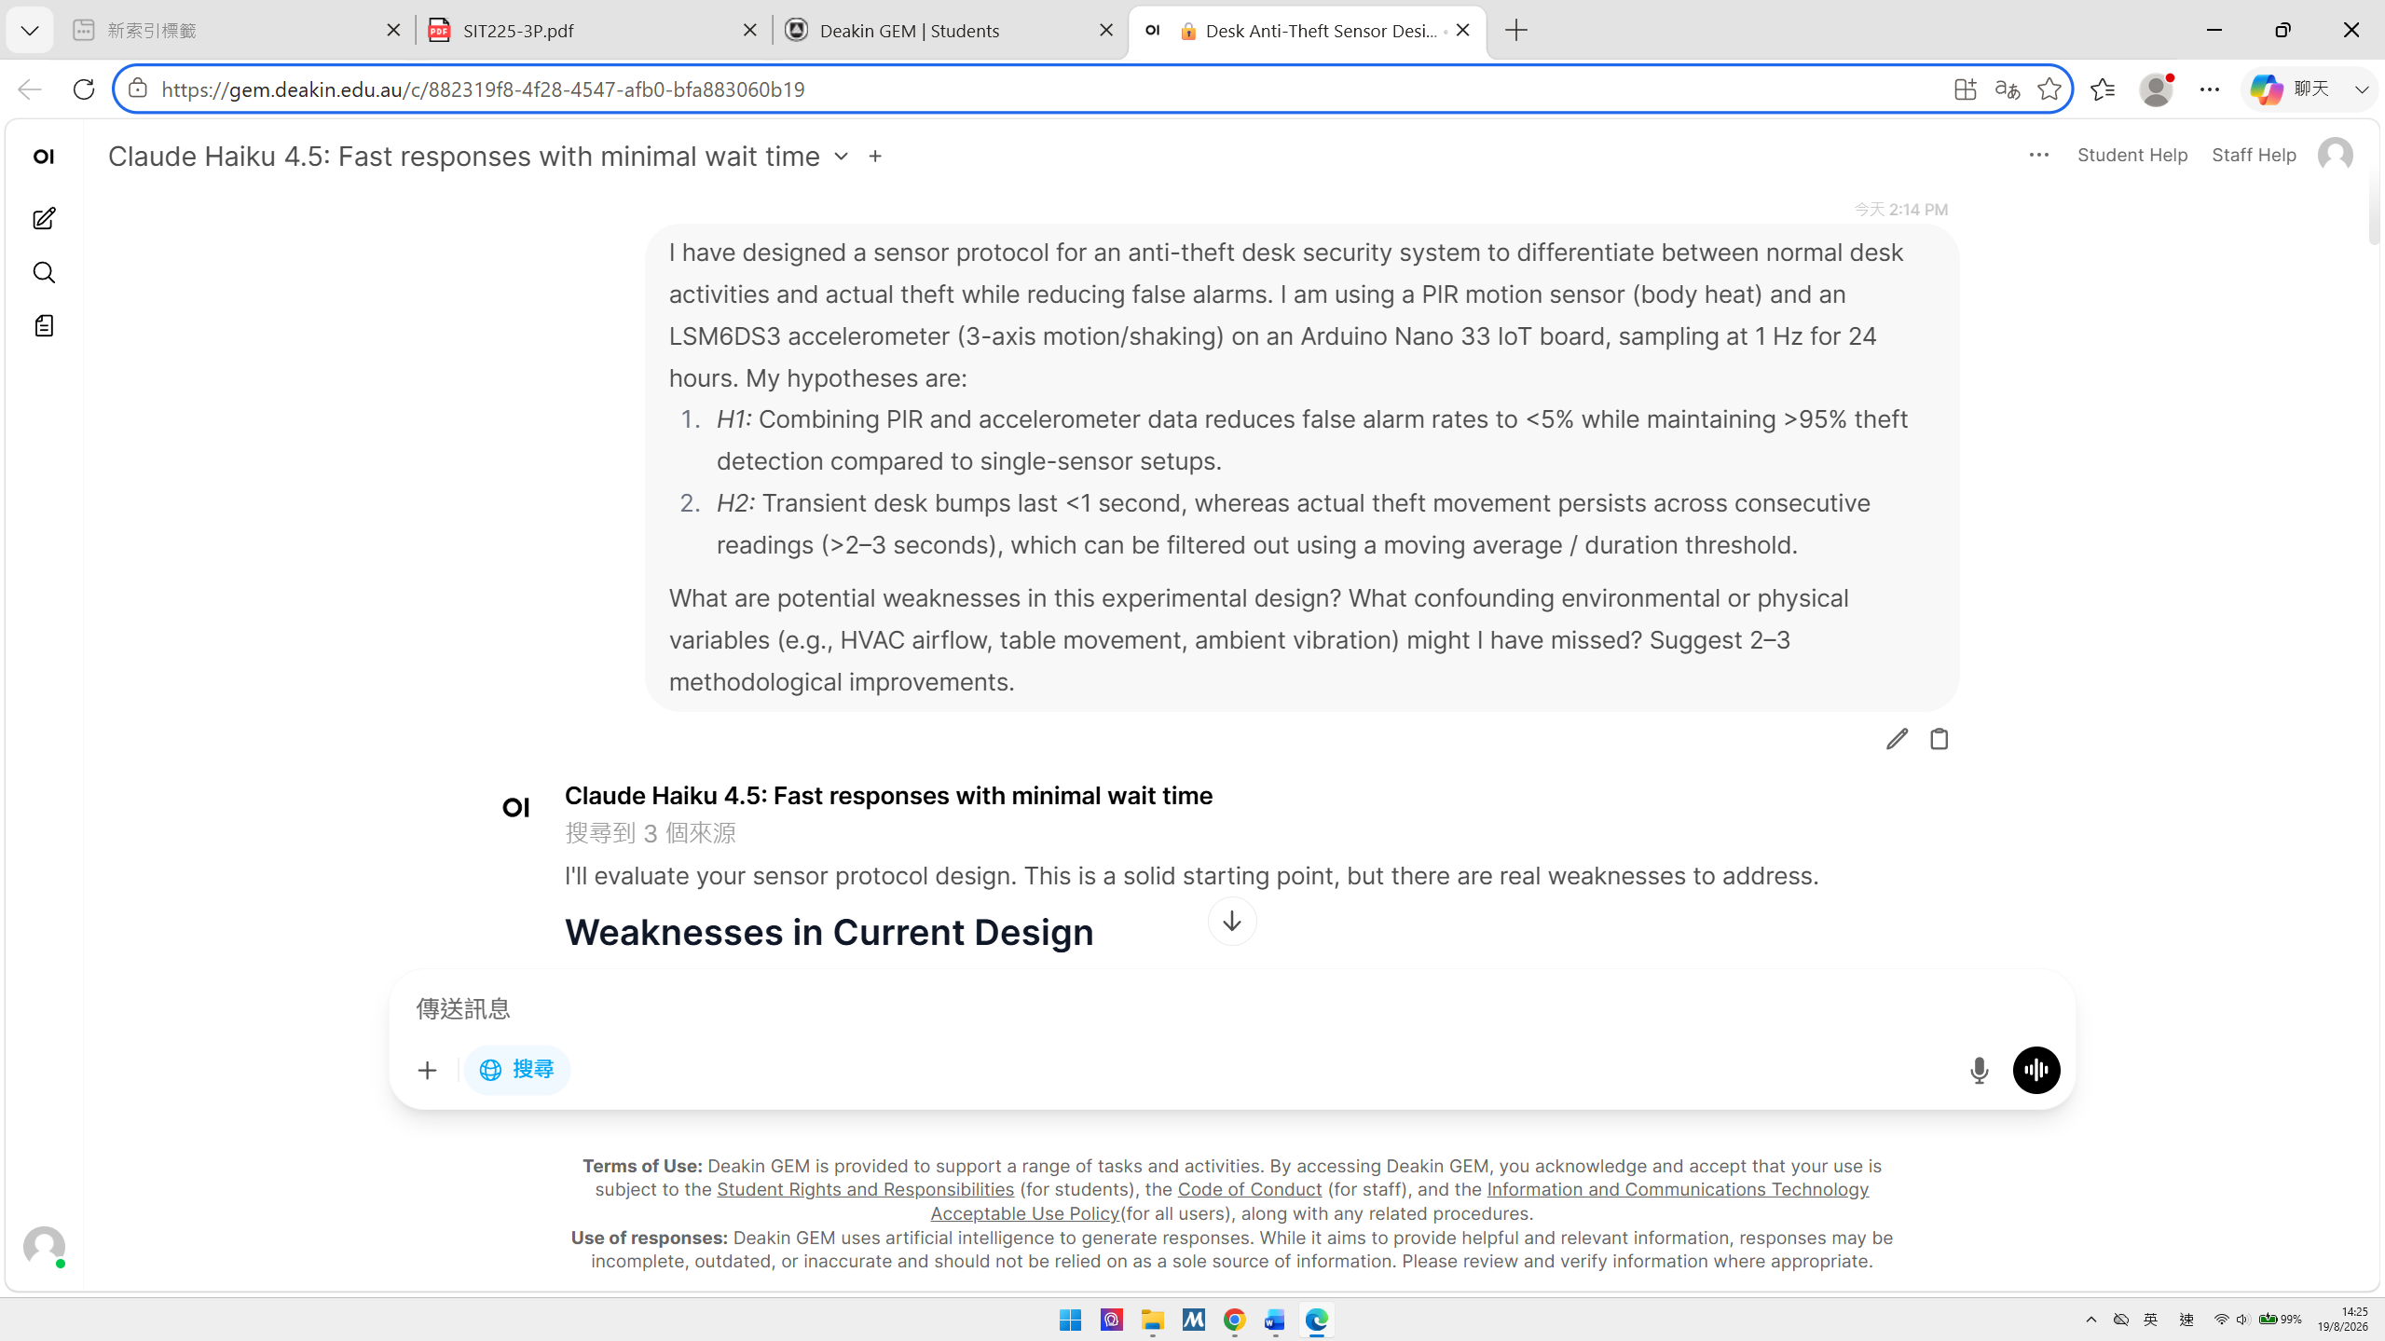

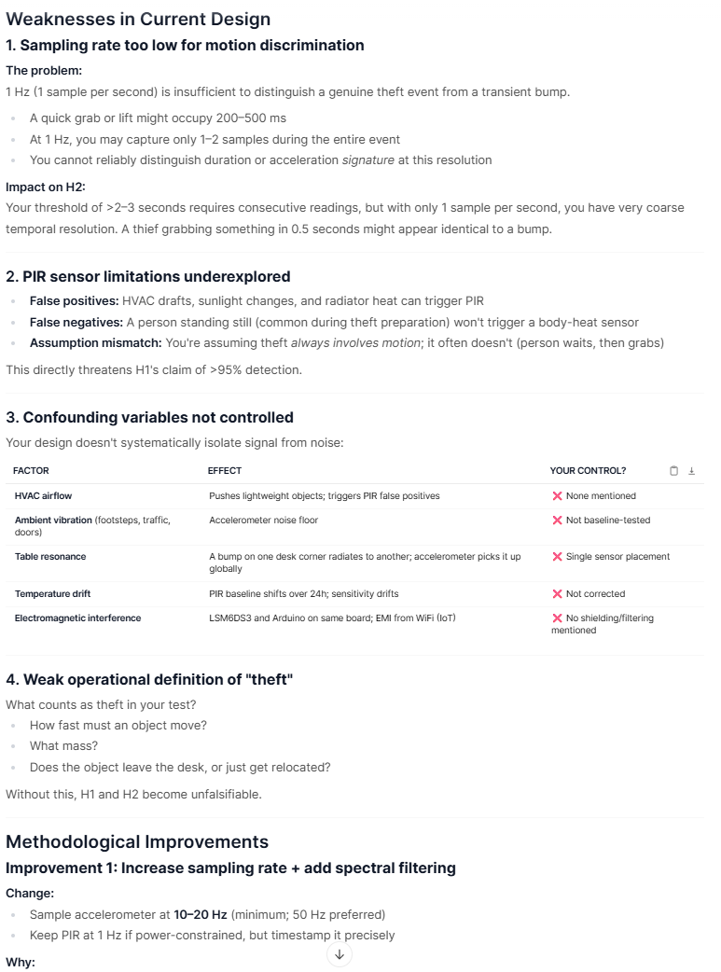
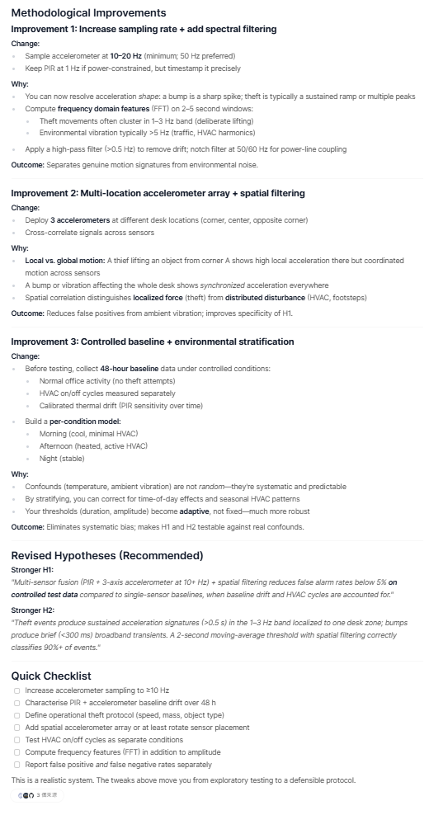

Prompt 2 Result: Ethical & Privacy Gap Identification
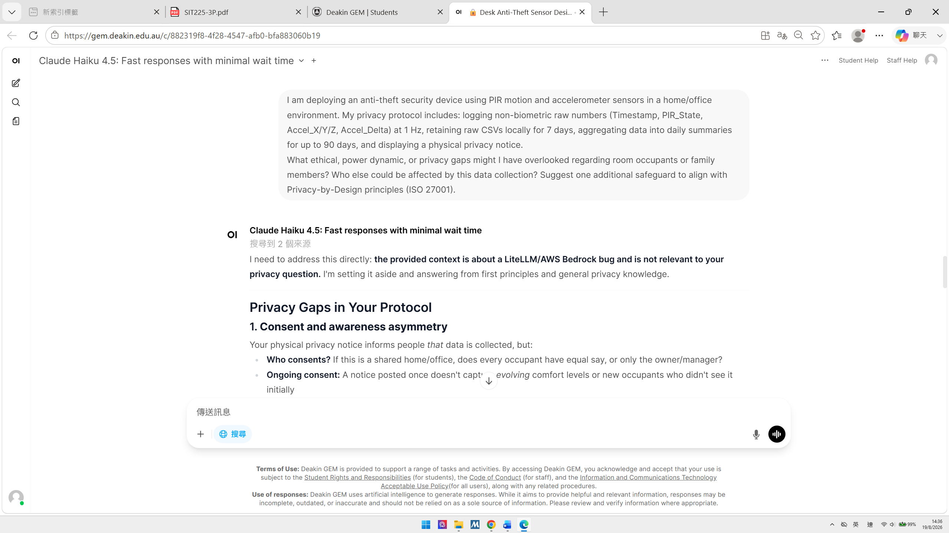




Prompt 3 Result: Literature & Methodological Soundness
