Student name: Gordon Tse
Student ID:s223532749

SIT225: Data Capture Technologies

Activity 4.1: Collect GPS data using mobile apps

Mobile phones have significant sensing capabilities such as GPS, acceleration and lux. In this task you will use existing free mobile apps to record some GPS data.

Hardware Required
- A smartphone with GPS.

Software Required
A web browser
Either Android Geo Tracker (https://play.google.com/store/apps/detailsid=com.ilyabogdanovich.geotracker&hl=en )
Or iOS myTracks (https://itunes.apple.com/au/app/mytracks-the-gps-logger/id358697908?mt=8 )

You may install and try out any other app well as, as long as they can track GPS & export tracks to GPX format.

Steps:
Step | Action
1 | Track a journey using one of the installed mobile apps. It is best if your tracked journey spans at least 5 kilometers. Export your track to GPX format and save the file to your computer. Alternatively, you can email the .gpx file from your phone and download it to your computer  Question: Upload your .gpx file to a cloud storage (such as OneDrive) and share a public link here.  Answer: SIT225_Week4.gpx
2 | Question: Open a browser on your computer and go to http://utrack.crempa.net/ . Upload your .GPX file to the site and click ‘Generate Report’. Take a screenshot and include it here.  Answer:  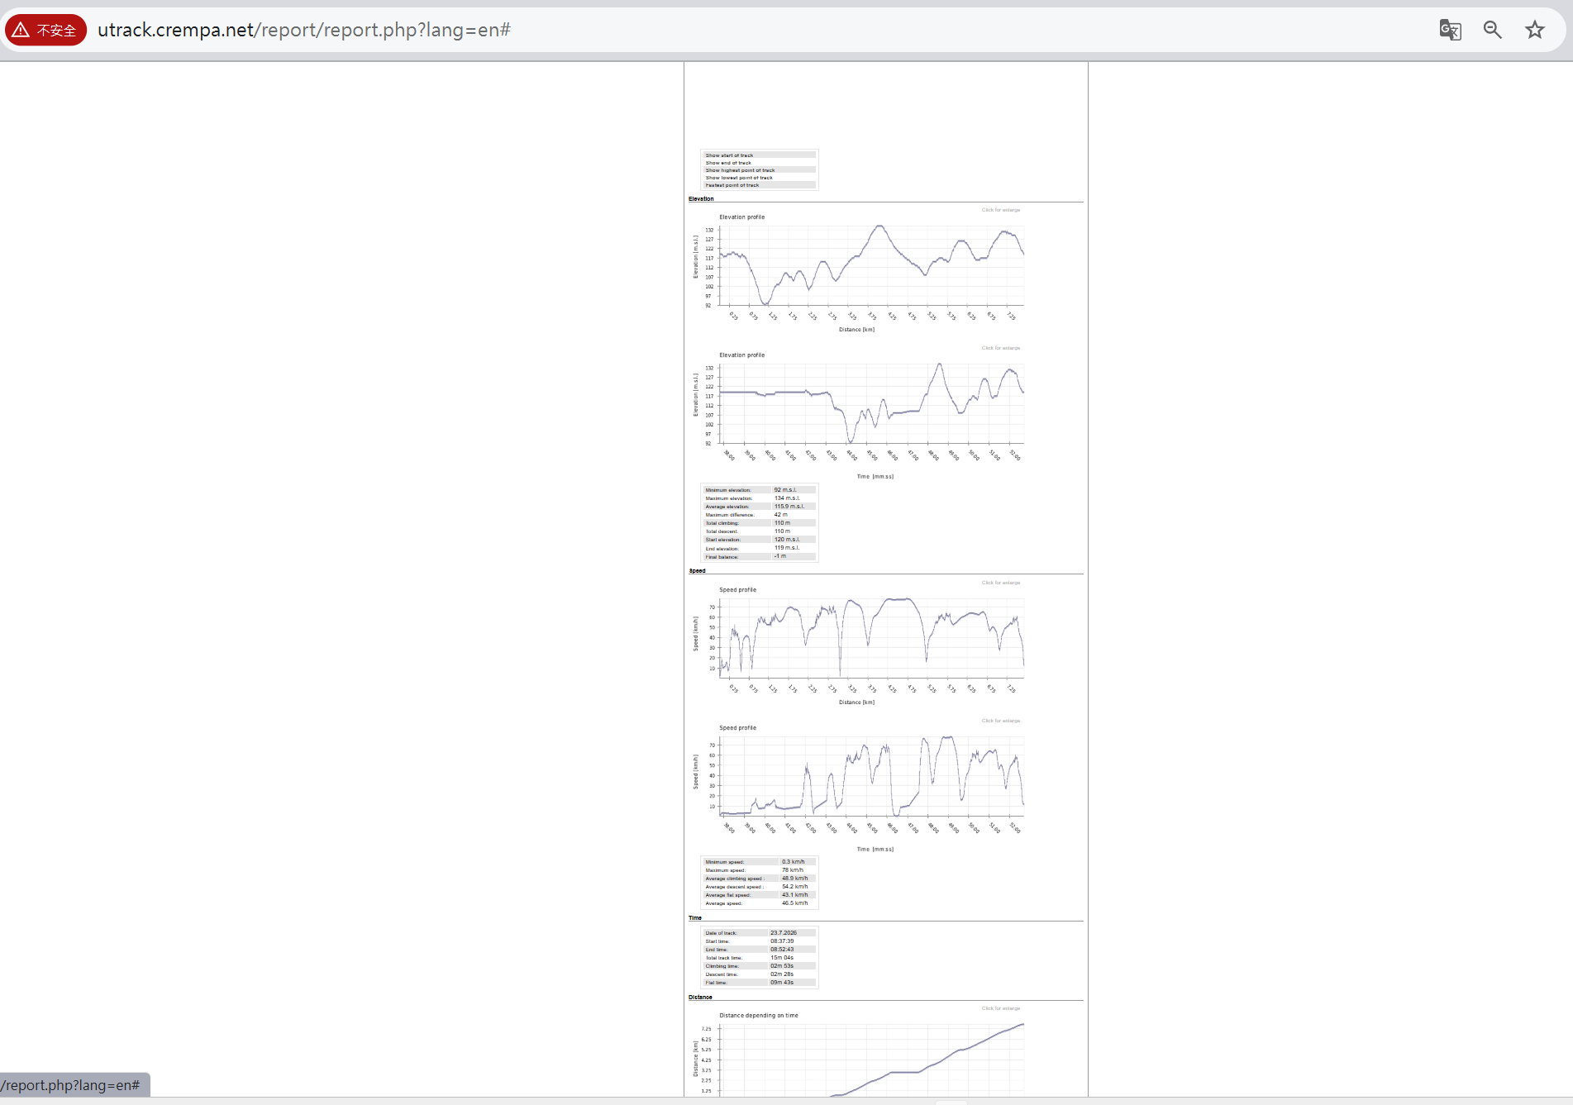
3 | Question: What information can you see from the generated report?  Note: Depending on the app you use to record the GPS data, timestamps could be either in local time (that is AEST if you are in Melbourne) or sometimes it could be in UTC.  Answer: I used IOS myTracks, time is show in Melbourne time. In the report I can see 4 main area elevation, Speed, Time, Distance. Each area include tirp detail and a graph to see.
4 | Question: Discuss in a group of 3 or 4 students to identify potential risks (more than one risk) if your data, which was collected by a service provider such as Google Map, was misused without your concern. Also suggest remedies - what kind of policies the service providers should adopt to mitigate these risks.  Answer: if this report data leak out, people can see where I go, when did I go back home and my daily route and path walked. This could be end up me getting rob, kidnap or even murder. For my house may get invasion when I’m not at home. For law side they could use this as evidence of some crime activity that I never did. They can even do a scam call to my family or friend.  To avoid this, company should build some rule to prevent this happened like restrict company employee to read Sensity data without approve. Or host the sever in save place.

Activity 4.2: The Ethics of Data Gathering
Digital privacy is top of mind for many Australians. With weekly data breach scandals, individuals are becoming more aware and concerned about who has their data, and more importantly, who controls how that information is gathered, used and shared. In this task, you will summarise a blog post regarding what should Australian businesses know regarding the ethics of data gathering.

Steps:
Step | Action
1 | Question: Study the web material which can be found here (https://www.insideinfo.com.au/business-intelligence-and-analytics/ethics-data-gathering-what-should-australian-businesses-know ). Discuss data legislation in Australia and (un)ethical use of customer data. Reflect your viewpoint.  Answer: This include  - 1988 privacy act: which company need to follow APPs and if serious data leakage happened, company must report to that person.  I agree this because when leakage happened company contact person let that person to know and do action to stop increase their loss in that leakage.  - Company only collect necessarily data and tell user what data they are collecting. By doing this customer can use the service or product safely and let user decide if they want to use or not by the collect data.  - Allow user to Anonymity and don’t link personal detail to that fake account. It good for user to use if they don’t want people are using.

Activity 4.3: The ethical dilemma of self-driving cars
Self-driving cars are already cruising the streets today. And while these cars will ultimately be safer and cleaner than their manual counterparts, they can’t completely avoid accidents altogether. In this video, you will explore and reflect on how the car should be programmed if it encounters an unavoidable accident.

Steps:
Step | Action
1 | Question: Study the web material which can be found here (https://www.youtube.com/watch?v=ixIoDYVfKA0 ). Reflect critically the ethical considerations and discuss to what extent you agree or disagree with justification.  Answer: the video is about auto car driving ethical question, I think it a good question to think about it, in extreme case, If must hit one, I will choose the way that every one is most likely to be survive. But one step backward I think there are technology that can prevent this kind of case from happening.  Like set the bigger distance to the front car.  Avoid car being box, decrease speed or cut len…  There are no correct way to answer this question what we can do is try our best to avoid stuck in this situation.

Activity 4.4: The ethical dilemma of abusing generative language models
The use of generative language models such as ChatGPT is increasing in our daily life. A specific question can be asked in the chat-bot command prompt which generates related answers. Students often find the chat-bot a handy tool to ask any study related questions to get a direct answer and feels reluctant to search online and compile an answer by navigating through several websites. While the use of chat-bots are useful, their improper use can limit the students ability to learn. For example, using chat-bots to generate a direct answer to parts of an assignment should be avoided considering an ethical, as well as productive point-of-view.

Steps:
Step | Action
1 | Question: How you feel chat-bots (such as ChatGPT) should be used in the context of solving an assignment question? Reflect critically the ethical and learning considerations.  Discuss the question in a group of 3 to 4 students and share your and some of the other students’ thoughts that attracted your attention.  Answer: what I think is AI chat bot is good. But it a dangerous tool to use. Talking about me, for my case I can feel I am getting Dummer. Although it gives you answer which I gain knowledge, AI give us answer so fast that we don’t even have time to think why is that. I would call this transferring human intelligence to knowledge. And one more thing is I am losing creativity, since everyone is using AI to generate image. All art work look the same.  We should use AI as a helper. It is ok to generate the answer but give yourself some time to think why is the answer is that and fully understand the answer.

