  - Student name: Gordon Tse
  - Student ID:s223532749

SIT225: Data Capture Technologies

Activity 6.1: Plotly data dashboard

Plotly Dash apps give a point-&-click interface to models written in Python, vastly expanding the notion of what's possible in a traditional "dashboard". With Dash apps, data scientists and engineers put complex Python analytics in the hands of business decision-makers and operators. In this activity, you will learn basic building blocks of Plotly to create Dash apps.

Hardware Required
- No hardware is required.

Software Required
Plotly library and Dash module
Python 3

Steps
Step | Action
1 | Install Plotly and dash using the command below in the command line.  $ pip install plotly dash  You can download Jupyter Notebook from here (https://github.com/deakin-deep-dreamer/sit225/blob/main/week_6/plotly_explore.ipynb ) and run all the cells. The Notebook contains multiple sections such as Hello World which follows a sample code in a following cell. If you run the Hello world cell it will show Plotly Dash web page. The cell also includes a Question (#*** Question) which you will need to carry out to get a modified output. You will need to capture the output and share the screenshot in the following steps.
2 | Question: Hello World cell has a question - add another html.Div to show your name, and re-run the cell for output. You will need to update the code, run the cell, capture the screenshot of the output and paste it here.  Answer:  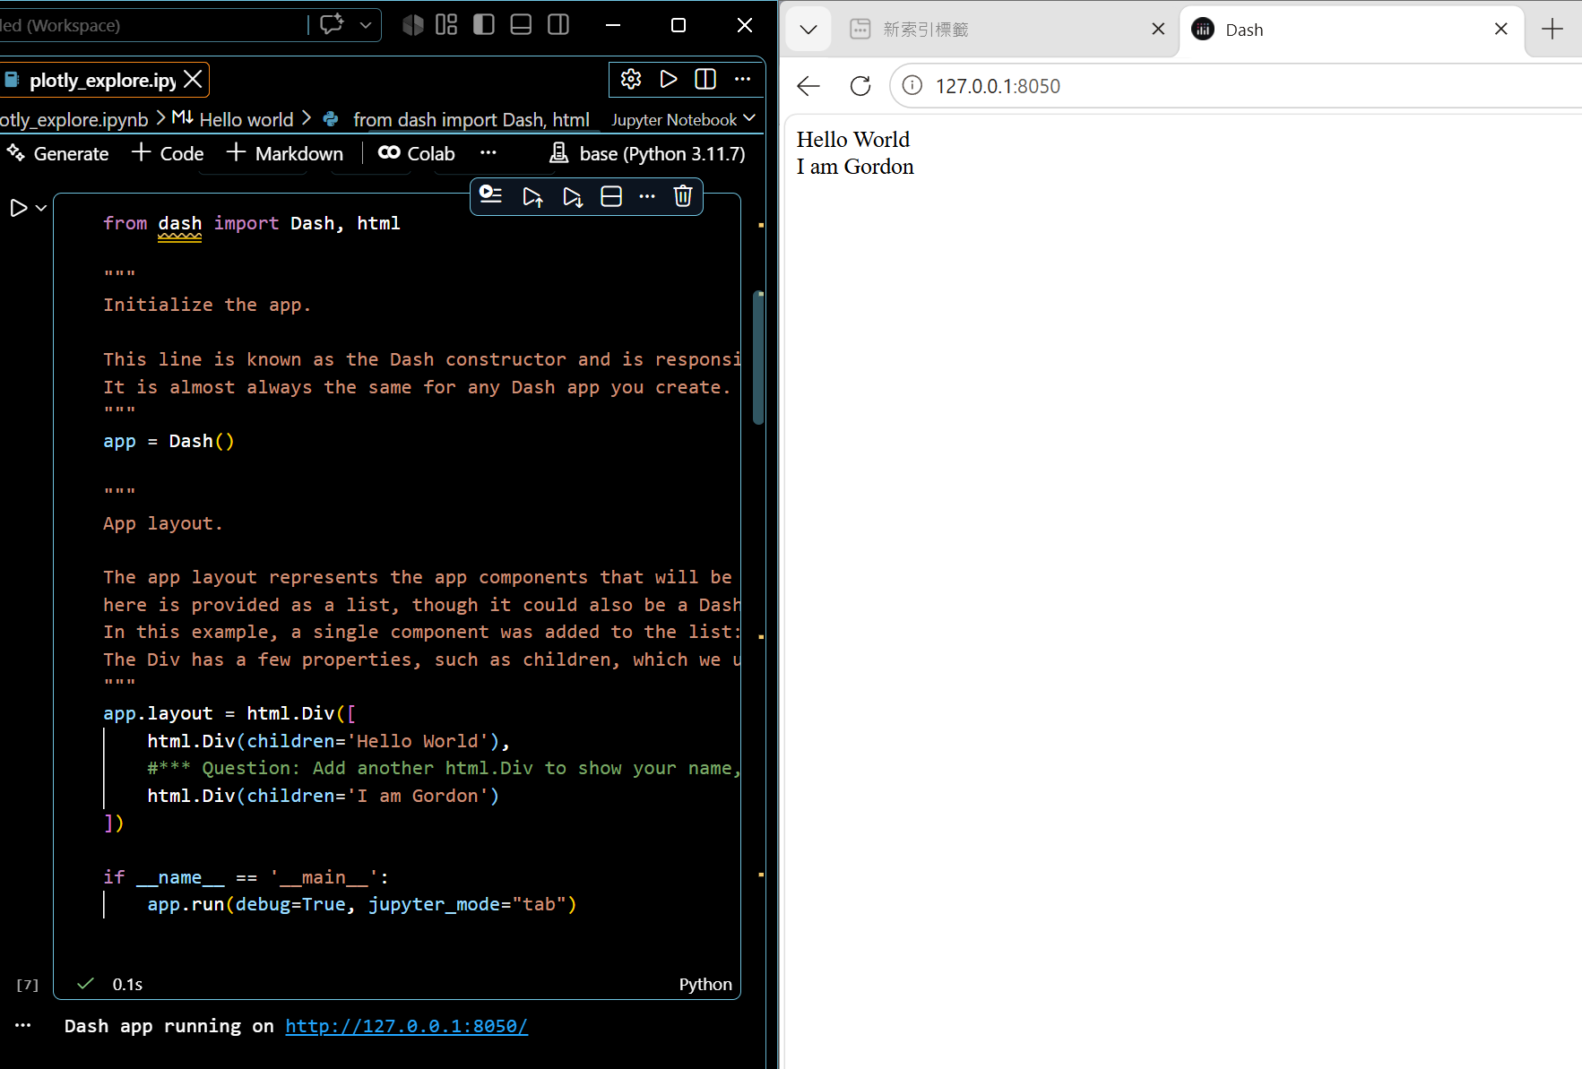
3 | Question: Connecting to Data cell has a question - change page size and observe the change in widget controls such as, total number of pages. You will need to update the code, run the cell, capture the screenshot of the output and paste it here.  Answer:  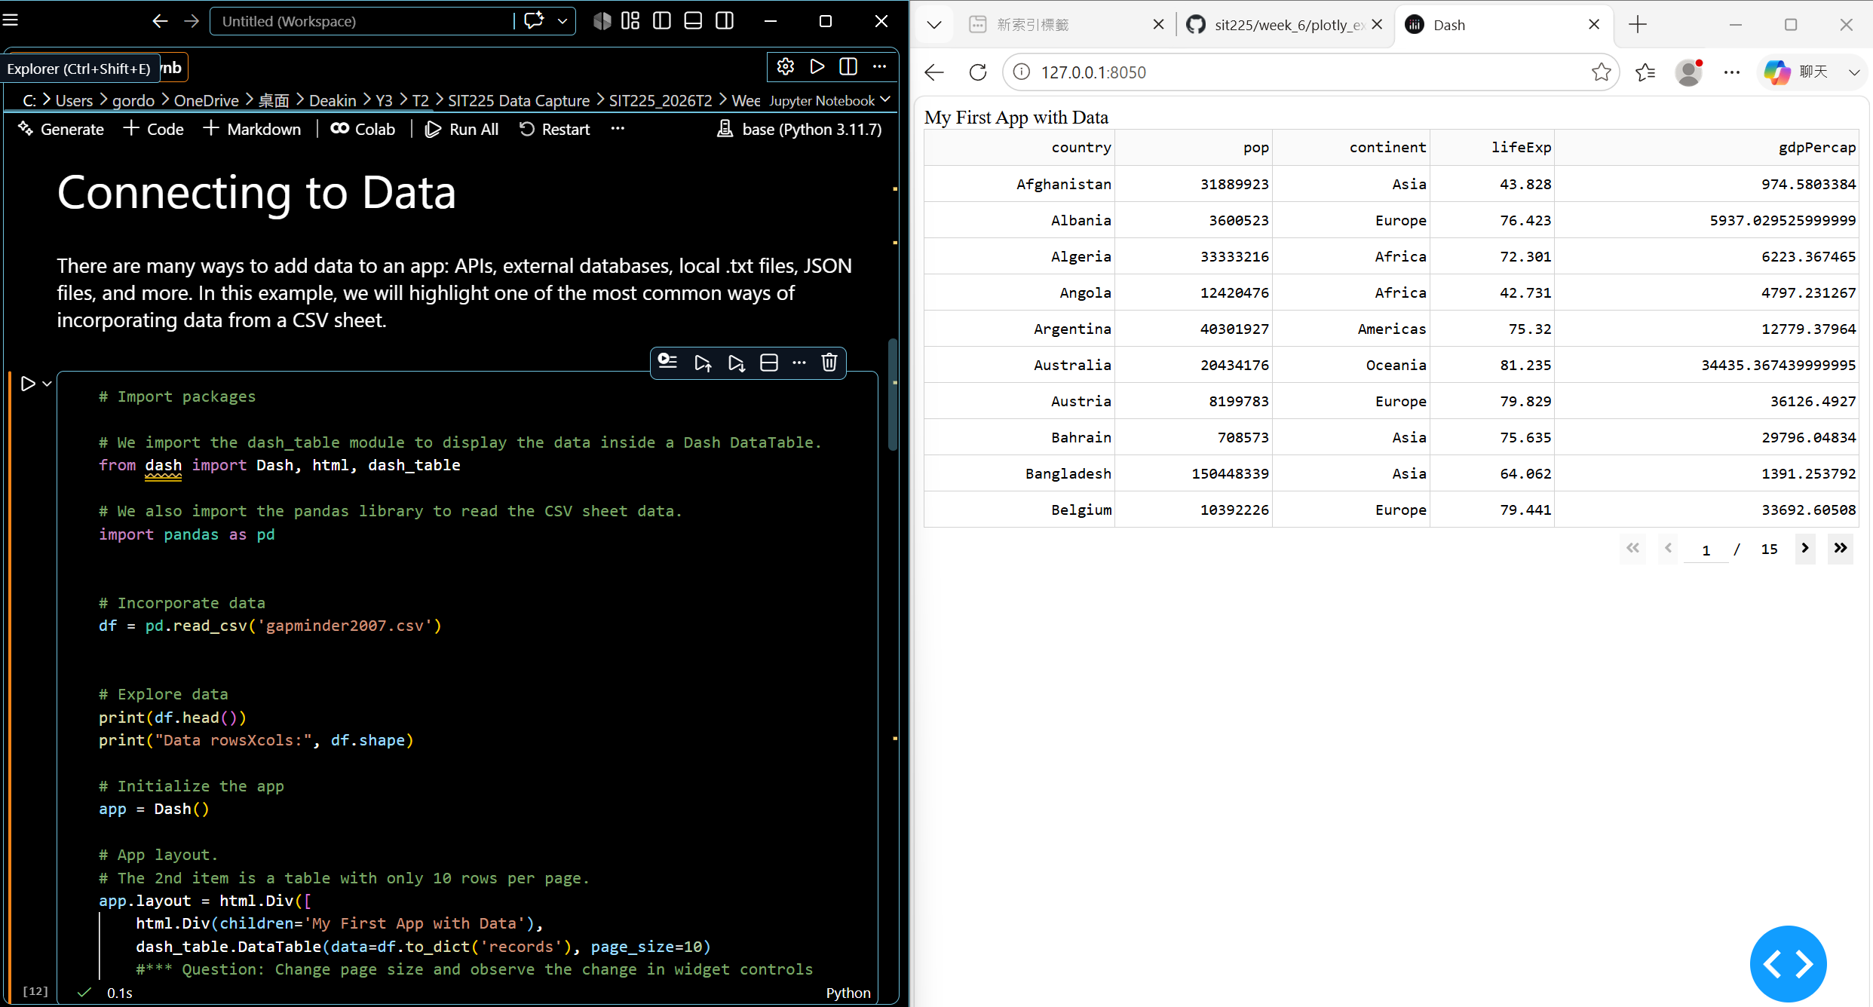  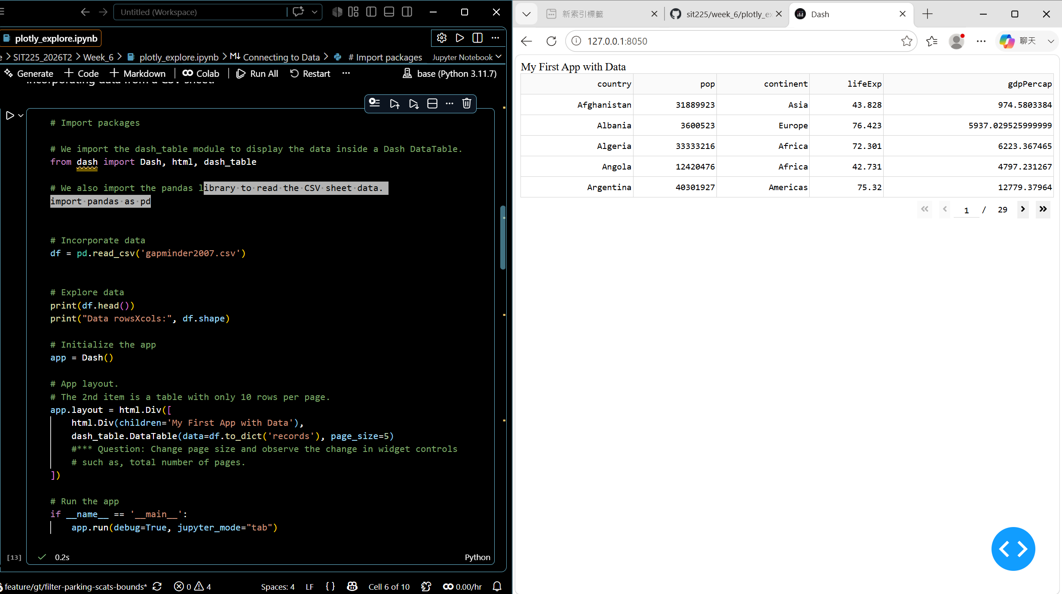
4 | Question: Visualising data cell has a question - explore another histfunc other than 'avg' used above and observe behaviour. You will need to update the code, run the cell, capture the screenshot of the output and paste it here.  Answer:  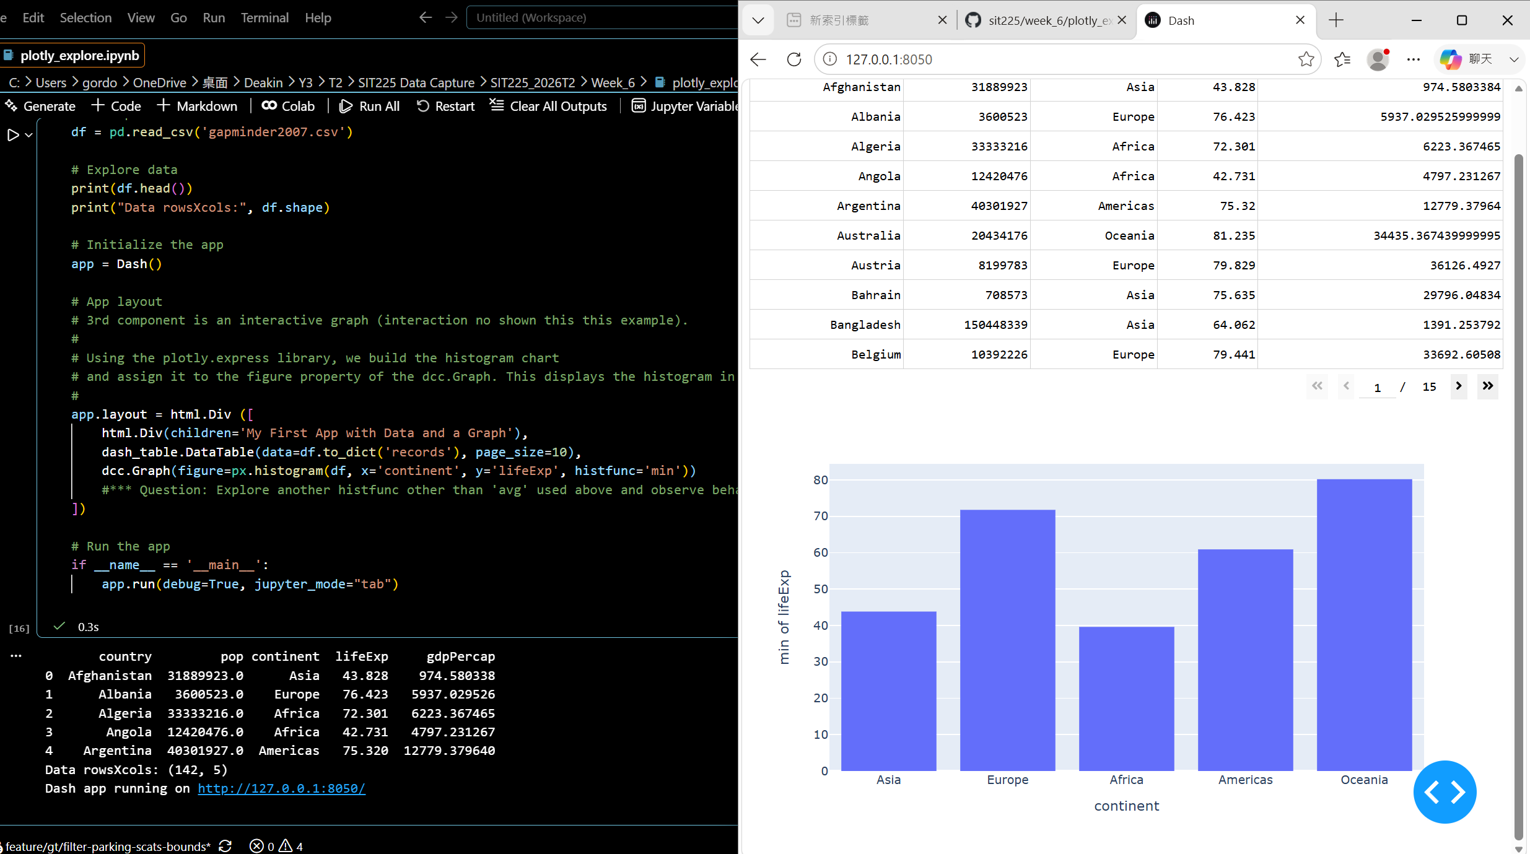
5 | Question: Controls and Callbacks cell has a question - use line graphs instead of histogram. You will need to update the code, run the cell, capture the screenshot of the output and paste it here.  Answer:  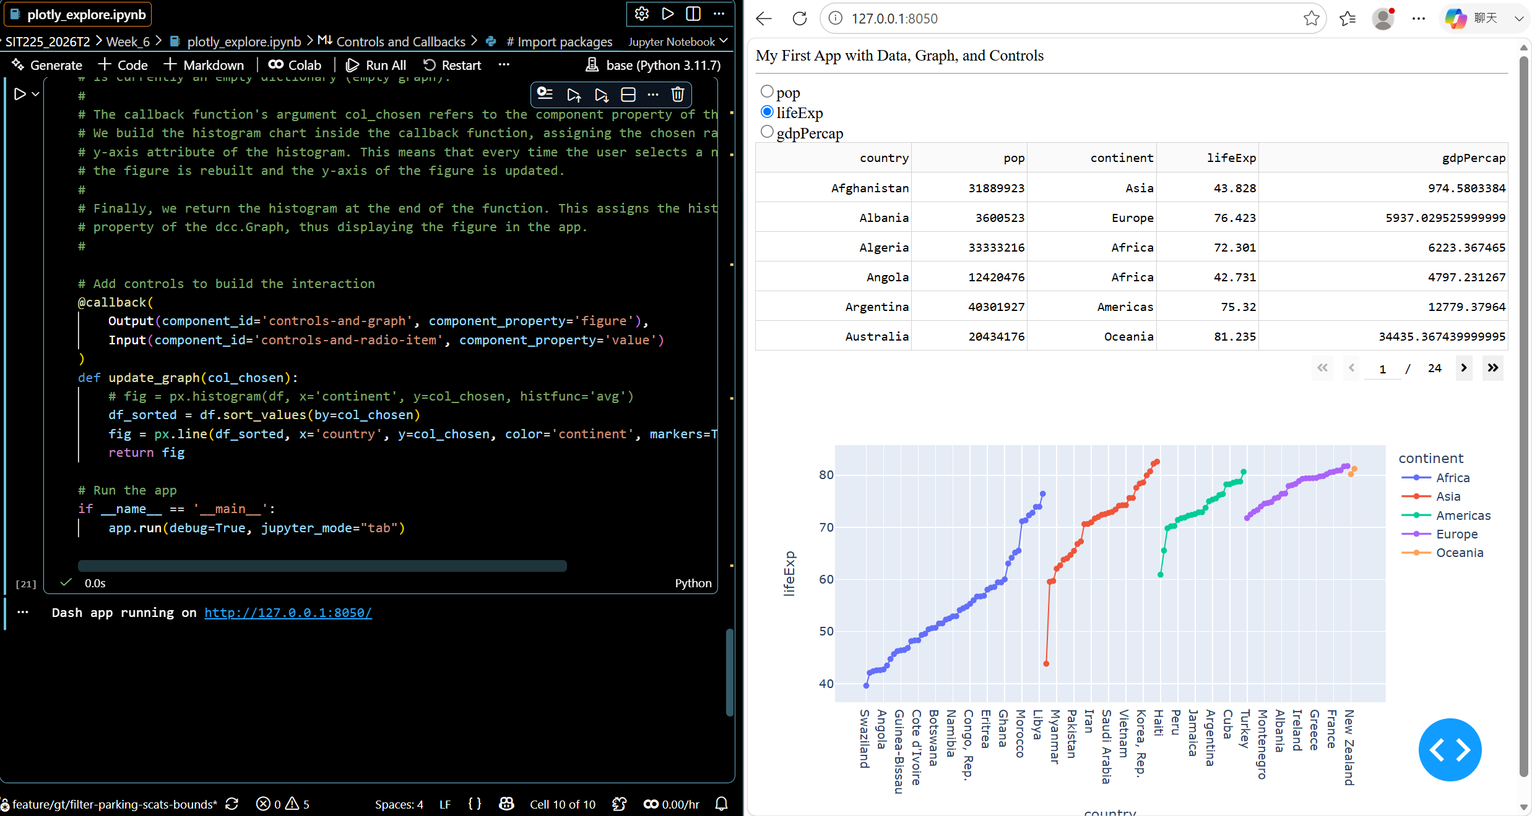
6 | Question: Now you have learned how to use Plotly Dash for visualising your data, describe how you will be using this tool for your desired sensor monitoring dashboard with a number of sensors including DHT22 or accelerometer data.  Answer: plotly dash is a tool to visualize data, since it manage by code base, I can use capture sensors data by Arduino cloud or python script then pass that data to dash so I can see the data in real time. And find out more patten.
7 | Question: Convert the Notebook to PDF and merge with this activity sheet PDF. You will need this merged PDF to combine with this week’s OnTrack task for submission.

