  - Student name: Gordon Tse
  - Student ID:s223532749

SIT225: Data Capture Technologies

Activity 7.1: Data analysis and interpretation

Data analysis is a broad term that covers a wide range of techniques that enable you to reveal any insights and relationships that may exist within raw data. As you might expect, Python lends itself readily to data analysis. Once Python has analyzed your data, you can then use your findings to make good business decisions, improve procedures, and even make informed predictions based on what you’ve discovered.

You have done data wrangling using Python Pandas module already in activity 5.2. In this activity, you will learn Data science statistics and linear regression models.

Hardware Required
- No hardware is required.

Software Required
Python 3
Python packages including Pandas, Numpy, Scikit-learn, seaborn, plotly

Steps:
Step | Action
1 | A Jupyter Notebook is provided for Data Science exploration here (https://github.com/deakin-deep-dreamer/sit225/tree/main/week_7 ). You will need to fill in your student ID and name and run all the cells to observe the output. Convert the Notebook into PDF and merge with this activity sheet which needs to be combined with this week’s task for OnTrack submission.  Question: There are sections in the Notebook. After running the cells and observing the outputs, provide your reflection in brief on the topic items for each section of the Notebook.  Answer:  - Descriptive Statistics – this section I learn about different math statistics like sum, avg, count and percentile.  1.1 Percentile – it let me find the what is the number at different %.  1.2 Standard Deviation – it showing me the core topic of Statistics, this show how spread are the data. Coefficient of variation show how large is the sdt is.  1.3 Variance - multiply the standard deviation by itself = Variance. It also a way to show how spread are the data.  1.4 Correlation – to show the relationship between two variables. It show if x change, what will happened to y.  1 = perfect linear relationship: x increase y increase.  0 = no linear relationship: x increase y no change.  -1 = perfect negative linear relationship: x increase y decrease.  1.5 Correlation Matrix – a array to show correlation.  1.6 Correlation Does not imply Causality – what I understand is when correlation cannot be apply to the variables. Like they have no relationship  But getting Correlation = 1 or -1.  1.7 Linear Regression – it help to draw a straight line to show the relationship  data. It can use for predict.
2 | Question: In the 1.1 Percentile subsection of Descriptive statistics section in the Notebook, you have calculated 10%, 25%, 50% and 75% percentiles for Max_Pulse. Compare these percentiles with Average_Pulse percentiles for any trend, if exists.  Answer: now I get the percentile for max_pulse, I found that overall in max_pulse is more then average_pulse which is normal because it showing the max number. also both when percentile increase the number also increase .  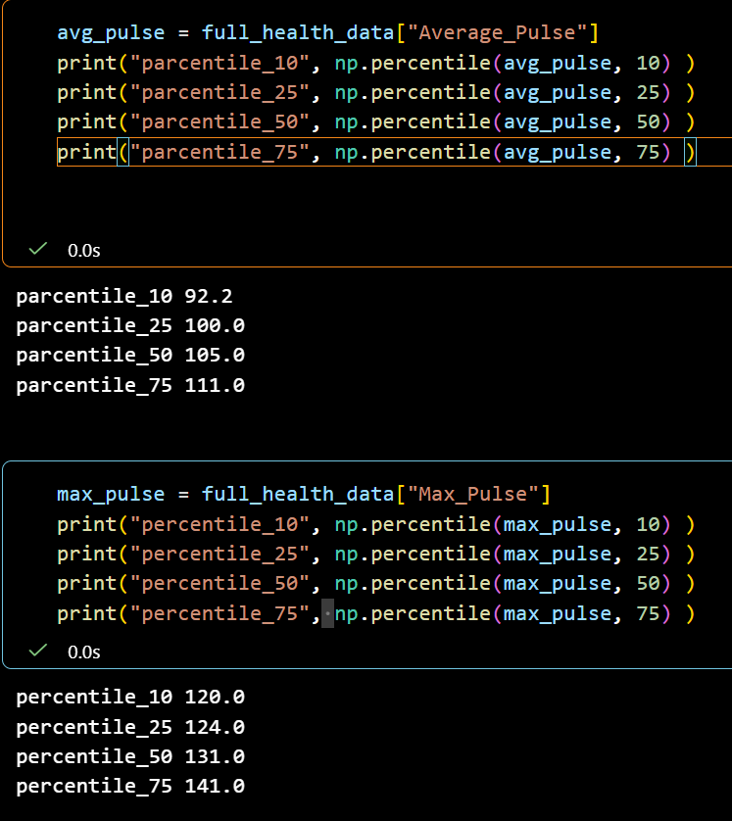
3 | Question: In the “Correlation Does not imply Causality” section answer the question regarding the increase of ice cream sale in your own understanding.  Answer: Correlation is the measures the relation between two variables, when we talk about during summer both sale of ice cream and drowning accidents increase, I will say it kind of having Correlation because of warm weather. The weather is the cause. But since when weather getting hot, people will buy ice cream and go to swimming, so I will they have the correlation. In short the direct cause of both event is warm weather.
4 | Question: In the 1.7 Linear Regression section in the Notebook, a linear regression model was used to predict Calorie_Burnage from attributes such as Average_Pulse. The Duration value was predicted from the model for all the value range of Average_Pulse and a regression line was drawn. You will need to answer the follow up question next to 1.7 section where it is required to generate a linear regression model for Duration instead of Average_Pulse to predict the Calorie_Burnage. Take a screenshot of the regression line and paste it here. Also, comment on both the regression lines.  Answer:  Looking at the Calorie_Burnage – Duration graph, is showing a upward trend and Calorie_Burnage - Average_Pulse is showing a flat line.  