Project: PowaFinance

Group: Functor

•Slobodeniuk Daniil - Backend developer and Project Manger

•Dmitry Egorov - Android Dev

•Ivan Reznik - Tester

•Roman Dubinskiy - Frontend developer

**Software Requirements Specification**

**Document**

**Version: 1** **Date: (06/10/2022)**

1. **Introduction**

**1.1 Purpose**

Neat and crisp app for tracking finances and investing

## 2.3 User Characteristics

Interested in finances and want to know more about them.

Reads a lot about finances and has a lot of experience with it.

Don't have a family budget because I don't live with my parents, and I'm not married

Familiar with investing, I analyzed the stock and bond market, currencies. Also, I invested in cryptocurrencies

## 2.4 Constraints

* Android smartphone with Android 7.1 or above, at least 512 mb of memory, not rooted
* Internet connection to sync data
* At least 1024 x 768 screen resolution

## 3.1 External Interfaces

* Investment platform
* Bank of Russia API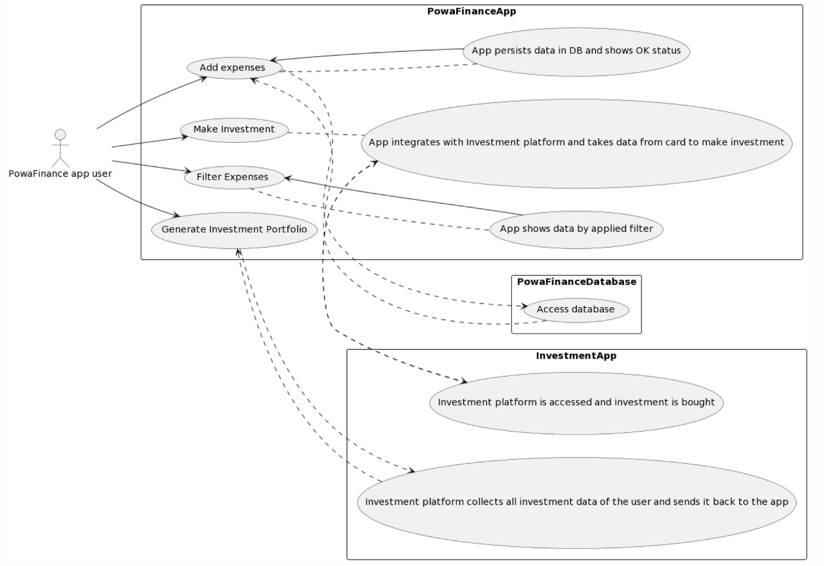

## 3.2 Functions

•finance calculation: simple and crisp way to track your daily expenses

•projection of expenditures for month/year with AI

•adjustment of expenses to current inflation

•provides option to create shared account where multiple users can enter their spending

•integration with trading platforms where you can evaluate investment opportunities

## 3.4 Logical Database RequirementsImage

### **3.6.3 Security**

* Password will be hashed by sha256
* SLA with Investment platform