Practice Project
By SleeplessSheep

Project Overview
CMS(Content Management System) with LAMP is made up of self-practice in web development, namely improve database(and query) design, frontend design and program structure. Furthermore, I would like to explore docker, web security and some APIs.

System Design
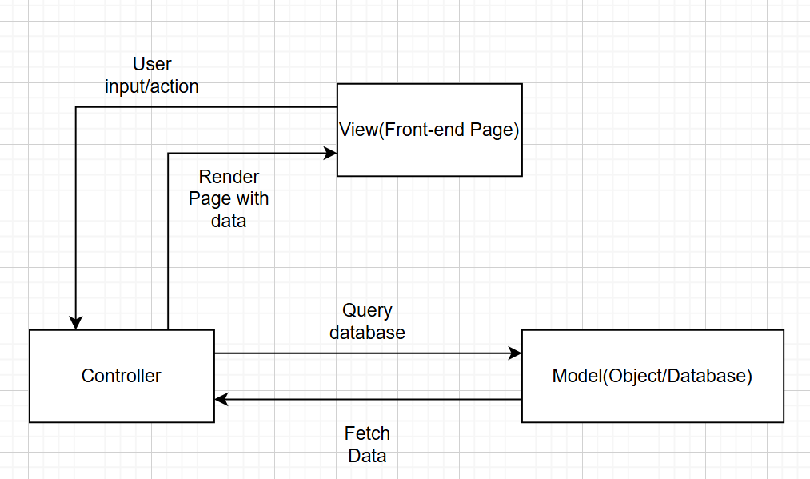

Project requirements

Functional requirements
Allow users to create, edit, delete and publish blog posts.
Allow users to create, login/logout and manage their account.
Allow users to use tag, title and time to filter blog.
Allow admin to hide or delete blog and comment.
Provide 2-factor authentication for login

Non-functional requirements
Support markdown and editor for easier content formatting.
Prevent SQL injection in both blog and comment.
Secure user passwords so that only the user would know his/her own password.
Ensure access control only the owner can edit the blog.
Provide a responsive layout for full screen, half screen and mobile.

Database Design

API Table

