

JavaScript Essentials
Training Assignments

Document Code | 25e-BM/HR/HDCV/FSOFT
Version | 1.1
Effective Date | 20/11/2012

Hanoi, 11/2024
RECORD OF CHANGES
No | Effective Date | Change Description | Reason | Reviewer | Approver
 | 11/11/2024 | Create new version | Create | AnhPH51 | PrajithNair

Contents
Exercise 1: DOM 4
Objectives: 4
Project Structure: 4
Technical Requirement 4
Task 1: 4
Task 2: 4
Task 3: 4
Exercise 2: Functions 6
Objectives: 6
Project Structure 6
Technical Requirement 6
Task 1: 6
Task 2: 6
Task 3: 7
Mark Scale 7

CODE : <JS.E_Assignment04_Op1>
TYPE : < Long >
LOC : <N/A>
DURATION : <180 minutes>

Exercise 1: DOM

Objectives:
Able to interact with HTML document using DOM API

Project Structure:
- Create a new folder called JS.E_Assignment04 (this will be your top folder)
- Create folder ex1_task1 and put every file related to this problem inside
- Create folder ex1_task2 and put every file related to this problem inside
- Create folder ex1_task3 and put every file related to this problem inside

Technical Requirement

Task 1:
- Your task is to use DOM API to query the following DOM element:
- div at line 13 (in HTML file) - save it to an variable called imageContainer
- Back button at line 18 (in HTML file) – save it to an variable called backBtn
- Next button at line 19 (in HTML file) – save it to an variable called nextBtn

Task 2:
Create a function called renderImage() that set the innerHTML of imageContainer to an HTML img with src is the variable images

Task 3:
- In body of function callback of backBtn you have to do the following:
- Decrease value of variable index by 1
- Check if that variable is less then 0 then set it to 0
- Call the function renderImage() from Task 2
- In body of function callback of nextBtn you have to do the following:
- Increase value of variable index by 1
- Check if that variable is greater or equal the length of array images then set index to the length of images - 1
- Call the function renderImage() from Task 2

- Expected output:


Exercise 2: Functions

Objectives:
Understand function feature of JavaScript and able to create your own function that solve common problem

Project Structure
In folder JS.E_Assignment04 (this will be your top folder), create
- Folder ex2_task1 and put every file related to this problem inside
- Folder ex2_task2 and put every file related to this problem inside
- Folder ex2_task 3 and put every file related to this problem inside,…

Technical Requirement

Task 1:
  - For the first task, you have to create a simple function — chooseName() — that prints a random name from the provided array (names) to the provided paragraph (para), and then run it once.
  - Expected output:

Task 2:
1 For our second functions-related task, you need to create a function that draws a rectangle on the provided <canvas> (reference variable canvas, context available in ctx), based on the five provided input variables:
- x — the x coordinate of the rectangle.
- y — the y coordinate of the rectangle.
- width — the width of the rectangle.
- height — the height of the rectangle.
- color — the color of the rectangle.
- You'll want to clear the canvas before drawing, so that when the code is updated in the case of the live version, you don't get lots of rectangles drawn on top of one another.

- Expected output:
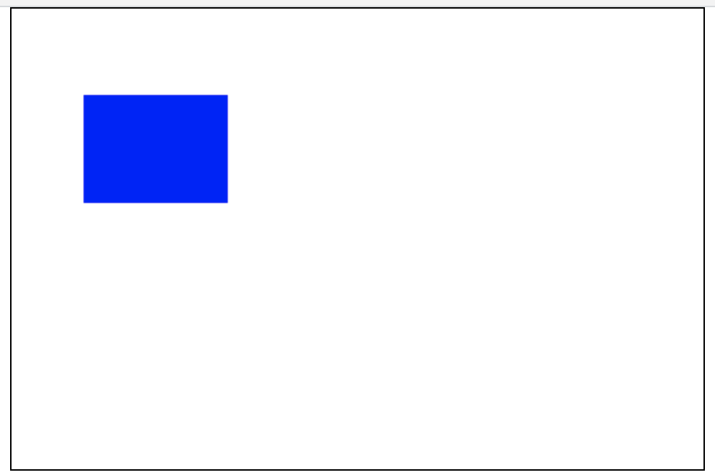

Task 3:
- In this task, you return to the problem posed in Problem 1, with the aim of improving it. The three improvements we want you to make are:
- Refactor the code that generates the random number into a separate function called random(), which takes as parameters two generic bounds that the random number should be between, and returns the result.
- Update the chooseName() function so that it makes use of the random number function, takes the array to choose from as a parameter (making it more flexible), and returns the result.
- Print the returned result into the paragraph (para)'s textContent.
- Expected Output
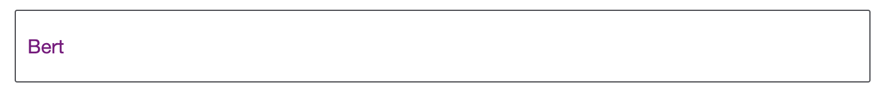

Mark Scale

Functionality | 50%
Code Quality | 30%
Maintainable | 20%

