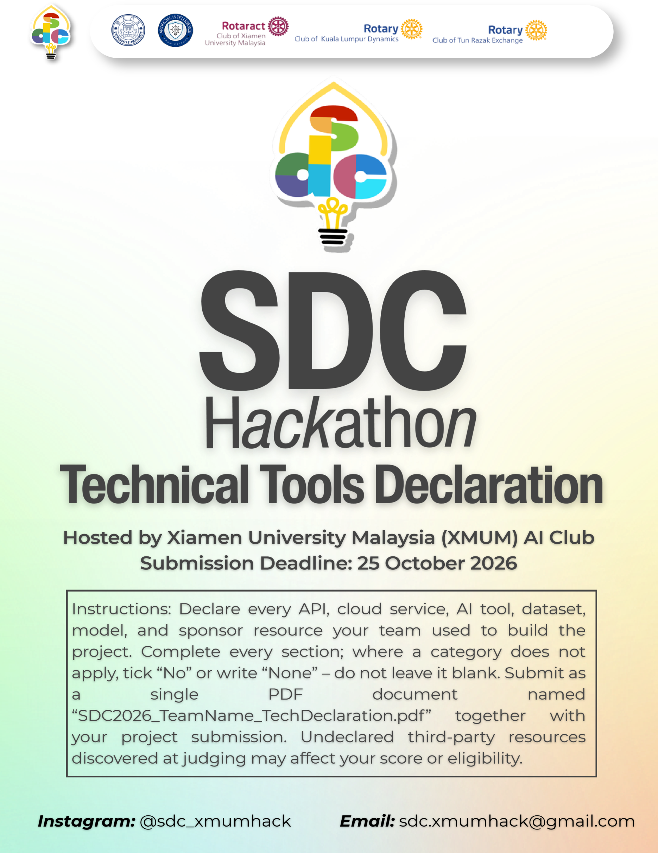
SDC HACKATHON 2026
Technical & Tools Declaration
Hosted by Xiamen University Malaysia (XMUM) AI Club
Submission Deadline: [Insert date]
Instructions: Declare every API, cloud service, AI tool, dataset, model, and sponsor resource your team used to build the project. Complete every section; where a category does not apply, tick “No” or write “None” – do not leave it blank. Submit as a single PDF document named “SDC2026_TeamName_TechDeclaration.pdf” together with your project submission. Undeclared third-party resources discovered at judging may affect your score or eligibility.

1. Team & Project Overview
Team Name | 418 I'm a Teapot
Project / Solution Name | AI Career Navigator
Name (Leader) | CHEN XIANGYU
Email & Phone (Leader) | CufoFlux@outlook.com +60173568532
University Affiliation(s) | Xiamen University Malaysia
Live Prototype URL | https://aicareer.replit.app
Code Repository URL (public / access granted to judges) | https://github.com/Sleepy-Tianhao/SDC_Hackathon_418-I-m-a-Teapot_Submission

2. Architecture & Technology Stack

2.1 System Architecture Overview
Describe how the components declared in this document connect end-to-end (e.g., user interface → backend → AI model/API → database → cloud hosting). Attach a system block diagram as an appendix if available.
[Maximum 200 words]
Our project is built on a simple but efficient client-server architecture. The frontend collects user inputs (like target roles and existing skills) and sends a JSON request to the FastAPI backend. To prevent AI hallucination and save token costs, the backend doesn't blindly ask the AI. Instead, it uses Pandas and Openpyxl to dynamically search through 8 real-world Malaysian labor market datasets (CSV/XLSX files) stored on the server. By extracting only the most relevant data rows, the backend creates a highly accurate context. This data is then combined with a custom prompt and sent to the DeepSeek API. The LLM processes this factual grounding and returns a structured JSON containing personalized reskilling pathways and SDG mappings, which the frontend renders. The entire app is deployed on Replit.

2.2 Languages, Frameworks & Libraries
List the main programming languages, frameworks, and third-party libraries that your team did not create. Open-source use is permitted provided it is declared and properly licensed/attributed.
Name & Version | Purpose in Project | License
JavaScript | Enhance the interactivity and dynamism of web pages | ECMAScript Specification License
Python 3 | Backend logic and API development. | Python Software Foundation License Version 2
CSS | Add styles to HTML or XML documents, including controlling colors, fonts, layouts, spacing, animations, and other visual presentations, in order to separate structure from style in web pages, enhancing maintainability and reusability. | MIT License
HTML | Create a Web Page | Creative Commons Attribution 4.0 International License
FastAPI | Modern Frameworks for Web APIs / Backend Services | MIT License
Pandas | Data processing and RAG retrieval from CSV files. | BSD 3-Clause License
Openpyxl | Parsing Excel (XLSX) datasets. | MIT License

3. APIs & Cloud Services

3.1 External APIs
List every external API your solution calls (GenAI, maps, payments, messaging, data feeds, etc.). Do not include API keys or secrets in this document.
API & Provider | Purpose in Project | Access Tier (free / paid / sponsor-provided)
DeepSeek: https://api.deepseek.com | Analyze user data and generate feedback. | paid

3.2 Cloud Platforms & Deployment
List every cloud service used for hosting, storage, databases, authentication, or compute, and indicate how the prototype is deployed.
Service & Provider | Purpose in Project | Plan / Region
Replit:  https://your-project.replit.app/ | Deploy and host the project | sponsor-provided

4. AI Tools, Models & Datasets

4.1 AI Models Used in the Solution
List every AI model embedded in or called by your application, including pre-trained, fine-tuned, and self-trained models.
Model & Version | Source / Provider | Usage (pre-trained / fine-tuned / self-trained) | License / Terms
DeepSeek-V4.1-Flash-1017 | Hangzhou Deep Search Artificial Intelligence Basic Technology Research Co., Ltd | pre-trained | MIT License
Deepseek-chat | Hangzhou Deep Search Artificial Intelligence Basic Technology Research Co., Ltd | pre-trained | MIT License

4.2 Datasets
List all datasets used for training, fine-tuning, evaluation, or in the running application. State clearly if a dataset contains personal or sensitive data.
Dataset Name | Source / URL | Type (public / private / self-collected / synthetic) | License | Personal Data? (Y/N)
Malaysia Graduate Employment Rate (MoHE 2024) | https://www.mohe.gov.my | public | Open Data | N
National & State Labour Force Statistics (DOSM) | https://data.gov.my | public | Open Data | N
Salary by Qualification & Industry Distribution | https://data.gov.my | public | Open Data | N
Global Labour Market Trends (2024) | https://www.ilo.org | public | Open Data | N
AI & Future Skills Signals | Synthesized from public reports | synthetic | N/A | N

4.3 AI-Assisted Development Tools
Tools used to help write code, design, content, or documentation (e.g., chat assistants, code completion tools, image generators). Declaring these tools does not reduce your score; undeclared use may.
Did your team use any generative-AI tool to help create code, design, text, or other project material?
✅ Yes ☐ No
If yes, list them below:
Tool & Version | Used For | Extent of Use (minor / moderate / major)
Replit | Deploy and host the project | minor
DeepSeek Harness DeepSeek-V4.1-Flash-1017 | Develop the frontend and backend of the project & Generative AI briefing | major
Deepseek-chat | Structured JSON Call | major

Briefly describe how your team reviewed, tested, and took responsibility for AI-generated output:
[Maximum 100 words]
While we used AI assistants to speed up coding, we maintained strict human oversight. Every FastAPI endpoint was manually tested locally before deployment. To prevent AI hallucinations in the final product, we designed a RAG (Retrieval-Augmented Generation) pipeline. The AI is strictly constrained to analyze only the real data we parsed from official Malaysian datasets, rather than relying on its pre-trained memory. All output is validated against a strict JSON schema.

5. Sponsor-Provided Resources
Declare any official SDC sponsor-provided GenAI API, cloud credits, tools, mentoring, or data that your team used.
Did your project use any official SDC sponsor-provided resource?
✅ Yes ☐ No
If yes, list them below:
Sponsor | Resource (API / credits / platform / data) | How It Was Used in the Project
Replit | $25 | Deploy and host the project

Was the sponsor resource essential to the core functionality of the prototype, or could it be replaced? Explain briefly:
[Maximum 100 words]
Replit is essential for providing a live, public URL for the judges to interact with our prototype. It serves our FastAPI backend and frontend seamlessly. However, our code is built with standard Python and is entirely platform-agnostic. If Replit were to become unavailable, we could migrate the entire project to another cloud provider like Render or AWS within a few hours just by updating the environment variables and deployment scripts.

6. Security, Privacy & Responsible Use

6.1 Data Handling & Privacy
What user or personal data does your application collect, store, or send to third-party services (including AI APIs)? How is it protected, and how long is it kept? State “No user data is collected” if applicable.
[Maximum 150 words]
We take user privacy seriously. Our application does not require account registration, and we do not store any personal data (like names, emails, or IPs) in a persistent database. The user's skills and target roles are processed in memory during the session and discarded immediately after. To generate the AI pathway, this non-personal data and the relevant labor statistics are sent to the DeepSeek API via a secure HTTPS connection. Furthermore, we have implemented CORS (Cross-Origin Resource Sharing) middleware to ensure secure communication between our frontend and backend.

6.2 Known Limitations & Risks
Identify the main technical limitations of your AI components (e.g., hallucination, bias, rate limits, dependency on a single provider) and any mitigation you have implemented.
[Maximum 150 words]
Limitations: The main limitation is our dependency on the third-party DeepSeek API. Network latency can cause generation to take 3-5 seconds, and we are subject to their rate limits. Additionally, our RAG search relies on keyword matching; if a user inputs highly niche skills not present in our CSV files, the AI has limited local data to work with.
Mitigations: To handle API failures, we implemented robust try...except blocks in our FastAPI backend so the server won't crash. If the API times out, it returns a clean error message. If no CSV data matches the user's query, our prompt design falls back to general AI reasoning, ensuring the user always receives a helpful response without breaking the app.

7. Compliance & Readiness Checklist
Tick all boxes that apply before submitting.
✅ | All APIs, cloud services, AI tools, models, and datasets used in the project are declared in this document.
✅ | All third-party code, datasets, and models are used in accordance with their licenses, and attribution is provided where required.
✅ | No API keys, passwords, or other credentials are exposed in the code repository, prototype, or this document.
✅ | Any use of generative-AI tools for development has been disclosed and reviewed by the team.
✅ | Any use of official SDC sponsor resources has been declared in Section 5.
✅ | The prototype described here is accessible to judges through the links provided in Section 1.
✅ | All fields in this template have been completed within the word limits stated.

8. Declaration
By submitting this document, the team leader confirms that the information provided is complete and accurate to the best of the team’s knowledge, and that every API, cloud service, AI tool, dataset, model, and sponsor resource used in the project has been declared.
[Signature]
[Date]

