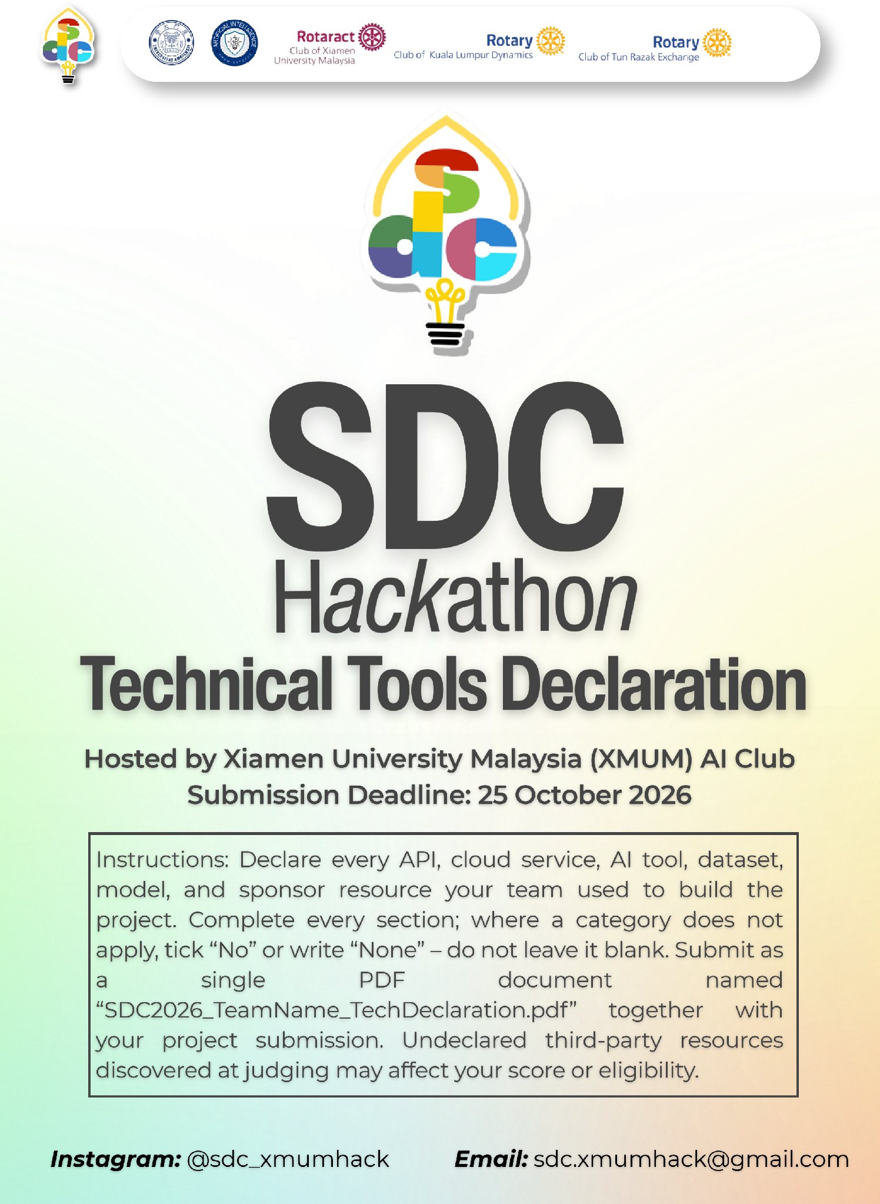
SDC HACKATHON 2026
Technical & Tools Declaration
Hosted by Xiamen University Malaysia (XMUM) AI Club
Submission Deadline: [Insert date]
Instructions: Declare every API, cloud service, AI tool, dataset, model, and sponsor resource your team used to build the project. Complete every section; where a category does not apply, tick “No” or write “None” – do not leave it blank. Submit as a single PDF document named “SDC2026_TeamName_TechDeclaration.pdf” together with your project submission. Undeclared third-party resources discovered at judging may affect your score or eligibility.

1. Team & Project Overview
Team Name | 418 I'm a Teapot
Project / Solution Name | AI Career Navigator
Name (Leader) | Chen Xiangyu
Email & Phone (Leader) | CufoFlux@outlook.com +60173568532
University Affiliation(s) | Xiamen University Malaysia
Live Prototype URL
Code Repository URL (public / access granted to judges) | https://github.com/Sleepy-Tianhao/SDC_Hackathon_418-I-m-a-Teapot_Submission

2. Architecture & Technology Stack

2.1 System Architecture Overview
Describe how the components declared in this document connect end-to-end (e.g., user interface → backend → AI model/API → database → cloud hosting). Attach a system block diagram as an appendix if available.
[Maximum 200 words]

2.2 Languages, Frameworks & Libraries
List the main programming languages, frameworks, and third-party libraries that your team did not create. Open-source use is permitted provided it is declared and properly licensed/attributed.
Name & Version | Purpose in Project | License
JavaScript | Enhance the interactivity and dynamism of web pages | ECMAScript Specification License
Python | Language/runtime for the whole backend. | Python Software Foundation License Version 2
CSS | Add styles to HTML or XML documents, including controlling colors, fonts, layouts, spacing, animations, and other visual presentations, in order to separate structure from style in web pages, enhancing maintainability and reusability. | MIT License
HTML | Create a Web Page | Creative Commons Attribution 4.0 International License
FastAPI | Modern Frameworks for Web APIs / Backend Services | MIT License
uvicorn | ASGI server that runs the FastAPI app | BSD 3‑Clause license
pydantic | Intended as FastAPI's request/response validation layer | MIT License
pandas | Intended for ingesting the labour-market tables | BSD 3‑Clause License
openpyxl | Excel engine behind pandas.read_excel for malaysia_graduate_labour_market.xlsx. | MIT License

3. APIs & Cloud Services

3.1 External APIs
List every external API your solution calls (GenAI, maps, payments, messaging, data feeds, etc.). Do not include API keys or secrets in this document.
API & Provider | Purpose in Project | Access Tier (free / paid / sponsor-provided)
DeepSeek: https://api.deepseek.com | Analyze user data and generate feedback. | paid

3.2 Cloud Platforms & Deployment
List every cloud service used for hosting, storage, databases, authentication, or compute, and indicate how the prototype is deployed.
Service & Provider | Purpose in Project | Plan / Region
Replit:  https://your-project.replit.app/ | Deploy and host the project | sponsor-provided

4. AI Tools, Models & Datasets

4.1 AI Models Used in the Solution
List every AI model embedded in or called by your application, including pre-trained, fine-tuned, and self-trained models.
Model & Version | Source / Provider | Usage (pre-trained / fine-tuned / self-trained) | License / Terms
DeepSeek-V4.1-Flash-1017 | Hangzhou Deep Search Artificial Intelligence Basic Technology Research Co., Ltd | pre-trained | MIT License

4.2 Datasets
List all datasets used for training, fine-tuning, evaluation, or in the running application. State clearly if a dataset contains personal or sensitive data.
Dataset Name | Source / URL | Type (public / private / self-collected / synthetic) | License | Personal Data? (Y/N)
Malaysia Graduates Statistics 2024 | https://www.dosm.gov.my/portal-main/release-content/graduates-statistics-2024 | public | DOSM — Government Open Data Terms of Use 1.0 | N
Malaysia Graduates Statistics 2023 | https://www.dosm.gov.my/portal-main/release-content/graduates-statistics-2023 | public | DOSM — Government Open Data Terms of Use 1.0 | N
Malaysia Graduates Statistics 2022 | https://www.dosm.gov.my/portal-main/release-content/graduates-statistics-2022 | public | DOSM — Government Open Data Terms of Use 1.0 | N
Malaysia Graduates Statistics 2021 | https://www.dosm.gov.my/portal-main/release-content/graduates-statistics-2021 | public | DOSM — Government Open Data Terms of Use 1.0 | N
Malaysia Graduates Statistics 2020 | https://www.dosm.gov.my/portal-main/release-content/graduates-statistics-2020 | public | DOSM — Government Open Data Terms of Use 1.0 | N
Malaysia Graduates Statistics 2019 | https://www.dosm.gov.my/portal-main/release-content/graduates-statistics-2019 | public | DOSM — Government Open Data Terms of Use 1.0 | N
Malaysia Graduates Statistics 2018 | https://www.dosm.gov.my/portal-main/release-content/graduates-statistics-2018 | public | DOSM — Government Open Data Terms of Use 1.0 | N
Malaysia Graduates Statistics 2024 infographic PDF | https://www.dosm.gov.my/uploads/release-content/file_20260331122058.pdf | public | DOSM — Government Open Data Terms of Use 1.0 | N
Malaysia Graduates Statistics release archive | https://www.dosm.gov.my/portal-main/release-archive/graduates-statistics-2019 | public | DOSM — Government Open Data Terms of Use 1.0 | N
Malaysia Publication / 数据申请入口 | https://www.dosm.gov.my/portal-main/publication | public | DOSM — Government Open Data Terms of Use 1.0 | N
Malaysia Graduate Employment Rate portal | https://ge.mohe.gov.my/CarianGraduateEmploymentBI.aspx | public | MoHE/KPT — None | N
Malaysia Graduate Employability portal | https://ge.mohe.gov.my/CarianGraduateEmployabilityBI.aspx | public | MoHE/KPT — None | N
United States Winter 2026 Salary Survey Executive Summary | https://www.naceweb.org/docs/default-source/default-document-library/2026/publication/executive-summary/nace-winter-2026-salary-survey-executive-summary.pdf | public | NACE — None | N
United States 2026 Student Survey | https://www.naceweb.org/about-us/press/2026/more-than-two-out-of-five-of-college-class-of-2026-had-a-job-offer-in-hand-by-graduation | public | NACE — None | N
United States Labor market outcomes by college major 2026 | https://www.lanacion.com.ar/estados-unidos/las-carreras-con-los-sueldos-mas-altos-y-menos-desempleo-en-2026-en-eeuu-segun-la-fed-nid27022026/ | public | Federal Reserve Bank of New York via CBS/La Nación — None | N
United Kingdom Graduate Outcomes 2023/24 | https://www.hesa.ac.uk/news/04-06-2026/sb275-higher-education-graduate-outcomes-statistics | public | HESA — Creative Commons 4.0 CC-BY | N
United Kingdom Drop in graduate employment ‘a cooling, not a collapse’ | https://www.timeshighereducation.com/news/drop-graduate-employment-cooling-not-collapse | public | Times Higher Education — None | N
Germany Akademikerarbeitslosigkeit 2025 | https://www.bpb.de/themen/bildung/dossier-bildung/576230/sind-studierte-am-arbeitsmarkt-weniger-gefragt-herr-weber/ | public | CC BY-NC-ND | N
Germany Handwerk oder Studium | https://www.tagesschau.de/ | public | CC BY-SA 4.0;  CC BY-NC-ND 4.0 DE | N
Japan 令和7年度大学等卒業者の就職状況調査 | https://www.mext.go.jp/ | public | CC BY 4.0 | N
Japan 2026届应届生起薪25.4228万日元/月 | https://zhuanlan.zhihu.com/p/2030591329944737236 | public | None | N
South Korea 2024年毕业生就业统计 | https://www.asiae.co.kr/article/2025122918315539619 | public | None | N
South Korea OECD Education at a Glance 2026 via UPI：25–64岁大学毕业生就业率80.1%（2025） | https://www.upi.com/Top_News/World-News/2026/09/29/oecd-education-employment/3791790724530/ | public | UPI — None | N
Australia 2025 Graduate Outcomes Survey National Report | https://qilt.edu.au/ | public | QILT — None | N
Australia 2025 GOS-L（三年后中位薪资A$91,000） | https://www.qilt.edu.au/surveys/graduate-outcomes-survey---longitudinal-(gos-l) | public | QILT — None | N
Canada Labour market outcomes of postsecondary graduates | https://www150.statcan.gc.ca/n1/en/surveys/5012 | public | Statistics Canada — Statistics Canada Open Licence | N
Canada Characteristics and median employment income by educational qualification and field of study | https://open.canada.ca/ | public | Open Government Portal — Open Government Licence – Canada | N

4.3 AI-Assisted Development Tools
Tools used to help write code, design, content, or documentation (e.g., chat assistants, code completion tools, image generators). Declaring these tools does not reduce your score; undeclared use may.
Did your team use any generative-AI tool to help create code, design, text, or other project material?
√ Yes ☐ No
If yes, list them below:
Tool & Version | Used For | Extent of Use (minor / moderate / major)
Replit | Deploy and host the project | minor
DeepSeek Harness DeepSeek-V4.1-Flash-1017 | Develop the frontend and backend of the project | major

Briefly describe how your team reviewed, tested, and took responsibility for AI-generated output:
[Maximum 100 words]

5. Sponsor-Provided Resources
Declare any official SDC sponsor-provided GenAI API, cloud credits, tools, mentoring, or data that your team used.
Did your project use any official SDC sponsor-provided resource?
√ Yes ☐ No
If yes, list them below:
Sponsor | Resource (API / credits / platform / data) | How It Was Used in the Project
Replit | $25 | Deploy and host the project

Was the sponsor resource essential to the core functionality of the prototype, or could it be replaced? Explain briefly:
[Maximum 100 words]

6. Security, Privacy & Responsible Use

6.1 Data Handling & Privacy
What user or personal data does your application collect, store, or send to third-party services (including AI APIs)? How is it protected, and how long is it kept? State “No user data is collected” if applicable.
[Maximum 150 words]

6.2 Known Limitations & Risks
Identify the main technical limitations of your AI components (e.g., hallucination, bias, rate limits, dependency on a single provider) and any mitigation you have implemented.
[Maximum 150 words]

7. Compliance & Readiness Checklist
Tick all boxes that apply before submitting.
☐ | All APIs, cloud services, AI tools, models, and datasets used in the project are declared in this document.
☐ | All third-party code, datasets, and models are used in accordance with their licenses, and attribution is provided where required.
☐ | No API keys, passwords, or other credentials are exposed in the code repository, prototype, or this document.
☐ | Any use of generative-AI tools for development has been disclosed and reviewed by the team.
☐ | Any use of official SDC sponsor resources has been declared in Section 5.
☐ | The prototype described here is accessible to judges through the links provided in Section 1.
☐ | All fields in this template have been completed within the word limits stated.

8. Declaration
By submitting this document, the team leader confirms that the information provided is complete and accurate to the best of the team’s knowledge, and that every API, cloud service, AI tool, dataset, model, and sponsor resource used in the project has been declared.
[Signature]
[Date]

