fun fold f acc xs =

case xs of

[] => acc

| x::xs’ => fold f (f(acc,x)) xs’

fun sum_inferior xs = fold (fn (x,y) => x+y) 0 xs

val sum = fold (fn (x,y) => x+y) 0

(* tournamnet를 인자로 받아서 이긴 플레이어를 반환

* 도우미 함수들을 let in end로

fun whosWinner(t) =

let (* 함수 next는현재 rsp 를 반환하고 다음 상태로 ref를 업데이트하는 함수 *)

fun next(strategyRef) =

let val Cons(rsp, func) = !strategyRef

in

strategyRef := func();

(* 이 rsp는 func()를 통해 업데이트되기전의 값이므로 현재 rsp 정보임에 유의 *)

rsp

end

[(fun? e)

(let* ([f_name (fun-nameopt e)]

[arg (fun-formal e)]

;[new_env (cons (cons f_name (closure env e)) env)]

;[body (eval-under-env (fun-body e) env)]

)

(cond [(and (string? f_name) (string? arg))

;(closure new_env e)]

(closure env e)]

[(and (false? f_name) (string? arg))

(closure env e)]

[#t (error "arguments are not valid : string or #f")])

)

]

[(call? e) ; env for (f_name . fun_closure) pair extended when call function,,, not when evaluating fun

(let* ([fun_closure (eval-under-env (call-funexp e) env)]

[fun_arg (eval-under-env (call-actual e) env)]

[function (closure-fun fun_closure)]

[fun_env (closure-env fun_closure)]

)

(if (closure? fun_closure)

(let* ([f_name (fun-nameopt function)]

[f_formal (fun-formal function)]

[f_body (fun-body function)]

[arg_env (cons (cons f_formal fun_arg) fun_env)]

[new_env (if (false? f_name)

arg_env

(cons (cons f_name fun_closure) arg_env))]

)

(eval-under-env f_body new_env)

)

(error "first argument is not valid : closure")

)

)

]

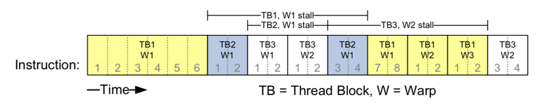

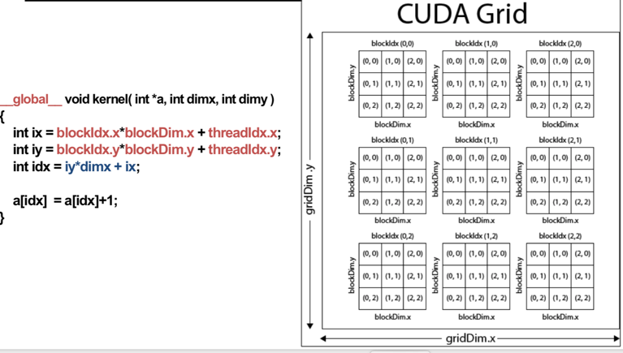

• Global memory is separate hardware from GPU SMs

• The vast majority of memory on a GPU is global memory

• If data doesn’t fit in global memory, process it in chunks that fit

• GPUs have 1~32GB of global memory, with most having ~10GB

• Global memory latency is ~300ns on Kepler and ~600ns on Fermi // Memory coalescing

• Memory accesses done in large groups of Memory Transactions • Done per warp

• Fully utilizes the way IO is setup at the hardware level

• Coalesced memory accesses minimize the number of cache lines read

• GPU cache lines are 128 bytes and are aligned

To fix the stride 32 case, we’ll waste a byte on padding and make the stride 33 :)

Don’t store any data in slots 32, 65, 98, .... Now we have

thread 0 ⇒ index 0 (bank 0)

thread 1 ⇒ index 33 (bank 1)

thread i ⇒ index 33 * i (bank i)

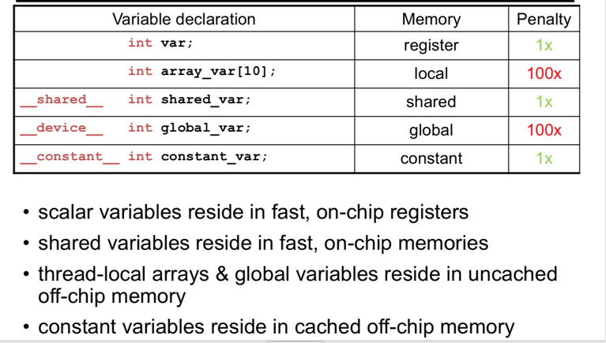

//L1 cache

• Caches local and/or global memory

• Same hardware as shared memory

• For some GPU architectures, configurable (16, 32, 48KB) • Each SM has its own L1 cache

//L2 cache

• Caches all global & local memory accesses • ~1MB in size

• Shared by all SM’s

__global__ void adj_diff(int *result, int *input){

int tx = threadIdx.x;

// allocate a __shared__ array, one element per thread

__shared__ int s_data[BLOCK_SIZE];

// each thread reads one element to s_data

unsigned int i = blockDim.x * blockIdx.x + tx;

s_data[tx] = input[i];

// avoid race condition: ensure all loads

// complete before continuing

__syncthreads();

...

}

__global__ void adj_diff(int *result, int *input){

...

if(tx > 0)

result[i] = s_data[tx] – s_data[tx–1];

else if(i > 0)

{

// handle thread block boundary

result[i] = s_data[tx] – input[i-1];

}

}

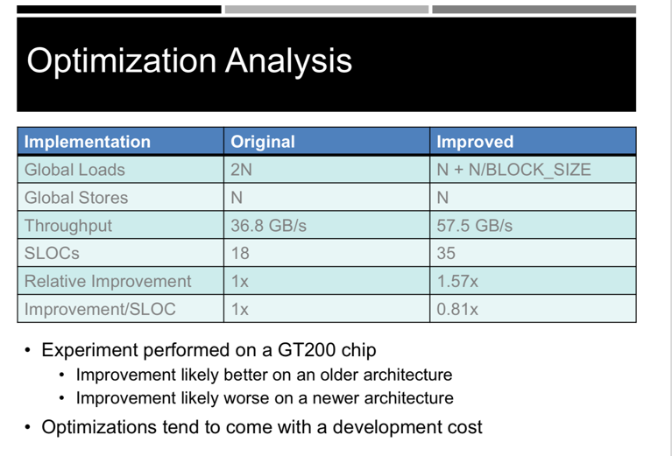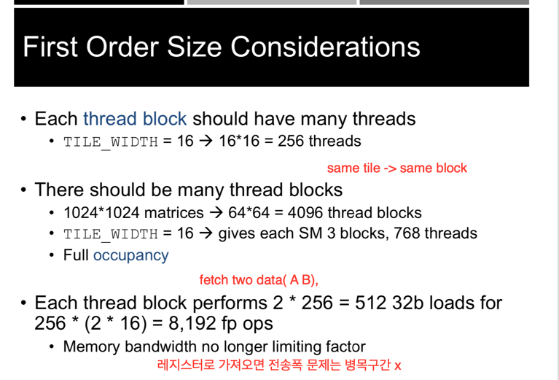

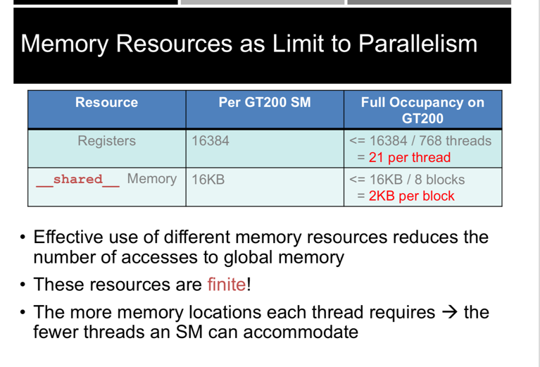

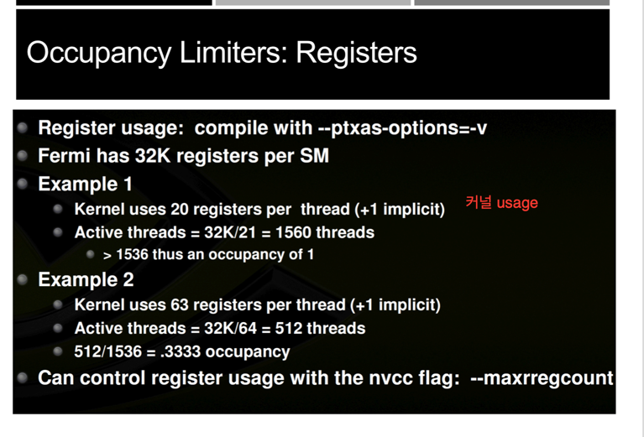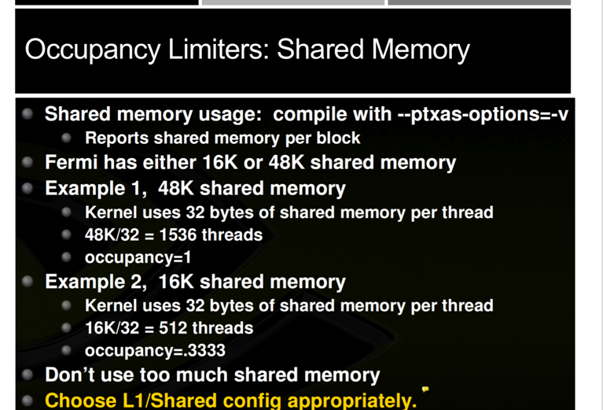

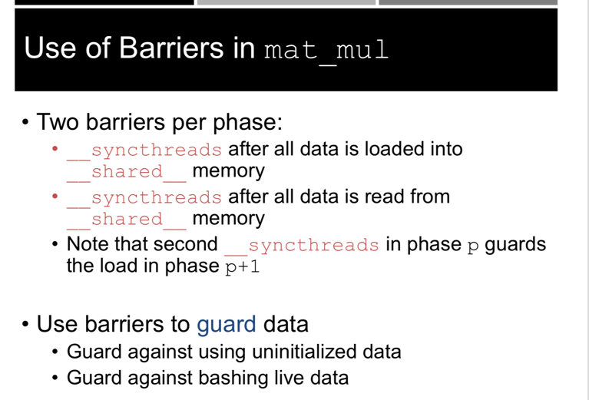

// global sum via per-block reductions

float sum(float *d_input, size_t n)

{

size_t block_size = ..., num_blocks = ...;

// allocate per-block partial sums

// plus a final total sum

float *d_sums = 0;

cudaMalloc((void**)&d_sums,

sizeof(float) * (num_blocks + 1));

... // reduce per-block partial sums

int smem_sz = block_size*sizeof(float); block_sum<<<num_blocks,block_size,smem_sz>>>(d_input, d_sums, n);

// reduce partial sums to a total sum

block_sum<<<1,block_size,smem_sz>>> (d_sums, d_sums + num_blocks, num_blocks);

// copy result to host

float result = 0;

cudaMemcpy(&result, d_sums+num_blocks, ...);

return result;

}

__global__ void inclusive_scan(int *data)

{

extern __shared__ int sdata[];

unsigned int i = ...

// load input into __shared__ memory

int sum = input[i];

sdata[threadIdx.x] = sum;

__syncthreads();

...

for(int o = 1; o < blockDim.x; o <<= 1){

if(threadIdx.x >= o)

sum += sdata[threadIdx.x - o];

// wait on reads

__syncthreads();

// write my partial sum

sdata[threadIdx.x] = sum;

// wait on writes

__syncthreads();

}

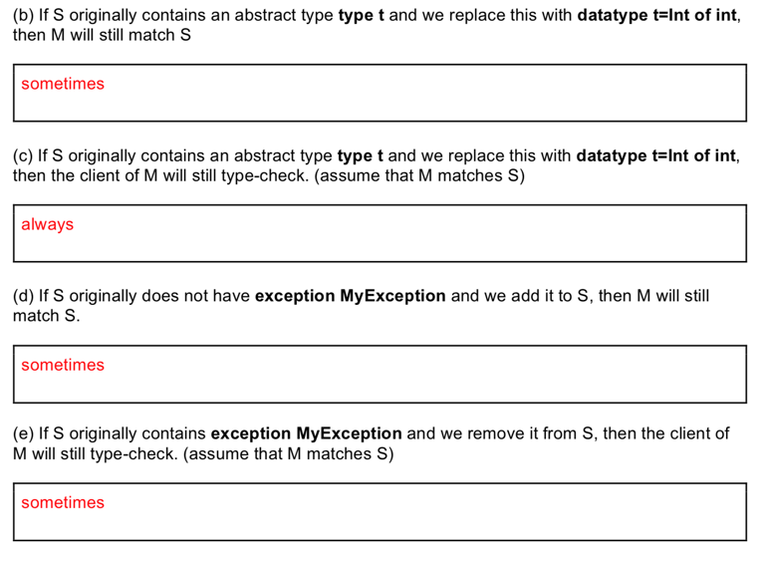

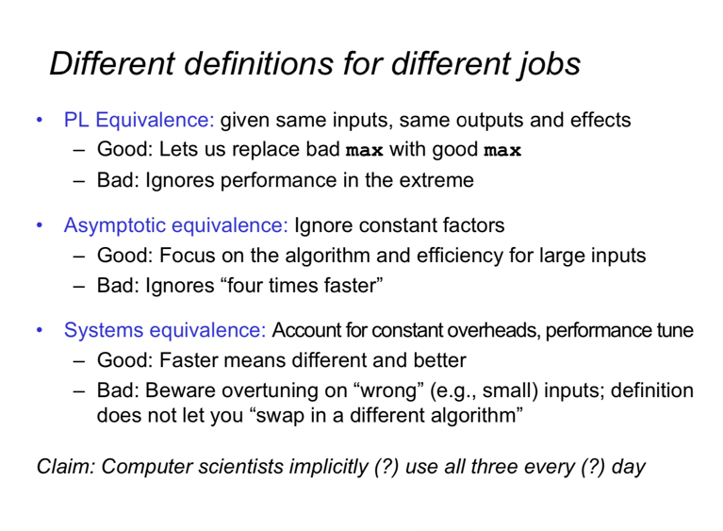

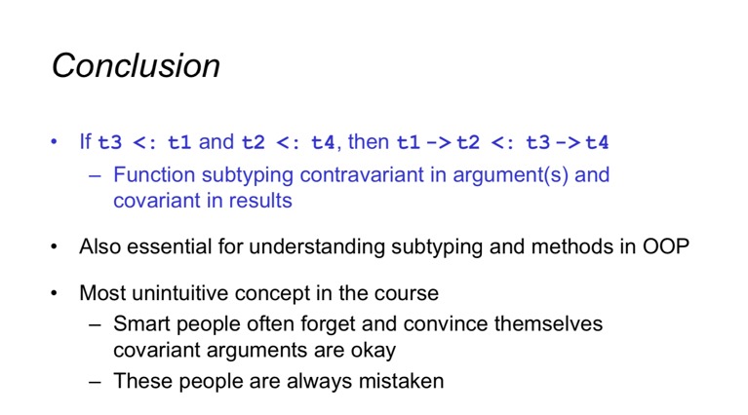

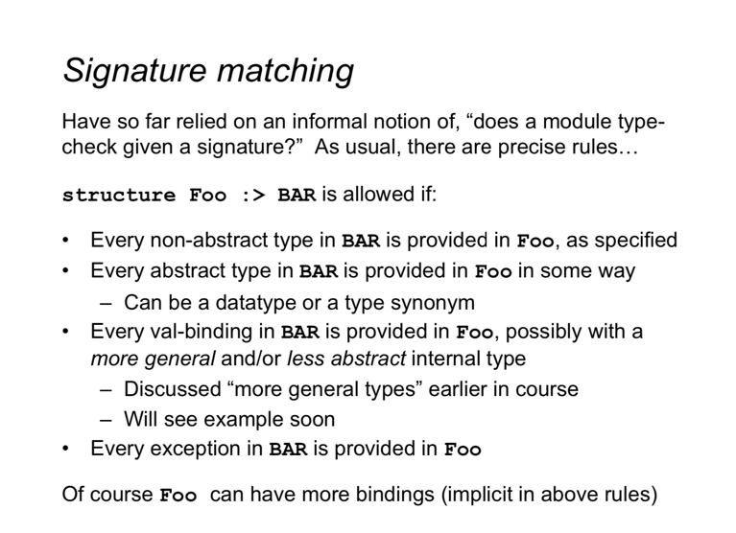

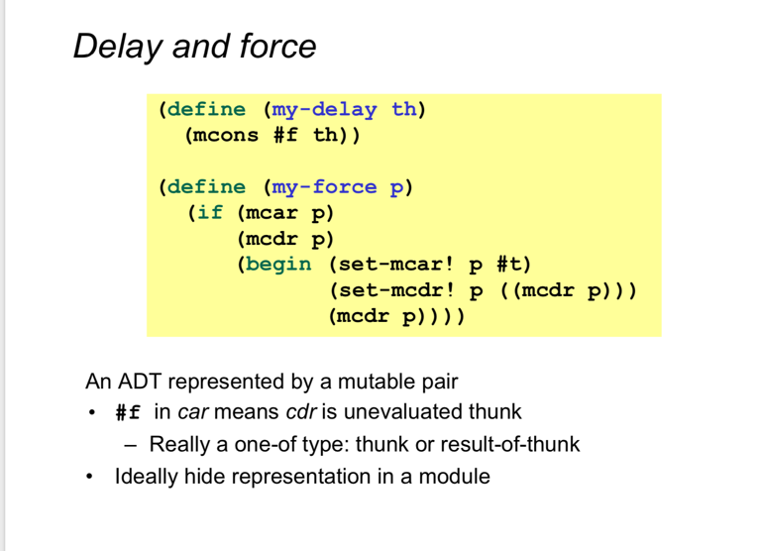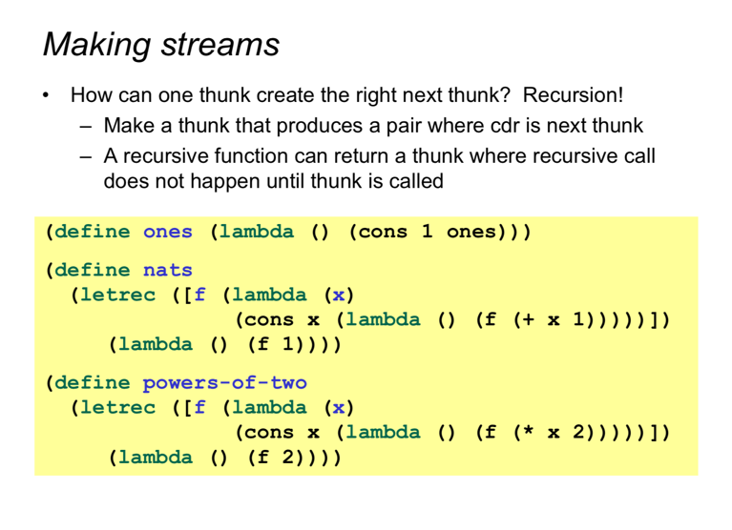

(define stream-factorial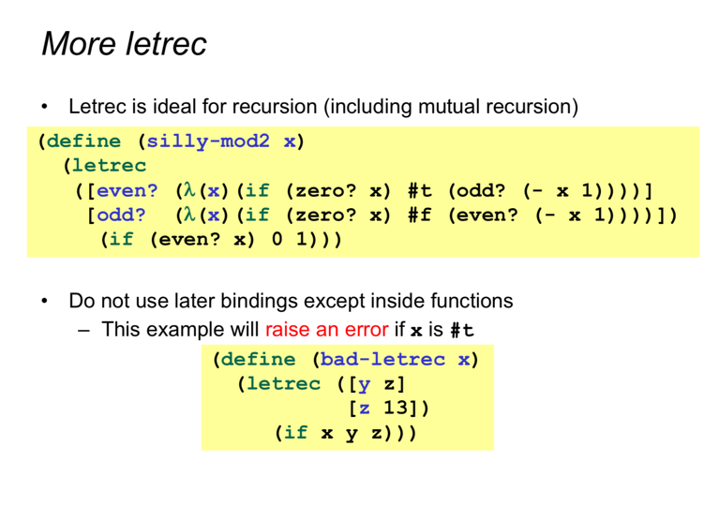

(let ([factorial-stream

(let loop ([i 1]

[a 1])

(stream-cons

a

(loop (add1 i) (* a i))))])

(λ (n)

(stream-ref factorial-stream n))))

