Development and DFT-based assessment of a DeepMD potential for Cu–Au nanoclusters
Dmytro Shyrokorad¹,* and Grygoriy V. Kornich¹,²
¹ Department of Systems Analysis and Computational Mathematics, National University Zaporizhzhia Polytechnic, Zaporizhzhia, Ukraine
² Faculty of Physics and Astronomy EP3, Universität Würzburg, D-97074 Würzburg, Germany
* Corresponding author: hoveringphoenix@gmail.com

Abstract
Atomistic simulations of bimetallic nanoclusters require interatomic potentials that describe chemically distinct surface, interface, and interior environments. The connection between DFT reference coverage and predictive accuracy is examined through the development and environment-resolved assessment of a Cu–Au DeepMD potential. A database of 285 configurations combines pure and mixed compositions, periodic crystalline structures, and isolated clusters containing 55 or 147 atoms. The model is fitted to 259 configurations, with 26 exposed development and diagnostic configurations excluded from fitting. On the 20-configuration development subset, energy and force-component root-mean-square errors of 11.789 meV/atom and 0.05786 eV/Å are obtained. A separate prospective test is performed on six new 55-atom configurations after the model has been fixed. With the adopted finite-cell DFT references, errors of 31.642 meV/atom and 0.17425 eV/Å are obtained. Lower force errors are found for the two unrelaxed cluster geometries, while the larger discrepancies are concentrated in two collision snapshots. By combining this independent configuration test with controlled contact and shear deformations, the accuracy of distinct cluster environments is resolved and specific refinement targets are identified. DeepMD provides a composition-sensitive many-body framework that can be extended systematically as additional cluster environments are included in the reference database.
Keywords: machine learning interatomic potential; DeepMD; Cu–Au nanoclusters; density functional theory; reference database; energy and force accuracy

1 Introduction
Bimetallic nanoclusters contain chemically distinct surface, interface, and interior environments within a small volume. Their structural response is governed by local coordination, chemical arrangement, and the interactions between the component regions. Molecular-dynamics studies of Cu–Au particles have shown that substantial atomic rearrangement can be induced by low-energy perturbations [1]. An interatomic potential intended for such systems must therefore represent a range of cluster environments rather than a single crystalline reference state.
Neural-network interatomic potentials represent potential-energy surfaces fitted to electronic-structure calculations [2,3]. In DeepMD, the total energy is expressed as a sum of local atomic contributions, and forces are obtained by differentiating that energy [3,4,5]. This representation allows a model fitted to small structures to be applied to a larger nanoparticle. Its range of application depends in part on the coverage of local atomic environments in the training data.
The development of a cluster potential involves two connected tasks: assembling a representative reference database and establishing which aspects of the potential-energy surface are reproduced. Energy and force errors provide complementary measures of this representation. Their interpretation is strengthened when configurations are grouped by structural character and by their role in fitting or assessment. Physically guided validation and clearly defined application domains have been emphasized in recent work [6,7], together with transparent reporting of data provenance and model evaluation [8].
Committee-guided exploration, including the concurrent-learning approach used in DP-GEN [9], provides a route to selecting informative structures for additional DFT calculations. For bimetallic clusters, coverage of pure and mixed compositions, free surfaces, internal interfaces, and distorted structures is needed. Targeted geometric probes can complement this sampling by testing a defined local deformation. In this way, database construction, model fitting, and physical assessment can be connected within a systematic development procedure.
A Cu–Au DeepMD potential is developed and assessed here using a traceable database of crystalline and finite-cluster configurations. The database composition, training procedure, and energy–force accuracy are presented first, with the 259-configuration fit as the principal research model. Local contact and shear deformations are used to extend the sampled environments, while controlled stronger contractions remain one focused diagnostic. The resulting assessment establishes the accuracy of the sampled configurations and identifies priorities for further dataset development. A related conference submission from the same Cu–Au modeling project concerns a dynamical application [10]; the present article addresses potential development and DFT-based assessment. A prospective test on six newly labeled configurations is then used to assess the fixed model beyond the exposed development populations.

2 Computational methods

2.1 Configuration database
Pure Cu, pure Au, and mixed Cu–Au configurations are represented in the database. Periodic crystalline structures are included alongside isolated clusters with surface and interface environments. The fitting population contains 33 pure Cu, 71 pure Au, and 155 mixed configurations. Its structural families include crystalline anchors, Janus-like and core–shell clusters, surface and interface rearrangements, strained structures, and collision-related configurations. Fifty-four collision-relevant configurations were selected through a project-specific committee-guided procedure inspired by concurrent learning [9].
The development database contains 285 configurations: 259 fitting configurations, 20 development configurations, and six targeted diagnostic configurations. The latter two groups together form 26 exposed assessment configurations. Six new configurations are reserved separately for the prospective test described in section 2.6, bringing the number of distinct configurations considered to 291 without changing the fitting set. Their sizes and boundary conditions are summarized in Table 1. The fitting set contains an ordinary 219-configuration population, 32 prescribed contact configurations, and eight collective shear configurations. Here, ordinary denotes configurations outside these prescribed deformation families; it does not imply that all structures are at equilibrium. Development and diagnostic configurations were excluded from fitting but inspected during model development, and are therefore distinguished from the new test set.
The fitting set contains eight Cu–Cu and eight Au–Au compression configurations. For each pair type, four parent environments were selected from pure, Janus-like, mixed, and core–shell clusters. A same-species pair was displaced along its original bond, keeping its center of mass fixed, to produce separations of 2.05 and 1.90 Å. The other 53 atomic positions, species order, and cell were unchanged. No relaxation was applied. Local deformation was therefore probed within the full many-body cluster environment.
Eight additional 55-atom configurations were generated from four existing fitting parents: Au–Au contacts at 2.25 Å in pure Au, Janus-like, mixed, and Cu-core clusters, and Cu–Au contacts at both 2.25 and 2.05 Å in Janus-like and mixed clusters. The pair was displaced along its bond with its mass-weighted center of mass fixed, accounting for the unequal Cu and Au masses. The other 53 atoms were fixed and no relaxation was applied. No duplicates were identified under the selection criteria, and no existing geometry or label was replaced.
The six compression diagnostics contain Cu–Cu, Cu–Au, and Au–Au pairs at separations of 1.70 and 1.85 Å. These configurations were excluded from fitting and used to examine the response at more severe compression.
The sixteen latest configurations were generated from eight existing 55-atom fitting parents. Eight localized pair contractions comprised four Cu–Au contacts at 2.25 Å, two Au–Au contacts at 2.35 Å, and two Cu–Cu contacts at 2.20 Å. Each selected pair was displaced along its bond with its mass-weighted center of mass fixed; the other 53 atoms were unchanged. Eight separate configurations were generated by applying a 4% xz simple shear about the whole-cluster center of mass to the original parents, without a preceding pair contraction. Cells and species order were preserved, and no relaxation was applied. These sixteen configurations were assigned only to fitting.
Historical and newly labeled configurations were reconciled using their geometry and reference provenance. Replacement of an energy-and-force label did not increase the configuration count. Exact and invariant-based duplicate checks found no duplicate pairs in the retained database. Eleven near-geometry pairs in the earlier database were retained and were not interpreted as independent evidence. The sixteen latest additions passed exact, invariant, and near-duplicate checks without replacing any earlier geometry or reference. These geometric checks do not establish independence of local atomic environments. The source of each retained label and the earlier database versions were preserved.
Table 1. Configuration populations and data roles. The 285-configuration development database and the six separately reserved test configurations are listed without merging their roles. The 259 fitting configurations comprise 219 ordinary configurations, 32 prescribed contacts, and eight collective shear configurations.
Population | Periodic  32 atoms | Isolated  55 atoms | Isolated  147 atoms | Total
Fitting | 43 | 212 | 4 | 259
Development | 4 | 16 | 0 | 20
Diagnostics | 0 | 6 | 0 | 6
Independent test | 0 | 6 | 0 | 6

2.2 Electronic structure references
Reference energies and forces were obtained using density functional theory [11,12], the PBE exchange-correlation functional [13], and Quantum ESPRESSO [14,15]. The targeted contact and shear calculations and eight refreshed fitting labels were evaluated with Quantum ESPRESSO 7.6 using non-spin-polarized states and Γ-point sampling. A PSlibrary Cu PAW pseudopotential [16] and a GBRV Au ultrasoft pseudopotential [17] were used, with wavefunction and charge-density cutoffs of 80 and 320 Ry. Marzari–Vanderbilt smearing [18] was applied with a width of 0.02 Ry, and the self-consistent-field threshold was 10⁻⁷ Ry. The Martyna–Tuckerman correction [19] was used for isolated clusters, retaining the parent cells. Davidson diagonalization and 328 bands were used for the targeted 55-atom calculations.
Electronic-structure inputs and outputs were retained with each configuration so that the reference settings remain traceable. Of the 259 fitting references, 104 were evaluated with the later protocol specified above and 155 were retained with their documented historical settings. Eight labels were refreshed without changing their geometries, atom order, cells, or fitting assignments. All sixteen contact and shear additions were evaluated with the later protocol. The distinction between replacement labels and additional geometries was preserved throughout database assembly.

2.3 Model representation and training
The smooth angular Deep Potential representation [20] was used with a 6 Å cutoff and a smoothing onset of 0.5 Å. The embedding network contained layers of 25, 50, and 100 neurons, and the fitting network contained three layers of 240 neurons. The axis dimension was 16. Neighbor selections were 96 for Cu and 88 for Au, with Cu preceding Au in the type order.
$E = \sum_{i = 1}^{N}{ε_{αᵢ}(D_{i})} , F_{i} = −\frac{∂E}{∂r_{i}}$ (1)
In equation (1), Dᵢ is the local descriptor of atom i, αᵢ is its chemical type, and ε is its learned atomic energy. Forces were obtained from the energy derivatives. Training was performed on the CPU with the TensorFlow backend of DeePMD-kit 3.1.3 [5] and TensorFlow 2.21.0. The network was initialized from a pretrained Cu–Au DeepMD model, with a fresh optimizer.
The model was trained for 10,000 steps with a batch size of one and seed 2026100201. An exponential learning-rate schedule decreased from 10⁻⁶ to 10⁻⁷, with a 1,000-step decay setting. Descriptor and fitting parameters were trainable; normalization, type statistics, and stored atomic-energy reference biases were held fixed. Parameter checks confirmed the intended updates and preservation of all 87 protected tensors. Energy and force loss prefactors were fixed at 10 and 100, respectively, and the virial prefactor was zero. No energy-offset refit or force projection was applied.
Before the eight-configuration extension, the core database comprised 261 geometries: 235 fitting, 20 development, and six diagnostic configurations. Its fitting population contained 43 periodic 32-atom structures, 188 isolated 55-atom clusters, and four isolated 147-atom clusters. For the 235-configuration fit, sampling probabilities of 9/11, 1/11, and 1/11 were assigned to the ordinary 219, Cu–Cu eight, and Au–Au eight configurations, respectively, with uniform sampling within each family. The 243-configuration fit was initialized independently from the same pretrained model, with a fresh optimizer and step counter, not from the 235-configuration endpoint. The architecture, seed, 10,000-step schedule, loss weights, and protected parameters were unchanged.
For the 259-configuration fit, a sampling probability of 9/14 was assigned to the ordinary 219-configuration family. A probability of 1/14 was assigned to each of five eight-configuration families: the original Cu–Cu contacts, the original Au–Au contacts, the additional Au–Au and Cu–Au contacts, the moderate-contact additions, and the shear additions. Configurations were sampled uniformly within each family. Evaluation was performed at the prescribed 10,000-step endpoint, without selecting a checkpoint from the assessment results. Contact responses from the 235- and 243-configuration fits are reported in sections 3.3 and 3.4.

2.4 Energy and force error measures
Energy RMSE was calculated from the per-atom energy residual of each configuration, with equal weight assigned to every configuration. Force RMSE was calculated from all Cartesian force-component residuals, dividing their summed squares by the total number of components. The force statistic therefore weights configurations according to atom count. The sampling probabilities used during training were not applied to either reported error measure.
${RMSE}_{E} = \sqrt{\frac{1}{M}\sum_{m = 1}^{M}{{\left(\frac{{E_{m}}^{pred} − {E_{m}}^{DFT}}{N_{m}}\right)}^{2}}}$ (2)
${RMSE}_{F} = \sqrt{\frac{\sum_{m = 1}^{M}{\sum_{i = 1}^{Nₘ}{\sum_{μ = 1}^{3}{{\left({F_{miμ}}^{pred} − {F_{miμ}}^{DFT}\right)}^{2}}}}}{3\sum_{m = 1}^{M}{N_{m}}}}$ (3)
Here M is the number of configurations, Nₘ is the number of atoms in configuration m, and μ denotes a Cartesian component. Energy and force-component RMSEs are reported in meV/atom and eV/Å, respectively. The maximum absolute force-component error and the contribution of each compression family to the summed squared error were also recorded. Predicted energies were not aligned to the DFT values during evaluation.

2.5 Environment-resolved assessment
The ordinary fitting population, the prescribed deformation families, and the two exposed assessment sets were evaluated separately. Whole-cluster energy increments and force-derived directional responses were considered together, so that an integrated deformation energy could be distinguished from a local slope of the potential-energy surface. Contact derivatives were evaluated along the fixed-center-of-mass pair displacement. Shear derivatives were evaluated with respect to the dimensionless shear strain and therefore have units of eV, rather than the eV/Å used for pair-separation derivatives. The controlled pair constructions are described in section 2.1, and their model-specific results are presented in sections 3.3 and 3.4.
For the sixteen targeted fitting configurations, the whole-cluster energy increment between the 2.05 and 1.90 Å versions of each parent was evaluated. Taking this difference removes a common energy zero and gives the energetic cost of the imposed contraction, including changes in interactions with the surrounding 53 atoms.
Pairing the additional Au–Au structures with their existing 2.05 Å counterparts and pairing the two Cu–Au distances gave six whole-cluster energy increments over 2.25–2.05 Å. Directional derivatives dE/dr, where r is the pair separation, were obtained from the atomic forces by the chain rule for the fixed-center-of-mass displacement. Negative values indicate repulsion. These derivatives describe the response within the surrounding cluster environment. The same reference records and error definitions were used for the 235- and 243-configuration fits, without further checkpoint selection.

2.6 Prospective independent configuration test
Six new Cu₂₈Au₂₇ configurations were reserved for a prospective test of the principal 259-configuration model. Four metal-only snapshots were taken from Ar₁₃ bombardment trajectories: a Cu-side precontact configuration and an Au-side peak-impact configuration generated with EAM, and a Cu-side peak-impact configuration and an Au-side postimpact configuration generated with a previous DeepMD potential. Two unrelaxed 55-atom geometries, with icosahedral and face-centered-cubic structures, completed the set. The argon atoms were not included in the DFT calculations. The snapshots and seeds were evaluated at fixed atomic positions, without an additional relaxation.
The geometries were selected without ranking by the tested model’s prediction errors. Exact, invariant-based, near-geometry, and parent-lineage checks were applied against the existing database and the initialization data; no blocking overlap was found. These checks reduce configuration leakage but do not imply that every local environment is unrelated to training. The model and error definitions were fixed before the new DFT labels became available. All six configurations were evaluated once with the frozen model, using nonperiodic inference and the preserved atom order. No test-based fitting, checkpoint selection, energy-offset adjustment, or force projection was performed.
The electronic-structure settings in section 2.2 were used for the six references, with a 24 Å cubic cell, 328 bands, and a self-consistent-field threshold of 10⁻⁷ Ry. Each output was checked for convergence and independently cross-checked for energies and forces. For the first geometry, increasing the cell to 26 Å changed the energy by 1.098 meV/atom and produced a force-component RMS difference of 0.00402 eV/Å. The energy difference was slightly above the 1 meV/atom cell-size target. The 24 Å cell was retained as a finite-cell approximation; convergence of cell size was not established for all six geometries. The test errors reported below refer to this reference protocol.

3 Results

3.1 Energy and force accuracy
The database combines composition and size diversity with distinct fitting and assessment roles (Table 1 and Figure 1). Most fitting structures are isolated 55-atom clusters, supplemented by periodic 32-atom structures and four 147-atom clusters. For the principal model, energy and force-component RMSEs of 12.283 meV/atom and 0.09927 eV/Å are obtained on the ordinary 219-configuration fitting subset. On the 20 exposed development configurations, the corresponding errors are 11.789 meV/atom and 0.05786 eV/Å. These populations differ in their structural content, so their error magnitudes are interpreted separately rather than as a ranking of performance.
Table 2. Energy and force-component RMSEs of the principal model fitted to 259 configurations. The ordinary 219 are contained within the retained 243; the retained 243 and added sixteen form the complete fitting population. Contact and shear rows partition the added sixteen, so rows are not all disjoint. Development and diagnostic sets are exposed assessment populations. Training-sampling weights are not applied to these metrics.
Configuration set | N | Energy RMSE  (meV/atom) | Force RMSE  (eV/Å)
All fitting | 259 | 12.881 | 0.39562
Ordinary fitting | 219 | 12.283 | 0.09927
Retained fitting | 243 | 13.047 | 0.40893
Added deformations | 16 | 10.039 | 0.03910
Moderate contacts | 8 | 10.041 | 0.04027
Shear deformations | 8 | 10.037 | 0.03789
Development | 20 | 11.789 | 0.05786
Compression diagnostics | 6 | 96.260 | 3.67655
Over all 259 fitting configurations, energy and force-component RMSEs of 12.881 meV/atom and 0.39562 eV/Å are obtained (Table 2). This population includes the 32 prescribed contacts and eight shear configurations in addition to the ordinary 219. The sixteen moderate-contact and shear additions give 10.039 meV/atom and 0.03910 eV/Å. The higher pooled force error is associated with the more demanding contact families included in the complete fitting set. Subset-resolved reporting therefore connects each accuracy measure with the environments represented in that population.
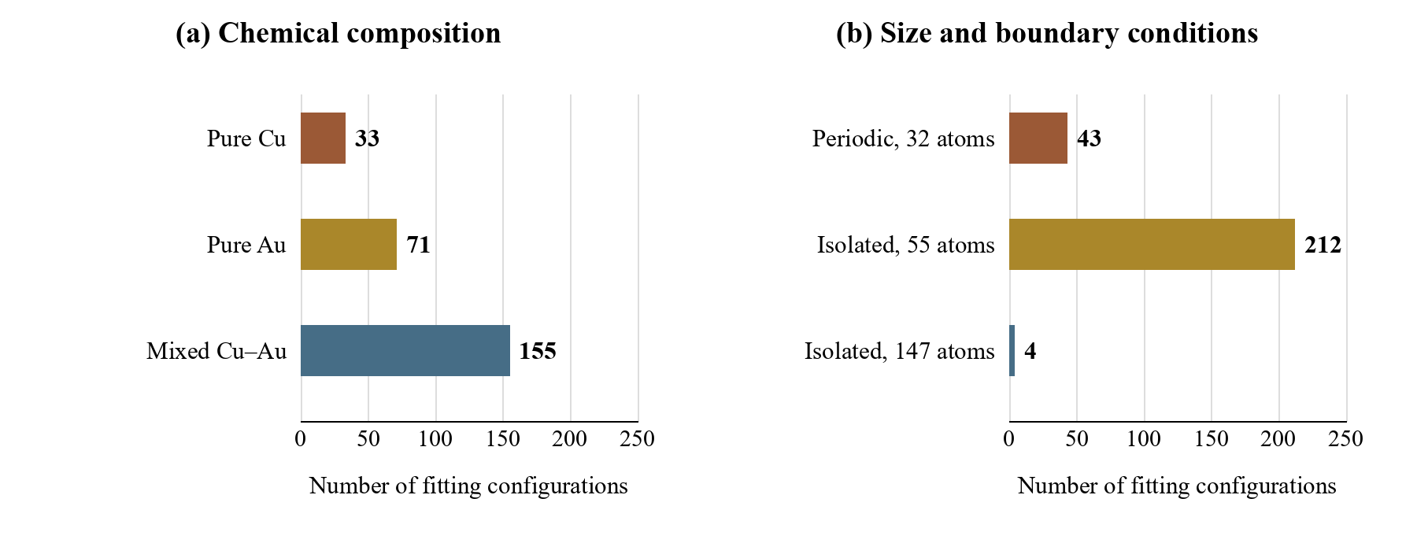
Figure 1. The 259 fitting configurations classified by composition (a) and by size and boundary conditions (b). Both panels describe the same population.

3.2 Local deformation assessment
The new moderate-contact and shear configurations are reproduced with force-component RMSEs of 0.04027 and 0.03789 eV/Å, respectively. The separate reporting of these families distinguishes a localized pair displacement from a collective distortion of the cluster. The eight earlier Au–Au and Cu–Au fitting contacts give 0.26337 eV/Å, whereas the six stronger-compression diagnostics excluded from fitting give 3.67655 eV/Å. The larger errors for the stronger-contraction diagnostics identify close contacts as a specific refinement target within a broader assessment of cluster configurations. Detailed contact responses from the 235- and 243-configuration fits are examined in sections 3.3 and 3.4.

3.3 Contact response by pair chemistry
The initial contact analysis was performed with the 235-configuration fit. On the 20 exposed development configurations, its energy and force-component RMSEs are 13.310 meV/atom and 0.058726 eV/Å. The fitting and assessment subsets are listed in Table 3 and shown in Figure 2.
Table 3. Energy and force-component RMSEs of the earlier model fitted to 235 configurations. Energy errors are averaged equally over configurations, while force errors are pooled over all Cartesian components. Development and diagnostic configurations are exposed assessment sets.
Configuration set | N | Energy RMSE  (meV/atom) | Force RMSE  (eV/Å)
All fitting | 235 | 13.222 | 0.40926
Ordinary fitting | 219 | 12.513 | 0.10014
Cu–Cu fitting | 8 | 9.788 | 0.33417
Au–Au fitting | 8 | 27.445 | 2.07647
Development | 20 | 13.310 | 0.05873
Compression diagnostics | 6 | 94.503 | 3.66575
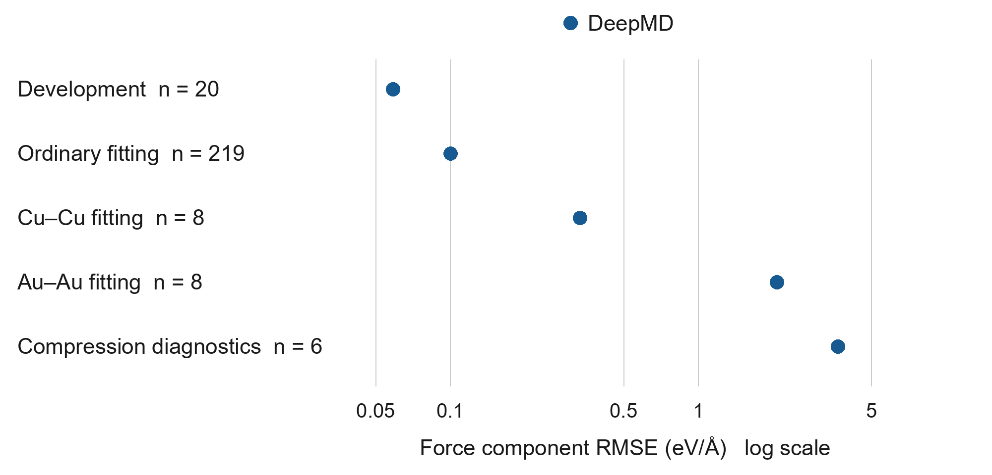
Figure 2. Force-component RMSE of the model fitted to 235 configurations, resolved by configuration set. The logarithmic axis shows the difference between ordinary configurations and compressed environments. The targeted Cu–Cu and Au–Au sets are fitting data; the six stronger-compression configurations are exposed diagnostics.
The six compression diagnostics give a force-component RMSE of 3.66575 eV/Å and a maximum absolute component error of 44.967 eV/Å. A clear dependence on pair chemistry is resolved: group RMSEs are 1.21490 eV/Å for Cu–Cu, 2.86210 eV/Å for Cu–Au, and 5.53585 eV/Å for Au–Au compression. Each value includes all force components in the corresponding configurations. The two Au–Au configurations contribute 76.02% of the total squared diagnostic force error, identifying this family as the main refinement target within the diagnostic set.
The shortest separations are also identified as the principal fitting targets within the compressed families. The four 1.90 Å Cu–Cu configurations contribute 99.07% of the squared force error in their eight-configuration family; the corresponding Au–Au contribution is 91.90%. This concentration of error localizes the refinement priority despite the inclusion of both separations in fitting. The balance of the fitting objective, coverage of strongly repulsive environments, and training duration are candidate factors whose individual contributions remain to be resolved.
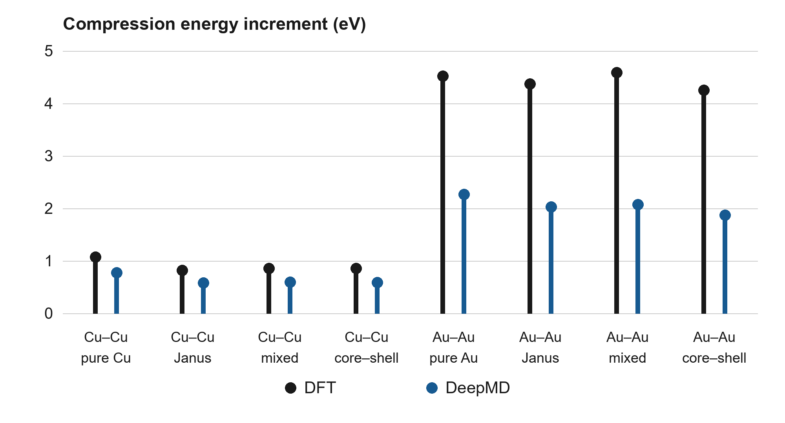
Figure 3. Whole-cluster energy increments for contraction of a selected pair from 2.05 to 1.90 Å, evaluated with the 235-configuration fit. DFT and DeepMD values are shown for four Cu–Cu and four Au–Au parent environments. All sixteen endpoint configurations are fitting data; the increments include interactions with the surrounding cluster.
The energy increments in Figure 3 resolve the energetic cost of local contraction independently of a constant total-energy offset. For the Cu–Cu parents, DFT increments range from 0.814 to 1.073 eV, whereas DeepMD gives 0.576–0.775 eV. The individual increments are underestimated by 27.8–31.4%. For Au–Au, DFT gives 4.248–4.586 eV and DeepMD gives 1.868–2.265 eV, corresponding to underestimation by 49.8–56.0%. The larger Au–Au discrepancy is consistent with the chemistry-dependent pattern in the force assessment.
The two compression sets provide complementary views of the response. The 1.90 and 2.05 Å fitting configurations quantify the representation of supplied deformation energies, while the excluded 1.70 and 1.85 Å diagnostics probe more severe contractions. Reporting them separately distinguishes fitting performance from the response outside the supplied compression range.

3.4 Response at additional contact separations
The earlier 243-configuration fit was completed for 10,000 steps. Its errors on the complete fitting set, the added configurations, and the unchanged assessment sets are reported in Table 4. The development energy error is 12.823 meV/atom and the force-component error is 0.05883 eV/Å. The eight added fitting configurations give 10.625 meV/atom and 0.26281 eV/Å, respectively. Resolving the added contacts by separation gives force-component errors of 0.06016 eV/Å for the four Au–Au configurations and 0.05932 eV/Å for the two Cu–Au configurations at 2.25 Å. At 2.05 Å, the two Cu–Au configurations give 0.51529 eV/Å, locating the larger fitting discrepancy at the shorter separation. On the six stronger-compression diagnostics, the force error is 3.66580 eV/Å, with a maximum absolute component error of 44.988 eV/Å.
Table 4. Energy and force-component RMSEs of the earlier 243-configuration fit. The ordinary 219 are contained within the retained 235; the retained 235 and added eight form the fitting population. Development and diagnostic populations are exposed assessment sets. These values belong to the earlier model and are distinct from the principal 259-configuration results in Table 2.
Configuration set | N | Energy RMSE  (meV/atom) | Force RMSE  (eV/Å)
All fitting | 243 | 13.312 | 0.40547
Ordinary fitting | 219 | 12.633 | 0.10012
Retained fitting | 235 | 13.394 | 0.40965
Added contacts | 8 | 10.625 | 0.26281
Development | 20 | 12.823 | 0.05883
Compression diagnostics | 6 | 95.269 | 3.66580
The 2.25-to-2.05 Å energy increments are shown in Figure 4(a). For the four Au–Au environments, DFT gives 2.773–3.140 eV and the expanded fit gives 2.300–2.711 eV, corresponding to underestimation by 13.6–17.1%. For Cu–Au, the Janus-like and mixed parents give DFT increments of 1.419 and 1.520 eV, compared with DeepMD values of 1.268 and 1.184 eV. The respective underestimations are 10.6% and 22.1%. All endpoint configurations used in this panel are included in the expanded fitting set.
The endpoint responses add local information to the compression-energy increments (Figure 4(b)). At 2.25 Å, the Cu–Au derivative magnitudes differ from DFT by 3.2% for the Janus-like environment and 7.0% for the mixed environment. At 2.05 Å, the repulsive magnitudes are 6.414 and 5.725 eV/Å, compared with DFT values of 10.328 and 10.823 eV/Å. The response is therefore underestimated by 37.9% and 47.1%, respectively. These results distinguish the relatively close agreement at the longer separation from the shorter-range gradient that requires further fitting attention.
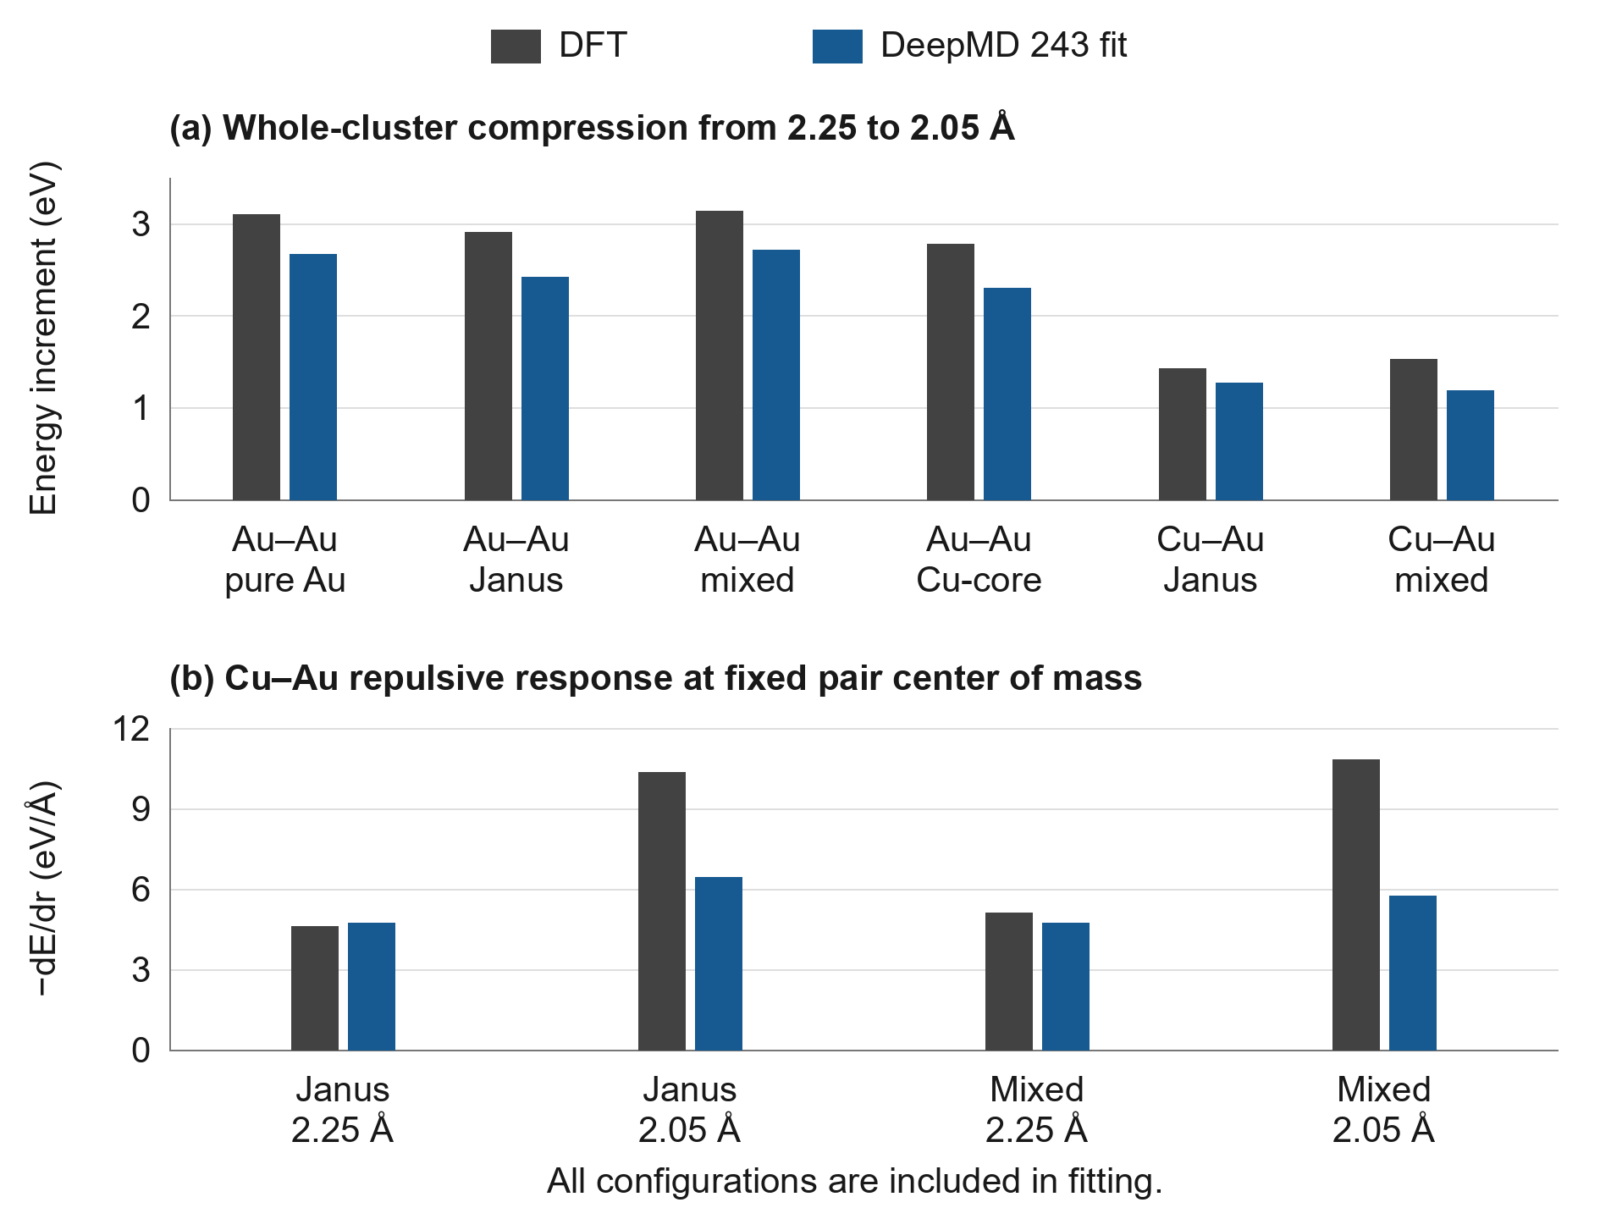
Figure 4. DFT and the 243-configuration fit for the additional fitting contact environments. (a) Whole-cluster energy increments for contraction from 2.25 to 2.05 Å. (b) Repulsive response −dE/dr for Cu–Au contacts at the indicated separations, with the mass-weighted pair center of mass fixed. The quantities in (a) are total-energy differences in eV; those in (b) are local derivatives in eV/Å.
Relative to the 235-configuration fit on identical reference records, modest reductions were obtained in energy and force errors for the eight added contacts and in development energy error. Development force error and the retained fitting errors did not decrease. The principal contribution of the extension is the broader contact coverage and the resulting separation-resolved assessment, rather than a uniform improvement in accuracy. The new references provide specific targets for refining the compression response while monitoring the ordinary configurations.

3.5 Independent configuration test
On all six prospective held-out configurations, energy and force-component RMSEs of 31.642 meV/atom and 0.17425 eV/Å were obtained (Table 5). The corresponding mean absolute errors were 27.817 meV/atom and 0.08143 eV/Å. All 330 atoms and 990 Cartesian force components were included. The four collision snapshots gave 34.951 meV/atom and 0.21123 eV/Å, whereas the two unrelaxed cluster geometries gave 23.674 meV/atom and 0.04301 eV/Å. These subsets differ in physical character and are reported separately rather than treated as equivalent samples.
Table 5. Prospective held-out test of the principal 259-configuration model. The four metal-only collision snapshots and two unrelaxed cluster geometries partition the six-configuration test. None was included in fitting or model selection. All references use the adopted 24 Å cell.
Test population | N | Energy RMSE  (meV/atom) | Force RMSE  (eV/Å)
All held-out configurations | 6 | 31.642 | 0.17425
Collision snapshots | 4 | 34.951 | 0.21123
Unrelaxed cluster geometries | 2 | 23.674 | 0.04301
The largest force errors were concentrated in the Cu-side peak-impact and Au-side postimpact snapshots, with configuration-level force RMSEs of 0.33955 and 0.22235 eV/Å. Together, these two configurations contributed 90.43% of the total squared force error. The maximum absolute component error was 2.43988 eV/Å at a Cu atom whose nearest Cu neighbor was 1.950 Å away. For the precontact and the other peak-impact snapshot, force RMSEs of 0.08040 and 0.08528 eV/Å were obtained. The icosahedral and face-centered-cubic seeds gave 0.05415 and 0.02770 eV/Å, respectively.
The small per-atom energy error of 4.031 meV/atom for the Cu-side peak-impact snapshot was accompanied by the largest force error. Agreement in a whole-cluster energy therefore did not ensure equally accurate local gradients. The prospective test extends the assessment to new configurations and identifies localized collision environments where additional fitting coverage or a revised short-range description could be examined.

4 Discussion

4.1 Implications for modeling heterogeneous nanoclusters
The principal outcome is a DFT-trained many-body representation assessed across a documented collection of Cu, Au, and Cu–Au environments. Pure and mixed configurations, crystalline references, and finite clusters are treated within the same model. This is useful for a bimetallic particle in which local chemical composition and coordination vary between the interior, the surface, and the interface. The local energy representation provides a common framework for incorporating these environments without assigning a separate empirical expression to each structural region.
The ordinary fitting and development results establish the accuracy obtained for the sampled cluster and crystalline configurations. Energy and force errors are both required: the former measures agreement in per-atom energies across the population, while the latter tests the gradients that govern atomic motion. Because the populations differ in composition and structural difficulty, their separate reporting is more informative than a single pooled value. The full-fitting force error is placed in context by the inclusion of prescribed contact and shear deformations.
Database enrichment can be directed toward missing or poorly represented environments while the retained configurations are used to monitor the existing description. The moderate-contact and shear additions broaden the sampled deformations without changing the development or diagnostic populations. Their small fitting force errors show that both localized and collective distortions can be represented within the same model. The combination of committee-guided selection, provenance checks, and configuration-resolved assessment provides a practical basis for extending this coverage. Refinement can then be directed toward identifiable atomic environments while the ordinary configurations are retained as reference points.
Controlled compression serves one specific purpose within this framework: it tests the energetic cost and force response of close contacts. The chemistry- and distance-dependent discrepancies in sections 3.3 and 3.4 identify further refinement targets, especially strongly contracted Au–Au environments and the shorter Cu–Au contacts. The effects of adding specialized training configurations or an explicit repulsive contribution, as explored for collision-oriented potentials in other materials [21], could be assessed against these probes. Any modification would also need to preserve the ordinary surface and interface response and maintain continuous energies and forces.
The prospective configuration test provides a first assessment beyond the exposed development populations. Both unrelaxed cluster seeds and nonequilibrium metal configurations are represented, and their errors are reported separately. The concentration of force error in two collision snapshots gives a more specific refinement target than the aggregate test value alone. Structural relaxation, finite-temperature stability, and longer independent trajectories can subsequently be examined to connect these static energy–force errors with dynamical observables.

4.2 Assessment scope and development directions
Fitting performance, exposed developmental assessment, and the prospective six-configuration test are distinguished in this study. The development and diagnostic groups were inspected during model development, whereas the new test references were evaluated only after the principal model had been fixed. The sixteen targeted fitting additions are derived from existing training parents and therefore characterize fitting coverage. The new test consists of four metal-only collision snapshots and two unrelaxed seeds; it is not a six-trajectory dynamical benchmark. Its results refer to the 24 Å DFT protocol described in section 2.6. A single optimization seed was used, so sensitivity to initialization remains to be assessed.
For subsequent refinement, additional fitting configurations can be selected around the collision environments identified in section 3.5, while the present test records are retained unchanged. If their errors are used to choose a new model or its settings, this set becomes exposed validation for that later model. A further untouched set would then be needed for an independent assessment. Repeated training seeds and independently selected structural and dynamical configurations would extend the present evidence for the potential’s application range.

5 Conclusions
A DeepMD potential for Cu–Au nanoclusters has been developed from a database spanning pure and mixed compositions, periodic crystalline structures, and isolated clusters of two sizes. The principal model is fitted to 259 configurations within the 285-configuration development database. On the 20 exposed development configurations, energy and force-component RMSEs of 11.789 meV/atom and 0.05786 eV/Å are obtained. A separate test on six new configurations gives 31.642 meV/atom and 0.17425 eV/Å against the adopted 24 Å DFT references. Force RMSEs of 0.21123 eV/Å for four collision snapshots and 0.04301 eV/Å for two unrelaxed cluster geometries show that the remaining discrepancies are strongly dependent on the sampled environment.
DeepMD allows chemically distinct cluster environments and complementary deformations to be represented within a common many-body model. The moderate-contact and shear results establish how additional environments can be incorporated, while the prospective test identifies localized collision configurations for further refinement without changing the fitted model. Traceable DFT references, separate data roles, and configuration-resolved errors provide a practical basis for extending the potential toward cluster dynamics. Further assessments can focus on the identified collision environments and on the stability and structural evolution of independently prepared clusters.

Data availability
The data archive published on GitHub (release v2026-11-06) contains the 285-configuration reference database with fitting, development, and diagnostic assignments; the model graphs used for the 235-, 243-, and 259-configuration assessments; saved per-configuration error records; training settings; and numerical data for the figures. File inventories and SHA-256 checksums identify the supplied versions. Instructions for reproducing the reported metrics and figures are included. Third-party pseudopotentials are identified by their source links and checksums rather than redistributed. Supporting data archive. Data and reproduction guide.
The six additional test references, preserved coordinates and species, raw model predictions, per-configuration errors, and an independent metric-reproduction script are supplied separately in CuAu_DeepMD_independent_test6_20261108.zip. They are not included in the earlier GitHub release. Their separation from the fitting and exposed assessment data is retained in the accompanying archive.

Funding
This research was supported by a grant of the President of Ukraine provided by the National Research Foundation of Ukraine (project No. 2025.04/0003).

Acknowledgments
OpenAI Codex assisted with manuscript drafting, analysis-code development, and consistency checks. Scientific interpretation, final verification, and responsibility for the submitted work remain with the authors.

References
[1] Shyrokorad D, Kornich G V and Buga S G 2019 Formation of the core-shell structures from bimetallic Janus-like nanoclusters under low-energy Ar and Ar₁₃ impacts: A molecular dynamics study Comput. Mater. Sci. 159 110–119 https://doi.org/10.1016/j.commatsci.2018.12.002
[2] Behler J and Parrinello M 2007 Generalized neural-network representation of high-dimensional potential-energy surfaces Phys. Rev. Lett. 98 146401 https://doi.org/10.1103/PhysRevLett.98.146401
[3] Zhang L, Han J, Wang H, Car R and E W 2018 Deep potential molecular dynamics: A scalable model with the accuracy of quantum mechanics Phys. Rev. Lett. 120 143001 https://doi.org/10.1103/PhysRevLett.120.143001
[4] Wang H, Zhang L, Han J and E W 2018 DeePMD-kit: A deep learning package for many-body potential energy representation and molecular dynamics Comput. Phys. Commun. 228 178–184 https://doi.org/10.1016/j.cpc.2018.03.016
[5] Zeng J et al. 2025 DeePMD-kit v3: A multiple-backend framework for machine learning potentials J. Chem. Theory Comput. 21 4375–4385 https://doi.org/10.1021/acs.jctc.5c00340
[6] Morrow J D, Gardner J L A and Deringer V L 2023 How to validate machine-learned interatomic potentials J. Chem. Phys. 158 121501 https://doi.org/10.1063/5.0139611
[7] Liu Y, He X and Mo Y 2023 Discrepancies and error evaluation metrics for machine learning interatomic potentials npj Comput. Mater. 9 174 https://doi.org/10.1038/s41524-023-01123-3
[8] Maxson T, Soyemi A, Chen B W J and Szilvási T 2024 Enhancing the quality and reliability of machine learning interatomic potentials through better reporting practices J. Phys. Chem. C 128 6524–6537 https://doi.org/10.1021/acs.jpcc.4c00028
[9] Zhang Y, Wang H, Chen W, Zeng J, Zhang L, Wang H and E W 2020 DP-GEN: A concurrent learning platform for the generation of reliable deep learning based potential energy models Comput. Phys. Commun. 253 107206 https://doi.org/10.1016/j.cpc.2020.107206
[10] Shyrokorad D and Kornich G V 2026 DeepMD and EAM comparison for Ar₁₃ bombardment of Cu₁₉₅Au₁₉₅ Janus-like nanoparticles Unpublished manuscript submitted to Micro Nano & Chips Tech 2026
[11] Hohenberg P and Kohn W 1964 Inhomogeneous electron gas Phys. Rev. 136 B864–B871 https://doi.org/10.1103/PhysRev.136.B864
[12] Kohn W and Sham L J 1965 Self-consistent equations including exchange and correlation effects Phys. Rev. 140 A1133–A1138 https://doi.org/10.1103/PhysRev.140.A1133
[13] Perdew J P, Burke K and Ernzerhof M 1996 Generalized gradient approximation made simple Phys. Rev. Lett. 77 3865–3868 https://doi.org/10.1103/PhysRevLett.77.3865
[14] Giannozzi P et al. 2009 QUANTUM ESPRESSO: A modular and open-source software project for quantum simulations of materials J. Phys.: Condens. Matter 21 395502 https://doi.org/10.1088/0953-8984/21/39/395502
[15] Giannozzi P et al. 2017 Advanced capabilities for materials modelling with QUANTUM ESPRESSO J. Phys.: Condens. Matter 29 465901 https://doi.org/10.1088/1361-648X/aa8f79
[16] Dal Corso A 2014 Pseudopotentials periodic table: From H to Pu Comput. Mater. Sci. 95 337–350 https://doi.org/10.1016/j.commatsci.2014.07.043
[17] Garrity K F, Bennett J W, Rabe K M and Vanderbilt D 2014 Pseudopotentials for high-throughput DFT calculations Comput. Mater. Sci. 81 446–452 https://doi.org/10.1016/j.commatsci.2013.08.053
[18] Marzari N, Vanderbilt D, De Vita A and Payne M C 1999 Thermal contraction and disordering of the Al(110) surface Phys. Rev. Lett. 82 3296–3299 https://doi.org/10.1103/PhysRevLett.82.3296
[19] Martyna G J and Tuckerman M E 1999 A reciprocal space based method for treating long range interactions in ab initio and force-field-based calculations in clusters J. Chem. Phys. 110 2810–2821 https://doi.org/10.1063/1.477923
[20] Zhang L, Han J, Wang H, Saidi W A, Car R and E W 2018 End-to-end symmetry preserving inter-atomic potential energy model for finite and extended systems Adv. Neural Inf. Process. Syst. 31 4436–4446 https://proceedings.neurips.cc/paper_files/paper/2018/hash/e2ad76f2326fbc6b56a45a56c59fafdb-Abstract.html
[21] Byggmästar J, Hamedani A, Nordlund K and Djurabekova F 2019 Machine-learning interatomic potential for radiation damage and defects in tungsten Phys. Rev. B 100 144105 https://doi.org/10.1103/PhysRevB.100.144105

