Customer Churn Intelligence

Predicting Customer Loss and Improving Retention Strategy

Portfolio Project Report

Tools Used:
Python | SQL | Power BI | Excel | Machine Learning

Prepared by:
Sahithi Lekhana Earlapally

1. Project Overview
This project analyses customer churn for a telecom company using data science and business analytics techniques. The main aim is to identify customer churn patterns, predict customers who are likely to leave, and recommend data-driven retention strategies.
Customer churn is a major business problem for subscription-based companies because losing customers directly affects revenue, customer lifetime value, and long-term business growth. This project demonstrates how raw customer data can be transformed into business insights and practical decision-making support.

2. Business Problem
Telecom companies often lose customers due to contract flexibility, pricing concerns, payment methods, service experience, and low customer engagement. If the business can identify high-risk customers early, it can take proactive actions such as personalised offers, onboarding support, and retention campaigns.
The key business question for this project is: Which customers are most likely to churn, why are they at risk, and what actions can the business take to reduce churn?

3. Dataset Description
The project uses a telecom customer churn dataset containing 7,043 customer records and 21 original columns. The dataset includes customer demographic details, account information, service subscriptions, billing information, contract type, and churn status.
The target variable is Churn, which indicates whether a customer left the company. Additional engineered fields were created to support analysis, including Churn_Flag, Tenure_Group, Monthly_Charge_Group, Churn_Probability, and Risk_Level.

4. Tools and Methodology
Python was used for data cleaning, exploratory data analysis, feature engineering, and machine learning. SQL was used to extract business KPIs and segment-level insights. Power BI was used to create an interactive dashboard for business users.
The project followed this workflow:
1. Data understanding
2. Data cleaning
3. Feature engineering
4. Exploratory data analysis
5. SQL business analysis
6. Predictive modelling
7. Power BI dashboard development
8. Business recommendations

5. Key Business KPIs
The analysis identified the following key business metrics:
Total Customers: 7,043
Churned Customers: 1,869
Churn Rate: 26.54%
Monthly Revenue: 456.12K
Revenue at Risk: 139.13K
The churn rate of 26.54% shows that approximately one in four customers left the company. This indicates a significant customer retention challenge and highlights the need for proactive churn reduction strategies.

6. Exploratory Data Analysis Findings
The exploratory analysis showed that customer churn is strongly linked with contract type, tenure, payment method, internet service, and monthly charges.
Month-to-month customers had the highest churn rate, while customers on two-year contracts had the lowest churn rate. This suggests that longer-term contracts are linked with stronger customer retention.
Customers in the first 12 months showed the highest churn risk, indicating that early customer experience and onboarding are important for retention.
Customers using electronic check had a higher churn rate compared to other payment methods. High monthly charge customers also showed higher churn risk, suggesting that price sensitivity may influence customer decisions.

7. Machine Learning Model
Two machine learning models were tested: Logistic Regression and Random Forest. The models were evaluated using accuracy, precision, recall, and F1-score.
Logistic Regression performed better overall and was selected as the final model.
Model Results:
Logistic Regression Accuracy: 79.91%
Logistic Regression Precision: 65.22%
Logistic Regression Recall: 52.14%
Logistic Regression F1 Score: 57.95%
In churn prediction, recall is important because the business wants to identify customers who are likely to leave before they actually churn. Missing a high-risk customer means the business may lose an opportunity to take retention action.

8. Power BI Dashboard
A three-page Power BI dashboard was developed to communicate the results clearly to business users.
The Executive Overview page shows total customers, churned customers, churn rate, monthly revenue, revenue at risk, churn by contract type, revenue at risk by contract type, and churn distribution.
The Churn Driver Analysis page shows churn patterns across tenure group, payment method, internet service, and monthly charge group.
The Retention Strategy page identifies customers by churn risk level, monthly revenue by risk level, high-risk customers, and recommended retention actions.

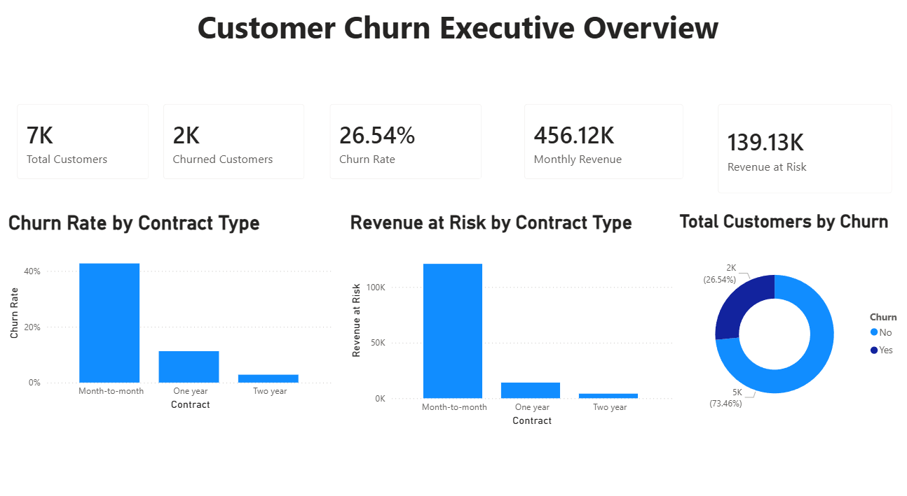
Figure 1: Customer Churn Executive Overview
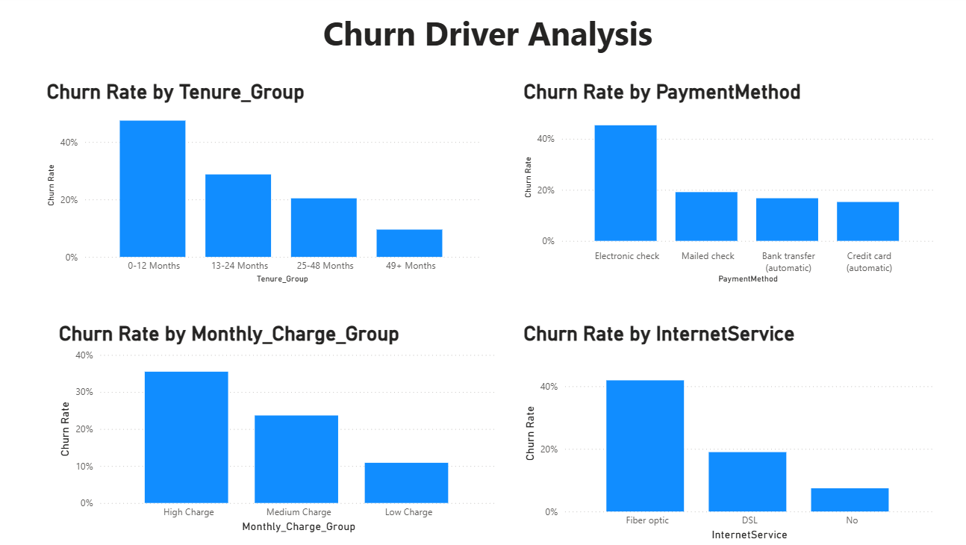
Figure 2: Churn Driver Analysis

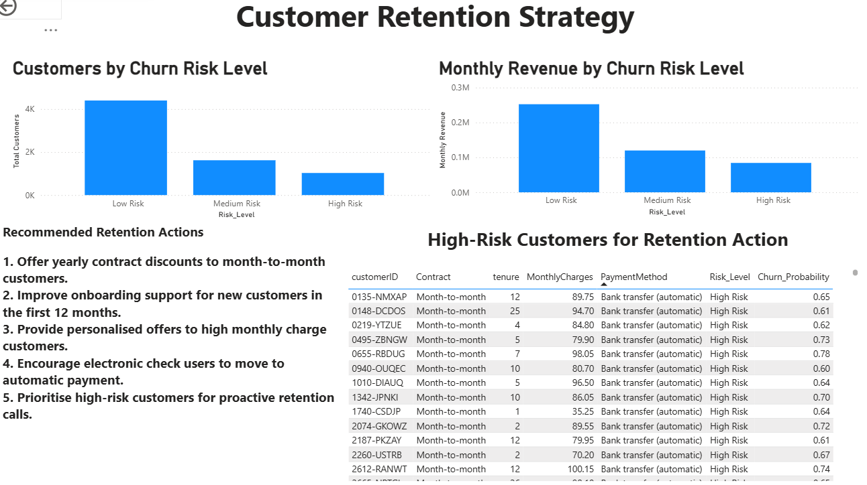
Figure 3: Customer Retention Strategy

9. Business Recommendations
Based on the analysis, the following business actions are recommended:
1. Offer yearly contract discounts to month-to-month customers.
2. Improve onboarding support for customers in their first 12 months.
3. Provide personalised offers to high monthly charge customers.
4. Encourage electronic check users to move to automatic payment methods.
5. Prioritise high-risk customers for proactive retention calls.
These actions can help the business reduce churn, protect revenue, and improve customer loyalty.

10. Conclusion
This project demonstrates how data science and business analytics can be combined to solve a real business problem. The analysis identified key churn drivers, built a churn prediction model, and created a Power BI dashboard to support retention decisions.
The project showcases practical skills in Python, SQL, Power BI, data cleaning, exploratory analysis, predictive modelling, dashboard development, and business storytelling.

