**Quiz Master (MAD-1 Project)**

**Author**

Name : Jishnu S G

Roll No. : 21f1006877

Email : 21f1006877@ds.study.iitm.ac.in

I’m a IITM BS student currently in the diploma level.

**Description**

A Flask-based quiz management system with admin/user roles, which enables multi-subject quizzes with timed attempts. Users can attempt quizzes as many times; the app provides performance tracking and analytics for both user and admin.

**Technologies Used**

* Backend
  + Flask : The entire web application is built on flask framework
  + Flask-SQLAlchemy : For creating and querying the relational database.
* Frontend
  + HTML : Used for structuring the contents of web pages.
  + Jinja2 : Used to enable dynamic content generation for HTML templates.
  + JavaScript : Used to have dynamic behavior in web pages.
  + CSS : Used to apply basic styling to enhance the web pages.
  + Bootstrap v5.3 : Used to create responsive and stylish web pages.
* Database
  + SQLite : Used as a relational database for the application.
* Libraries
  + Plotly : Used for creating interactive web-based visualization.

**DB Schema Design**

The database follows the relational model with multiple tables linked via foreign keys. Below is the ER Diagram:

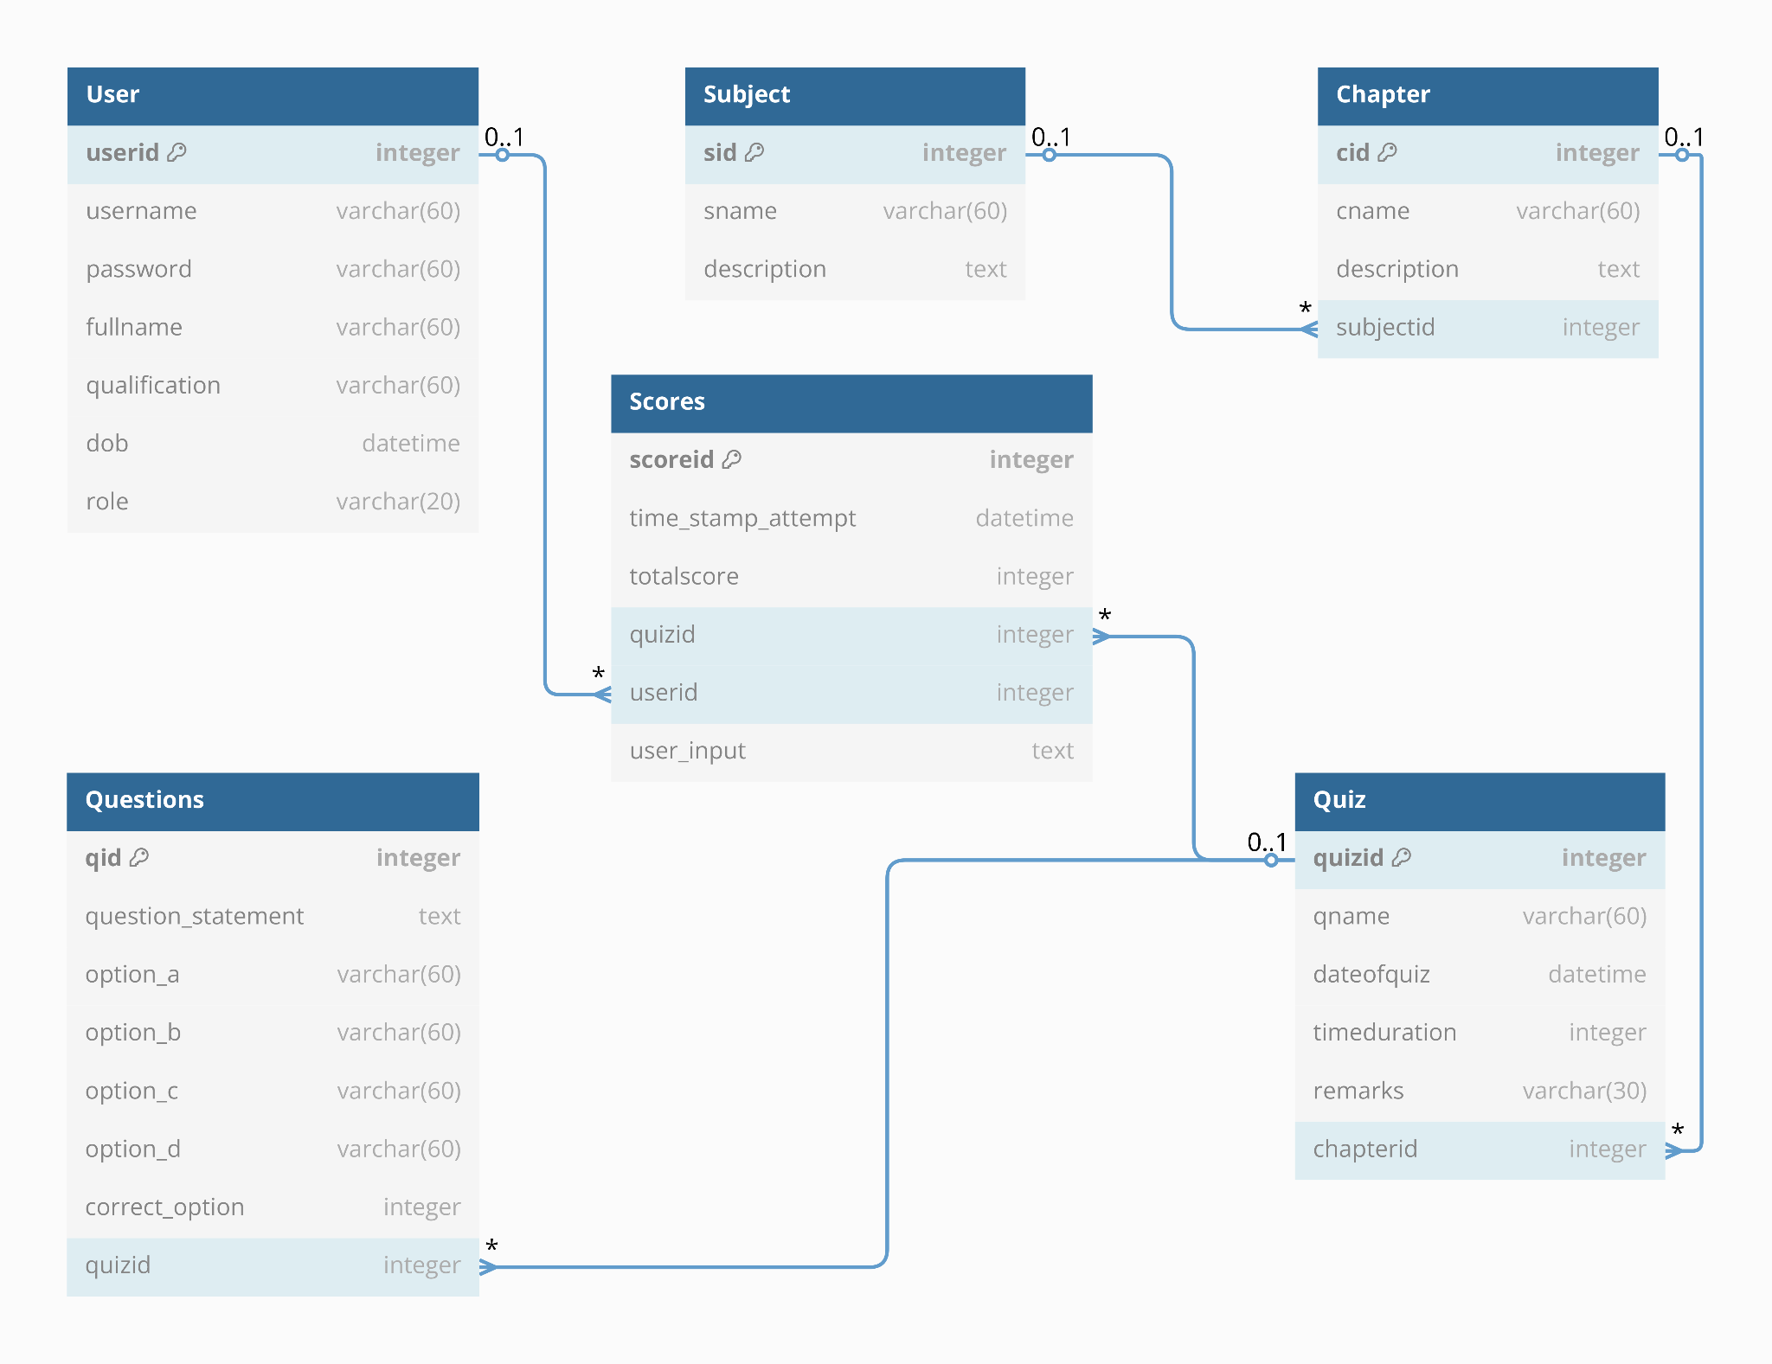

* User : userid integer [primary key], username varchar(60) [not null, unique], password varchar(60) [not null],  
   fullname varchar(60) [not null], qualification varchar(60) [not null], dob datetime [not null],  
   role varchar(20) [not null, default: 'User']
* Subject : sid integer [primary key], description text [not null], sname varchar(60) [not null, unique]
* Chapter : cid integer [primary key], cname varchar(60) [not null], description text [not null],  
   subjectid integer [not null, ref: > Subject.sid]
* Quiz : quizid integer [primary key], qname varchar(60) [not null], dateofquiz datetime [not null],  
   timeduration integer [not null], remarks varchar(30), chapterid integer [not null, ref: > Chapter.cid]
* Questions : qid integer [primary key], question_statement text [not null], option_a varchar(60) [not null],  
   option_b varchar(60) [not null], option_c varchar(60) [not null], option_d varchar(60) [not null],  
   correct_option integer [not null], quizid integer [not null, ref: > Quiz.quizid]
* Scores : scoreid integer [primary key], time_stamp_attempt datetime, totalscore integer [not null],  
   quizid integer [not null, ref: > Quiz.quizid], userid integer [not null, ref: > User.userid],  
   user_input text [not null]

Flask-SQLAlchemy enables easy table relationships and direct access across models. Example, user.scores fetches all quiz attempts by user via User ↔ Scores relationship defined using db.relationship() and foreign keys.

**Architecture and Features**

**Architecture :**

The quiz application follows the Model-View-Controller architecture pattern using Flask.

* Models : The database schema is defined in models.py using Flask-SQLAlchemy, covering Users, Subject, Chapter, Quiz, Questions and Scores.
* Views : The HTML templates are stored in templates/ directory and inherited templates using Jinja2 rendering.
* Controllers : The application logic resides in routes.py and utils.py, which both handles user authentication, quiz management, quiz result calculations and admin functionalities.
* Database : The application uses SQLite relational database which is stored in an instance/ directory.

**Features :**

* User Roles
  + Admin : Create/Edit/Delete subjects, chapters, quizzes, and questions.
  + Users : Attempt any number of quizzes, view scores and view attempt history.
* Quiz Management
  + Time-limited quizzes with multiple questions (with only one correct option)
  + Automatic scoring system (takes place only after the quiz deadline ends)
  + Quiz attempt history tracking (records users each attempt option markings)
* Subject Hierarchy
  + Subjects → Chapters → Quizzes → Questions
* Search Functionality
  + Admin : Unified search across users, subjects, chapters, quizzes and questions
  + Users : Unified search across subjects, chapters, quizzes
* Analytics & Charts
  + Admin : Quiz performance and User engagement analytics.
  + User : Quiz Performance over time and Quiz participation metrics.

**Project Presentation Video :**

<https://vimeo.com/1076348892/14243e5a57>