

系统分析与设计课程设计实验报告

学号：

姓名：

指导老师：

完成时间：

# 实验五 界面设计与文件存取

## 一、实验目的

(1)练习 SQL Server 数据库的创建与使用方法。

(2)练习存储过程的创建与调用方法练习简单的统计査询方法。

(3)练习绑定 DataGridView 到数据源的方法。

(4)练习绑定其他控件到数据源的方法。

(5)练习数据库中图片的显示和存取方法。。

## 二、实验结果

界面运行截图：

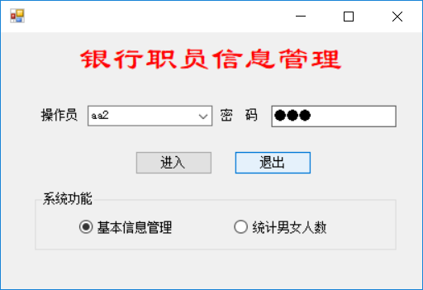

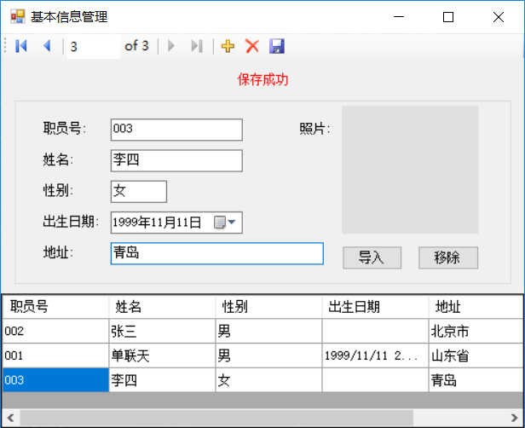

## 三、主要代码

## [FormMain.cs]

using System;

using System.Collections.Generic;

using System.ComponentModel;

using System.Data;

using System.Drawing;

using System.Text;

using System.Windows.Forms;

using System.Data.SqlClient;

using System.Data.SqlTypes;

namespace BankEmployee

{

public partial class FormMain : Form

{

public FormMain()

{

InitializeComponent();

}

private void FormMain_Load(object sender, EventArgs e)

{

this.selectAllUserNameFromOperatorTableAdapter.Fill(this.employeeDataSet1.SelectAllUserNameFromOperator);

comboBoxOperator.DataSource = employeeDataSet1.SelectAllUserNameFromOperator;

comboBoxOperator.DisplayMember = employeeDataSet1.SelectAllUserNameFromOperator.usernameColumn.ColumnName;

}

private void buttonLogin_Click(object sender, EventArgs e)

{

selectOperatorTableAdapter1.Fill(employeeDataSet1.SelectOperator, comboBoxOperator.Text, textBoxPassword.Text);

if (employeeDataSet1.SelectOperator.Count == 0)

{

MessageBox.Show("操作员或密码不正确", "", MessageBoxButtons.OK, MessageBoxIcon.Error);

groupBox1.Enabled = false;

}

else

{

groupBox1.Enabled = true;

}

}

private void buttonExit_Click(object sender, EventArgs e)

{

this.Close();

}

private void radioButtonManage_CheckedChanged(object sender, EventArgs e)

{

if (radioButtonManage.Checked == true)

{

this.Hide();

FormEmployee fm = new FormEmployee();

fm.ShowDialog();

this.Show();

}

}

private void radioButtonQuery_CheckedChanged(object sender, EventArgs e)

{

if (radioButtonQuery.Checked == true)

{

int? maleNumber = 0;

int? femaleNumber = 0;

simpleQueryTableAdapter1.GetData(ref maleNumber , ref femaleNumber);

MessageBox.Show(string.Format("男：{0}，女：{1}", maleNumber, femaleNumber));

}

}

private void groupBox1_Enter(object sender, EventArgs e)

{

}

}

}

## [formemploy.cs]

using System;

using System.Collections.Generic;

using System.ComponentModel;

using System.Data;

using System.Drawing;

using System.Text;

using System.Windows.Forms;

namespace BankEmployee

{

public partial class FormEmployee : Form

{

public FormEmployee()

{

InitializeComponent();

groupBox1.Text = "";

}

private void basicTableBindingNavigatorSaveItem_Click(object sender, EventArgs e)

{

try

{

this.Validate();

this.basicTableBindingSource.EndEdit();

this.basicTableTableAdapter.Update(this.employeeDataSet.BasicTable);

labelTip.Text = "保存成功";

}

catch(Exception err)

{

labelTip.Text = "保存失败：" + err.Message;

}

}

private void Form1_Load(object sender, EventArgs e)

{

this.basicTableTableAdapter.Fill(this.employeeDataSet.BasicTable);

ChangeCurrentPosition(CurrentOperator.当前记录);

}

private void buttonImport_Click(object sender, EventArgs e)

{

OpenFileDialog openFileDialog1 = new OpenFileDialog();

if (openFileDialog1.ShowDialog() == DialogResult.OK)

{

//根据打开的图像文件创建原始图像大小的Bitmap对象

Bitmap image = new Bitmap(openFileDialog1.FileName);

//按比例缩放显示（因为Picture的SizeMode属性为Zoom）,但原始图像大小未变

pictureBoxPhoto.Image = image;

}

}

private void buttonClear_Click(object sender, EventArgs e)

{

pictureBoxPhoto.Image = null;

}

private void basicTableBindingNavigator_RefreshItems(object sender, EventArgs e)

{

}

private void bindingNavigatorAddNewItem_Click(object sender, EventArgs e)

{

try

{

basicTableBindingSource.AddNew();

ChangeCurrentPosition(CurrentOperator.当前记录);

textBoxName.Focus();

}

catch(Exception err)

{

labelTip.Text = "当前记录有错："+err.Message;

}

}

enum CurrentOperator { 第一个记录, 前一个记录, 下一个记录, 最后一个记录, 当前记录 };

private void ChangeCurrentPosition(CurrentOperator cp)

{

labelTip.Text = "温馨提示：操作一段时间后别忘了保存一下";

try

{

switch (cp)

{

case CurrentOperator.第一个记录:

basicTableBindingSource.MoveFirst();

break;

case CurrentOperator.前一个记录:

basicTableBindingSource.MovePrevious();

break;

case CurrentOperator.下一个记录:

basicTableBindingSource.MoveNext();

break;

case CurrentOperator.最后一个记录:

basicTableBindingSource.MoveLast();

break;

}

}

catch (Exception err)

{

labelTip.Text = "当前记录有错：" + err.Message;

}

int pos = basicTableBindingSource.Position;

int max=basicTableBindingSource.Count;

bindingNavigatorMoveFirstItem.Enabled = pos <= 0 ? false : true;

bindingNavigatorMovePreviousItem.Enabled = pos <= 0 ? false : true;

bindingNavigatorMoveNextItem.Enabled = pos >= max - 1 ? false : true;

bindingNavigatorMoveLastItem.Enabled = pos >= max - 1 ? false : true;

if (basicTableBindingSource.Count == 0)

{

labelTip.Text = "操作提示：库中无记录，请单击【+】添加新记录";

groupBox1.Enabled = false;

}

else

{

groupBox1.Enabled = true;

}

}

private void bindingNavigatorMovePreviousItem_Click(object sender, EventArgs e)

{

ChangeCurrentPosition(CurrentOperator.前一个记录);

}

private void bindingNavigatorMoveNextItem_Click(object sender, EventArgs e)

{

ChangeCurrentPosition(CurrentOperator.下一个记录);

}

private void bindingNavigatorMoveLastItem_Click(object sender, EventArgs e)

{

ChangeCurrentPosition(CurrentOperator.最后一个记录);

}

private void bindingNavigatorMoveFirstItem_Click(object sender, EventArgs e)

{

ChangeCurrentPosition(CurrentOperator.第一个记录);

}

private void bindingNavigatorDeleteItem_Click(object sender, EventArgs e)

{

try

{

basicTableBindingSource.RemoveCurrent();

ChangeCurrentPosition(CurrentOperator.当前记录);

}

catch (Exception err)

{

labelTip.Text = "出错：" + err.Message;

}

}

}

}

## 四、问题及解答

(1). 写出你认为有必要解释的关键步骤或代码。

见上述代码。

(2). 写出实验中遇到的问题及解决方法。

有时候FinControl（）函数找不到控件。

解决方法：重新编译一下

## 五、实验小结

通过此次实验基本掌握了绑定DataGrindView以及其他控件到数据源的方法，了解了数据库中有关图片的显示和存取。