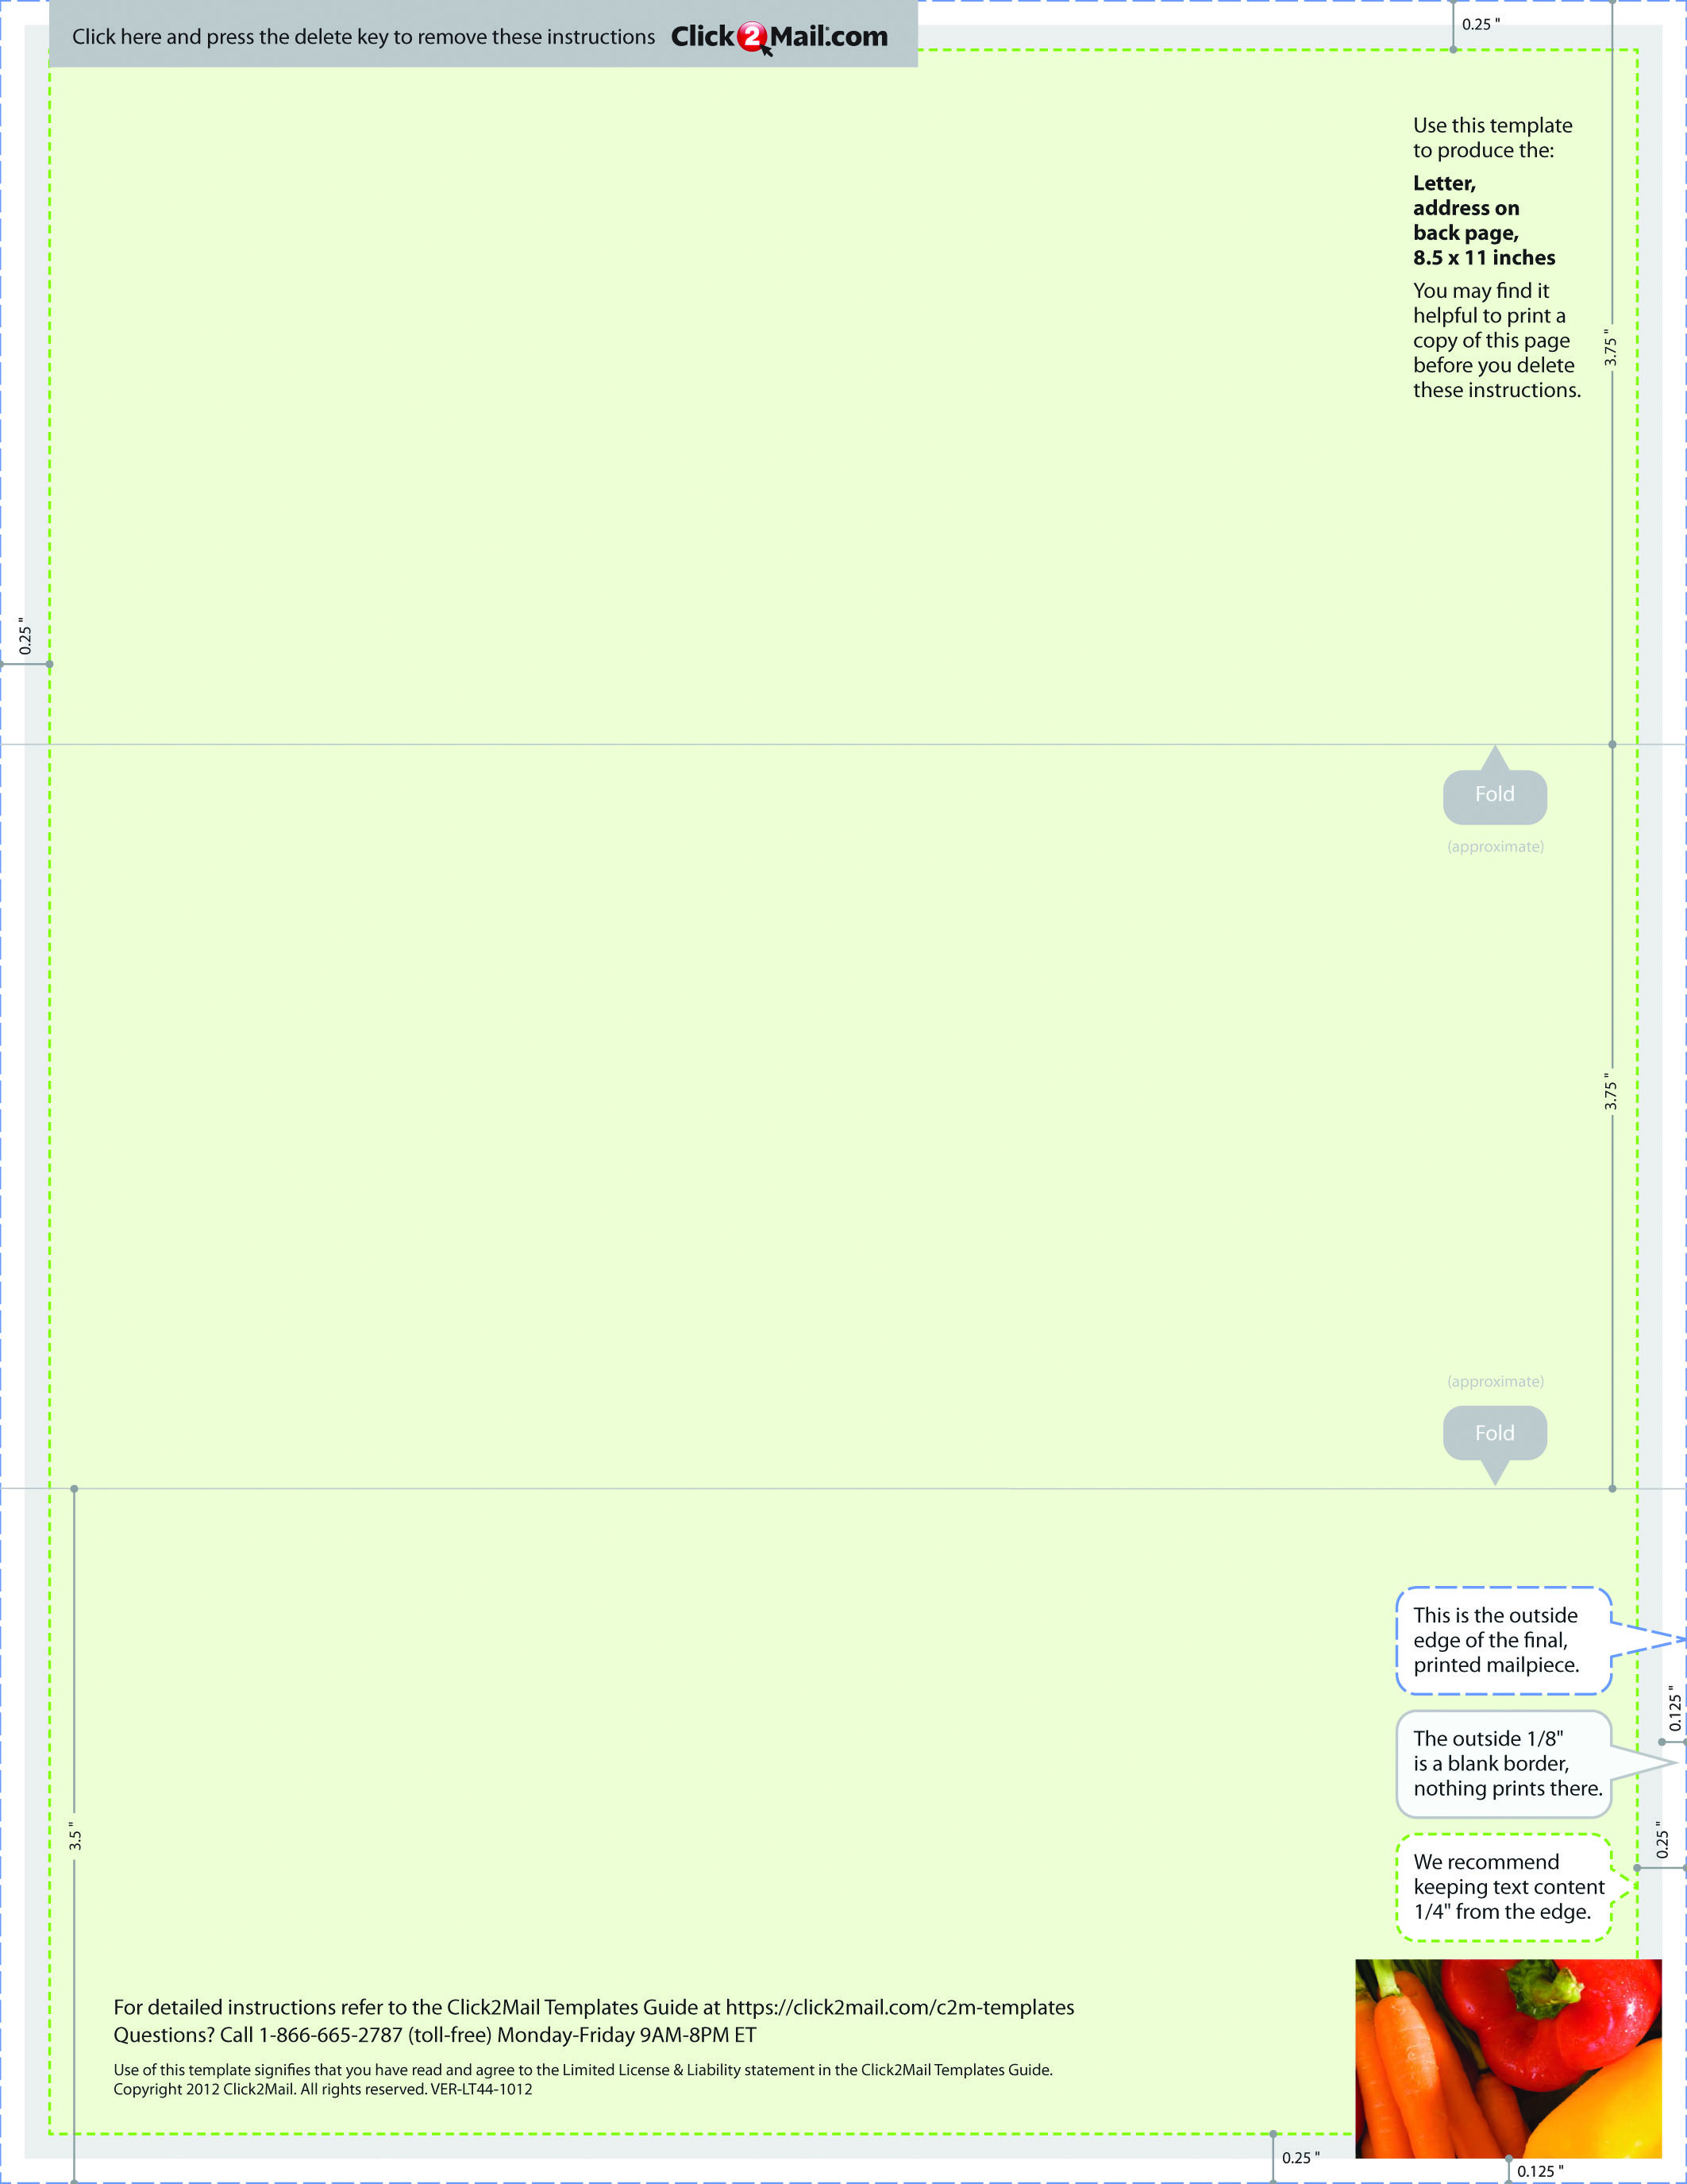

Placeholder text... Replace this placeholder text with text of your own. Use Click2Mail.com to

print, finish, post, and deliver your mailpieces quickly and economically. Click2Mail.com

makes it easy to design brilliant, full-color, affordable postal mail without permits, sorting,

stamps, or trips to the Post Office. How does it work? We use a network of strategically

located, high-quality printers to print, prep, and sort large volumes of mail daily. That network

and our understanding of strict postal requirements allows your mailpiece to receive optimal

handling and delivery. You benefit from high volume processing without setup fees or minimum quantities.