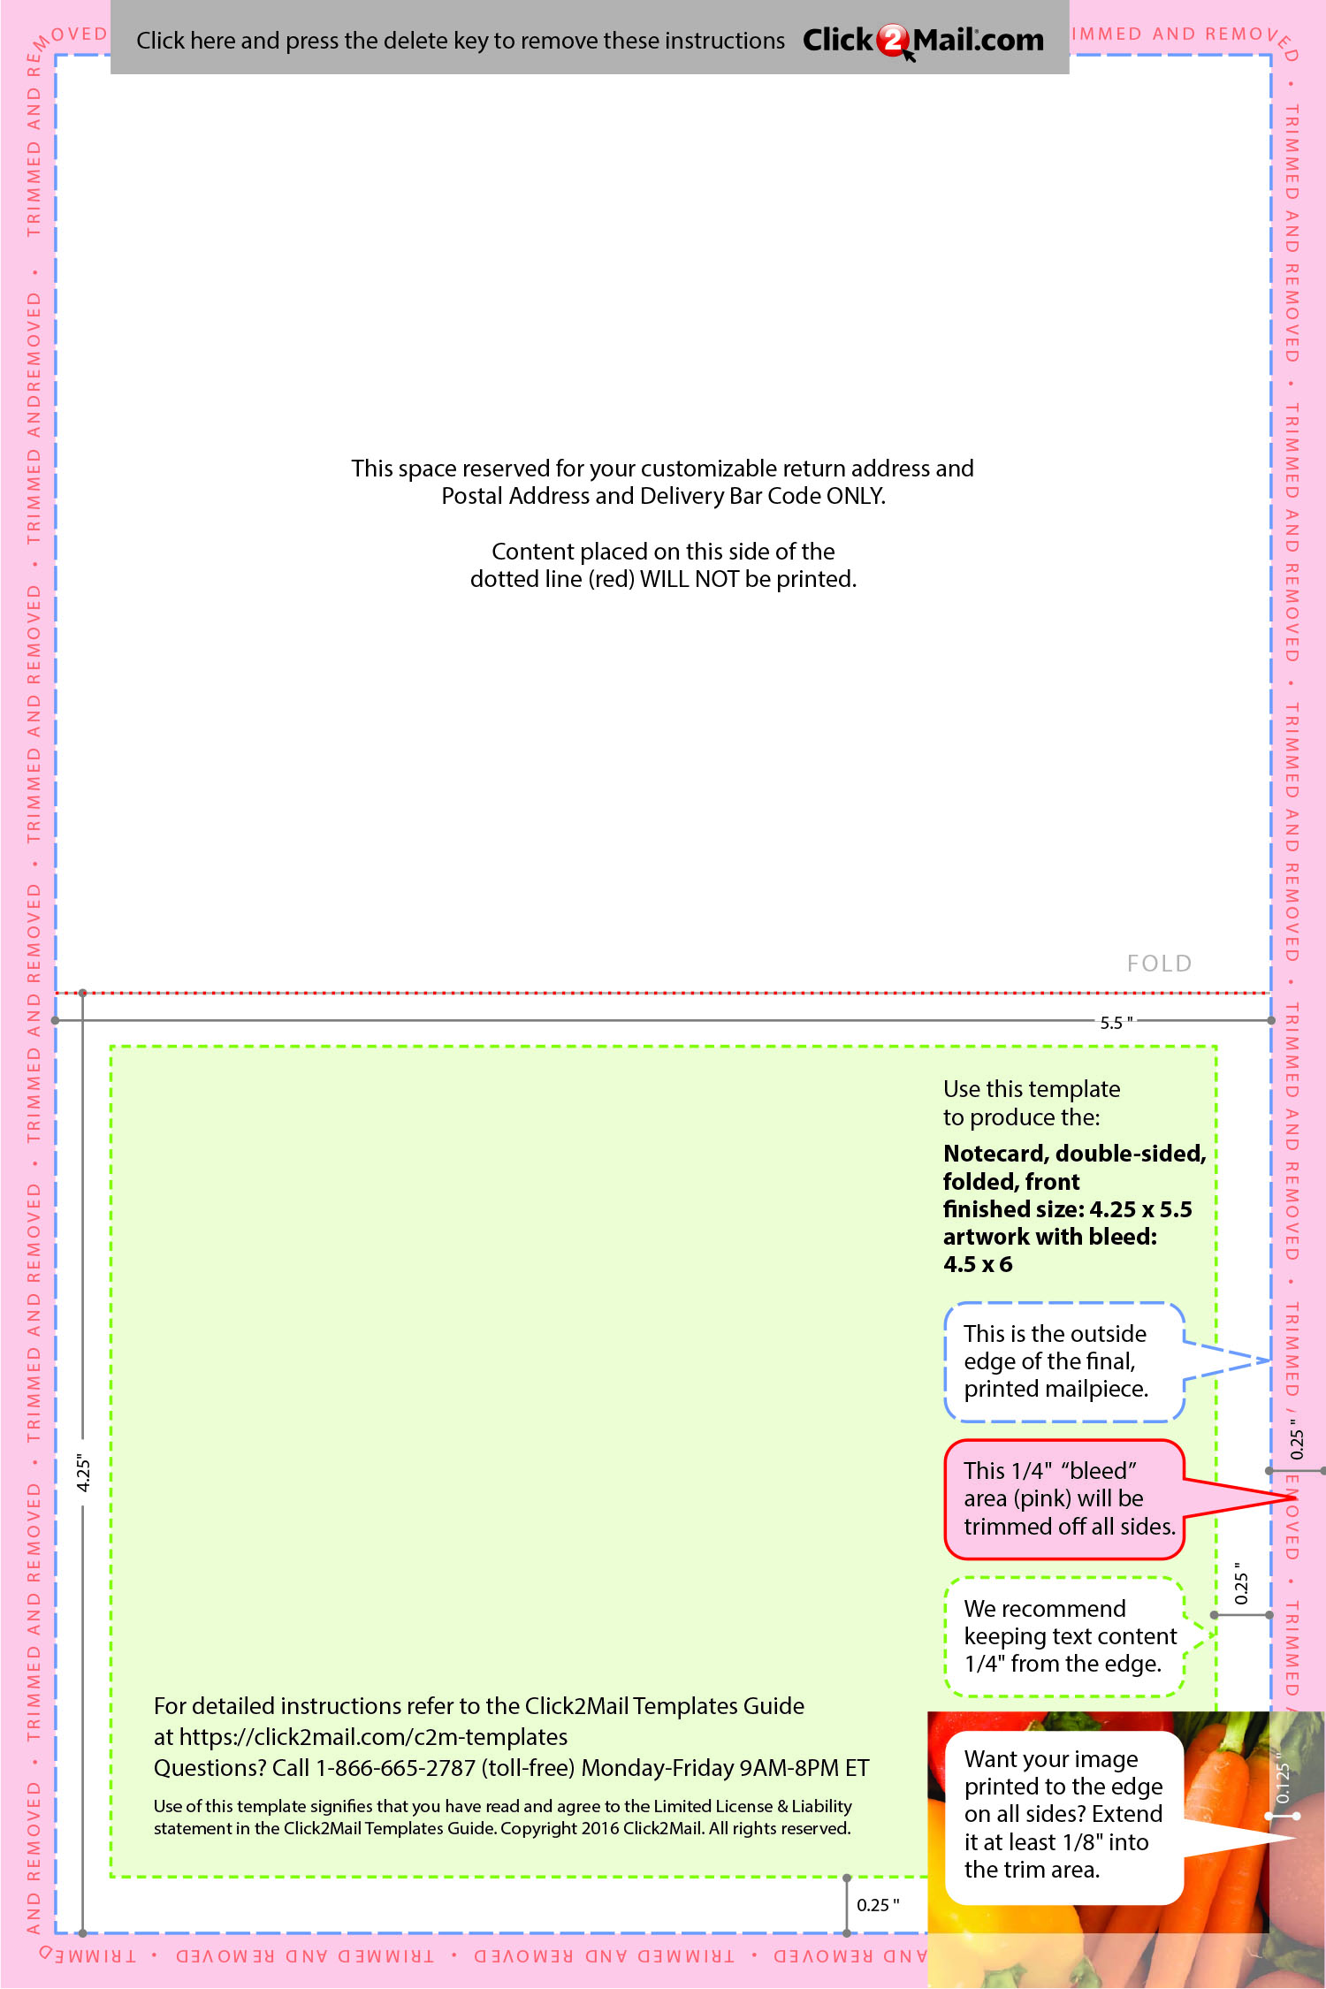

Replace this placeholder text with text of your own.

Use Click2Mail.com to print, finish, post, and

deliver your mailpieces quickly and economically.

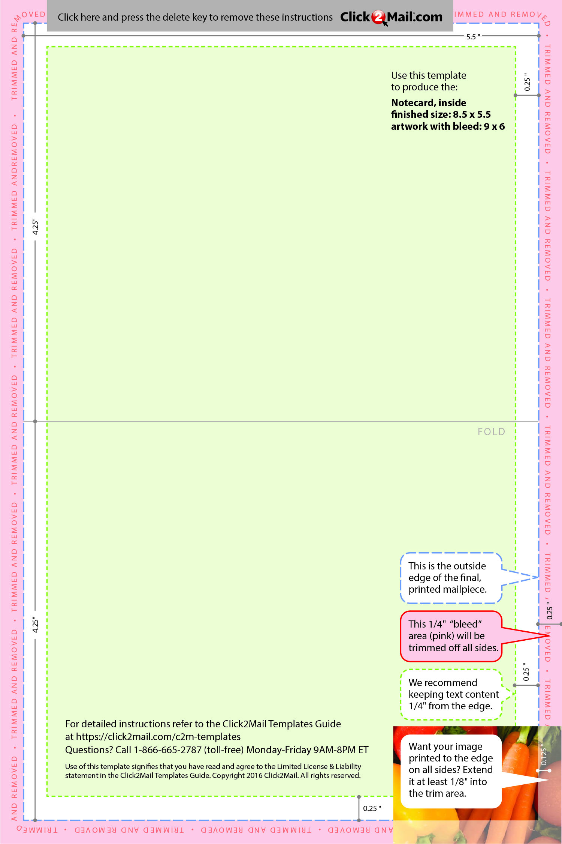

Replace this placeholder text with text of your own. Use Click2Mail.com to print, finish, post, and deliver your mailpieces quickly and economically.

Replace this placeholder text with text of your own.

Use Click2Mail.com to print, finish, post, and

deliver your mailpieces quickly and economically.