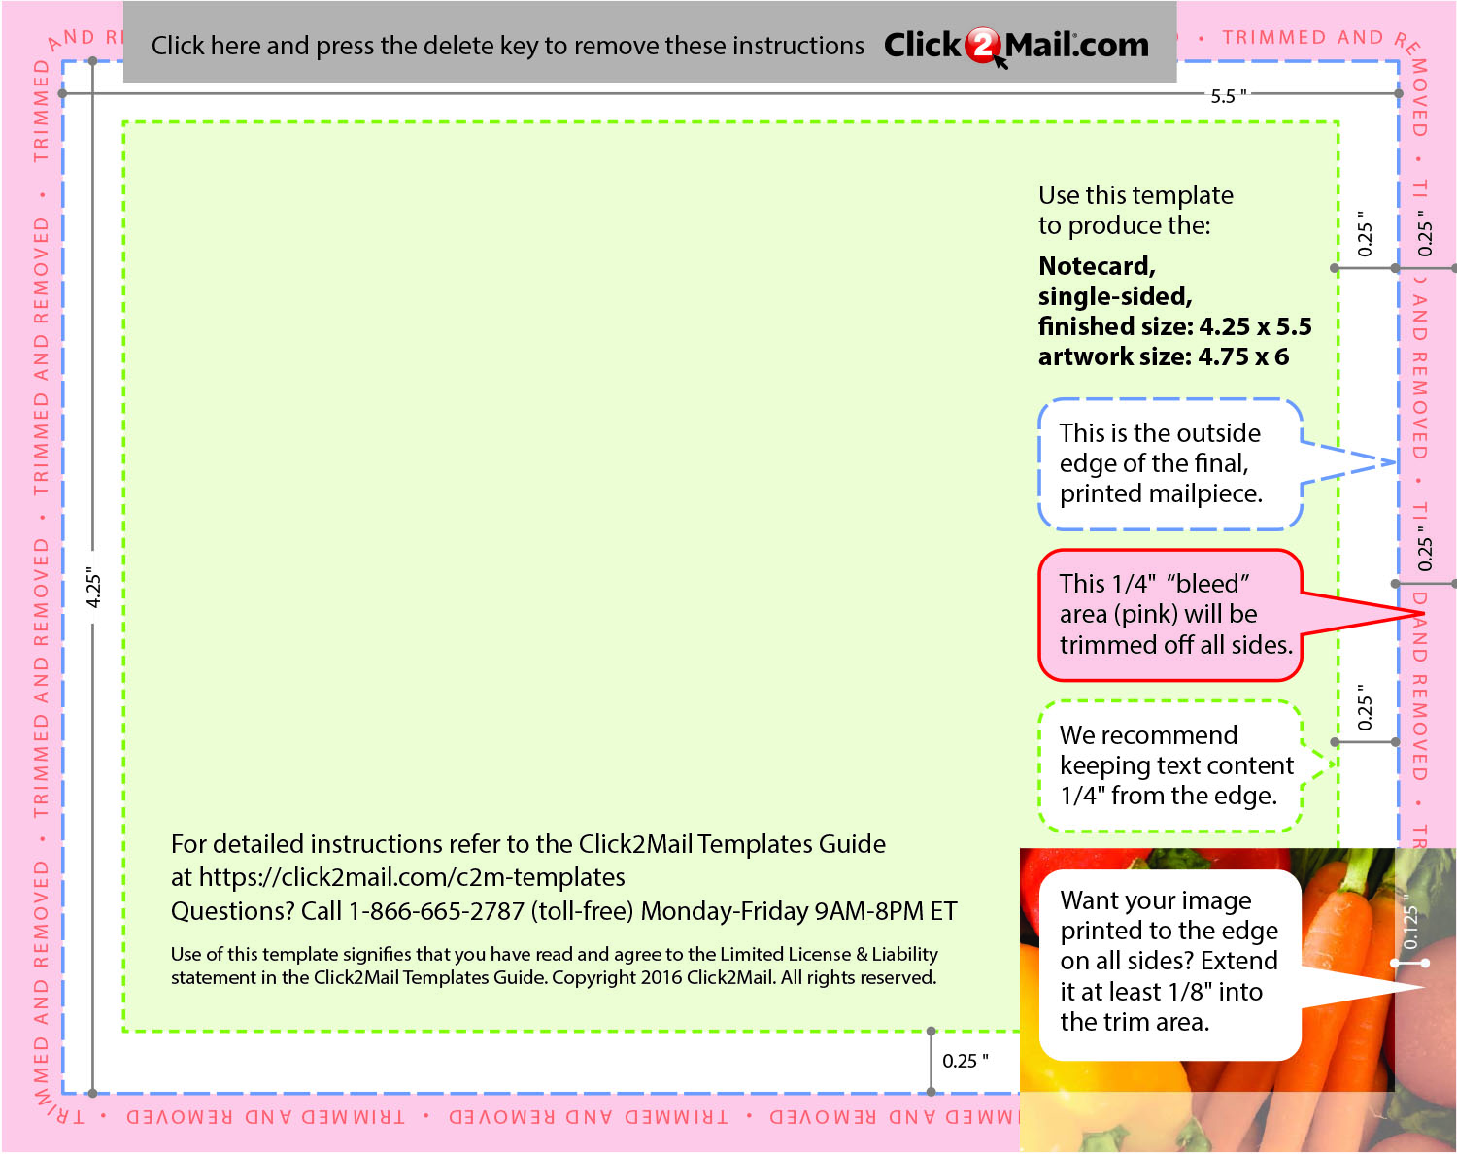

Replace this placeholder text with text of your own.

Use Click2Mail.com to print, finish, post, and

deliver your mailpieces quickly and economically.