I am making a dodgeball based game with a projectile motion physics engine and an orthographic view. I originally had the idea of a full on pseudo-3d system of view but I realised I didn’t know how to make the equations for my ideas in C# and I figured even just integrating mechanics homework into this was pretty far for what is honestly quite a generous standard.
Originally, I thought that a 45 degree angle, lines on the X and Z axis would appear half the actual length, but according to Blender and the Pythagorean theorem, it should be multiplied by 0.7071 (or more accurately, multiplied by √(1/2) ).
As of the 7th of April (2 days before the due date), I have not documented my progress on any document. Thankfully, in the latter half of this, I made a Git repo on GitHub for this so I could work on it at home. As such, I can reference some of my commits. I will still document the following 2 days.
8/4/25
I have not finished my leaderboard system. This is because I have not finished my point system, because I have not finished my enemy ball throw system. My whole projectile motion thing which I spent weeks obsessing over can be put on the sidelines for now, because nowhere in the standard does it say to make a game which uses physics calculations. This applies to other features such as ball parrying and enemy overlapping functions, which are not neccesary to make something playable. And now I wish I could’ve told myself this 2 weeks ago.
I’ve been running short on time because of 3 other internals and Sound Collective day-camp. I am now having to skip out on that because of this and Physics (which I just finished half an hour before writing this paragraph).
A key component of enemies throwing the balls is their statuses, so I did work on the throwing cycle. Enemies cycle between not holding a ball, holding a ball, preparing to throw a ball, and throwing a ball. The balls of the enemies are defined as an array of object classes, each with a set of variables for position and velocity, as well as code for updating the balls’ positions based on their velocity. I was going to generate a Z value for the physically based projectile throwing system, but for now, due to confusion on how best to generate the angle the enemy throws the ball at, the ball will only travel in 2D X and Y space. The ball will be assigned a dropping time, to simulate the ball hitting the floor before hitting the player.
I changed my
(I forgot what I was going to write here)
10/4/25
I am now genuinely concerned I won’t get this finished. After builiding a basic GUI for the game, it turns out my player input code is completely busted. I still haven’t made a leaderboard, and my game won’t be playable for scores to be made.
I’m currently working on making a leaderboard system and a start screen. In the start screen, I make sure the user has not inputted more than 12 characters for their name, or any characters which aren’t a letter or a number. I also make sure the name box is not empty.
I was on the way to finishing after I just figured out why the player was not moving, but sadly this was one of those cases where the bell did anything but save. The main thing which has been left unfinished is the graphics. Apart from that, I cannot know if anything else is broken.
Here is the repo, just in case:
https://github.com/SliceJosiah/3dDodgeball
20/10/25
Welp, time to figure out my code for a second time.
The first improvements I’m making are related to the player controls. A major issue with them is that the boundary detection in the movement functions is overwritten by the next line. This was fixed by putting that in an else statement. These basic fixes were all that was required to fix player movement.
I managed to get my enemy positions displaying. I thought I made their positions change at some point but looking at the code this doesn’t seem to be the case.
27/10/25
After a long while of testing multiple setups, I was able to return to working on this. A few days ago I successfully made the positions of the balls display, but due to some issues in the renderer which I have not yet fixed, the balls seem to start far above the enemies. This shouldn’t be a major problem. It took me a while to figure out why the balls were always throwing in directions seemingly unrelated to the player’s position. I found this even after commenting out the randomisation part. After using breakpoints to check the variables when they’re generated, it turned out that the whole problem was that the angles were the opposite of what they should be, so the balls were being thrown away from the player. That was a significantly easier fix than the time I took to troubleshoot it deserves.
28/10/25
This is how my game currently looks, displaying directional ball throwing and correct enemy position display:
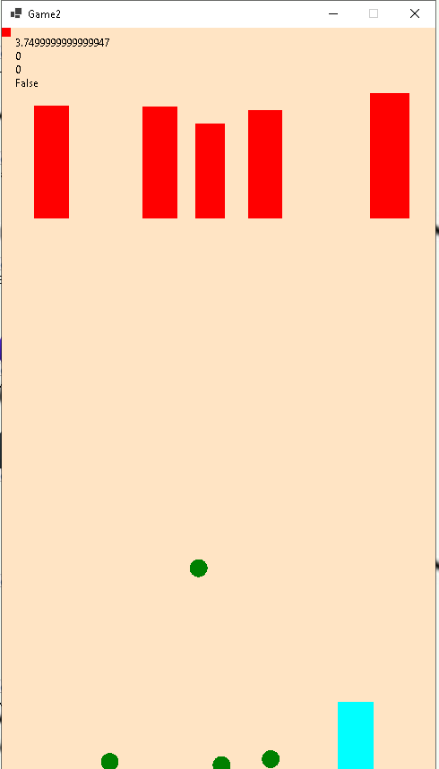
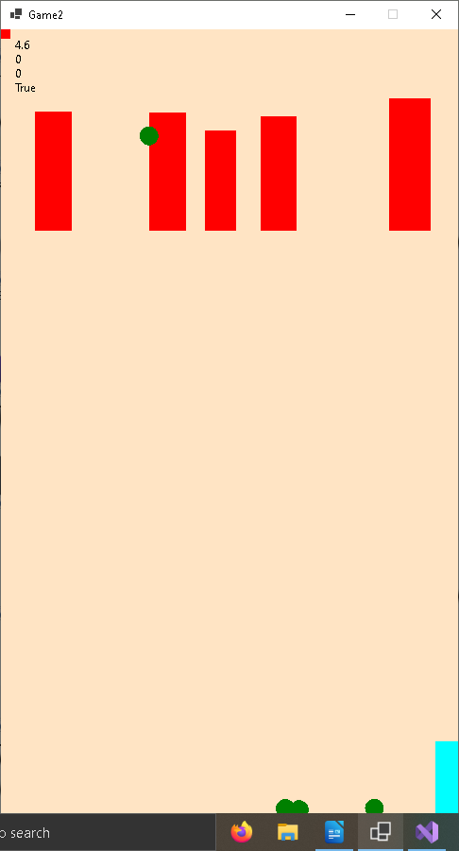
The enemy positioning issue was a simple calculation error, as I pretty much assumed. Another major problem was related to the scores. If the scores.txt file didn’t exist, the game would throw an error. This is a problem on computers other than the one I first made the file on. I fixed this by making it check if the file exists before attempting to write to it. If it doesn’t exist, it writes a placeholder ‘Nobody’ score with 0 points so the later lines don’t complain about there being no entries. The scores menu does not currently display when a game over is triggered, and the score is not sent to scores.txt. Before adding this function, I made some changes to the enemy behaviour to spice up the game difficulty and make it less slow and boring. I made it so that the balls are thrown from different heights depending on the enemy’s height, which could make a difference if I have time to re-introduce gravity.
29/10/25
I started working on the project on one of the Macs in the music department. Since I can’t test the software on a Mac, I worked on adding the extra ball throwing functions so I can test them later. I can’t really debug if I can’t test. Now, the ball start from the Z value of the enemy’s height minus its width, so the ball starts from the bottom left corner of a square at the top of the enemy’s rectangle, essentially its shoulder. The ball’s upward Z acceleration decreases by 9.81 every second, similarly to real life. When it hits the floor, its Z acceleration inverts and is dampened by x0.5, and the other acceleration values are dampened by x0.7. The ball can hit the floor a maximum number of 4 times before it stops. This means that if an enemy throws the ball too slow, it can fail to reach the player’s side. I also added a green bar at the top of the window to signal the player’s health.
When I got home and fixed some minor issues, I found that the balls were, once again, appearing in the wrong position in the y axis. It turns out that they were being generated with a negative starting Z value. It turns out, I was swapping the parameters of the enemy width and height when I was preparing the ball. The X/Y damping value of x0.7 was looking a bit odd and making too many balls fail so I found that 0.8 was a bit better.
30/10/25
I didn’t get much time to work on this one today except for after we went to dinner. It’s currently 9:13 PM so I’ll have to rush a little. There is a problem which I’ve been noticing for a while, and that’s that the player can still travel about half the player width ahead of the right point. I decided to try and fix it when I got the idea that I might’ve only made it reset to half the distance in the code. However, this doesn’t seem to be the case. When I put a breakpoint at that boundary check and watch the values, the playerPos and playerWidth do add up, as they should. This suggests that it’s just a visual bug. I worked on some extra stuff with enemy behaviour and adding shadows under the balls (and discovering what seems to be another enemy visual positioning bug, dammit). I eventually found out that the problem with the player going slightly off the screen was just about how I was determining the window size. Currently my main goals are continuing to fix vertical rendering, displaying points and making sure they’re calculated properly (along with health) and going through the marking schedule to make sure I’ve got everything ticked off.
31/10/25
I gotta speed on this now. I figured out that the issues with ball positioning were created by a basic subtraction issue. I added a display for the points, and adjusted values to make the system more reasonable. At this point, I felt there weren’t any major issues present. I skimmed through the marking schedule looking for little catches but found none.
Test case table for enemy generation (Enemies1.cs, EnemyPosTest1.cs)
Test Case ID | Test Scenario | Input Data | Expected Output | Test Number | Actual Output | P/F | Remarks
TEG01 | Position test form loads | N/A | Testing form should load with 2 empty listboxes and a button | 1 | N/A | P | Form loaded with all expected content
TEG02 | Position numbers load | Click on button1 | Listboxes are filled in with the left and right positions of each enemy generated | 1 | None | F | Got an error, can’t remember what it was
 |  |  |  | 2 | Left and right positions of each enemy | P | Listboxes were filled in with the correct data
TEG03 | Random enemy positions that do not overlap | Click on button1 | All enemy positions are clearly randomised, none of the numbers are equal, and no numbers are between the numbers of another enemy | 1 | Points seemed mostly random, but some enemies had the same 2 points. | F | Some identical points. Can’t remember if there were overlaps.
 |  |  |  | 2 | Points are fully random, with no overlaps and equal values. | P | Expected result, enemy position generation code must be working.

Test case table for 2D physics (VertThrowTest1.cs, VertThrowTester.cs)

Test case table for starting the game (Game2.cs, GameUpd1.cs, and other forms which are activated by them)
Test Case ID | Test Scenario | Input Data | Expected Output | Test No. | Actual Output | P/F | Remarks
TSG01 | Game form loads | N/A | Game form should load with an orange background, and no errors should crash the game. | 1 | Game form showed for split second, then crashed. | F | Recieved an error stating that player1 was null (when called from GameUpd.cs). This was because I needed to pass the already running instance of Player1 to the instance of GameUpd. This problem applied to other instances where I made this mistake.
 |  |  |  | 2 | Game form showed, and did not crash. | P | No graphics appeared, as I have not yet made the graphics. System resource usage was high, but I was testing on a virtual machine.
TSG02 | Player moves properly | Left and right keys pressed | Player should move left at a constant speed when left key is pressed, and right at a constant speed when right key is pressed | 1 | Player did nothing when right key was pressed. When left key was pressed, player teleported outside the left boundary. When right key was pressed after this, player teleported to 0. No other inputs worked. | F | I made labels showing which direction key was being registered, and what the value of the player position was. It turns out there was an error with how I wrote my if statements.
 |  |  |  | 2 | Player did not move. | F | Direction key toggle was working properly, as signified by the value of the label.
 |  |  |  | 3 | Player moved. | P | Run key did not work.

Test case table for scores list/leaderboard (ScoresList1.cs, Scores.cs, Start.cs)
Test Case ID | Test Scenario | Input Data | Expected Output | Test Number | Actual Output | P/F | Remarks
TLS01 | Start form loads | N/A | Start form should load with buttons, a text input and text. All text should be in Comic Sans. | 1 | N/A | P | Form loaded with all expected content
TLS02 | Scores list form loads with content, | username = foobar, score = 69420 | Scores list form should load with 2 listboxes, a label and 2 buttons. The label should show the score in between 2 lines of text. The lists should show player names and scores, in order by score number. A new entry should be added with the name foobar and a score of 69420.

Test table for scores/leaderboard (continued) and game over behaviour
ID | No. | Description of pass | P/F | Actual result | Output
gpy01 /  tls03 | 001 | When player is hit by the ball enough times and faces a game over, the leaderboard is shown and the player’s score is added. | F | No leaderboard is shown. Testing the leaderboard from the menu gives an error. | System.IO.FileNotFoundException  HResult=0x80070002  Message=Could not find file 'C:\Users\vcuum\source\repos\SliceJosiah\3dDodgeball\3dDodgeball\bin\Debug\net8.0-windows\scores.txt'.
gpy01 /  tls03 | 002 |  | F | No leaderboard is shown. Testing the leaderboard from the menu gives an error. | System.InvalidOperationException: 'Sequence contains no elements'
gpy01 /  tls03 | 003 | When player is hit by the ball enough times and faces a game over, the leaderboard is shown and the player’s score is added, whether or not scores.txt existed previously. | F /  P | Testing the leaderboard from the menu previews scores correctly. When player has a game over, the game window is closed but no leaderboard is shown and nothing is added to scores.txt. | foobar,69420  Nobody,0
gpy01 | 004 |  | P | When the player has a game over, the leaderboard shows and a score under the player’s name is added. It is not known at the moment whether the score is correct. | and, 0

Test table for enemy behaviour
ID | No. | Description of pass | P/F | Actual result | Output
enb01 | 001 | Without the angle randomisation or position prediction, enemies throw balls in the direction of the player. | F | Enemies threw at completely different angles from the player. This was later discovered to be the negative of the intended direction. | N/A
enb01 | 002 |  | P | Correct result | N/A

