Question 1.E: In a Scrum-based project management approach, when facing a situation where the client wants to add new activities (M, N, and O) as backlog items during the ninth week, the necessary actions and responsibilities can be addressed as follows:

1. Product Owner (PO):
- Assess the impact: The PO needs to evaluate the impact of adding these new activities on the project timeline, cost, and overall goals.
- Prioritize the backlog: Collaborate with the client and the development team to understand the priority of the newly requested activities in relation to existing backlog items.
- Determine the sprint goal: Consider the importance of the new activities and their alignment with the project's objectives to determine if they should be included in the upcoming sprint or scheduled for a future sprint.
- Communicate with the client: Engage in open communication with the client to understand the rationale behind the request, manage expectations, and negotiate any necessary trade-offs.

2. Development Team:
- Estimate the effort: The development team needs to estimate the effort required for the new activities (M, N, and O) using techniques like story points or relative sizing.
- Collaborate on prioritization: Work together with the PO to understand the importance of the new activities and their impact on the project. This collaboration will help in prioritizing the backlog effectively.
- Assess capacity: Evaluate the team's capacity to take on additional work during the upcoming sprint, considering the already planned backlog items and any potential impact on existing commitments.
- Provide input on feasibility: Provide input on the feasibility of including the new activities within the sprint, considering the available resources, skill sets, and dependencies.

3. Scrum Master:
- Facilitate the discussion: The Scrum Master ensures that all necessary discussions take place among the PO, development team, and client to address the addition of new backlog items.
- Promote transparency: Encourage open and transparent communication between the client and the development team to ensure that everyone understands the implications of adding new activities and any adjustments that may be required.
- Help in decision-making: Assist the PO and development team in making informed decisions regarding the inclusion of the new activities, considering the project's constraints, sprint goals, and team capacity.
- Adjust the sprint plan: If the decision is made to include the new activities in the upcoming sprint, the Scrum Master helps the team adjust the sprint plan, backlog, and any dependencies accordingly.

1F. If You have complete all the activity “F”, and its dependecies at the end of week 20,means your are saving 2 weeks respect to the critical path target. Also, activity E are a “botteneck”, meaning you have completed A, B, C, D, and E if you are done with F.
Now, If you are not done with G, means you are going to lost part of your savings, and the critical path has change. Same reasoning for task (H, I), and (H, K), because all has to be done before start task L.
Question 2:

I am considering a software application for a system for handling credit card applications.

Question 2A

Stakeholders:
- Customers: These are people or businesses applying for credit cards. They use the application to fill out forms, provide information, and track their application progress.
- Credit Card Companies: These are the banks or companies that receive and review credit card applications. They rely on the application to make the application process smooth, check applicant information, and decide whether to approve or reject applications.
- Compliance Officers: These are people who make sure the credit card application process follows rules and policies. They use the application to check if applications meet legal requirements, identify fraud or risky situations, and minimize problems.
Actors:
- Applicants: These are the people or businesses who use the application to apply for credit cards. They fill out the necessary forms, provide personal or business information, and submit their applications for review.
- Application Reviewers: These are the individuals responsible for assessing and evaluating the credit card applications. They review the information provided by the applicants, analyze their creditworthiness, and make decisions on whether to approve or reject the applications.
- Automated System: This is a non-human actor that performs various tasks within the application. It includes functionalities such as data storage, document verification, credit scoring, and application status tracking. The automated system interacts with the applicants and reviewers, handles the processing of applications, and supports decision-making processes.

Question 2B

User Story for Applicants: As an applicant, I want to be able to securely submit my credit card application online, so I can conveniently apply for a credit card without having to visit a physical branch. I want to fill out the application form, provide my personal information, upload supporting documents, and receive a confirmation that my application has been successfully submitted.
- User Story for Application Reviewers: As an application reviewer, I want to efficiently review and evaluate credit card applications, so I can make informed decisions on approving or rejecting applications. I need access to a centralized system that presents the applicant's information clearly, highlights important details, and provides tools for verifying documents and assessing creditworthiness. I want to be able to track the status of each application, leave comments or notes for further review, and generate reports on application processing metrics.
- User Story for Automated System: As an automated system, I need to ensure the security and integrity of applicant data throughout the credit card application process. I should be able to securely store and retrieve applicant information, perform document verification using advanced algorithms or OCR technology, calculate credit scores based on predefined rules, and communicate the application status to applicants and reviewers in a timely manner. I should also generate real-time notifications or alerts for any fraudulent or suspicious activities detected during the application review process.

Question 2C

Use Case 1: Online Credit Card Application Submission (for Applicants)
Description: Title: Submit Credit Card Application Online Primary Actor: Applicant Preconditions: The applicant has access to the credit card application system. Postconditions: The credit card application is successfully submitted for review.
Main Success Scenario:
- The applicant accesses the online credit card application system.
- The applicant fills out the required application form with accurate personal information.
- The applicant uploads supporting documents such as identification, proof of income, and address verification.
- The applicant reviews the provided information and documents for accuracy.
- The applicant confirms the submission of the credit card application.
- The application system securely processes and stores the applicant's information and documents.
- The applicant receives a confirmation message indicating the successful submission of the credit card application.
Extensions:
- If any required fields in the application form are left blank: a. The application system displays an error message indicating the missing information. b. The applicant fills in the missing information and resubmits the application.
- If there is an issue with the uploaded documents: a. The application system detects the issue and prompts the applicant to re-upload the document. b. The applicant re-uploads the corrected document and submits the application again.
Use Case 2: Credit Card Application Review (for Application Reviewers)
Description: Title: Review Credit Card Application Primary Actor: Application Reviewer Preconditions: The application reviewer has access to the credit card application review system. Postconditions: The application is reviewed and a decision is made on whether to approve or reject it.
Main Success Scenario:
- The application reviewer logs into the credit card application review system.
- The reviewer accesses the list of pending applications.
- The reviewer selects an application from the list to review.
- The reviewer examines the applicant's personal information, financial details, and supporting documents.
- The reviewer verifies the authenticity of the uploaded documents.
- The reviewer evaluates the applicant's creditworthiness based on predetermined criteria.
- The reviewer makes a decision to approve or reject the application.
- The reviewer records the decision in the application review system.
- The system generates a notification to inform the applicant of the decision.
Extensions:
- If additional information is required from the applicant: a. The reviewer adds a note in the application review system requesting the specific information. b. The system sends an automated email to the applicant, requesting the additional information. c. The applicant receives the email and provides the requested information through a secure link. d. The reviewer reviews the additional information provided by the applicant and proceeds with the decision-making process.
- If the application is flagged for further investigation due to potential fraud: a. The reviewer marks the application as flagged for investigation in the application review system. b. The system automatically triggers an alert to the compliance officers for further scrutiny. c. The compliance officers review the flagged application, conduct a detailed investigation, and provide their findings to the reviewer. d. Based on the findings, the reviewer makes a decision to approve or reject the application, or escalate it for further action.

Question 2D:

User Story 1: Online Credit Card Application Submission (for Applicants) Reliability Metric: Availability
Justification: The most appropriate reliability metric for the user story of online credit card application submission would be Availability. Availability measures the percentage of time that a system or service is operational and accessible to users. In this case, the availability of the online credit card application system is crucial to ensure that applicants can access and submit their applications without any downtime or interruptions. It reflects the reliability of the system in terms of its ability to remain operational and accessible for applicants whenever they need to use it.
User Story 2: Credit Card Application Review (for Application Reviewers) Reliability Metric: Mean Time to Resolve (MTTR)
Justification: The most suitable reliability metric for the user story of credit card application review by application reviewers would be Mean Time to Resolve (MTTR). MTTR measures the average time it takes to restore a system or service to normal operation after an incident or issue. In this case, MTTR would reflect the reliability of the application review system in terms of how quickly any technical or operational issues are resolved, ensuring that reviewers can efficiently access and review applications without significant delays. It focuses on minimizing the downtime or disruptions in the application review process, thus enhancing the reliability of the system for the reviewers.

Question 2E

User Story 1: Online Credit Card Application Submission (for Applicants)
- Intuitive User Interface: The application system should have a user-friendly interface that is easy to navigate and understand, enabling applicants to complete the credit card application process without confusion or the need for extensive instructions.
- Clear Progress Indicators: The application system should provide clear progress indicators or steps, allowing applicants to track their progress and know how much more information or steps are required to complete the application.
- Error Handling and Validation: The system should provide real-time error handling and validation mechanisms to assist applicants in correcting mistakes or missing information. It should clearly highlight any errors or missing fields and provide helpful error messages to guide applicants in resolving them.
User Story 2: Credit Card Application Review (for Application Reviewers)
- Efficient Application Filtering and Sorting: The application review system should allow reviewers to easily filter and sort applications based on relevant criteria such as application status, priority, or submission date. This enables efficient management and prioritization of applications for review.
- Comprehensive Applicant Profile View: The system should provide a comprehensive view of an applicant's profile, including all relevant information, supporting documents, and application history. This ensures that reviewers have all the necessary information at their disposal to make informed decisions.
- Collaboration and Communication Tools: The system should include communication and collaboration features that enable reviewers to communicate with other team members, share insights or notes, and seek clarification on certain applications. This promotes efficient collaboration and enhances the overall usability of the system.
User Story 3: Credit Card Application Review (for Automated System)
- Robust Data Security: The automated system should incorporate robust data security measures to protect applicant information and maintain data privacy. It should comply with industry-standard encryption protocols, access controls, and secure data storage practices to ensure the usability of the system without compromising sensitive data.
- Real-time Notifications and Alerts: The system should provide real-time notifications and alerts to inform relevant stakeholders, such as compliance officers or reviewers, of any critical events or actions required. This ensures prompt response and timely decision-making.
- Scalability and Performance: The automated system should be designed to handle a high volume of credit card applications efficiently. It should be scalable to accommodate increased application submissions without significant performance degradation. This guarantees that the system remains usable and responsive even during peak application periods.

Question 3A:

Input Condition | Valid Equivalence Class | Invalid Equivalence Class
Position within bounds | Position in bounds | Position out of bounds
Direction valid | Valid direction | Invalid direction

Question 3B:

Boundaries:

- Top speed and acceleration values at the lower boundaries (valid input):
  - top_speed_one = 0.0001
  - top_speed_two = 0.0001
  - acceleration_one = 0.0001
  - acceleration_two = 0.0001

- Top speed and acceleration values just below the lower boundaries (invalid input):
  - top_speed_one = 0
  - top_speed_two = 0
  - acceleration_one = 0
  - acceleration_two = 0

3. Tie condition
  - top_speed_one = 10
  - top_speed_two = 10
  - acceleration_one = 10
  - acceleration_two = 10

Question3 PartC:
Test the case where the number of people and pies is positive:
  - Input: num_people = 5, num_pies = 20
  - Expected Output:
    - Number of pies each person gets: 4
    - Number of leftover pies: 0
    - "Perfect" message should be printed
- Test the case where the number of people is 0:
  - Input: num_people = 0, num_pies = 20
  - Expected Output:
    - "Invalid" message should be printed
    - Prompt for input again until a valid number of people is provided
- Test the case where the number of people is negative:
  - Input: num_people = -5, num_pies = 20
  - Expected Output:
    - "Invalid" message should be printed
    - Prompt for input again until a valid number of people is provided
- Test the case where the number of pies is negative:
  - Input: num_people = 5, num_pies = -20
  - Expected Output:
    - "Invalid" message should be printed
    - Prompt for input again until a valid number of pies is provided
- Test the case where the number of people is 1:
  - Input: num_people = 1, num_pies = 20
  - Expected Output:
    - Number of pies each person gets: 20
    - Number of leftover pies: 0
    - "Perfect" message should be printed
- Test the case where the number of people is greater than the number of pies:
  - Input: num_people = 10, num_pies = 5
  - Expected Output:
    - Number of pies each person gets: 0
    - Number of leftover pies: 5
    - "Perfect" message should not be printed
- Test the case where the number of people and pies is 0 initially, but a valid input is provided later:
  - Input: num_people = 0, num_pies = 0 (initially), then num_people = 4, num_pies = 16 (valid input)
  - Expected Output:
    - "Invalid" message should be printed initially
    - Prompt for input again until a valid number of people is provided
    - Number of pies each person gets: 4
    - Number of leftover pies: 0
    - "Perfect" message should be printed

Question 3 PartD.

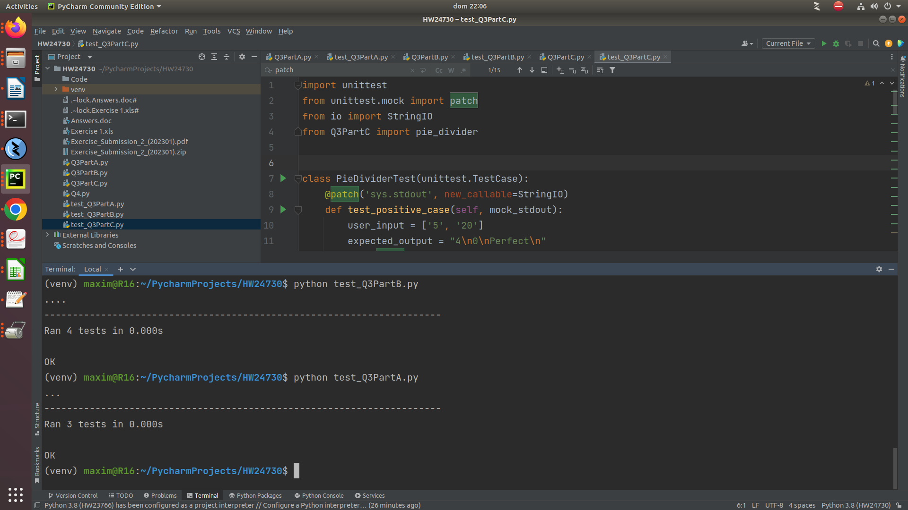

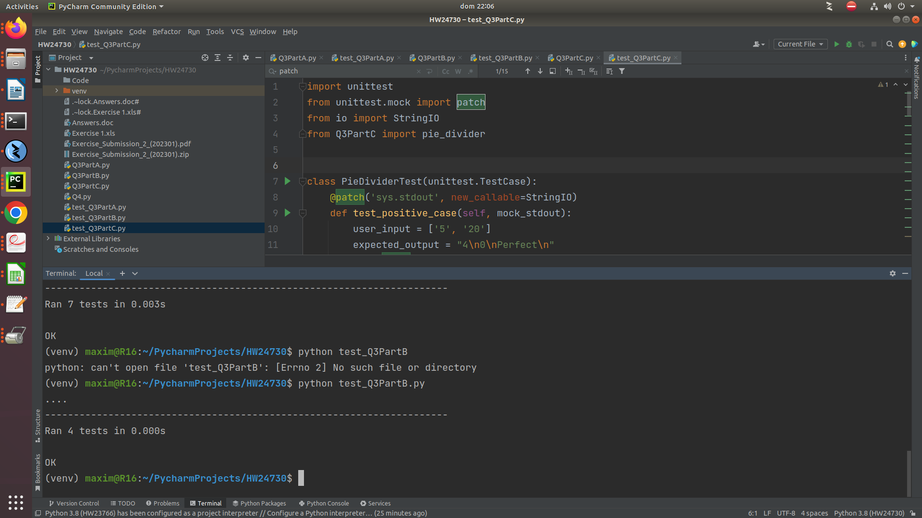

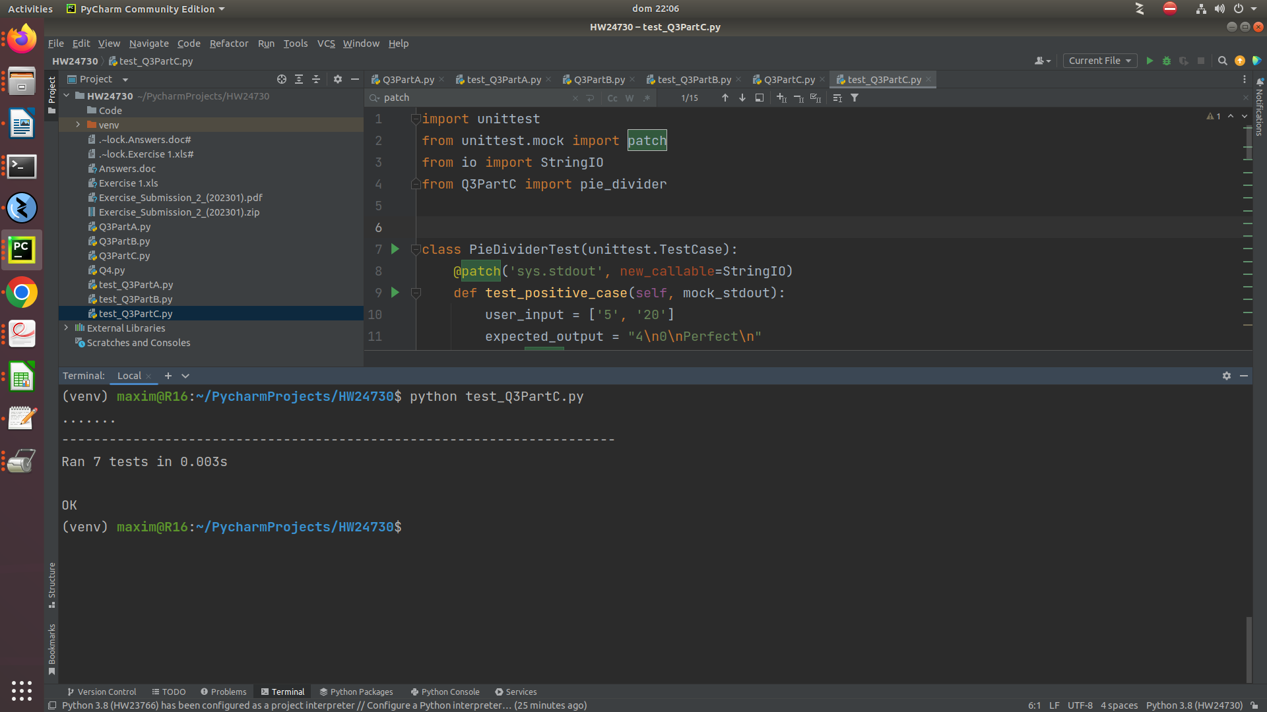

Sr. | Function name | Identified Issue | Category of Issue | Comments | Proposed Solution
1 | times_or_divide | Global variable usage (num_one, num_two) and tight coupling. | Global State, Coupling. | The function relies on global variables num_one and num_two, which makes it tightly coupled to the global state and limits its reusability. | Pass the necessary values as arguments to the function instead of relying on global variables. This will improve modularity and allow the function to be used with different values.
2 | add_or_subtract | Global variable usage (num_one, num_two) and tight coupling. | Global State, Coupling. | Similar to the previous function, this function also relies on global variables, limiting its reusability and increasing coupling. | Pass the necessary values as arguments to the function instead of relying on global variables.
3 | get_number | Mixing I/O and logic, lack of error handling.  User missinformation.  Bad use of global variables. | Separation of Concerns, Error Handling.  Global State coupling | This function is responsible for both input/output (I/O) and logic. Additionally, it lacks proper error handling for invalid inputs. | Split the function into separate functions, separating the I/O and logic concerns. Implement proper error handling to handle invalid inputs using try-except blocks.

Question 5 A: A travel agency booking system & requeriments.
If the functional requirements do not properly address the security measures needed to protect customer payment information, it could lead to vulnerabilities in the system. Hackers or malicious actors may exploit these vulnerabilities to gain unauthorized access to sensitive customer data, including credit card details, personal identification information, and booking history.
Consequences of such a breach could include:
- Financial Loss: If customer payment information is compromised, unauthorized transactions may occur, resulting in financial loss for both the affected customers and the travel agency. The agency may be held responsible for any fraudulent charges made using the stolen payment information.
- Reputation Damage: A security breach involving customer payment information can severely damage the reputation of the travel agency. Customers may lose trust in the agency's ability to protect their data, leading to a loss of business and negative word-of-mouth publicity.
- Legal and Regulatory Consequences: Mishandling customer payment information can result in legal and regulatory repercussions. Data protection and privacy laws, such as the General Data Protection Regulation (GDPR) in Europe or the California Consumer Privacy Act (CCPA) in the United States, impose strict obligations on businesses to protect customer data. Failure to comply with these regulations can lead to fines, lawsuits, and reputational damage.

Question 5B: Testing in a RDBM system
Data Corruption: Inadequate functional requirements and improper data handling can lead to data corruption within the RDBMS. If there are no proper constraints, validations, or checks in place, invalid or inconsistent data may be stored, compromising the integrity and reliability of the database. This can result in inaccurate information, incorrect calculations, and erroneous reports.

Question 5C: Project Management in Smart TV OS.
It can lead to several harmful outcomes, including poor user experience, project delays, and inefficient resource allocation.
- Project Delays: Inadequate definition of functional requirements can cause project delays and cost overruns. Without a clear understanding of project scope, deliverables, and dependencies, project teams may face challenges in planning, resource allocation, and task prioritization. This can lead to missed deadlines, inefficient workflows, and project bottlenecks.
- Inefficient Resource Allocation: Poorly defined functional requirements can result in inefficient resource allocation and utilization. If requirements are ambiguous, conflicting, or constantly changing, development teams may spend time and effort on unnecessary tasks or rework. This can lead to wasted resources, increased development costs, and reduced productivity.

