Dyshawn Payne

11-26-22

CTEC 298

Plots

**Pie Chart**

import matplotlib.pyplot as plt

# Pie chart, where the slices will be ordered and plotted counter-clockwise:

labels = 'Frogs', 'Hogs', 'Dogs', 'Logs'

sizes = [15, 30, 45, 10]

explode = (0, 0.1, 0, 0) # only "explode" the 2nd slice (i.e. 'Hogs')

fig1, ax1 = plt.subplots()

ax1.pie(sizes, explode=explode, labels=labels, autopct='%1.1f%%',

shadow=True, startangle=90)

ax1.axis('equal') # Equal aspect ratio ensures that pie is drawn as a circle.

plt.show()

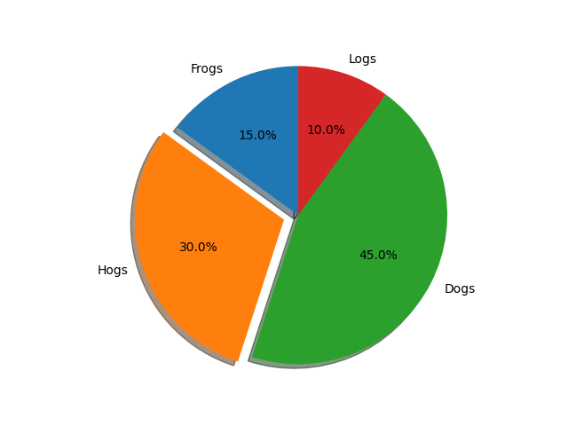

**Bar Graph**

import matplotlib.pyplot as plt

import numpy as np

plt.style.use('_mpl-gallery')

# make data:

np.random.seed(3)

x = 0.5 + np.arange(8)

y = np.random.uniform(2, 7, len(x))

# plot

fig, ax = plt.subplots()

ax.bar(x, y, width=1, edgecolor="white", linewidth=0.7)

ax.set(xlim=(0, 8), xticks=np.arange(1, 8),

ylim=(0, 8), yticks=np.arange(1, 8))

plt.show()

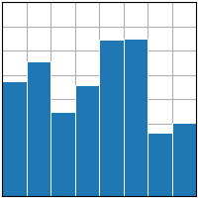

**Tableau Bar Graph**

