3/10/05

Jim,

I am looking at these links in Example 1 now and concerned that users may find them confusing if they try to follow the directions we provided. I think the fact that there are so many of them right at the top is the problem. The words are no longer grey and the combination of the link and the checkbox might be a problem for some people. I wonder if something that looks like this might be better.

Examining School Performance on StatewideTests
- How did students perform on the state reading test at grade 3?
Coming Soon. You may download these data from another page.
- How did students perform on state tests at grades 4, 8, and 10?
Coming Soon. You may download these data from another page.
- How did performance of all students enrolled compare to continuing students only?
You may download these data from another page.

Examining Spending Patterns
- How much money is received and spent in this district?
- Where can I find more detailed school finance data?
You may download these data from another page.

The phrase “download data from another page” would be an active links to the URLs I gave you. Let me know what you think. Sorry to go back and forth about this but I didn’t think of this until I woke up this AM. Let me know if you disagree or if this will not be easy to change.

Also can the blue “Using WINSS Download Options” link look more like the links in the red column on the other pages? In other words, does it have to be blue or can it be cream-colored like the links in Example 2. The blue link really sticks out. I don’t feel strongly about this, but it just looks inconsistent so is distracting.

Example 1
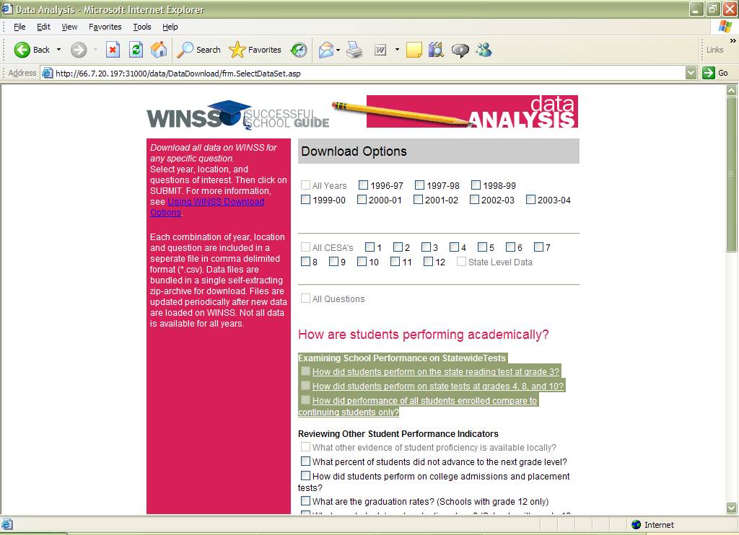

Example 2
