

Process MeNtOR 3.o
Uni-SEP

<Project Name>
Requirements Model

Version:
Print Date: | 5/14/1998 03:32:00 PM
Release Date:
Release State:
Approval State:
Approved by:
Prepared by:
Reviewed by:
Path Name:
File Name: | 0000.doc
Document No:
Document Change Control

Version | Date | Authors | Summary of Changes

Document Sign-Off

Name (Position) | Signature | Date
Contents
1 Introduction
1.1 Purpose
1.2 Overview
1.3 References
2 Business Scenario Model
2.1 Actors
2.1.1 Overview
2.1.2 Actor Diagram
2.1.3 Actor Definitions
2.1.4 A-nn <Actor Name>
2.2 Graphical Scenario Diagrams
2.3 Business Scenarios
2.3.1 XXXX-NNNN <Scenario Title>
3 Business Domain Model
3.1 Business Class Diagram
3.2 Business Object Definitions
3.2.1 <Business Object Name>
4 User Interface Requirements Specification
4.1 View Navigation Diagrams
4.1.1 <View Navigation Diagram Name>
4.2 View Definitions
4.2.1 <View Definition Name>
5 Non-Functional Requirements Specification
5.1 Overview
5.2 Enabling Technologies
5.2.1 Target Hardware & Hardware Interfaces
5.2.2 Target Development Environment
5.2.3 System Interfaces
5.3 Capacity Planning
5.3.1 Traffic Volumes over Time
5.3.2 User Populations and Locations
5.3.3 Permanent Storage
5.4 Printing
5.5 Network
5.6 Workstations
5.7 Operational Parameters
5.7.1 Useability
5.7.2 Reliability
5.7.3 Maintainability
5.7.4 Portability
6 Domain Dictionary
6.1 Terms and Abbreviations
6.2 Notation/Formula

Introduction

Purpose
This document details the requirements the system <System Name>.
For small projects (ie. Uni-SEP) this document may contain the complete set of business scenarios for the project. In larger projects this document will cover only a particular subject area.

Overview
Provide a brief overview of the problem to be solved and the requirements of the system. This section should be a brief executive summary.

References
Include references to other documents that may assist in the understanding of this document. (ie. Project Plan)

Business Scenario Model

Actors

Overview
Describe in one or two paragraphs the environment in which the actors exist.
Note that actors can be people or external systems.

Actor Diagram
Introduce the diagram by explaining it in words.
Insert an actor inheritance diagram here that illustrates the relationships that exist between the various actor types. This diagram is critical when abstract actor types are included in the Requirements Model. An example follows:

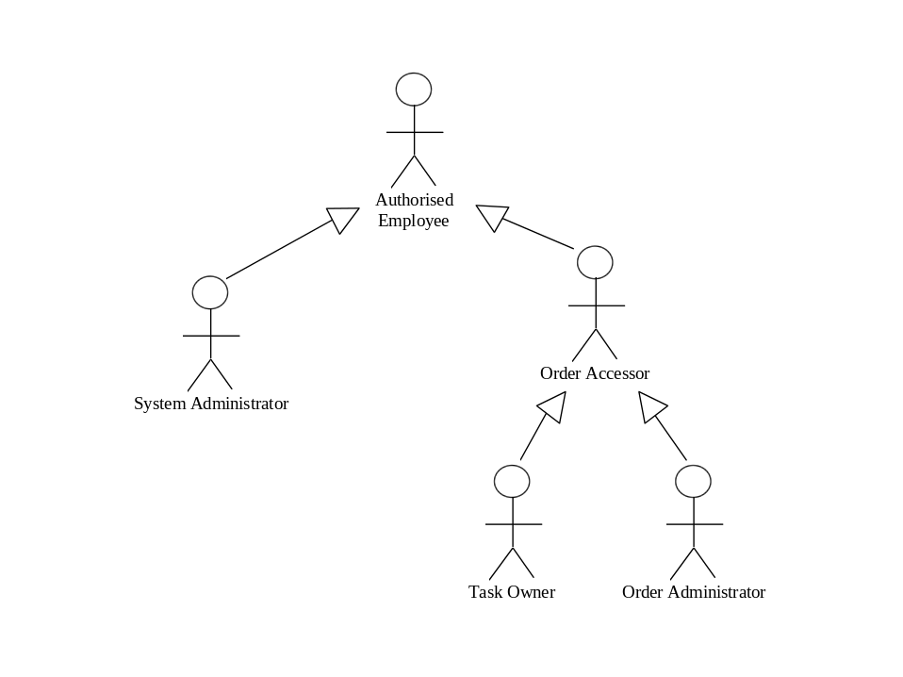

Actor Definitions
Repeat the section below for each actor.
Description | Brief description of the actor and its role in the system. This description should be no more than a small paragraph and should give the reader an understanding of the role of the actor in the organisation. Mandatory.
Aliases | Any other names by which this actor may be known. A simple list is sufficient. Say ‘None’ if there are none.
Inherits | The ancestors for the actor. Some actors may be specialised types of other actors. A simple list of the names of the ancestors will suffice. Say ‘None’ if there are none.
Actor Type | Active/Passive - Person/External System. Mandatory.
Contact Person | Person to contact about the actor. This may be the person who interviewed the actor or the user who is actually an instance of the actor. Mandatory.
Contact Details | The contact details for the contact person. These details are recorded to allow questions and follow-up to be directly appropriately. Mandatory.

A-nn <Actor Name>
Description
Aliases
Inherits
Actor Type
Contact Person
Contact Details

Graphical Scenario Diagrams
This section presents the business scenarios of the subject area in a graphical form.
Assign an appropriate title to the graphical scenario model and insert the diagram here.

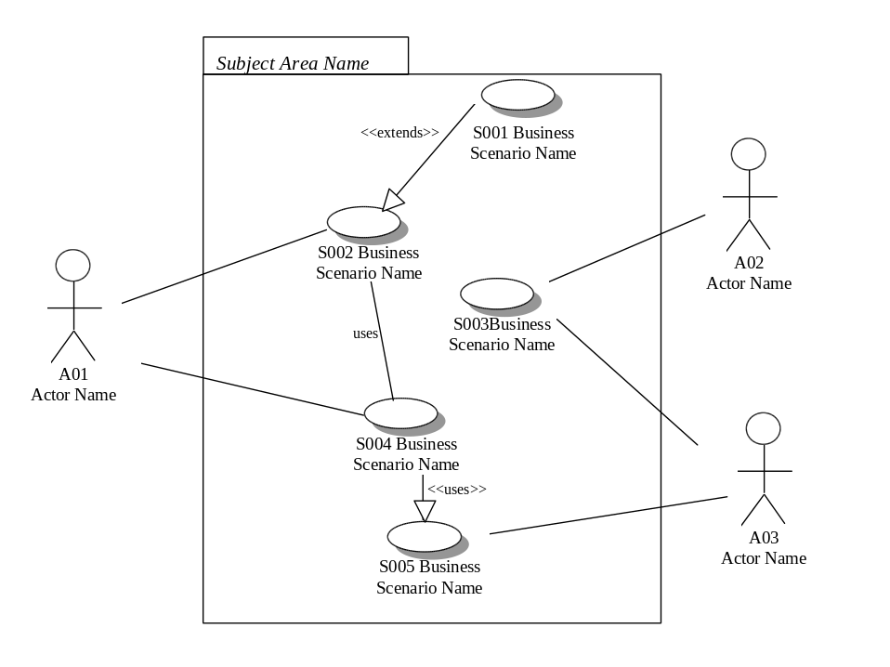

Business Scenarios
This section documents the complete business scenarios within the scope of this project.

XXXX-NNNN <Scenario Title>
Insert each business scenario definition for the subject area in here.
Description:
Brief description of the business scenario and its context. This description should be no more than one paragraph and should give the reader an understanding of the role of the scenario but not the detail. Mandatory.
Actors:
List the actor names that perform the scenario. Ensure that their details are entered in an actor definition template. Mandatory.
Preconditions:
Specify any conditions that must be met before this scenario can be performed. These should be set out as a numbered list. The list of preconditions should be stated in a declarative fashion (eg. ‘the alarm must be on’). This will help put the business scenario in context. It will also facilitate verification and the generation of test cases. If there are none then say ‘None’.
Scenario Text:
Narrative of the scenario. The scenario narrative should be stated in concise sentences for each step of the scenario. Each step should be numbered (eg. 1, 2, 3) with sub-steps using levelled numbers (eg. 1.1, 1.2, 1.3). Levelling should not generally extend to more than three levels deep.
When referencing other business scenarios, the key word uses, and the business scenario name following it, should be italicised. Try to begin the step with the uses and then explain why it is needed. For example.
- Use Maintain Customer to update the postal address
- Calculate commission fee (see note 4).
Details of business rules should not be included in the text. Instead refer to a note for details.
Any error messages should also be presented as part of the scenario. Any alternatives should be referred to as alternative n (where n is the number of the alternative as specified in the alternative section) and italicised in the text.
The text should not generally extend for more than one to two pages.
Alternative Courses:
Narrative of alternative scenario. This section should include the prerequisite conditions necessary for the alternative scenario to occur. Each alternative scenario should be numbered sequentially (eg. 1, 2, 3) and it should be ensured that the alternative is used in the scenario narrative above. If there are not any then say ‘None’. Alternative courses have a similar layout and structure as scenario text.
Extends:
Include the coma delimited names of any other business scenarios that this scenario extends. If there are none then say ‘None’.
User Interfaces:
Unique ids of the logical views used in accomplishing this scenario. If there are none then say ‘None’.
Constraints:
Describe any constraints or requirements that will not be met or are out of scope. Such explicit statement avoid confusion and helps clarify any limitations implicit in the business scenario. These should be numbered sequentially (eg. 1, 2, 3). If there are none then say ‘None’.
Questions:
State any questions that need to addressed before the business scenario can be considered complete. Delete the question one it has been answered within another part of the business scenario. The business scenario can not become final if there questions still in this section. Include the name of the person who is charged with resolving the question. If there are none then say ‘None’.
Notes:
State any notes that relate to this business scenario. Keep them to 2 to 3 sentences. Do not state complex business rules here, instead just include the name of the source document and page or section number where they are defined. If business rules do not yet exist then specify the contact who will define it.
If necessary, include any comments concerning business practices that assist in explaining how a particular step fits into the overall business environment.
State any business practices that will require changing as a result of this business scenario.
If there are none then say ‘None’.
Authors:
The names and designated initials of the people who are responsible for writing this scenario. This will usually be a User Representative and a Requirements Modeller assigned to define and document this area of the requirements. Mandatory.
Source Documents:
List of the sources and documents from which the requirements for this specific scenario have been drawn.

Business Domain Model
A Business Domain Model is a high level object model of the classes that exist in the business domain supported with a general statement about each Class covered within the model.
Given that the model is largely used to structure the problem, emphasis is placed on the assignment of a unique name and description as well as the identification of candidate relationships between the classes.

Business Class Diagram
Insert a copy of the business class diagram here. Complex systems may need to be partitioned into Subject Areas as in the example below.
Example (An Customer Care System):
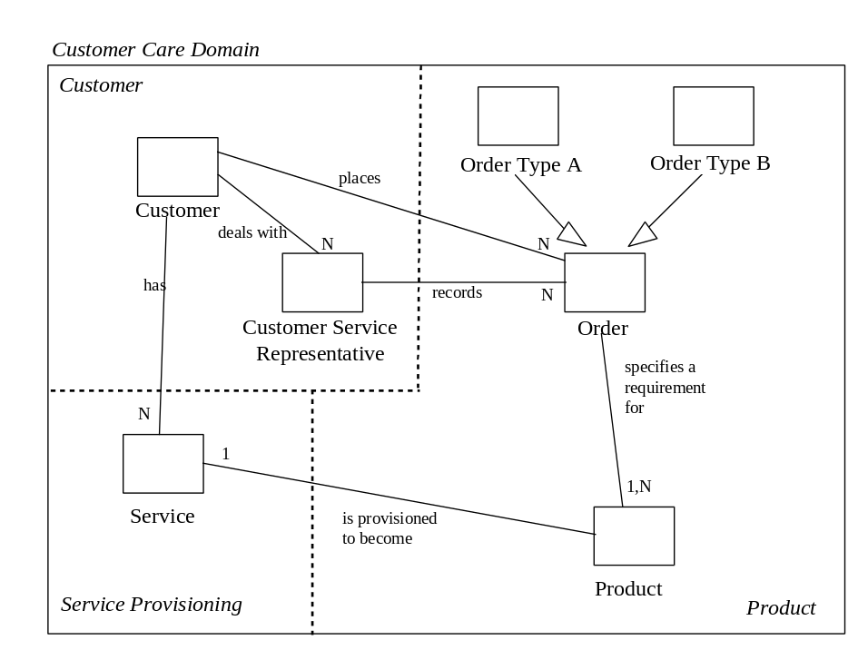

Business Object Definitions
Detailed below is an account of each business object contained within the business domain model. Group the definitions by subject area if required.
During the initial and core releases of the requirements model, the attributes and responsibilities assigned to each object will be preliminary and require refinement.
Repeat the following section for each business object in the diagrams in the previous section.

<Business Object Name>
Description | Provide a one paragraph description of the role of the business object.
Attributes | List the attributes of the business object and their type if it is known.
Responsibilities | List each of the responsibilities identified for the business object. Each responsibility should be able to be state in one sentence. If collaborators are known then list them for each responsibility.
Business Rules | State any important business rules or constraints that need to be implemented by business object.
State Diagram | Complete a state transition diagram if this is a complex business objects. Optional - Remove this section if there is not a state transition diagram for this business object.
Example | The life cycle of an Order in an Order Management system (ie. a view of the state changes for the “status” attribute).  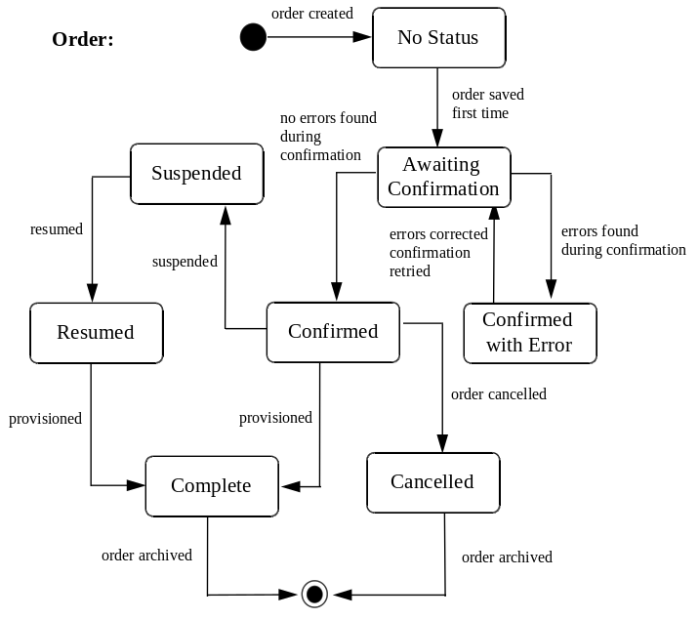

User Interface Requirements Specification

View Navigation Diagrams
The purpose of a user interface (UI) view navigation diagram is to document the navigation paths that may result from performing actions from the various user interfaces that are defined and documented as part of the business scenario model.

<View Navigation Diagram Name>
Divide the view into a number of subject areas. Where a subject area is defined as a number of interrelated views. Assign an appropriate title and produce a navigation model for each one and insert the diagram here.
When this chapter is complete, the table of contents should list all of the user interface navigation models by name.
Provide a brief one paragraph description of the diagram defining its scope and basic purpose.
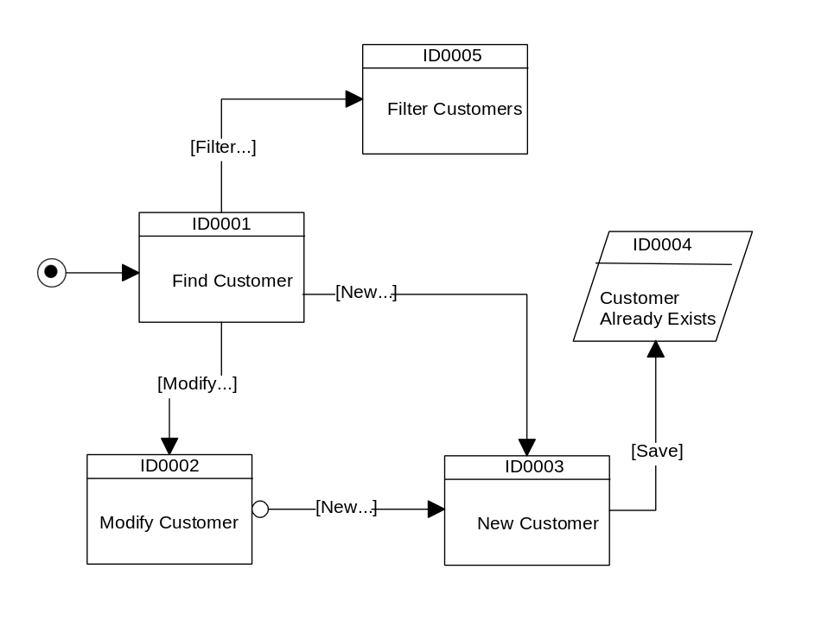
Figure 1 View Navigation Diagram for <subject area>

The notation to use is:
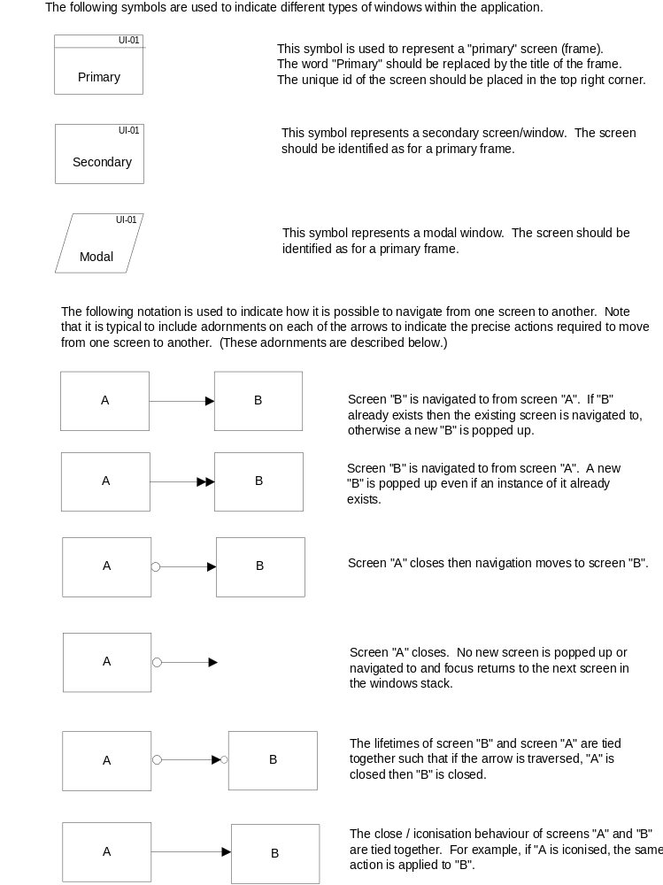

View Definitions
Use the following template to define each view within the user interface. A view is defined as a collection of user interface elements that would be viewed together in the system user interface. Views typically become windows or forms. There is no predefined graphical notation for the illustration of a view. This is left largely up to the author, although the bounds of the notation that can be used in the illustration should be guided by the design standards.

<View Definition Name>
View Title |  | View title.
Number |  | Unique number for view.
Description |  | Brief one paragraph description of the use and purpose of the view.
View Illustration
Optional section, remove if not used. The view image can be either a screen print or a sketch illustration. Simple line drawings will illustrate the requirement and avoid the contentious issue of “does this interface constitute the final screen design” (which it does not!).

Field List
List the field definitions within this view in there natural entry (ie tab) order.
Fields Name | Comment
The name of the field in the Field List. | Any notes or comments specific to this field within this view. Optional.
Cross Field Edit Rules |  | Describe the cross field edit rules that apply between the fields within this view.
Scenario References |  | A comma delimited list the business scenarios that refer to this view.

Non-Functional Requirements Specification
Often when the full requirements of a system are explored, it is difficult to represent all of the requirements on a Business Scenario Model. The Business Scenario Model is best at representing truly "functional" requirements that map to the process of the business. Those that are non-functional in nature (ie. statements on useability, reliability etc) can only be embedded within the context of a functional requirement, and as such, risk getting lost in the paper work.
This document exists to document the "non-functional" requirements of the system.
They should be clearly and concisely stated.

Overview
Provide a brief overview of the non-functional requirements.

Enabling Technologies

Target Hardware & Hardware Interfaces
Where a requirement exists for a specific hardware environment to be used to deliver the system, detail the requirements.
This should specify the logical characteristics of each interface between software product and the hardware components of the system. It also covers such matters as what devices are to be supported, how they are to be supported, and protocols. For example, terminal support may specify full screen support as opposed to line by line.

Target Development Environment
Where a requirement exists for the system to be developed using specific platforms, software and tools, state the requirement.

System Interfaces
Due to deployment requirements, specific system interfaces may be required (eg. “the business cannot deliver service X if the new system does not talk to System B”). If these are known, state them. Focus on the enabling technology aspect of these connections.
Where specific technology must be used, document the requirements.
The account should list each system interface and identify the functionality of the software to accomplish the system requirement and the interface description to match the system.

Capacity Planning

Traffic Volumes over Time
Traffic volumes differ throughout the hours of operation. Discuss the expected traffic volumes over the normal operating period.
Often, it is most sensible to rate the traffic levels in terms of 0 for the lightest level, 1 for the heaviest, and 0.5 for the medium load.

User Populations and Locations
State the user population levels expected on a per location basis. Where different user groups are expected to generate different traffic levels, state the differences.

Permanent Storage
What are the expected requirements with respect to permanent storage? What volume of data is to be held?

Printing
What are the printing requirements?

Network
What are the networking requirements? Explore these requirements in as much detail as possible.

Workstations
Explore the requirements for a workstation by covering the following subjects:
- Diskspace
- Performance
- Memory
- Screen attributes
- Processor requirements
- Interfaces.

Operational Parameters

Useability
Discuss the useability requirements for the new system. How understandable, learnable and operable is the new system to be?

Reliability
Discuss the requirements which respect to the level of reliability that is expected with the new system.
In particular, consider the following section on the recoverability requirements for the new system.
Recoverability & Backup
Describe the backup and recovery requirements for the system.
Restart
Describe the requirements for restarting the system after a temporary problem in the system hardware or software.

Maintainability
Explore the maintainability requirements for the new system. How easy should it be to analyse it, change it and test it?
What criteria will be used to measure the stability of the system?

Portability
Review the requirements of the system in terms of portability. Consider how adaptable, installable, and replaceable the system is to be.
Should the system conform to any portability standards?
The section should specify the attributes of software that relate to the ease of porting the software to other host machines and/or operating systems. This may include:
- Use of proven portable languages
- Use of a particular compiler or language subset
- Use of a particular operating system.

Domain Dictionary

Terms and Abbreviations
Term | Definition
Place term here | Place a definition of the term here. Make the definition short and concise and consistent with other terms. Only used terms defined elsewhere in the domain dictionary.
Place synonym here | This is a synonym of <another term>
Long Position | One of the parties in a forward contract assumes a long position and agrees to buy the underlying asset on a certain specified future date for a certain specified price
Short Position | One of the parties in a forward contract assumes a short position and agrees to sell on the same date for the same price.
Warrant | A call option issued by a company on its own stock.  Differs from a call option in the fact that when a warrant is exercised, the company issues new treasury stock in return for the exercise price specified in the contract.

Notation/Formula
Define any special notation used in the above definitions.
Notation | Definition
Place notation here | Place a description and definition of the notation here. Use standard symbols for the notation where possible.
∀ | For all symbol as used in mathematics
∪ | union of sets as used in set theory
∞ | Infinity symbol as used in mathematics

