Assignment 2
1- explain the code
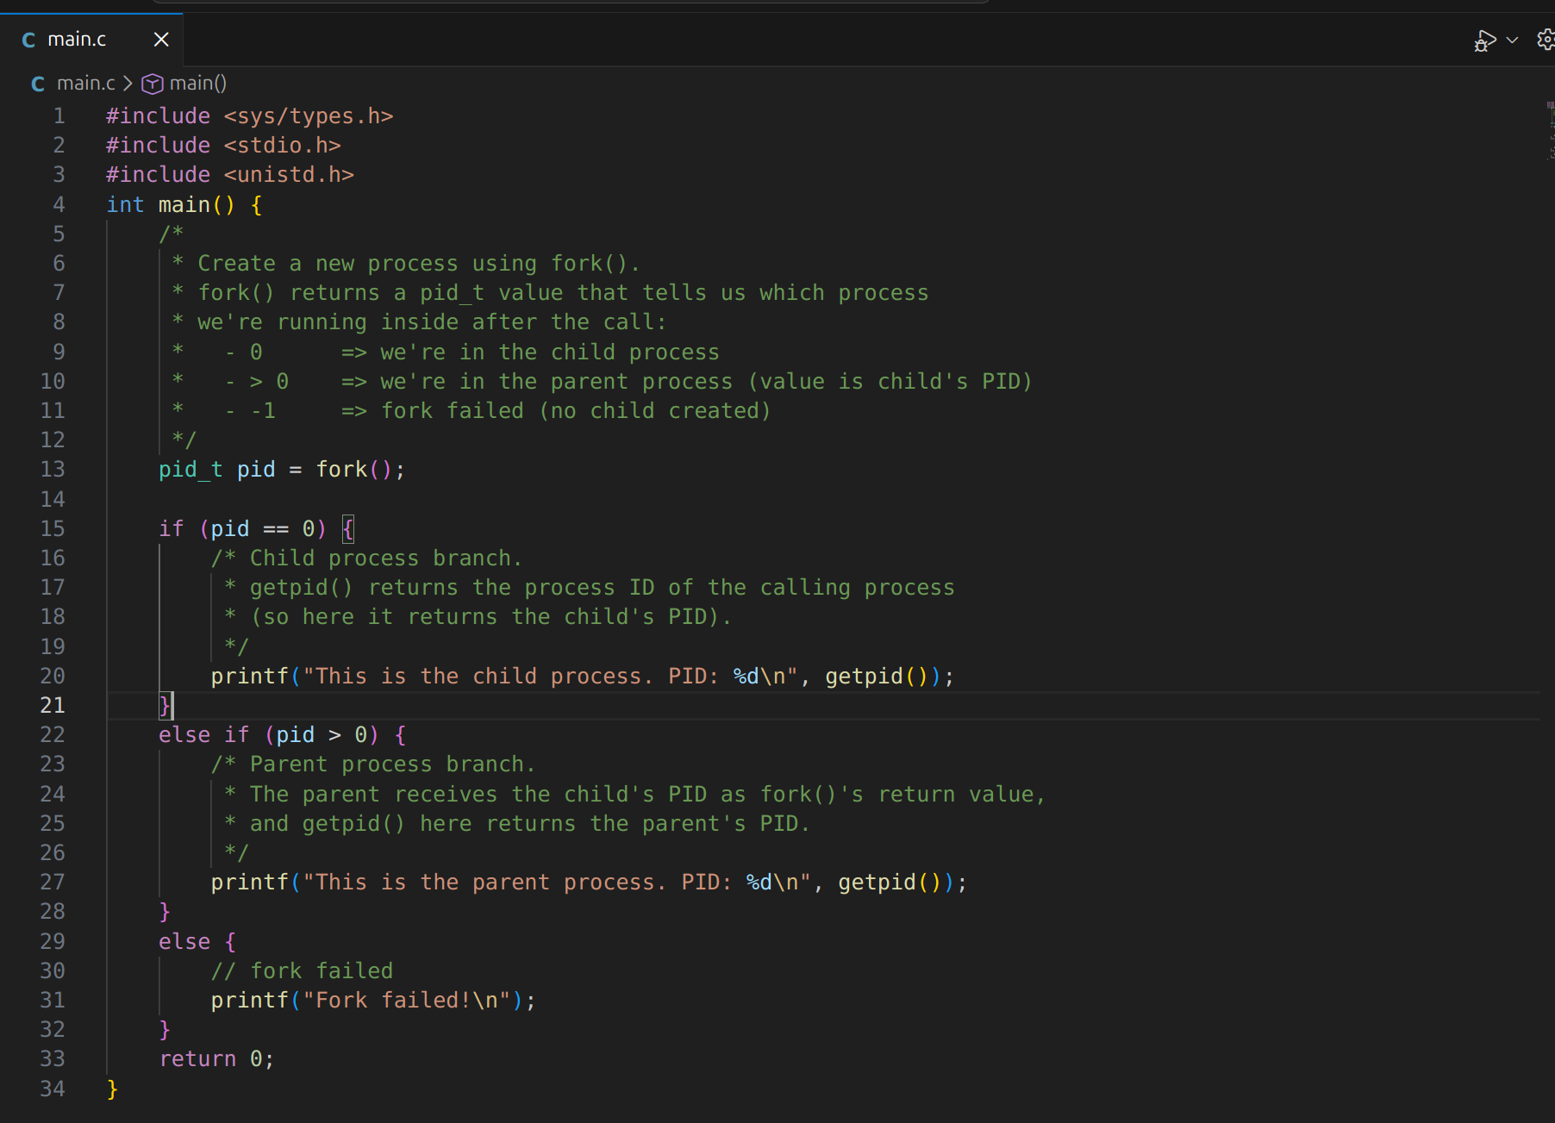

The explain on the comment

2- Explain what is the job of the Linker.
When we are writing two C files and want to compile it and link them together
Like in the Lab 5 we have Hello function and we call it on another file
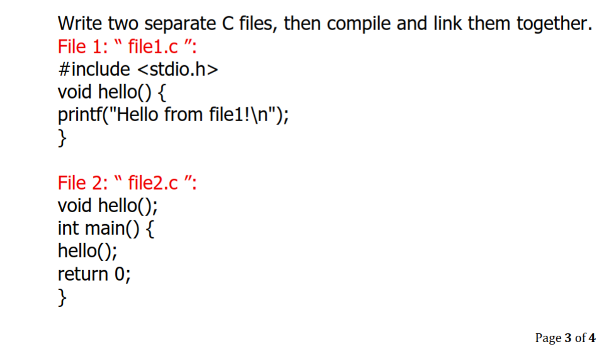The linker connects separate compiled object files into a single runnable program by filling in the missing memory addresses for functions defined in other files

3- Explain what is the job of the Loader.
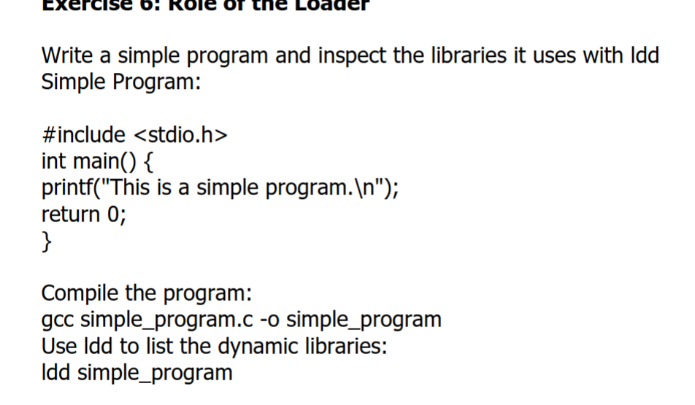

The loader reads the executable file from the disk, places its code and data into the main memory (RAM), and tells the CPU to start executing the program.
This is some explain from geeksofgeeks
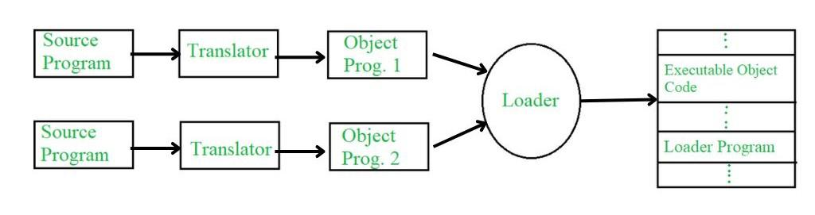

So a loader is a program that is responsible for loading executable programs into memory for execution. The loader reads the object code of a program, which is usually in binary form, and copies it into memory. It also performs other tasks such as allocating memory for the program's data and resolving any external references to other programs or libraries. The loader is typically part of the operating system and is invoked by the system's bootstrap program or by a command from a user. Loaders can be of two types:
- Absolute Loader: It loads a program at a specific memory location, specified in the program's object code. This location is usually absolute and does not change when the program is loaded into memory.
- Relocating Loader: It loads a program at any memory location, and then adjusts all memory references in the program to reflect the new location. This allows the same program to be loaded into different memory locations without having to modify the program's object code.
3- makefile
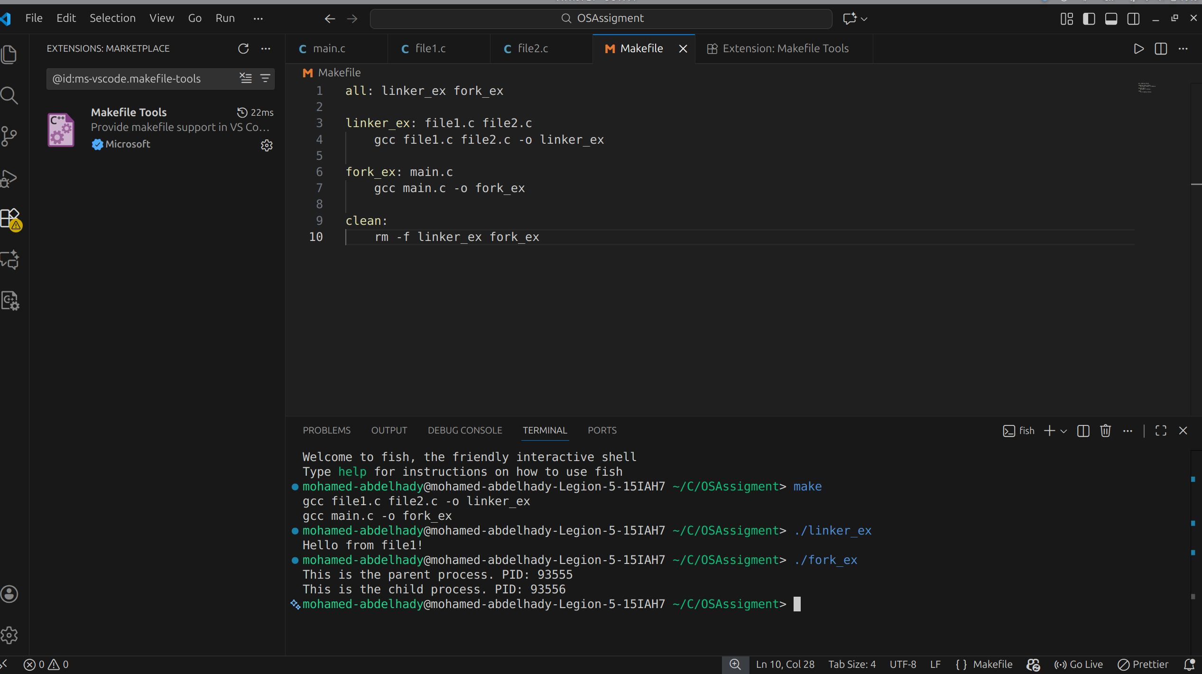
This is MakeFile code and run

