Individual Submission 4: The Database

**Task 5: Database Creation**

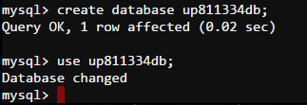

Create database up811334db;

Use up811334db

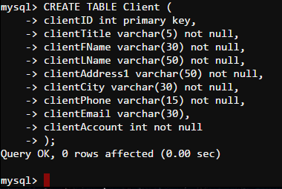

CREATE TABLE Client (

clientID int primary key,

clientTitle varchar(5) not null,

clientFName varchar(30) not null,

clientLName varchar(50) not null,

clientAddress1 varchar(50) not null,

clientCity varchar(30) not null,

clientPhone varchar(15) not null,

clientEmail varchar(30),

clientAccount int not null

);

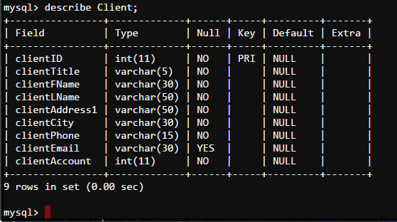

insert into Client (ClientID, ClientTitle, ClientFName, ClientLName, ClientAddress1, ClientCity, ClientPhone, ClientEmail, ClientAccount) values (1, 'Dr', 'Betty', 'Ramos', '7 Scofield Center', 'Ciodeng', '62-(710)629-7638', 'bramos0@plala.or.jp', '35280169');

insert into Client (ClientID, ClientTitle, ClientFName, ClientLName, ClientAddress1, ClientCity, ClientPhone, ClientEmail, ClientAccount) values (2, 'Mrs', 'Sharon', 'Mason', '701 Westend Lane', 'Bagan', '7-(754)573-3186', 'smason1@wunderground.com', '50484373');

insert into Client (ClientID, ClientTitle, ClientFName, ClientLName, ClientAddress1, ClientCity, ClientPhone, ClientEmail, ClientAccount) values (3, 'Dr', 'Steven', 'Kennedy', '15 Farragut Court', 'Watthana Nakhon', '66-(586)958-4034', 'skennedy2@washingtonpost.com', '49118648');

insert into Client (ClientID, ClientTitle, ClientFName, ClientLName, ClientAddress1, ClientCity, ClientPhone, ClientEmail, ClientAccount) values (4, 'Mrs', 'Howard', 'Montgomery', '1202 Commercial Circle', 'Mashi', '234-(188)190-3475', 'hmontgomery3@skyrock.com', '63846150');

insert into Client (ClientID, ClientTitle, ClientFName, ClientLName, ClientAddress1, ClientCity, ClientPhone, ClientEmail, ClientAccount) values (5, 'Ms', 'Tina', 'Ford', '5 Linden Point', 'Kolwezi', '242-(684)991-7982', 'tford4@biblegateway.com', '35323365');

insert into Client (ClientID, ClientTitle, ClientFName, ClientLName, ClientAddress1, ClientCity, ClientPhone, ClientEmail, ClientAccount) values (6, 'Mrs', 'Lawrence', 'Hill', '6403 Springs Park', 'Sandvika', '47-(391)602-6740', 'lhill5@shareasale.com', '63984459');

insert into Client (ClientID, ClientTitle, ClientFName, ClientLName, ClientAddress1, ClientCity, ClientPhone, ClientEmail, ClientAccount) values (7, 'Ms', 'Willie', 'Henderson', '157 Kim Alley', 'Quận Phú Nhuận', '84-(335)805-5312', 'whenderson6@homestead.com', '35636288');

insert into Client (ClientID, ClientTitle, ClientFName, ClientLName, ClientAddress1, ClientCity, ClientPhone, ClientEmail, ClientAccount) values (8, 'Mr', 'Roger', 'Wells', '0 Dayton Park', 'Castres', '33-(681)487-8162', 'rwells7@google.com.hk', '36959902');

insert into Client (ClientID, ClientTitle, ClientFName, ClientLName, ClientAddress1, ClientCity, ClientPhone, ClientEmail, ClientAccount) values (9, 'Mrs', 'Wayne', 'Hughes', '0 Independence Place', 'Tomelilla', '46-(951)694-9168', 'whughes8@hc360.com', '50382098');

insert into Client (ClientID, ClientTitle, ClientFName, ClientLName, ClientAddress1, ClientCity, ClientPhone, ClientEmail, ClientAccount) values (10, 'Mrs', 'Tammy', 'Ellis', '7311 Crescent Oaks Parkway', 'Taipa', '64-(349)215-5178', 'tellis9@goodreads.com', '51001751');

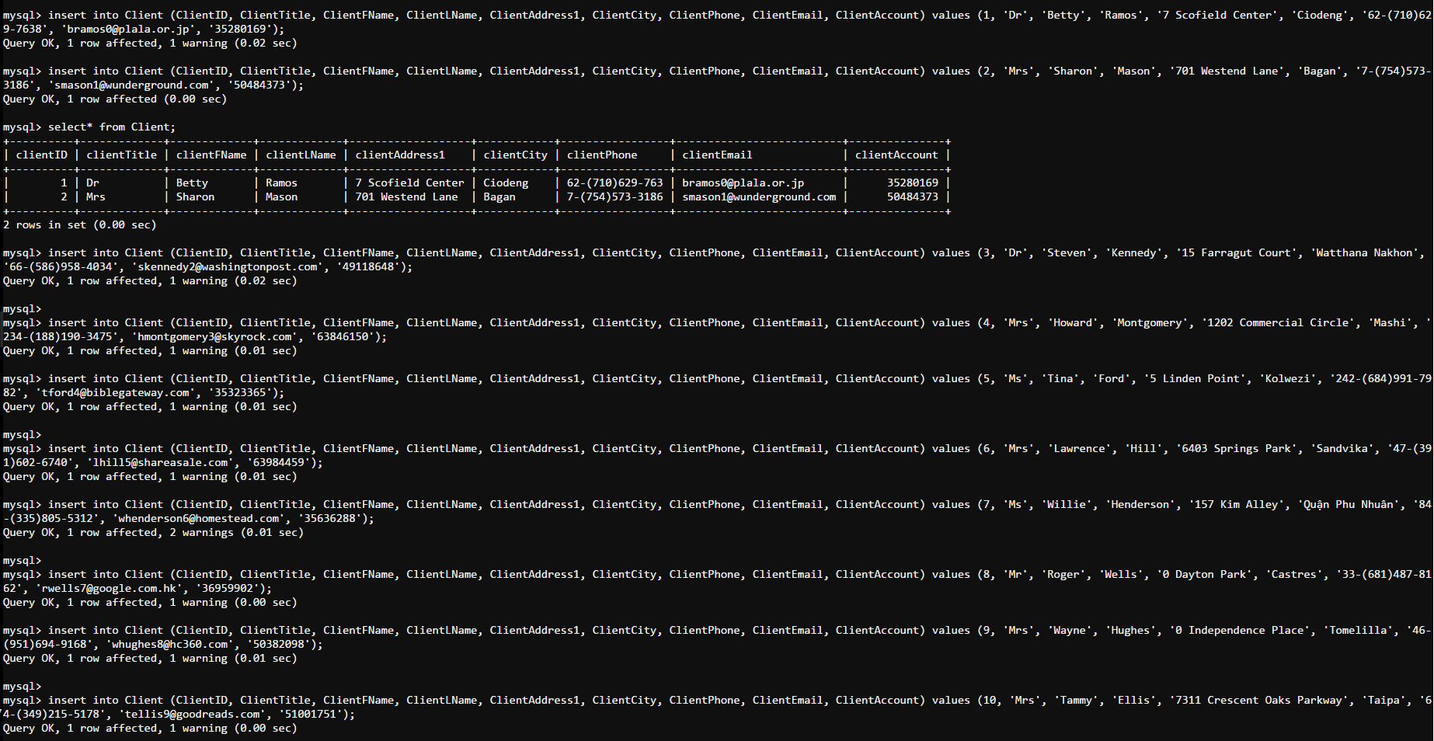

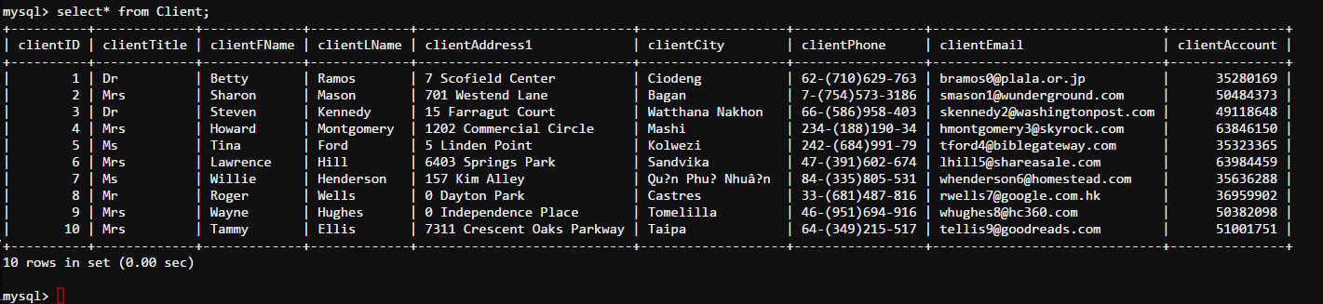Select* from Client;

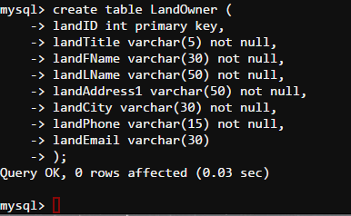

create table LandOwner (

landID int primary key,

landTitle varchar(5) not null,

landFName varchar(30) not null,

landLName varchar(50) not null,

landAddress1 varchar(50) not null,

landCity varchar(30) not null,

landPhone varchar(15) not null,

landEmail varchar(30)

);

describe LandOwner;

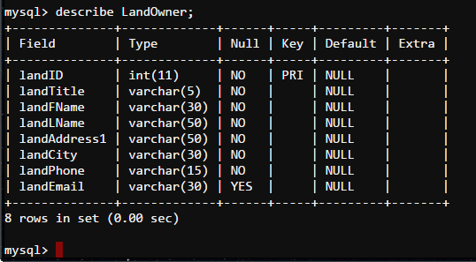

insert into LandOwner (landID, landTitle, landFName, landLName, landAddress1, landCity, landPhone, landEmail) values (1, 'Dr', 'Anne', 'Gonzalez', '0 Ridgeview Place', 'Eydhafushi', '960-(694)252-4370', 'agonzalez0@huffingtonpost.com');

insert into LandOwner (landID, landTitle, landFName, landLName, landAddress1, landCity, landPhone, landEmail) values (2, 'Mr', 'Anne', 'Arnold', '6663 Clemons Road', 'Tianjiaba', '86-(633)755-8231', 'aarnold1@hhs.gov');

insert into LandOwner (landID, landTitle, landFName, landLName, landAddress1, landCity, landPhone, landEmail) values (3, 'Mr', 'Cynthia', 'Lewis', '58 Mayfield Junction', 'Boden', '46-(748)357-9645', 'clewis2@eepurl.com');

insert into LandOwner (landID, landTitle, landFName, landLName, landAddress1, landCity, landPhone, landEmail) values (4, 'Mrs', 'Sean', 'Clark', '5 Carpenter Drive', 'Kuniran', '62-(744)677-0605', 'sclark3@godaddy.com');

insert into LandOwner (landID, landTitle, landFName, landLName, landAddress1, landCity, landPhone, landEmail) values (5, 'Mr', 'Michelle', 'Reyes', '88126 Schmedeman Hill', 'Omutninsk', '7-(447)505-0939', 'mreyes4@slashdot.org');

insert into LandOwner (landID, landTitle, landFName, landLName, landAddress1, landCity, landPhone, landEmail) values (6, 'Dr', 'Stephanie', 'Watson', '68841 Riverside Center', 'Giồng Riềng', '84-(627)686-5240', 'swatson5@flavors.me');

insert into LandOwner (landID, landTitle, landFName, landLName, landAddress1, landCity, landPhone, landEmail) values (7, 'Mr', 'Carolyn', 'Powell', '319 Thierer Plaza', 'San Agustin', '52-(983)754-4808', 'cpowell6@indiatimes.com');

insert into LandOwner (landID, landTitle, landFName, landLName, landAddress1, landCity, landPhone, landEmail) values (8, 'Dr', 'Steve', 'Arnold', '6418 Derek Parkway', 'Nanshui', '86-(703)755-3611', 'sarnold7@dagondesign.com');

insert into LandOwner (landID, landTitle, landFName, landLName, landAddress1, landCity, landPhone, landEmail) values (9, 'Mr', 'Fred', 'Castillo', '1 Truax Park', 'Cerrillos', '54-(591)214-3960', 'fcastillo8@google.fr');

insert into LandOwner (landID, landTitle, landFName, landLName, landAddress1, landCity, landPhone, landEmail) values (10, 'Ms', 'Robert', 'Sanders', '15998 Daystar Trail', 'Ágios Spyrídon', '30-(918)816-9089', 'rsanders9@altervista.org');

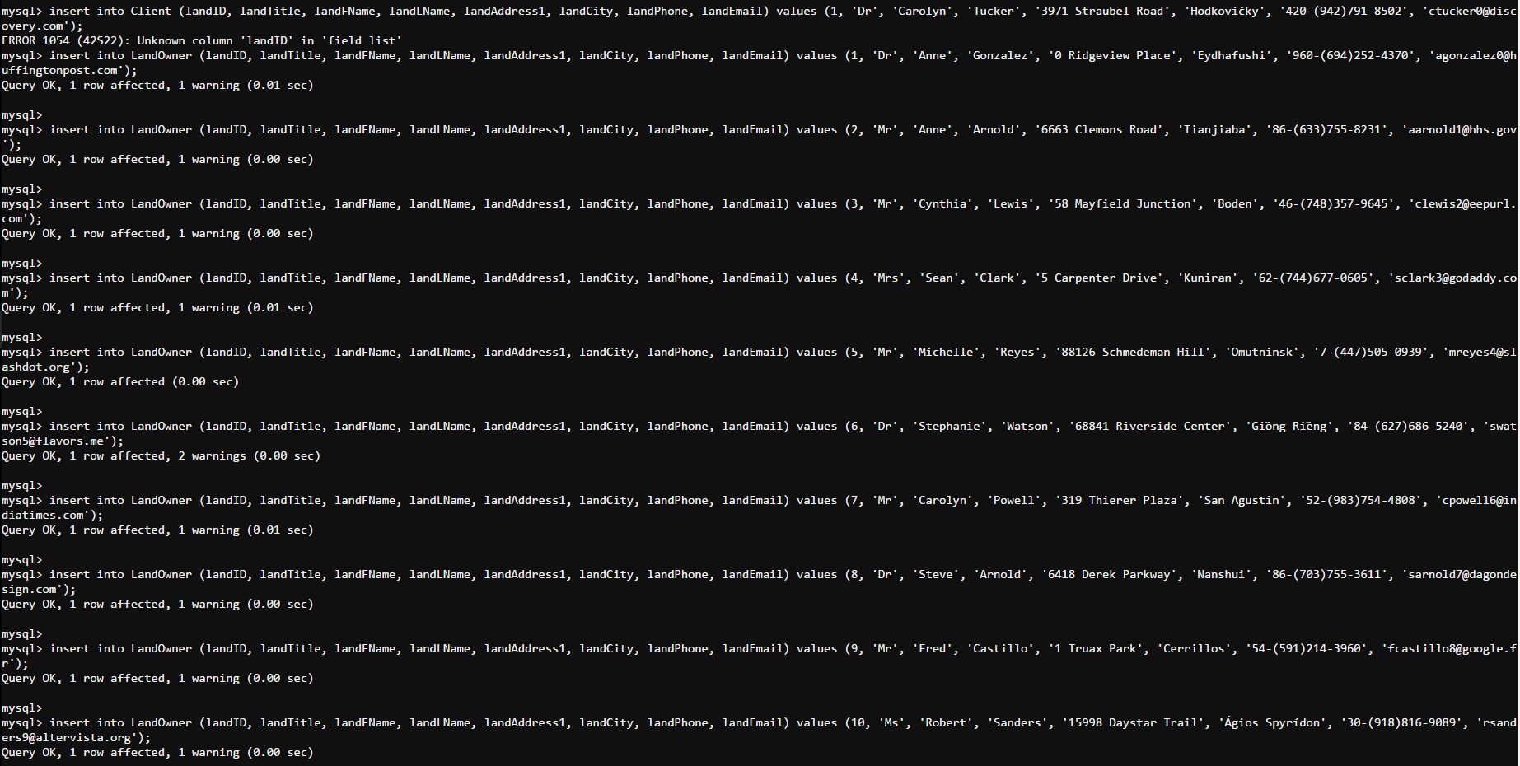

select* from LandOwner;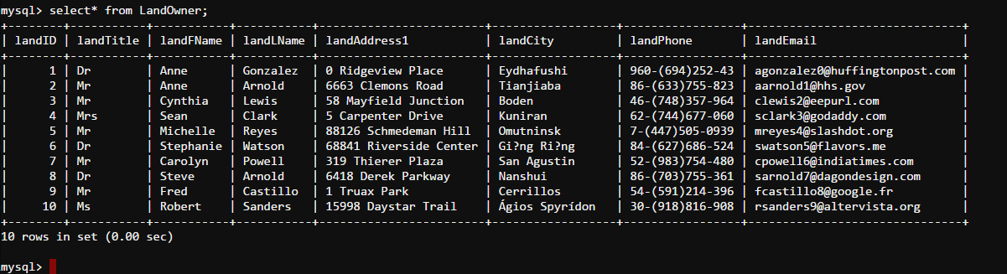

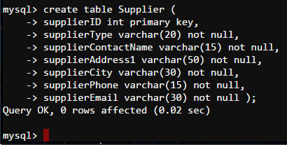

create table Supplier (

supplierID int primary key,

supplierType varchar(20) not null,

supplierContactName varchar(15) not null,

supplierAddress1 varchar(50) not null,

supplierCity varchar(30) not null,

supplierPhone varchar(15) not null,

supplierEmail varchar(30) not null );

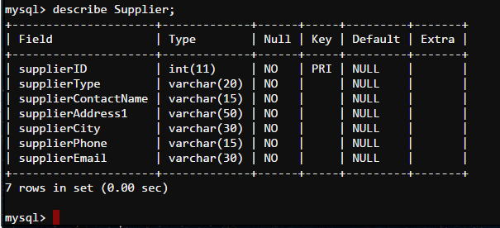describe Supplier;

insert into Supplier (supplierID, supplierType, supplierContactName, supplierAddress1, supplierCity, supplierPhone, supplierEmail) values (1, 'Agency', 'Lawrence', '674 Eggendart Point', 'Lešná', '420-(280)290-4486', 'lhicks0@intel.com');

insert into Supplier (supplierID, supplierType, supplierContactName, supplierAddress1, supplierCity, supplierPhone, supplierEmail) values (2, 'Accommodation', 'Ronald', '0 Portage Trail', 'Picton', '64-(335)248-0172', 'rlopez1@skype.com');

insert into Supplier (supplierID, supplierType, supplierContactName, supplierAddress1, supplierCity, supplierPhone, supplierEmail) values (3, 'Water', 'Henry', '11 Golden Leaf Hill', 'Laascaanood', '252-(465)909-6489', 'hperry2@accuweather.com');

insert into Supplier (supplierID, supplierType, supplierContactName, supplierAddress1, supplierCity, supplierPhone, supplierEmail) values (4, 'Food', 'Harry', '967 Fairfield Way', 'Beloye', '7-(615)743-1157', 'hshaw3@oaic.gov.au');

insert into Supplier (supplierID, supplierType, supplierContactName, supplierAddress1, supplierCity, supplierPhone, supplierEmail) values (5, 'Water', 'Adam', '1183 Straubel Way', 'Javarthushuu', '976-(745)452-6018', 'ahansen4@qq.com');

insert into Supplier (supplierID, supplierType, supplierContactName, supplierAddress1, supplierCity, supplierPhone, supplierEmail) values (6, 'Merchandise', 'Eric', '97647 Westerfield Court', 'Nida', '370-(611)310-8408', 'edean5@shareasale.com');

insert into Supplier (supplierID, supplierType, supplierContactName, supplierAddress1, supplierCity, supplierPhone, supplierEmail) values (7, 'Food', 'Heather', '6 Spaight Terrace', 'Agrela', '351-(805)768-5221', 'hhansen6@paginegialle.it');

insert into Supplier (supplierID, supplierType, supplierContactName, supplierAddress1, supplierCity, supplierPhone, supplierEmail) values (8, 'Agency', 'Anna', '96 Haas Junction', 'Linköping', '46-(276)339-5605', 'agriffin7@twitter.com');

insert into Supplier (supplierID, supplierType, supplierContactName, supplierAddress1, supplierCity, supplierPhone, supplierEmail) values (9, 'Accommodation ', 'Scott', '2 Laurel Park', 'Rochester', '1-(315)795-7454', 'ssimpson8@prweb.com');

insert into Supplier (supplierID, supplierType, supplierContactName, supplierAddress1, supplierCity, supplierPhone, supplierEmail) values (10, 'Merchandise', 'Brian', '47 American Road', 'Hezhang', '86-(141)650-5492', 'bbrown9@so-net.ne.jp');

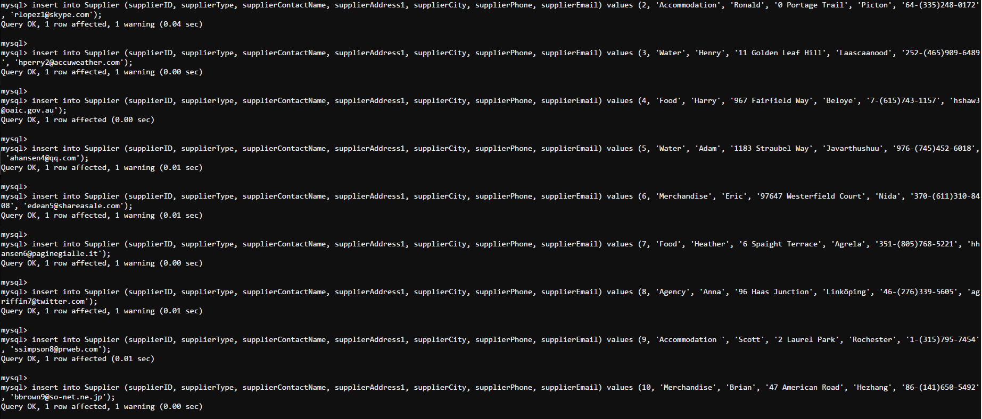

select* from Supplier;

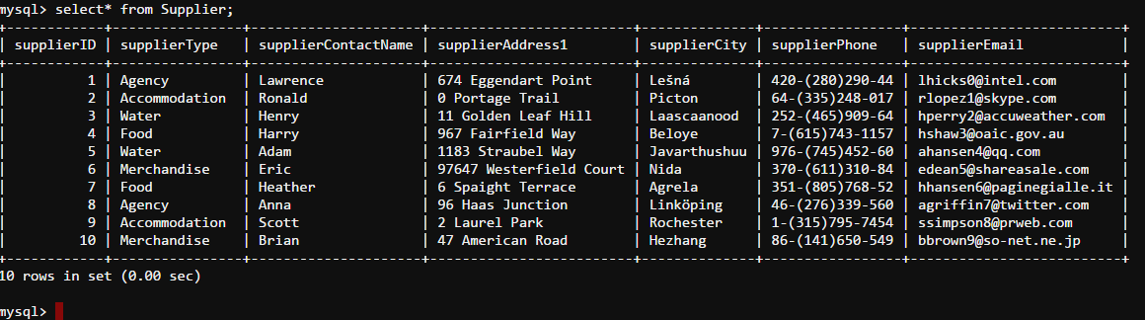

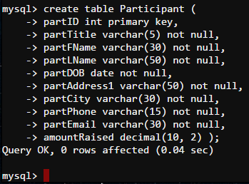

create table Participant (

partID int primary key,

partTitle varchar(5) not null,

partFName varchar(30) not null,

partLName varchar(50) not null,

partDOB date not null,

partAddress1 varchar(50) not null,

partCity varchar(30) not null,

partPhone varchar(15) not null,

partEmail varchar(30) not null,

amountRaised decimal(10, 2) );

describe Participant;

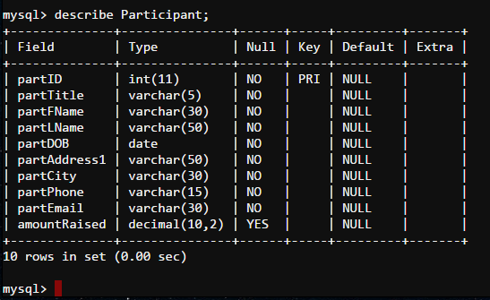

insert into Participant (partID, partTitle, partFName, partLName, partDOB, partAddress1, partCity, partPhone, partEmail, amountRaised) values (1, 'Mr', 'Sharon', 'Brown', '2008-04-09', '00 Mesta Junction', 'Kamenka', '7-(423)714-0342', 'sbrown0@cbslocal.com', 247);

insert into Participant (partID, partTitle, partFName, partLName, partDOB, partAddress1, partCity, partPhone, partEmail, amountRaised) values (2, 'Ms', 'Kevin', 'Moore', '1999-11-20', '9 Cardinal Street', 'Aguilar', '63-(456)711-5948', 'kmoore1@unc.edu', 184);

insert into Participant (partID, partTitle, partFName, partLName, partDOB, partAddress1, partCity, partPhone, partEmail, amountRaised) values (3, 'Mr', 'Raymond', 'Fuller', '1999-11-24', '5 Mockingbird Street', 'El Tablón', '504-(715)968-5576', 'rfuller2@examiner.com', 410);

insert into Participant (partID, partTitle, partFName, partLName, partDOB, partAddress1, partCity, partPhone, partEmail, amountRaised) values (4, 'Mr', 'Andrew', 'Price', '2005-05-02', '76925 Forster Alley', 'Fengjia', '86-(178)394-6879', 'aprice3@eventbrite.com', 153);

insert into Participant (partID, partTitle, partFName, partLName, partDOB, partAddress1, partCity, partPhone, partEmail, amountRaised) values (5, 'Dr', 'Jimmy', 'Cook', '2006-12-13', '8 Dunning Pass', 'La Floresta', '598-(518)375-2591', 'jcook4@un.org', 232);

insert into Participant (partID, partTitle, partFName, partLName, partDOB, partAddress1, partCity, partPhone, partEmail, amountRaised) values (6, 'Ms', 'Charles', 'Stevens', '2009-07-06', '577 Jay Alley', 'Lete', '62-(288)402-1512', 'cstevens5@zimbio.com', 254);

insert into Participant (partID, partTitle, partFName, partLName, partDOB, partAddress1, partCity, partPhone, partEmail, amountRaised) values (7, 'Mrs', 'Keith', 'Butler', '1994-05-25', '53184 Mesta Parkway', 'Libas', '63-(719)715-6896', 'kbutler6@purevolume.com', 345);

insert into Participant (partID, partTitle, partFName, partLName, partDOB, partAddress1, partCity, partPhone, partEmail, amountRaised) values (8, 'Ms', 'Juan', 'Torres', '2010-02-07', '2 Johnson Crossing', 'Inya', '7-(575)510-8665', 'jtorres7@360.cn', 297);

insert into Participant (partID, partTitle, partFName, partLName, partDOB, partAddress1, partCity, partPhone, partEmail, amountRaised) values (9, 'Mrs', 'Walter', 'Mills', '2002-04-02', '5 Dryden Parkway', 'Mairana', '591-(631)464-2026', 'wmills8@ning.com', 111);

insert into Participant (partID, partTitle, partFName, partLName, partDOB, partAddress1, partCity, partPhone, partEmail, amountRaised) values (10, 'Mrs', 'Terry', 'Simpson', '2001-03-11', '181 Donald Court', 'Guaratinguetá', '55-(534)323-8268', 'tsimpson9@sohu.com', 113);

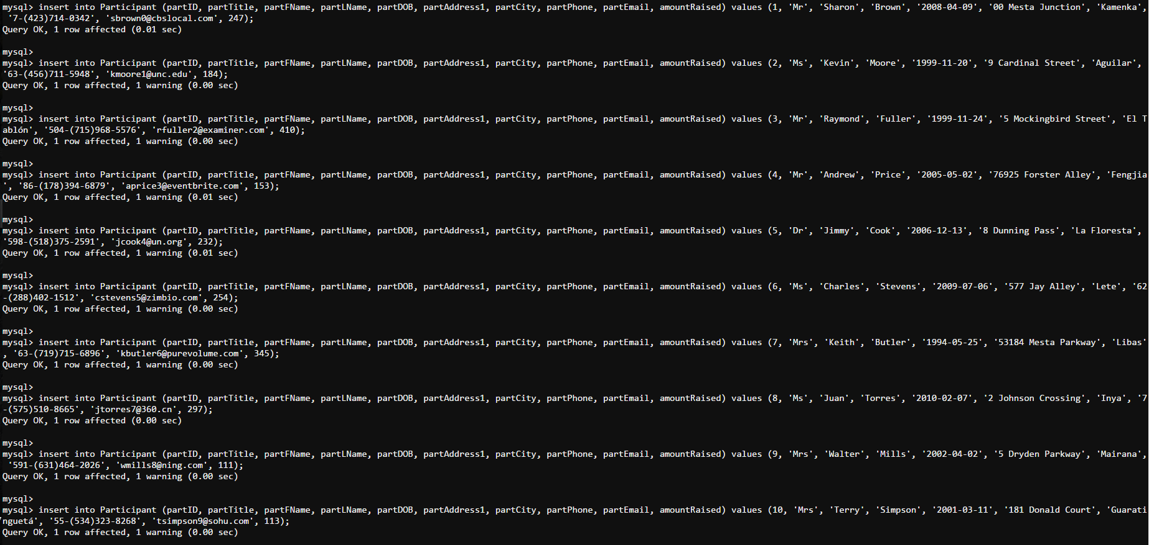

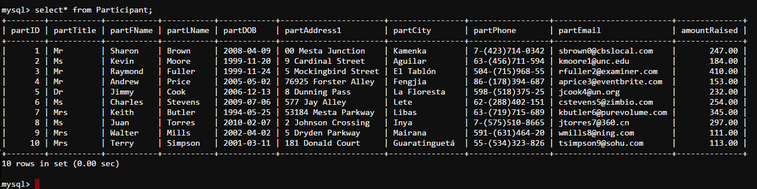select* from Participant;

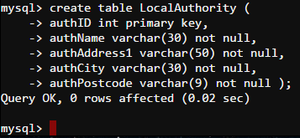



create table LocalAuthority (

authID int primary key,

authName varchar(30) not null,

authAddress1 varchar(50) not null,

authCity varchar(30) not null,

authPostcode varchar(9) not null );

describe LocalAuthority;

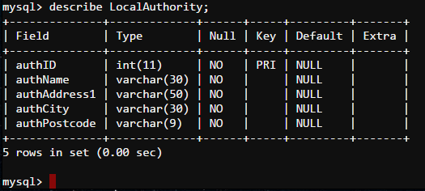

insert into LocalAuthority (authID, authName, authAddress1, authCity, authPostcode) values (1, 'Christina', 'Gale', 'Taquaritinga', 'CM24 8WD');

insert into LocalAuthority (authID, authName, authAddress1, authCity, authPostcode) values (2, 'Kimberly', 'Browning', 'Kansas City', 'DHR4 6HL');

insert into LocalAuthority (authID, authName, authAddress1, authCity, authPostcode) values (3, 'Betty', 'Marquette', 'Fenglin', 'N1G1 1SF');

insert into LocalAuthority (authID, authName, authAddress1, authCity, authPostcode) values (4, 'Justin', 'Summerview', 'Leninsk', 'BN32 OHX');

insert into LocalAuthority (authID, authName, authAddress1, authCity, authPostcode) values (5, 'Nicholas', 'Riverside', 'Sungaipuntik', 'FKT2 OHX');

insert into LocalAuthority (authID, authName, authAddress1, authCity, authPostcode) values (6, 'Albert', 'Petterle', 'Banjar Pande', 'LDL8 2DH');

insert into LocalAuthority (authID, authName, authAddress1, authCity, authPostcode) values (7, 'Dennis', 'Montana', 'Rāmhormoz', 'BRQ1 3JJ');

insert into LocalAuthority (authID, authName, authAddress1, authCity, authPostcode) values (8, 'Gary', 'Walton', 'Bielawa', 'CBB6 3PT');

insert into LocalAuthority (authID, authName, authAddress1, authCity, authPostcode) values (9, 'Earl', 'Toban', 'Izyaslav', 'EHT1 1BB');

insert into LocalAuthority (authID, authName, authAddress1, authCity, authPostcode) values (10, 'Kelly', 'Pine View', 'Kingscourt', 'N812 5JL');

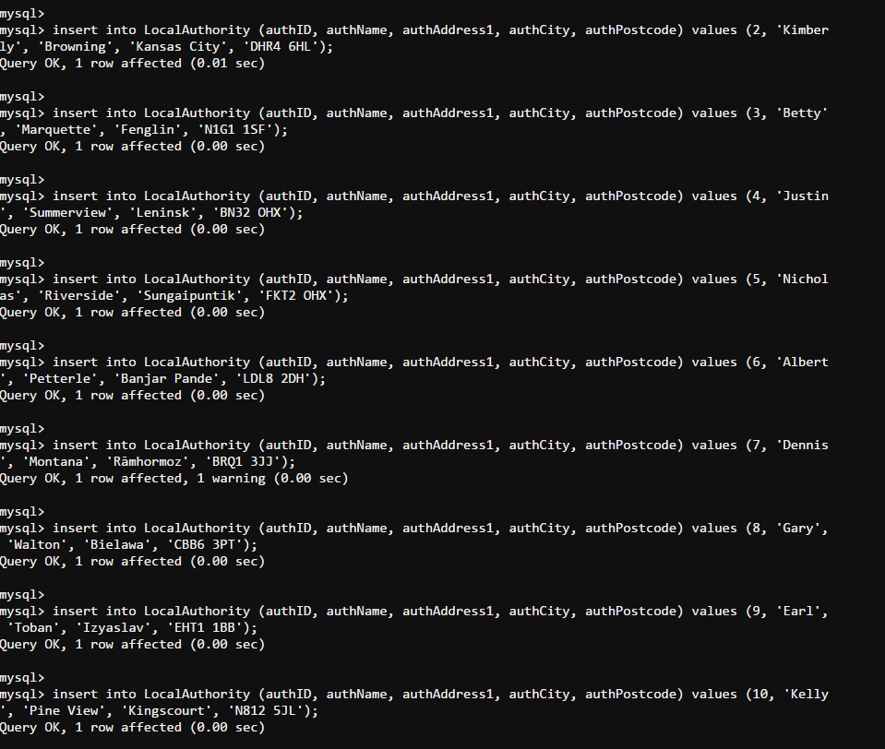

select* from LocalAuthority;

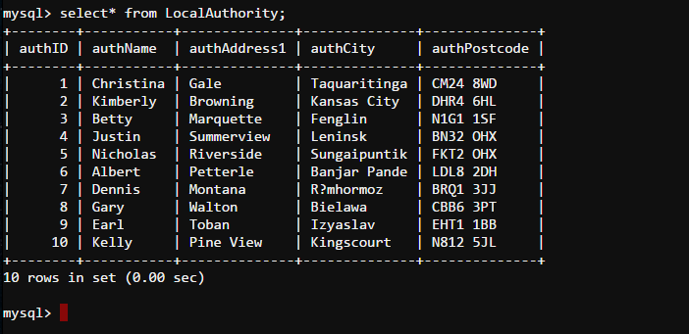

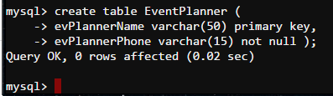

create table EventPlanner (

evPlannerName varchar(50) primary key,

evPlannerPhone varchar(15) not null );

describe Eventplanner;

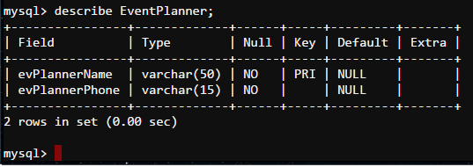

insert into EventPlanner (evPlannerName, evPlannerPhone) values ('Billy', '86-(896)411-8887');

insert into EventPlanner (evPlannerName, evPlannerPhone) values ('David', '504-(493)333-1356');

insert into EventPlanner (evPlannerName, evPlannerPhone) values ('Bruce', '260-(756)574-2861');

insert into EventPlanner (evPlannerName, evPlannerPhone) values ('Jean', '52-(689)280-7353');

insert into EventPlanner (evPlannerName, evPlannerPhone) values ('Walter', '62-(458)944-4414');

insert into EventPlanner (evPlannerName, evPlannerPhone) values ('Howard', '86-(825)564-2249');

insert into EventPlanner (evPlannerName, evPlannerPhone) values ('Amy', '33-(746)628-9587');

insert into EventPlanner (evPlannerName, evPlannerPhone) values ('Jeremy', '60-(974)632-2266');

insert into EventPlanner (evPlannerName, evPlannerPhone) values ('Joshua', '351-(337)924-1285');

insert into EventPlanner (evPlannerName, evPlannerPhone) values ('Linda', '7-(981)275-3397');

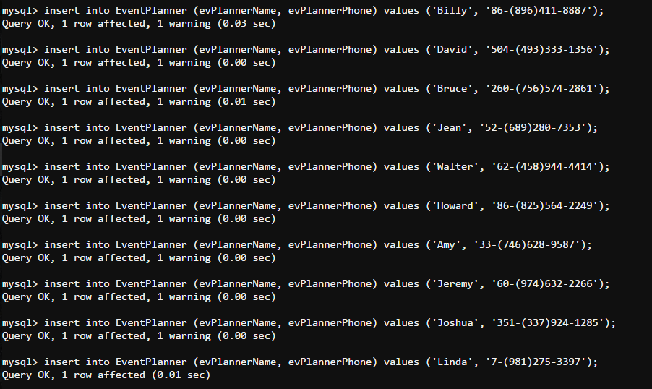

select* from EventPlanner;

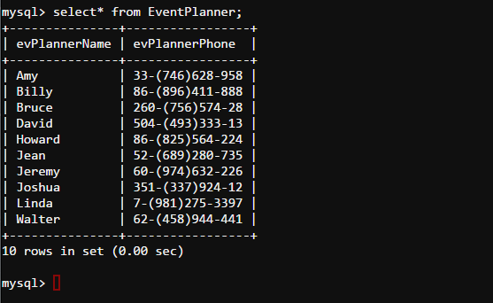

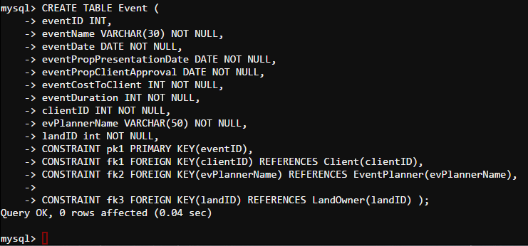

CREATE TABLE Event (

eventID INT,

eventName VARCHAR(30) NOT NULL,

eventDate DATE NOT NULL,

eventPropPresentationDate DATE NOT NULL,

eventPropClientApproval DATE NOT NULL,

eventCostToClient INT NOT NULL,

eventDuration INT NOT NULL,

clientID INT NOT NULL,

evPlannerName VARCHAR(50) NOT NULL,

landID int NOT NULL,

CONSTRAINT pk1 PRIMARY KEY(eventID),

CONSTRAINT fk1 FOREIGN KEY(clientID) REFERENCES Client(clientID),

CONSTRAINT fk2 FOREIGN KEY(evPlannerName) REFERENCES EventPlanner(evPlannerName),

CONSTRAINT fk3 FOREIGN KEY(landID) REFERENCES LandOwner(landID) );

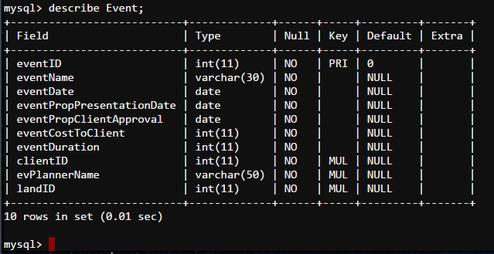describe Event;

insert into Event (eventID, eventName, eventDate, eventPropPresentationDate, eventPropClientApproval, eventCostToClient, eventDuration, clientID, evPlannerName, landID) values (1, 'Brian', '2017-01-04', '2016-10-01', '2016-12-10', 649, 4, 1, 'Amy', 1);

insert into Event (eventID, eventName, eventDate, eventPropPresentationDate, eventPropClientApproval, eventCostToClient, eventDuration, clientID, evPlannerName, landID) values (2, 'Justin', '2017-01-10', '2016-09-10', '2016-07-16', 262, 3, 2, 'Billy', 2);

insert into Event (eventID, eventName, eventDate, eventPropPresentationDate, eventPropClientApproval, eventCostToClient, eventDuration, clientID, evPlannerName, landID) values (3, 'Melissa', '2016-11-30', '2016-11-04', '2016-09-10', 230, 3, 3, 'Bruce', 3);

insert into Event (eventID, eventName, eventDate, eventPropPresentationDate, eventPropClientApproval, eventCostToClient, eventDuration, clientID, evPlannerName, landID) values (4, 'Juan', '2016-10-10', '2016-08-08', '2017-03-21', 757, 2, 4, 'David', 4);

insert into Event (eventID, eventName, eventDate, eventPropPresentationDate, eventPropClientApproval, eventCostToClient, eventDuration, clientID, evPlannerName, landID) values (5, 'Amy', '2016-09-24', '2016-10-23', '2017-01-08', 420, 1, 5, 'Howard', 5);

insert into Event (eventID, eventName, eventDate, eventPropPresentationDate, eventPropClientApproval, eventCostToClient, eventDuration, clientID, evPlannerName, landID) values (6, 'Martha', '2016-10-20', '2016-10-14', '2016-09-08', 958, 1, 6, 'Jean', 6);

insert into Event (eventID, eventName, eventDate, eventPropPresentationDate, eventPropClientApproval, eventCostToClient, eventDuration, clientID, evPlannerName, landID) values (7, 'Brandon', '2016-12-22', '2016-11-02', '2016-08-20', 370, 2, 7, 'Jeremy', 7);

insert into Event (eventID, eventName, eventDate, eventPropPresentationDate, eventPropClientApproval, eventCostToClient, eventDuration, clientID, evPlannerName, landID) values (8, 'Jennifer', '2016-05-19', '2016-06-03', '2016-07-14', 380, 4, 8, 'Joshua', 8);

insert into Event (eventID, eventName, eventDate, eventPropPresentationDate, eventPropClientApproval, eventCostToClient, eventDuration, clientID, evPlannerName, landID) values (9, 'Walter', '2017-01-06', '2016-08-07', '2016-10-29', 976, 5, 9, 'Linda', 9);

insert into Event (eventID, eventName, eventDate, eventPropPresentationDate, eventPropClientApproval, eventCostToClient, eventDuration, clientID, evPlannerName, landID) values (10, 'Emily', '2016-10-08', '2016-10-25', '2016-09-11', 230, 2, 10, 'Walter', 10);

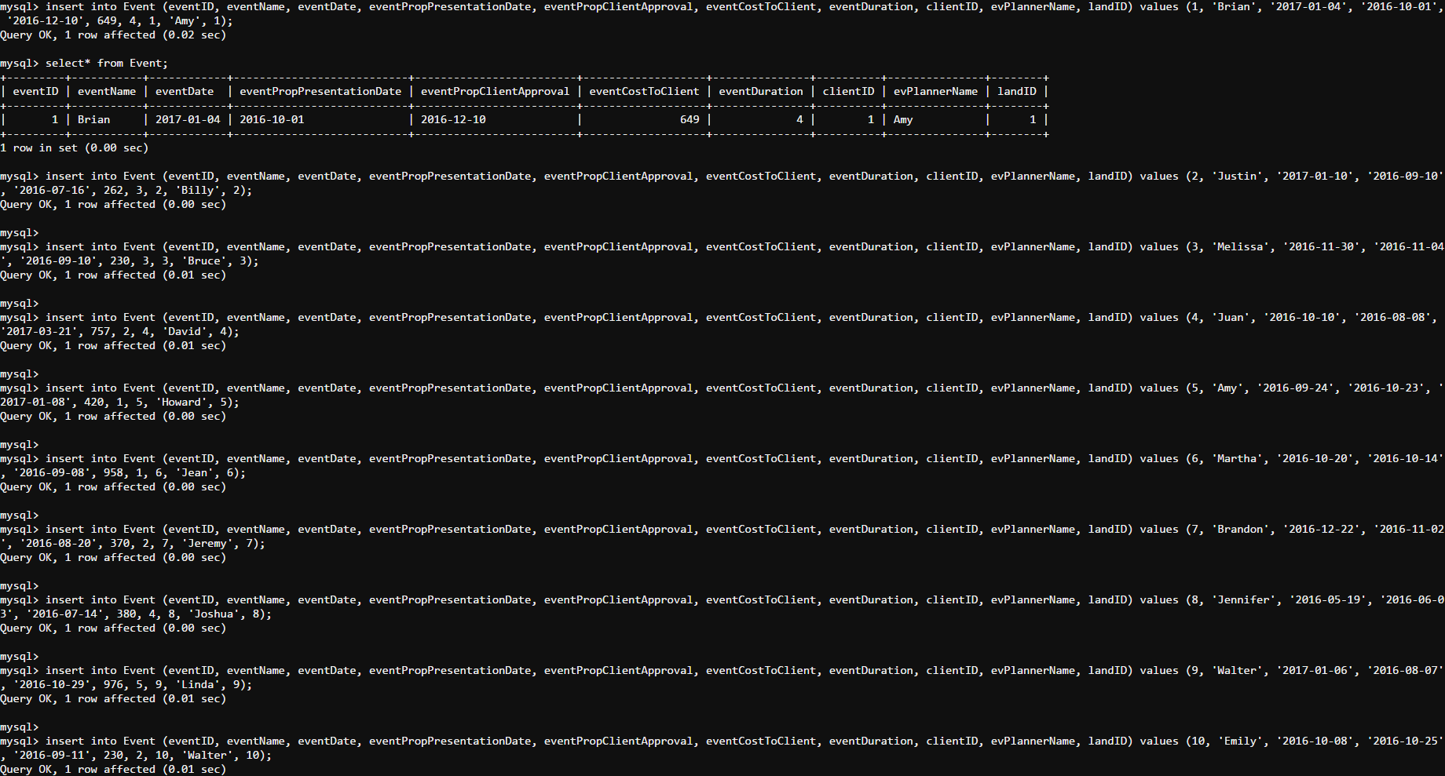

select* from Event;

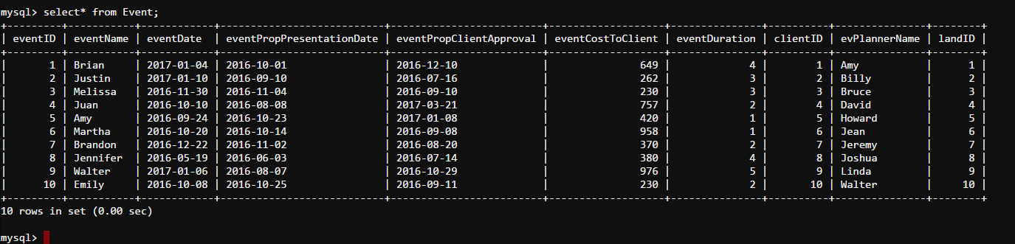

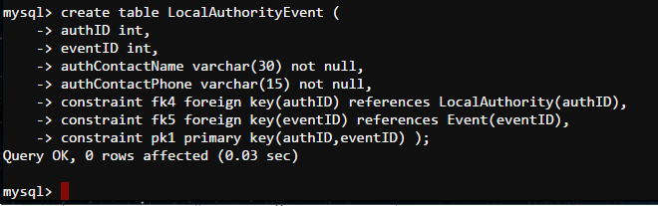

create table LocalAuthorityEvent (

authID int,

eventID int,

authContactName varchar(30) not null,

authContactPhone varchar(15) not null,

constraint fk4 foreign key(authID) references LocalAuthority(authID),

constraint fk5 foreign key(eventID) references Event(eventID),

constraint pk1 primary key(authID,eventID) );

describe LocalAuthorityEvent;

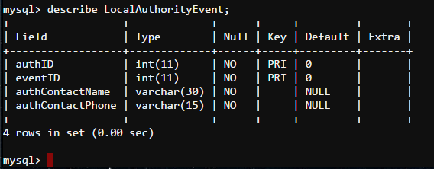

insert into LocalAuthorityEvent (authID, eventID, authContactName, authContactPhone) values (1, 1, 'Christina', '86-(400)352-7765');

insert into LocalAuthorityEvent (authID, eventID, authContactName, authContactPhone) values (2, 2, 'Kimberly', '64-(110)674-3165');

insert into LocalAuthorityEvent (authID, eventID, authContactName, authContactPhone) values (3, 3, 'Betty', '52-(572)995-5314');

insert into LocalAuthorityEvent (authID, eventID, authContactName, authContactPhone) values (4, 4, 'Justin', '51-(838)244-4853');

insert into LocalAuthorityEvent (authID, eventID, authContactName, authContactPhone) values (5, 5, 'Nicholas', '1-(720)915-9837');

insert into LocalAuthorityEvent (authID, eventID, authContactName, authContactPhone) values (6, 6, 'Albert', '62-(747)699-8640');

insert into LocalAuthorityEvent (authID, eventID, authContactName, authContactPhone) values (7, 7, 'Dennis', '242-(771)497-6881');

insert into LocalAuthorityEvent (authID, eventID, authContactName, authContactPhone) values (8, 8, 'Gary', '86-(699)399-8945');

insert into LocalAuthorityEvent (authID, eventID, authContactName, authContactPhone) values (9, 9, 'Earl', '63-(549)823-7995');

insert into LocalAuthorityEvent (authID, eventID, authContactName, authContactPhone) values (10, 10, 'Kelly', '86-(815)710-2569');

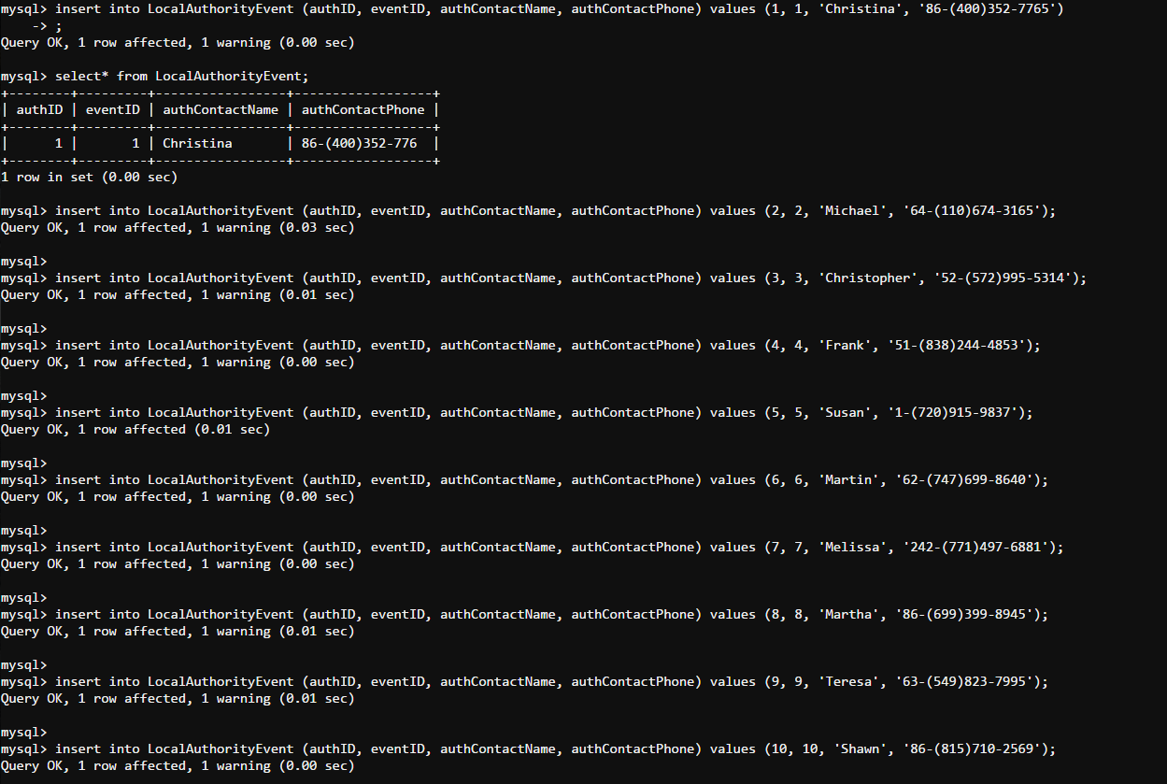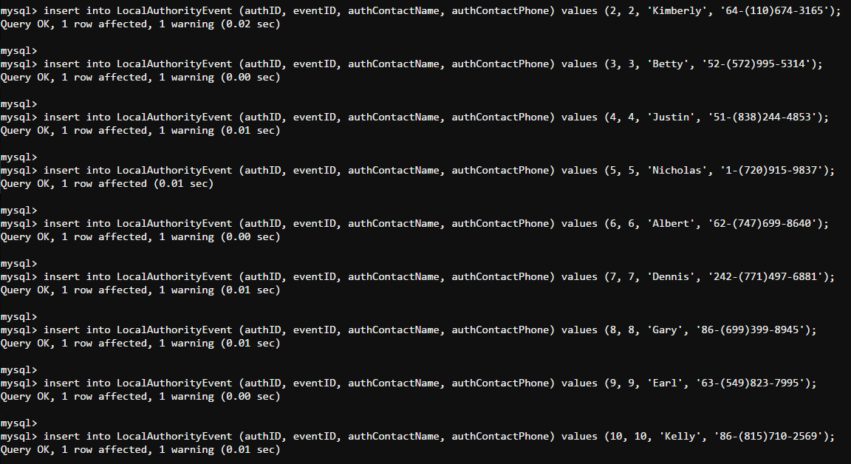

select* from LocalAuthorutyEvent;

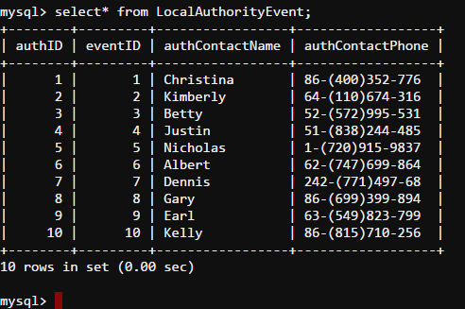

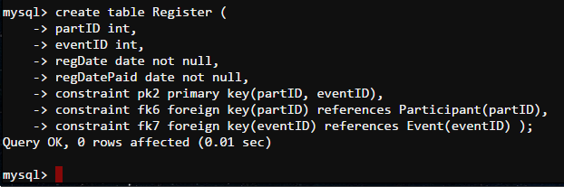

create table Register (

partID int,

eventID int,

regDate date not null,

regDatePaid date not null,

constraint pk2 primary key(partID, eventID),

constraint fk6 foreign key(partID) references Participant(partID),

constraint fk7 foreign key(eventID) references Event(eventID) );

describe Register;

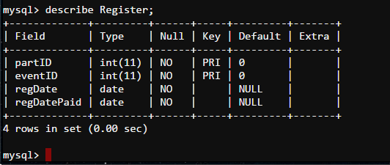

insert into Register (partID, eventID, regDate, regDatePaid) values (1, 1, '2016-06-19', '2017-02-12');

insert into Register (partID, eventID, regDate, regDatePaid) values (2, 2, '2016-09-16', '2017-03-07');

insert into Register (partID, eventID, regDate, regDatePaid) values (3, 3, '2016-05-21', '2016-07-13');

insert into Register (partID, eventID, regDate, regDatePaid) values (4, 4, '2016-11-19', '2016-04-23');

insert into Register (partID, eventID, regDate, regDatePaid) values (5, 5, '2016-03-31', '2016-11-01');

insert into Register (partID, eventID, regDate, regDatePaid) values (6, 6, '2016-08-04', '2016-11-12');

insert into Register (partID, eventID, regDate, regDatePaid) values (7, 7, '2017-03-23', '2016-08-22');

insert into Register (partID, eventID, regDate, regDatePaid) values (8, 8, '2017-01-11', '2016-12-21');

insert into Register (partID, eventID, regDate, regDatePaid) values (9, 9, '2016-05-23', '2016-09-07');

insert into Register (partID, eventID, regDate, regDatePaid) values (10, 10, '2016-07-25', '2016-11-28');

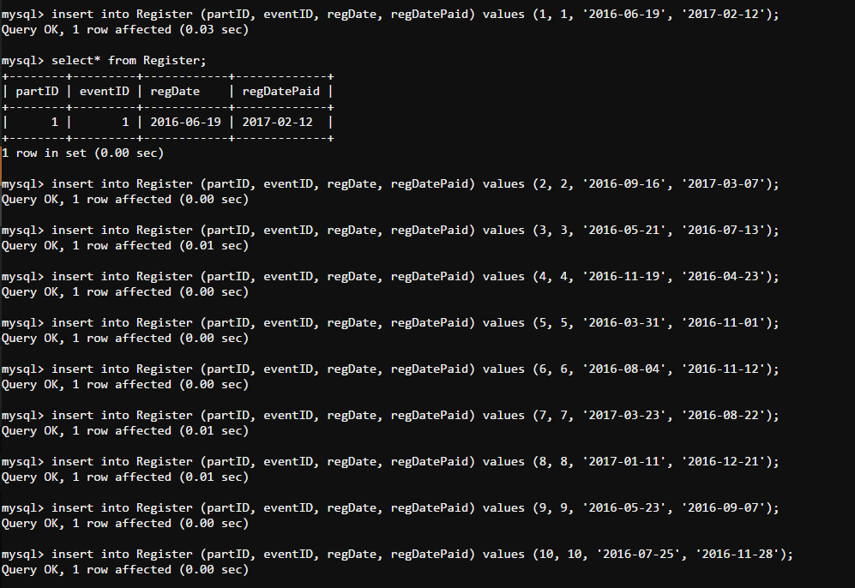

select* from Register;

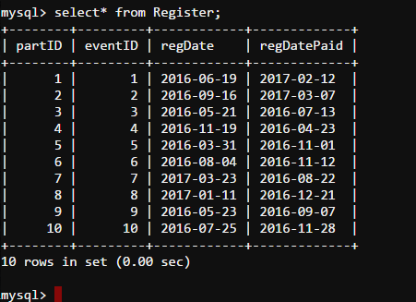

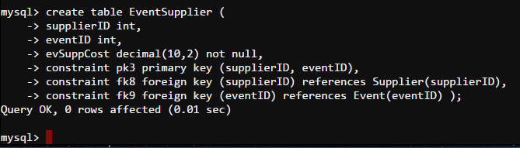

create table EventSupplier (

supplierID int,

eventID int,

evSuppCost decimal(10,2) not null,

constraint pk3 primary key (supplierID, eventID),

constraint fk8 foreign key (supplierID) references Supplier(supplierID),

constraint fk9 foreign key (eventID) references Event(eventID) );

describe EventSupplier;

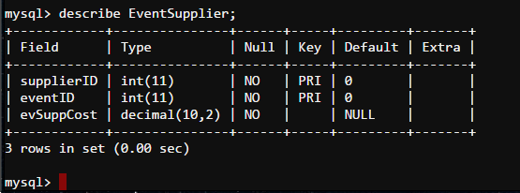

insert into EventSupplier (supplierID, eventID, evSuppCost) values (1, 1, 447.56);

insert into EventSupplier (supplierID, eventID, evSuppCost) values (2, 2, 470.47);

insert into EventSupplier (supplierID, eventID, evSuppCost) values (3, 3, 305.89);

insert into EventSupplier (supplierID, eventID, evSuppCost) values (4, 4, 265.25);

insert into EventSupplier (supplierID, eventID, evSuppCost) values (5, 5, 343.61);

insert into EventSupplier (supplierID, eventID, evSuppCost) values (6, 6, 362.4);

insert into EventSupplier (supplierID, eventID, evSuppCost) values (7, 7, 247.99);

insert into EventSupplier (supplierID, eventID, evSuppCost) values (8, 8, 262.0);

insert into EventSupplier (supplierID, eventID, evSuppCost) values (9, 9, 237.58);

insert into EventSupplier (supplierID, eventID, evSuppCost) values (10, 10, 474.12);

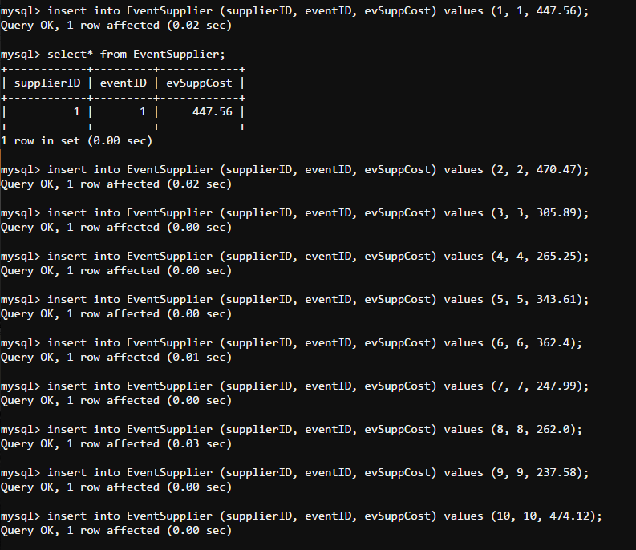

select* from EventSupplier;

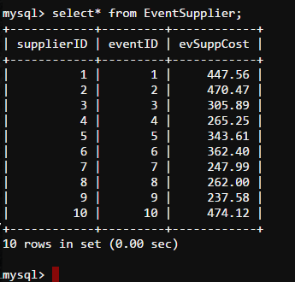

**Task 6: SQL Queries**

Description – if the company wants to know the specific Client city then they will need their first name.

Algebra - 𝚷 clientCity (𝝈 ClientFName=Betty (Client))

SQL – select clientCity

from Client

where ClientFName=”Betty”;

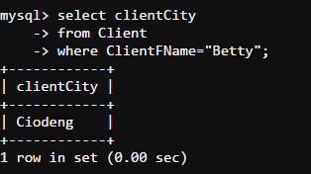

Description – if the company wants to know the cost of the event then they will need their eventID.

Algebra - 𝚷 clientCity (𝝈 ClientFName=Betty (Client))

SQL – select eventID, eventCostToClient

from Event

order by eventCostToClient desc;

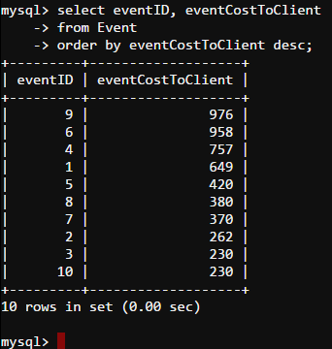

Description – if the company wants to know the specific cost for the specific client then they will need their contact deail.

Algebra - 𝚷 Event.eventID, Event.eventCostToClient, Client.clientPhone

SQL – select Event.eventID, Event.eventCostToClient, Client.clientPhone

from Event

Inner join Client on Event.ClientID=Client.clientID

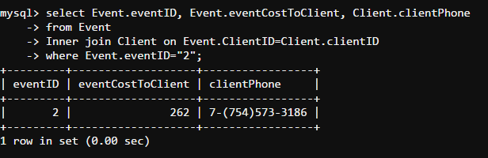 Where Event.eventID=”2”;

Description – if the company wants to contact a specific event they will need their eventID.

Algebra - 𝚷 Even.eventID, Event.eventDuration, LandOwner.landID, LandOwner.landFName, LandOwner.landLName

SQL – select Event.eventID, Event.eventDuration, LandOwner.landID, LandOwner.landFName , LandOwner.landLName

from Event

right join LandOwner on Event.landID = LandOwner.landID

order by Event.eventID;

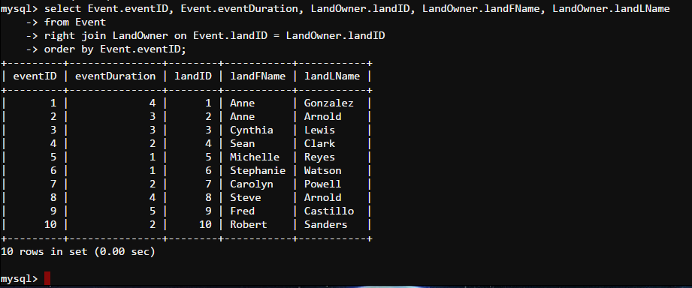

**Task 7: SQL Advanced Queries**

Description:

If the company wants to get contact details of all the past suppliers, then you can use the following sql.

SQL:

select Event.eventName, Event.eventDate, Supplier.supplierType, Supplier.supplierPhone, Supplier.supplierEmail

from Event inner join EventSupplier on (Event.eventID = EventSupplier.eventID) inner join Supplier on (EventSupplier.supplierID = Supplier.supplierID);

Screenshot:

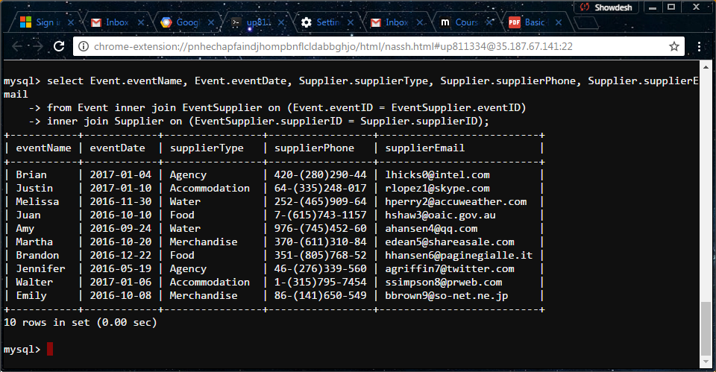

Description:

If the company wants to