Міністерство освіти і науки України

Національний лісотехнічний університет України

Кафедра інформаційних технологій

**Звіт до лабораторної роботи**

з навчальної дисципліни

**«Методи та засоби ООАП»**

**Виконав:**

студент групи КНС-21

Марущак С. І.

**Перевірив:**

Волинець Є.О.

Львів – 2024

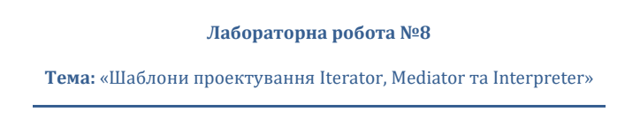



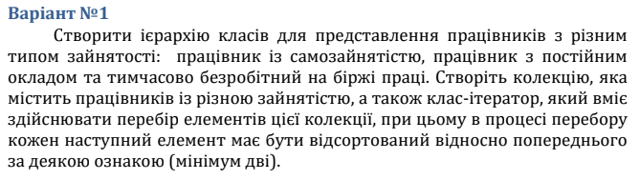

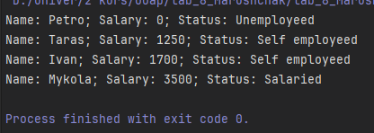

using System;  
using System.Collections.Generic;  
  
namespace lab_8_Marushchak  
{  
 class Employee  
 {  
 public string Name { get; set; }  
 public double Salary { get; set; }  
   
 public string Status { get; set; }  
  
 public Employee(string name, double salary)  
 {  
 Name = name;  
 Salary = salary;  
 }  
 }  
   
 class SelfEmployee : Employee  
 {  
 public SelfEmployee(string name, double salary) : base(name, salary)  
 {  
 Status = "Self employeed";  
 }  
   
 }  
   
 class SalariedEmployee: Employee  
 {  
 public SalariedEmployee(string name, double salary) : base(name, salary)  
 {  
 Status = "Salaried";  
 }  
 }  
   
 class UnemployedEmployee : Employee  
 {  
 public UnemployedEmployee(string name) : base(name, 0)  
 {  
 Status = "Unemployeed";  
 }  
 }  
  
 class EmployeeIterator  
 {  
 private List<Employee> _employees;  
 private int _currentIndex;  
  
 public EmployeeIterator(List<Employee> employees)  
 {  
 _employees = employees;  
 _employees.Sort((emp1,emp2) => emp1.Salary.CompareTo(emp2.Salary));  
 _currentIndex = 0;  
 }  
  
 public bool HasNext()  
 {  
 return _currentIndex < _employees.Count;  
 }  
  
 public Employee Next()  
 {  
 if (!HasNext())  
 {  
 throw new InvalidOperationException("No more elements in the collection");  
 }  
  
 Employee nextEmployee = _employees[_currentIndex];  
 _currentIndex++;  
 return nextEmployee;  
 }  
 }  
  
 internal class Program  
 {  
 public static void Main(string[] args)  
 {  
 List<Employee> employees = new List<Employee>  
 {  
 new SelfEmployee("Ivan", 1700),  
 new SelfEmployee("Taras", 1250),  
 new SalariedEmployee("Mykola", 3500),  
 new UnemployedEmployee("Petro")  
 };  
  
 EmployeeIterator employeeIterator = new EmployeeIterator(employees);  
  
 while (employeeIterator.HasNext())  
 {  
 Employee employee = employeeIterator.Next();  
 Console.WriteLine($"Name: {employee.Name}; Salary: {employee.Salary}; Status: {employee.Status}");  
 }  
 }  
 }  
}

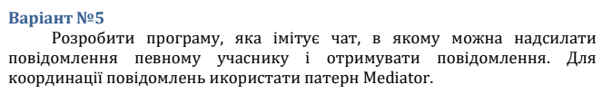

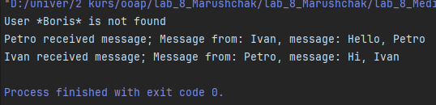

using System;  
using System.Collections.Generic;  
  
namespace lab_8_Mediator  
{  
 interface IChatMediator  
 {  
 void SendMessage(string message, User sender, string receiverName);  
 }  
  
 abstract class User  
  
 {  
 protected IChatMediator _chatMediator;  
 public string Name { get; }  
  
 protected User(IChatMediator chatMediator,string name)  
 {  
 _chatMediator = chatMediator;  
 Name = name;  
 }  
  
 public abstract void ReceiveMessage(string message);  
 }  
   
 class ChatMediator : IChatMediator  
 {  
 private List<User> _users = new List<User>();  
  
 public void AddUser(User user)  
 {  
 _users.Add(user);  
 }  
   
 public void SendMessage(string message, User sender, string receiverName)  
 {  
 User receiver = _users.Find(usr => usr.Name== receiverName);  
  
 if (receiver != null)  
 {  
 receiver.ReceiveMessage($"Message from: {sender.Name}, message: {message}");  
 }  
 else  
 {  
 Console.WriteLine($"User *{receiverName}* is not found");  
 }  
 }  
 }  
   
 class ConctreateUser : User  
 {  
 public ConctreateUser(IChatMediator chatMediator, string name) : base(chatMediator, name)  
 {  
 }  
  
 public override void ReceiveMessage(string message)  
 {  
 Console.WriteLine($"{Name} received message; {message}");  
 }  
  
 public void SendMessage(string message, string receiverName)  
 {  
 _chatMediator.SendMessage(message,this,receiverName);  
 }  
 }  
  
 internal class Program  
 {  
 public static void Main(string[] args)  
 {  
 ChatMediator mediator = new ChatMediator();  
  
 ConctreateUser user1 = new ConctreateUser(mediator, "Ivan");  
 ConctreateUser user2 = new ConctreateUser(mediator, "Petro");  
  
 mediator.AddUser(user1);  
 mediator.AddUser(user2);  
  
 user1.SendMessage("Hello, Boris","Boris");  
 user1.SendMessage("Hello, Petro", "Petro");  
 user2.SendMessage("Hi, Ivan", "Ivan");  
 }  
 }  
}

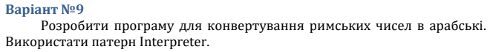

**Висновок:** на даній лабораторній роботі використовував шаблон проектування Iterator, Mediator, Interpreter.