**HTML**(Hyper Text Markup Language): **Structure**

**CSS**(Cascading Style Sheet): **Styling**

**JS**(JavaScript): **Functionality**

**EVENT LISTENERS:**

document.getElementById("changeList").onclick = newList;

document.getElementById("changeList").addEventListener("click", newList);

**FUNCTIONS:**

A JavaScript function is a block of code designed to perform a particular task.

A JavaScript function is executed when "something" invokes it (calls it).

**DEBUGGING STEPS:**

**Step 1:**

Place a breakpoint(s) on each **Event Listener** and the first line of each **Function**.

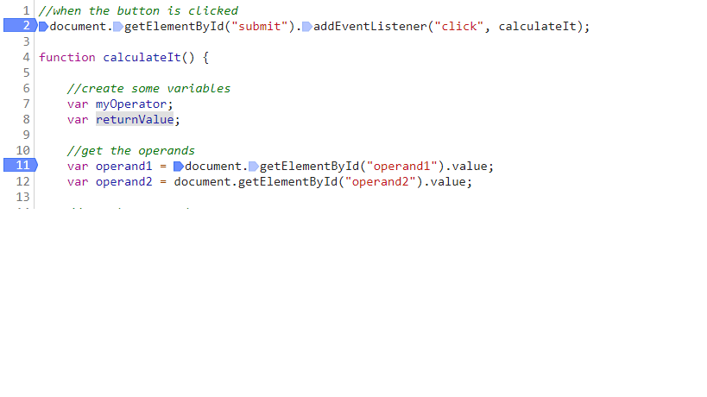

**Step 2:**

Add watch expressions in your **WATCH**. Watch expressions are **variables** that you predict will change.

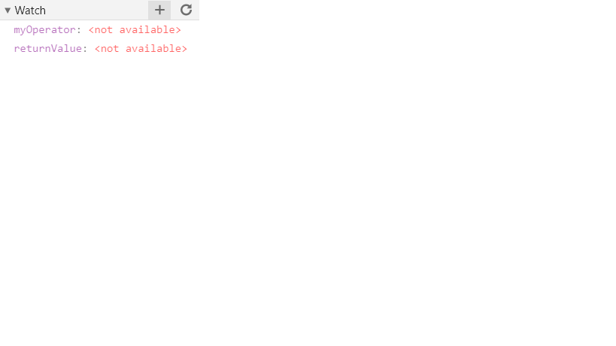

**Step 3:**

Use the Web Application.

Homework:

1. Go to <https://www.w3schools.com/js/default.asp>

Revise from **JS Output** to **JS Functions**. Leave out **JS Objects**.

1. Add an event-listener for the **rightArm** and link it to the **moveUpDown** function.

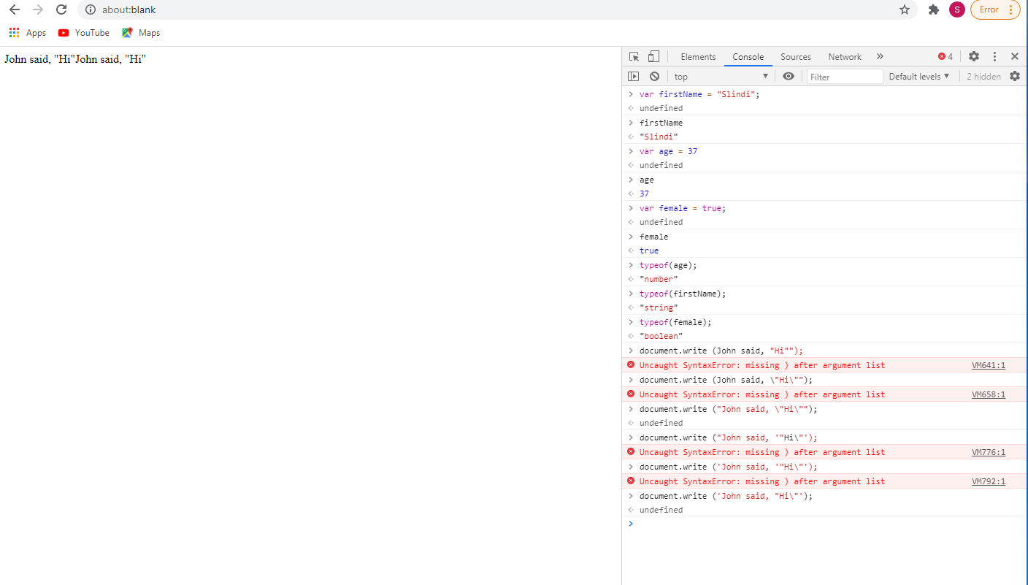

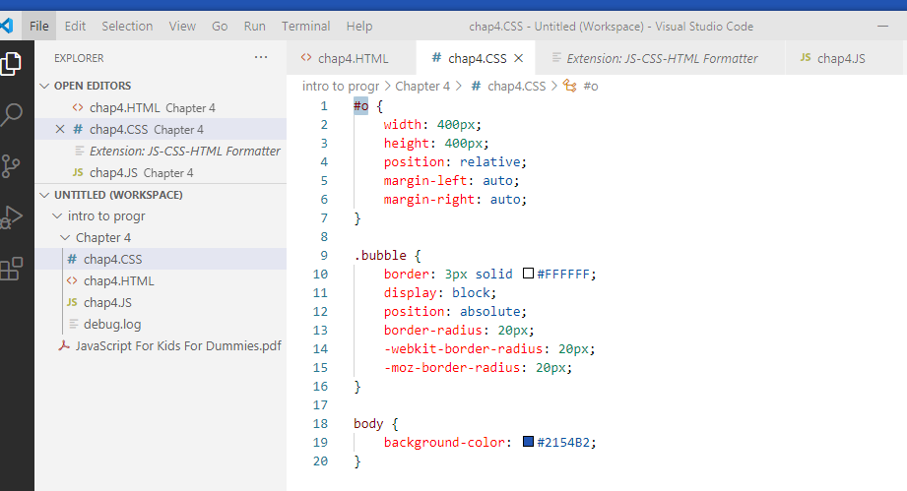1

text selector

class selector

ID selector