
MARUDENI FOODS
WEBSITE REQUIREMENTS & DESIGN SPECIFICATION
Premium Delicacies. Exceptional Experience.
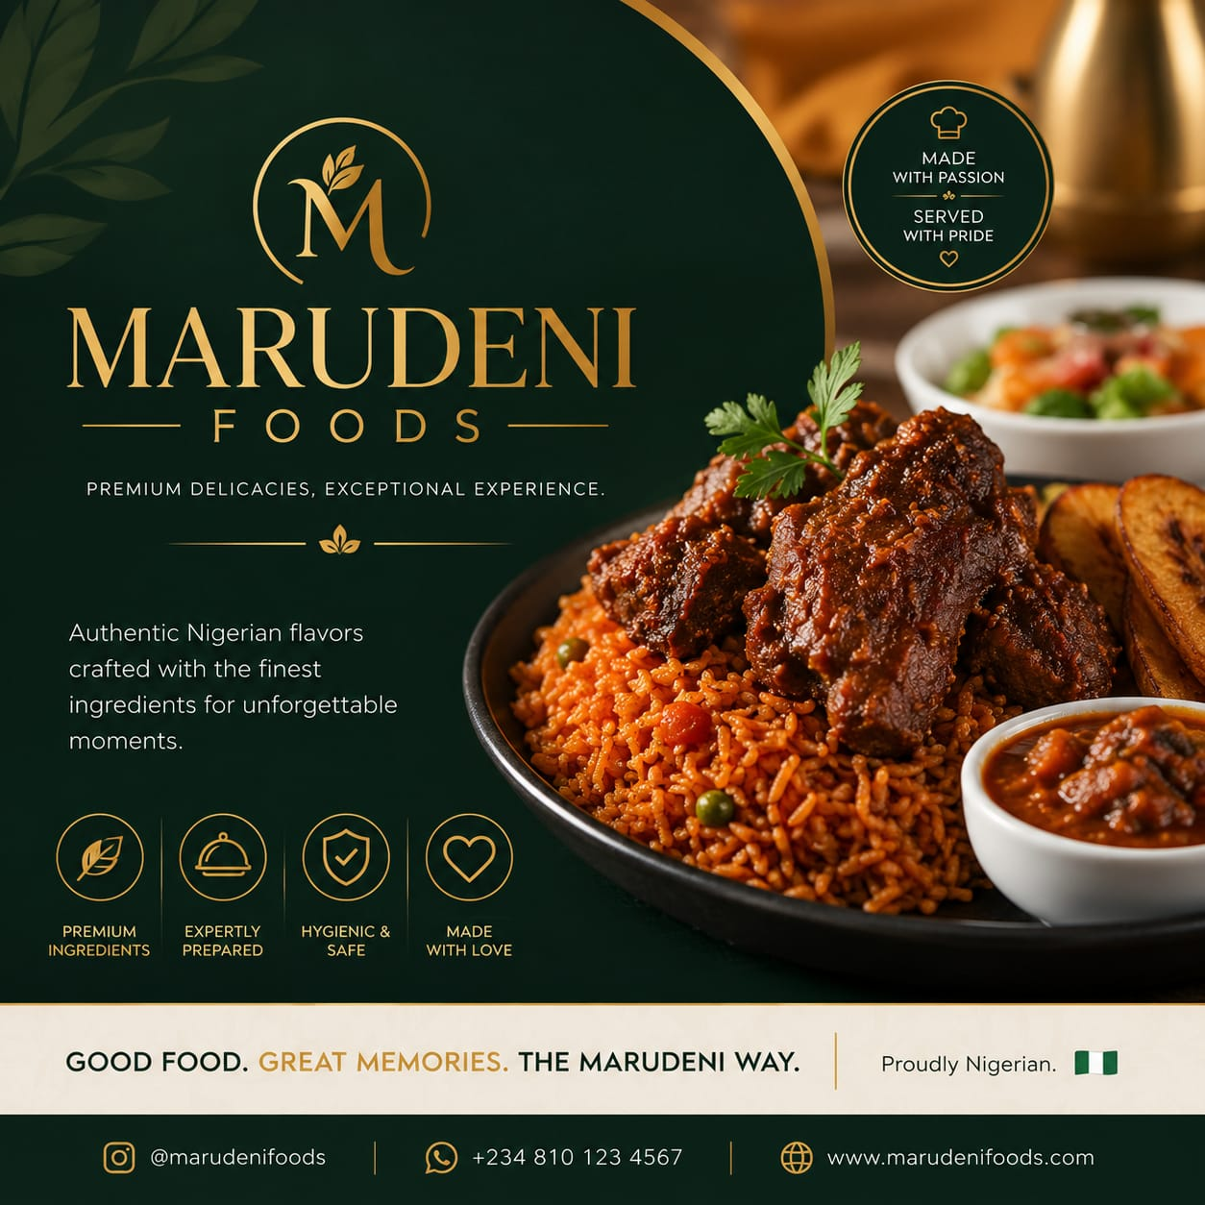
DEEP GREEN  #0B2117 | GOLD  #C99A3D | WARM CREAM  #EFE7DC | WHITE  #FFFFFF

Prepared as a practical blueprint for design, development and client approval.

1. Website Vision
The Marudeni Foods website should function as a premium digital storefront for ordering food, discovering the brand, and requesting catering services. The experience should feel elegant, warm, trustworthy and distinctly Nigerian while remaining simple enough for customers to place an order quickly.

Primary Goals
GOAL | REQUIREMENT
Sell food online | Customers browse products, select quantities, add items to cart and review their order.
Simple checkout | Checkout uses bank transfer for now, with the final order sent to WhatsApp for confirmation.
Build trust | Use strong food photography, hygiene/safety messaging, brand story and clear contact details.
Generate catering leads | Dedicated catering page and enquiry flow for events, corporate orders and private functions.
Prepare for growth | Structure the system so online payment gateways, delivery tracking and more automation can be added later.

2. Brand Direction
The supplied logo and flyer establish a premium visual identity built around deep green and gold, supported by warm cream/white space. The website should preserve this identity rather than introducing bright generic restaurant colours.
COLOUR | HEX | USE
Deep Green | #0B2117 | Primary background, navigation, buttons and strong headings.
Secondary Green | #173B2A | Cards, subtle sections and supporting surfaces.
Luxury Gold | #C99A3D | Accents, icons, borders, highlights and key calls-to-action.
Warm Cream | #EFE7DC | Soft section backgrounds and premium contrast.
White | #FFFFFF | Main content background and clean spacing.

Brand language
• Premium Delicacies. Exceptional Experience.
• Authentic Nigerian flavors crafted with the finest ingredients for unforgettable moments.
• Good Food. Great Memories. The Marudeni Way.
• Made with passion. Served with pride.

3. Recommended Website Structure
PAGE | PURPOSE
Home | Brand introduction, featured foods, value propositions, catering CTA, testimonials/social proof and WhatsApp ordering CTA.
Menu / Order | Product categories, food cards, product details, quantity controls, add-to-cart and cart summary.
Catering | Catering services, event types, packages/offerings, gallery, enquiry form and WhatsApp follow-up.
About Us | Marudeni Foods story, brand values, food quality, hygiene and service philosophy.
Contact | Phone, WhatsApp, social media, operating information and enquiry CTA.
Cart | Selected products, quantities, subtotal, customer notes and checkout action.
Checkout | Customer details, delivery/pickup details, bank-transfer instructions and WhatsApp order confirmation.
Order Confirmation | Order reference, summary, payment instructions and WhatsApp confirmation link.

4. Homepage Experience
SECTION | CONTENT / FUNCTION
Hero | Large premium food image + Marudeni Foods logo + headline such as “Premium Delicacies. Exceptional Experience.” + Order Now and Catering buttons.
Featured Menu | Show best-selling or signature dishes with image, name, short description, price and Add to Cart.
Why Marudeni | Premium ingredients, expertly prepared, hygienic & safe, made with love — matching the flyer's four-value structure.
Food Experience | Large editorial food photography with short brand copy about authentic Nigerian flavours.
Catering | Dedicated visual section encouraging customers to book Marudeni for events, corporate functions and private occasions.
Social Proof | Customer reviews/testimonials, event photos or selected Instagram content when available.
WhatsApp CTA | Persistent or strategically placed “Order on WhatsApp” action.
Footer | Logo, contact details, social links, quick links, service areas and legal/policy links.

5. Food Ordering & Cart System
The core ordering experience should be fast and mobile-first because many customers will likely order from a phone.
1. Customer opens Menu / Order.
2. Customer selects a category and views food items.
3. Customer opens a product, selects quantity/options where applicable, and taps Add to Cart.
4. Cart drawer/page shows items, quantities, prices and subtotal.
5. Customer proceeds to Checkout.
6. Customer enters name, phone number, delivery/pickup preference, address where required, and optional order note.
7. Website displays bank-transfer payment instructions.
8. Customer taps “Confirm Order on WhatsApp”.
9. WhatsApp opens with a pre-filled order message containing order reference, items, quantities, total and customer details.
10. Marudeni confirms payment and order fulfilment manually for the initial phase.

Cart requirements
- Increase/decrease quantity.
- Remove item.
- Display item price and line total.
- Display subtotal and any applicable delivery fee.
- Optional customer order note.
- Persist cart during the current browsing session.
- Clear cart after successful order submission.

6. Bank Transfer + WhatsApp Checkout
For Phase 1, the website does not need an online card/payment gateway. Instead, the system should generate a clear bank-transfer instruction and then move the customer to WhatsApp for order confirmation.
CHECKOUT ELEMENT | RECOMMENDATION
Order Reference | Generate a unique reference such as MRD-2026-0001.
Payment Details | Show Marudeni's approved bank name, account name and account number. These details should be editable from the admin area.
Amount | Clearly display the exact order total the customer should transfer.
Proof of Payment | Optional Phase 1 approach: customer sends transfer proof through WhatsApp.
WhatsApp Message | Auto-compose a structured order message rather than asking customers to type the order manually.
Order Status | Use Pending Payment → Payment Confirmed → Preparing → Ready/Dispatched → Completed.
Important: payment instructions should be centrally editable so the website does not need a code deployment whenever Marudeni changes its bank account.

7. Catering Section
Catering should be treated as a lead-generation service rather than a normal product checkout. The page should communicate capability and make it easy for a potential client to request a quote.
SECTION | REQUIREMENT
Catering Hero | Premium event image, “Catering by Marudeni Foods” headline and Request a Catering Quote CTA.
Services | Private parties, birthdays, weddings, corporate events, meetings, launches, celebrations and other suitable event types.
Menu / Packages | Optional package cards or sample catering menus. Prices can be “Starting from” or “Request Quote” where pricing depends on event size.
Event Gallery | High-quality photos of food presentation, buffet setups and events.
Enquiry Form | Name, phone/WhatsApp, email, event type, event date, guest count, location, food preferences, budget range and message.
WhatsApp Follow-up | Submit the enquiry and offer a direct WhatsApp action with the captured information.
Trust Section | Quality, hygiene, presentation, punctuality and professional service.

8. Admin / Content Management
A simple admin dashboard is recommended so Marudeni can manage the business without depending on a developer for everyday updates.
- Products: create, edit, archive, price, image, category, description and availability.
- Categories: manage food categories and display order.
- Orders: view order reference, customer details, items, amount, payment status and fulfilment status.
- Bank details: update bank name, account name and account number.
- Catering enquiries: view, update status and export/contact leads.
- Homepage content: featured products, promotional banners and selected text.
- Business settings: WhatsApp number, phone number, social links and operating information.

9. Core Data Structure
ENTITY | KEY DATA
Product | name, slug, description, category, price, image, availability, featured, options.
Category | name, slug, description, image, display order, active status.
Cart | session/cart identifier, products, quantities, subtotal.
Order | order reference, customer, items, subtotal, delivery fee, total, payment status, order status, notes, timestamps.
Customer | name, phone, email, delivery details where required.
Catering Enquiry | contact details, event type, date, guests, location, budget, requirements, status.
Business Settings | bank details, WhatsApp number, contact details, social links and other configurable settings.

10. UI / UX Direction
PRINCIPLE | IMPLEMENTATION
Premium, not crowded | Use generous spacing, large food photography, restrained gold accents and strong typography.
Mobile-first | Cart, menu filters, buttons and checkout must work comfortably on small screens.
Photography-led | Food should be the visual hero. Avoid excessive decorative graphics that compete with food images.
Clear CTAs | Use consistent actions: Order Now, Add to Cart, View Cart, Checkout, Request Catering Quote, Chat on WhatsApp.
Trust at checkout | Show clear totals, payment instructions, contact support and order reference.
Fast ordering | A customer should be able to go from homepage to cart with minimal steps.

11. Technical Recommendation
The website can be implemented as a modern responsive web application with a database-backed admin area. The architecture should keep the ordering, catalogue and catering modules separate enough to support future growth.
AREA | RECOMMENDATION
Frontend | Next.js / React with responsive UI and strong SEO support.
Styling | Tailwind CSS or an equivalent design system using the Marudeni palette.
Backend | Next.js server/API layer or a dedicated Node.js API where appropriate.
Database | MySQL or PostgreSQL for products, orders, customers, catering enquiries and settings.
Images | Optimised cloud image storage/CDN for food and gallery photography.
WhatsApp | Click-to-chat with dynamically generated order/enquiry messages.
Authentication | Secure admin authentication with role-based access if multiple staff will manage the system.
Payments | Phase 1 bank transfer; design checkout service so a gateway such as Paystack/Flutterwave can be added later without rebuilding the storefront.
Hosting | Deploy on a reliable cloud platform with SSL, backups and environment-variable based configuration.

12. SEO, Marketing & Conversion
- SEO-friendly pages for Marudeni Foods, Nigerian food, catering and relevant local service searches.
- Unique page titles and meta descriptions.
- Structured product/category URLs.
- Optimised food images with descriptive alt text.
- Google-friendly performance and mobile responsiveness.
- WhatsApp CTA visible across key pages.
- Social media links, especially Instagram, using the handle shown on the supplied flyer: @marudenifoods.
- Analytics should be installed to measure menu views, Add to Cart, checkout starts, WhatsApp clicks and catering enquiries.

13. Suggested Development Phases
PHASE | SCOPE
Phase 1 — Foundation | Brand UI, Home, Menu, Product details, Cart, responsive navigation and core content.
Phase 2 — Ordering | Checkout, bank-transfer instructions, order creation, WhatsApp order generation and order status management.
Phase 3 — Catering | Catering landing page, enquiry form, gallery and WhatsApp follow-up.
Phase 4 — Admin | Product management, order management, catering enquiries, bank details and business settings.
Phase 5 — Launch & Optimisation | SEO, analytics, performance, security checks, content loading, testing and production launch.

14. Information Required from Marudeni Foods
- Final menu/product list with prices and categories.
- Food product images and any additional brand photography.
- Approved bank-transfer details.
- Official WhatsApp number for orders.
- Phone number, email address and physical/service location.
- Instagram and other social media links.
- Delivery areas, delivery pricing and pickup arrangements.
- Opening hours / order cut-off times.
- Catering packages, sample menus and pricing rules.
- Catering service areas and minimum guest/order requirements.
- Customer testimonials, event photos or other proof of service.
- Any existing policies: cancellation, refund, delivery and privacy.

15. Definition of a Successful First Version
The first production version is successful when a customer can discover Marudeni Foods, browse the menu, add multiple food items to a cart, see an accurate total, receive bank-transfer instructions, submit the order through WhatsApp, and contact Marudeni for support — while a separate visitor can request catering services without needing to call first.
MARUDENI FOODS
GOOD FOOD. GREAT MEMORIES. THE MARUDENI WAY.

