Our team have implemented a traditional supervised learning, metric learning, and vision transformer approach to an image classification problem. Is it fine to use the same pre-processing for these three types of models? Aiming to minimise systematic error between each method to ensure we get a fair comparison between each disparate method.

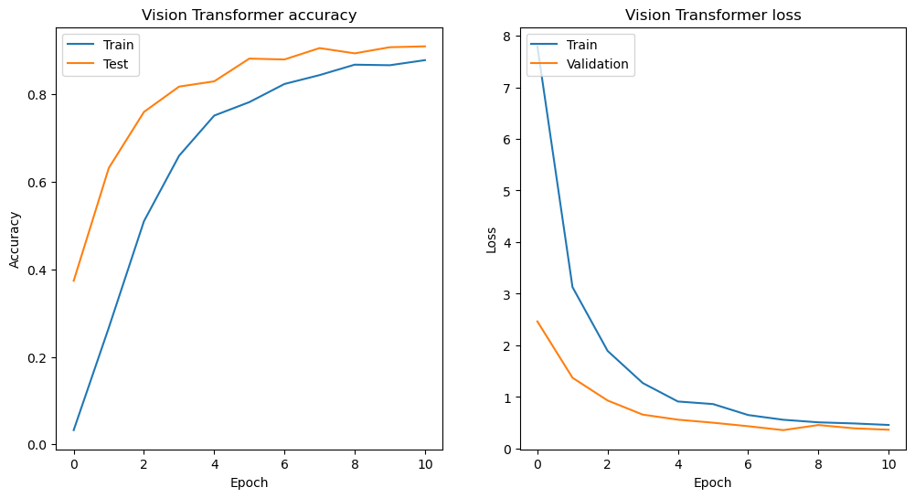

Training Time: 1666.6700189113617 seconds

Total Inference Time: 5.125186920166016 seconds

F1 Score: 0.9436356421356421

Accuracy: 0.946

precision recall f1-score support

ADONIS 0.75 0.60 0.67 5

AFRICAN GIANT SWALLOWTAIL 1.00 1.00 1.00 5

AMERICAN SNOOT 1.00 1.00 1.00 5

AN 88 1.00 1.00 1.00 5

APPOLLO 0.83 1.00 0.91 5

ARCIGERA FLOWER MOTH 1.00 1.00 1.00 5

ATALA 1.00 1.00 1.00 5

ATLAS MOTH 1.00 0.80 0.89 5

BANDED ORANGE HELICONIAN 1.00 1.00 1.00 5

BANDED PEACOCK 1.00 1.00 1.00 5

BANDED TIGER MOTH 1.00 0.80 0.89 5

BECKERS WHITE 0.83 1.00 0.91 5

BIRD CHERRY ERMINE MOTH 1.00 0.80 0.89 5

BLACK HAIRSTREAK 1.00 1.00 1.00 5

BLUE MORPHO 1.00 0.80 0.89 5

BLUE SPOTTED CROW 1.00 1.00 1.00 5

BROOKES BIRDWING 1.00 1.00 1.00 5

BROWN ARGUS 1.00 1.00 1.00 5

BROWN SIPROETA 1.00 1.00 1.00 5

CABBAGE WHITE 0.83 1.00 0.91 5

CAIRNS BIRDWING 1.00 1.00 1.00 5

CHALK HILL BLUE 0.71 1.00 0.83 5

CHECQUERED SKIPPER 1.00 1.00 1.00 5

CHESTNUT 1.00 1.00 1.00 5

CINNABAR MOTH 1.00 1.00 1.00 5

CLEARWING MOTH 1.00 1.00 1.00 5

CLEOPATRA 1.00 1.00 1.00 5

CLODIUS PARNASSIAN 0.80 0.80 0.80 5

CLOUDED SULPHUR 1.00 0.80 0.89 5

COMET MOTH 0.83 1.00 0.91 5

COMMON BANDED AWL 1.00 1.00 1.00 5

COMMON WOOD-NYMPH 1.00 1.00 1.00 5

COPPER TAIL 0.83 1.00 0.91 5

CRECENT 1.00 1.00 1.00 5

CRIMSON PATCH 1.00 1.00 1.00 5

DANAID EGGFLY 1.00 0.40 0.57 5

EASTERN COMA 0.75 0.60 0.67 5

EASTERN DAPPLE WHITE 0.83 1.00 0.91 5

EASTERN PINE ELFIN 1.00 0.80 0.89 5

ELBOWED PIERROT 1.00 1.00 1.00 5

EMPEROR GUM MOTH 0.83 1.00 0.91 5

GARDEN TIGER MOTH 0.83 1.00 0.91 5

GIANT LEOPARD MOTH 0.83 1.00 0.91 5

GLITTERING SAPPHIRE 1.00 1.00 1.00 5

GOLD BANDED 1.00 1.00 1.00 5

GREAT EGGFLY 0.71 1.00 0.83 5

GREAT JAY 1.00 1.00 1.00 5

GREEN CELLED CATTLEHEART 1.00 1.00 1.00 5

GREEN HAIRSTREAK 1.00 1.00 1.00 5

GREY HAIRSTREAK 1.00 1.00 1.00 5

HERCULES MOTH 0.83 1.00 0.91 5

HUMMING BIRD HAWK MOTH 1.00 1.00 1.00 5

INDRA SWALLOW 1.00 0.60 0.75 5

IO MOTH 1.00 1.00 1.00 5

Iphiclus sister 1.00 1.00 1.00 5

JULIA 0.83 1.00 0.91 5

LARGE MARBLE 1.00 0.40 0.57 5

LUNA MOTH 1.00 0.80 0.89 5

MADAGASCAN SUNSET MOTH 1.00 1.00 1.00 5

MALACHITE 1.00 1.00 1.00 5

MANGROVE SKIPPER 1.00 1.00 1.00 5

MESTRA 1.00 1.00 1.00 5

METALMARK 1.00 1.00 1.00 5

MILBERTS TORTOISESHELL 1.00 1.00 1.00 5

MONARCH 1.00 1.00 1.00 5

MOURNING CLOAK 1.00 1.00 1.00 5

OLEANDER HAWK MOTH 1.00 1.00 1.00 5

ORANGE OAKLEAF 1.00 1.00 1.00 5

ORANGE TIP 1.00 1.00 1.00 5

ORCHARD SWALLOW 1.00 1.00 1.00 5

PAINTED LADY 1.00 1.00 1.00 5

PAPER KITE 1.00 1.00 1.00 5

PEACOCK 1.00 1.00 1.00 5

PINE WHITE 1.00 1.00 1.00 5

PIPEVINE SWALLOW 1.00 1.00 1.00 5

POLYPHEMUS MOTH 1.00 0.80 0.89 5

POPINJAY 1.00 1.00 1.00 5

PURPLE HAIRSTREAK 1.00 0.80 0.89 5

PURPLISH COPPER 1.00 1.00 1.00 5

QUESTION MARK 0.67 0.80 0.73 5

RED ADMIRAL 0.83 1.00 0.91 5

RED CRACKER 1.00 1.00 1.00 5

RED POSTMAN 1.00 1.00 1.00 5

RED SPOTTED PURPLE 1.00 1.00 1.00 5

ROSY MAPLE MOTH 1.00 1.00 1.00 5

SCARCE SWALLOW 0.83 1.00 0.91 5

SILVER SPOT SKIPPER 1.00 1.00 1.00 5

SIXSPOT BURNET MOTH 1.00 1.00 1.00 5

SLEEPY ORANGE 0.67 0.80 0.73 5

SOOTYWING 1.00 1.00 1.00 5

SOUTHERN DOGFACE 0.60 0.60 0.60 5

STRAITED QUEEN 1.00 1.00 1.00 5

TROPICAL LEAFWING 1.00 0.80 0.89 5

TWO BARRED FLASHER 1.00 1.00 1.00 5

ULYSES 1.00 1.00 1.00 5

VICEROY 1.00 1.00 1.00 5

WHITE LINED SPHINX MOTH 1.00 1.00 1.00 5

WOOD SATYR 1.00 1.00 1.00 5

YELLOW SWALLOW TAIL 0.83 1.00 0.91 5

ZEBRA LONG WING 1.00 1.00 1.00 5

accuracy 0.95 500

macro avg 0.95 0.95 0.94 500

weighted avg 0.95 0.95 0.94 500