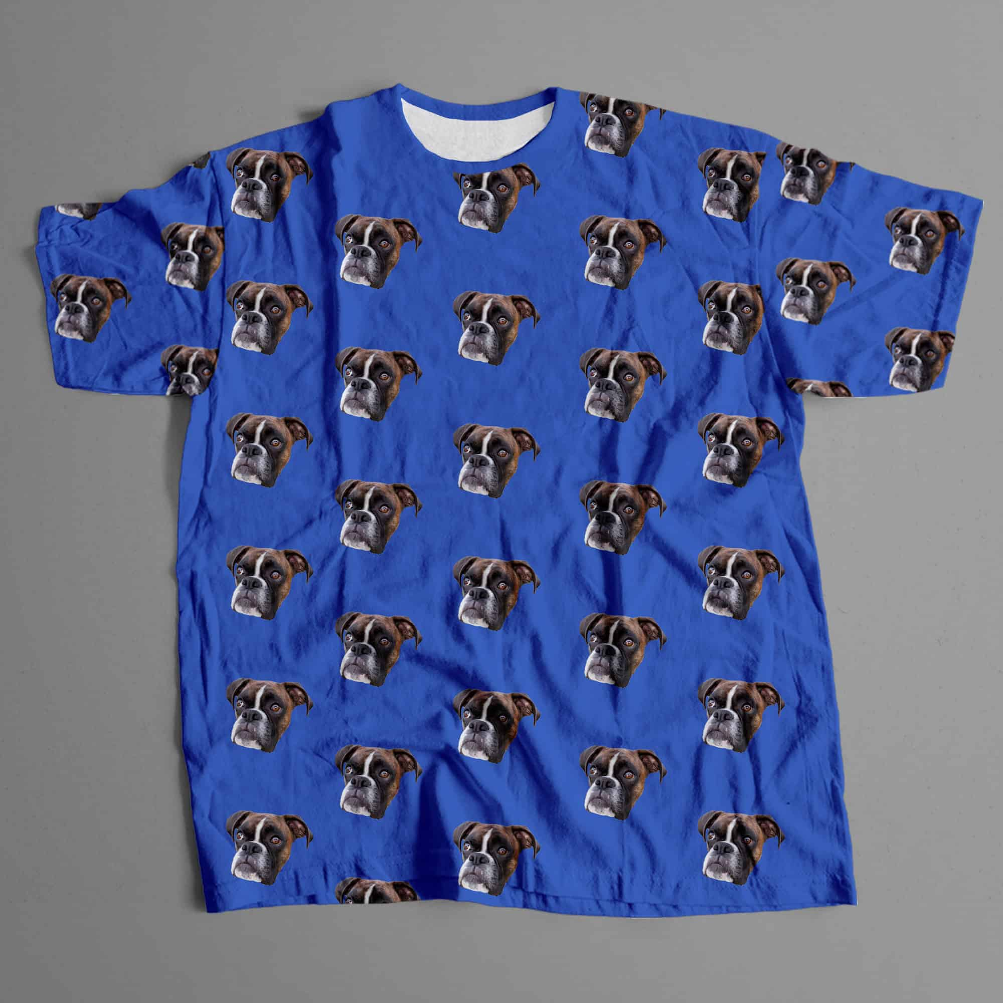

Blue shirt with dog pattern

condition: new

Bright blue, dog - patterned shirt. Perfect for going out during summer or special occasions.

If you want to stand out from the crowd, this shirt is the first thing you need. Being made from cotton, it feels great to wear, therefore you won’t only look, but feel outstanding.

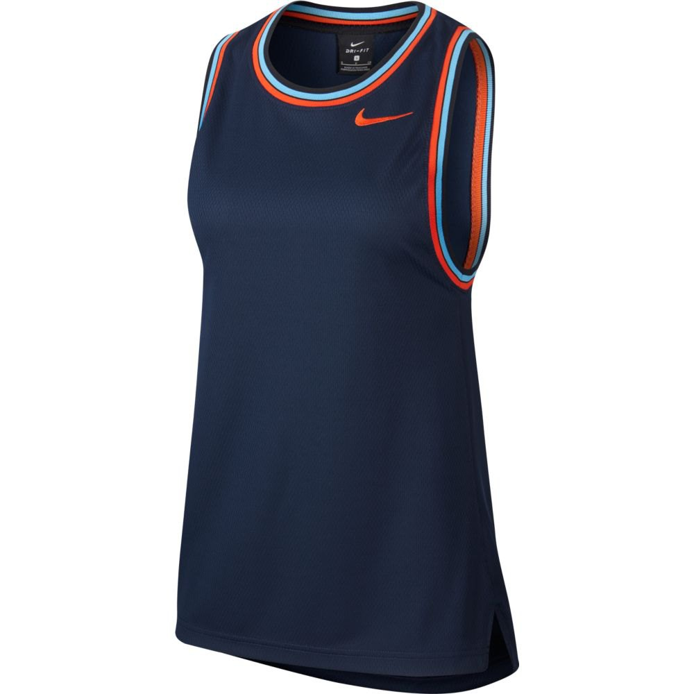

Blue basketball sleeveless t-shirt.

Condition: new

Black-blue, basketball sleeveless t-shirt. You gonna be the best on the court and looks great. Also, you can wear it on summer for a walk and looks very stylish. This is synthetic t-shirt, that’s why it feels good while doing sport.