**Improvements**

1. When the field “First Name” stays empty below fields “First Name” and “Last Name” appear messages. It is probably better to message that appears only below the field “First Name”. Picture below.

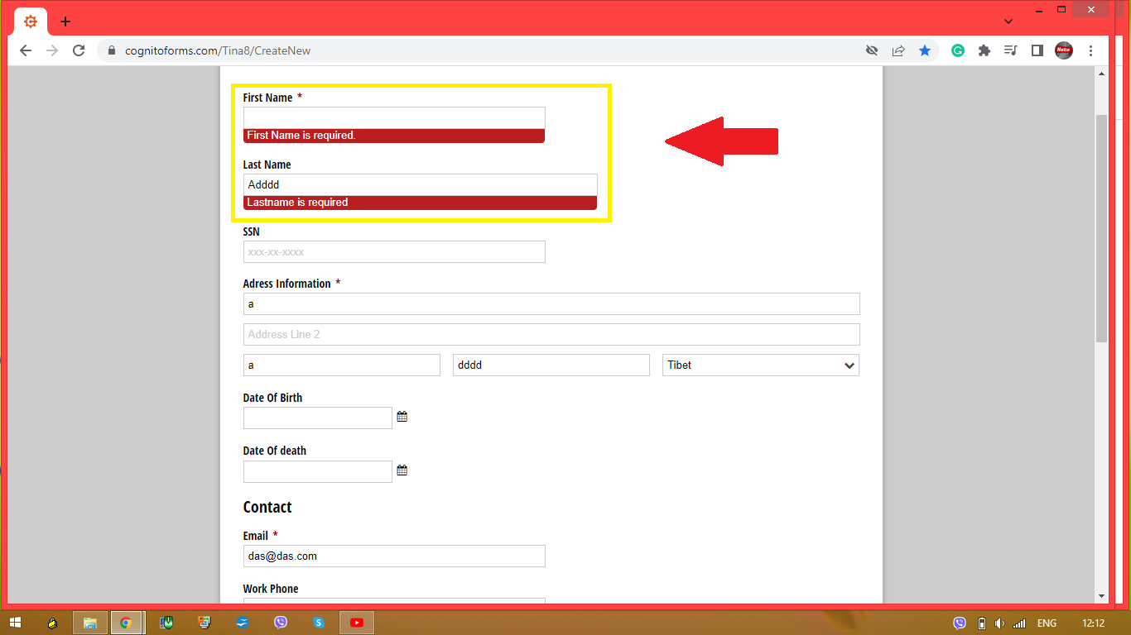

1. When in the field “First Name” enters the special character in the message that appears is missing bolded part "First Name must only contain letters **and "Space" character**". Picture below.

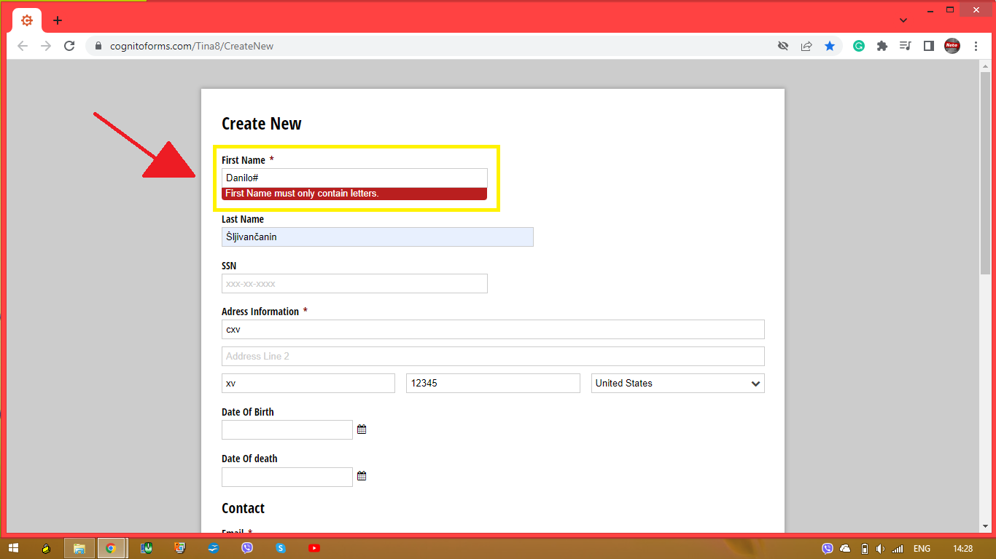

1. Under the section “Address Information *”, the field “Country” needs to offer an option “Country” like in the picture below.

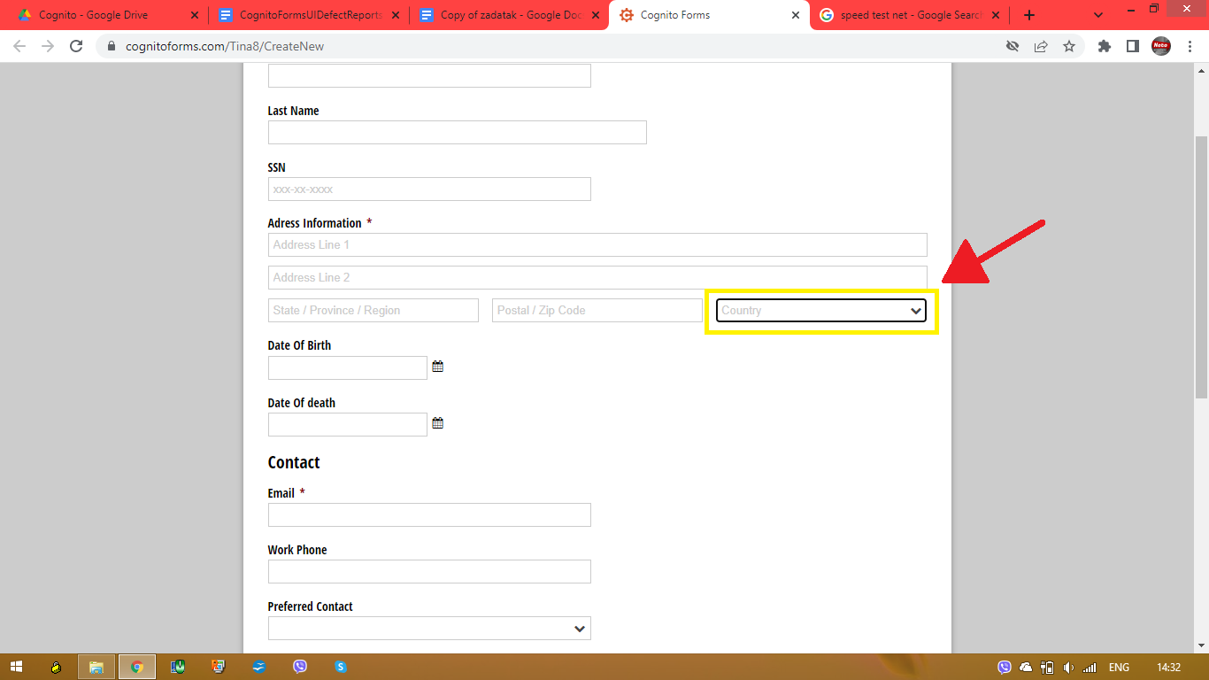

1. Fields “First Name”, “Last Name”, “Address Line 1”, “Address Line 2”, “State/Province/Region”, and “Username” could have some limitations like the number of characters that can be used in fields, the limitation can be 50 characters.
2. Fields “Date Of Birth” and “Date Of Death” can have limitations to make it impossible for the date of death to be before the date of birth. Picture below.

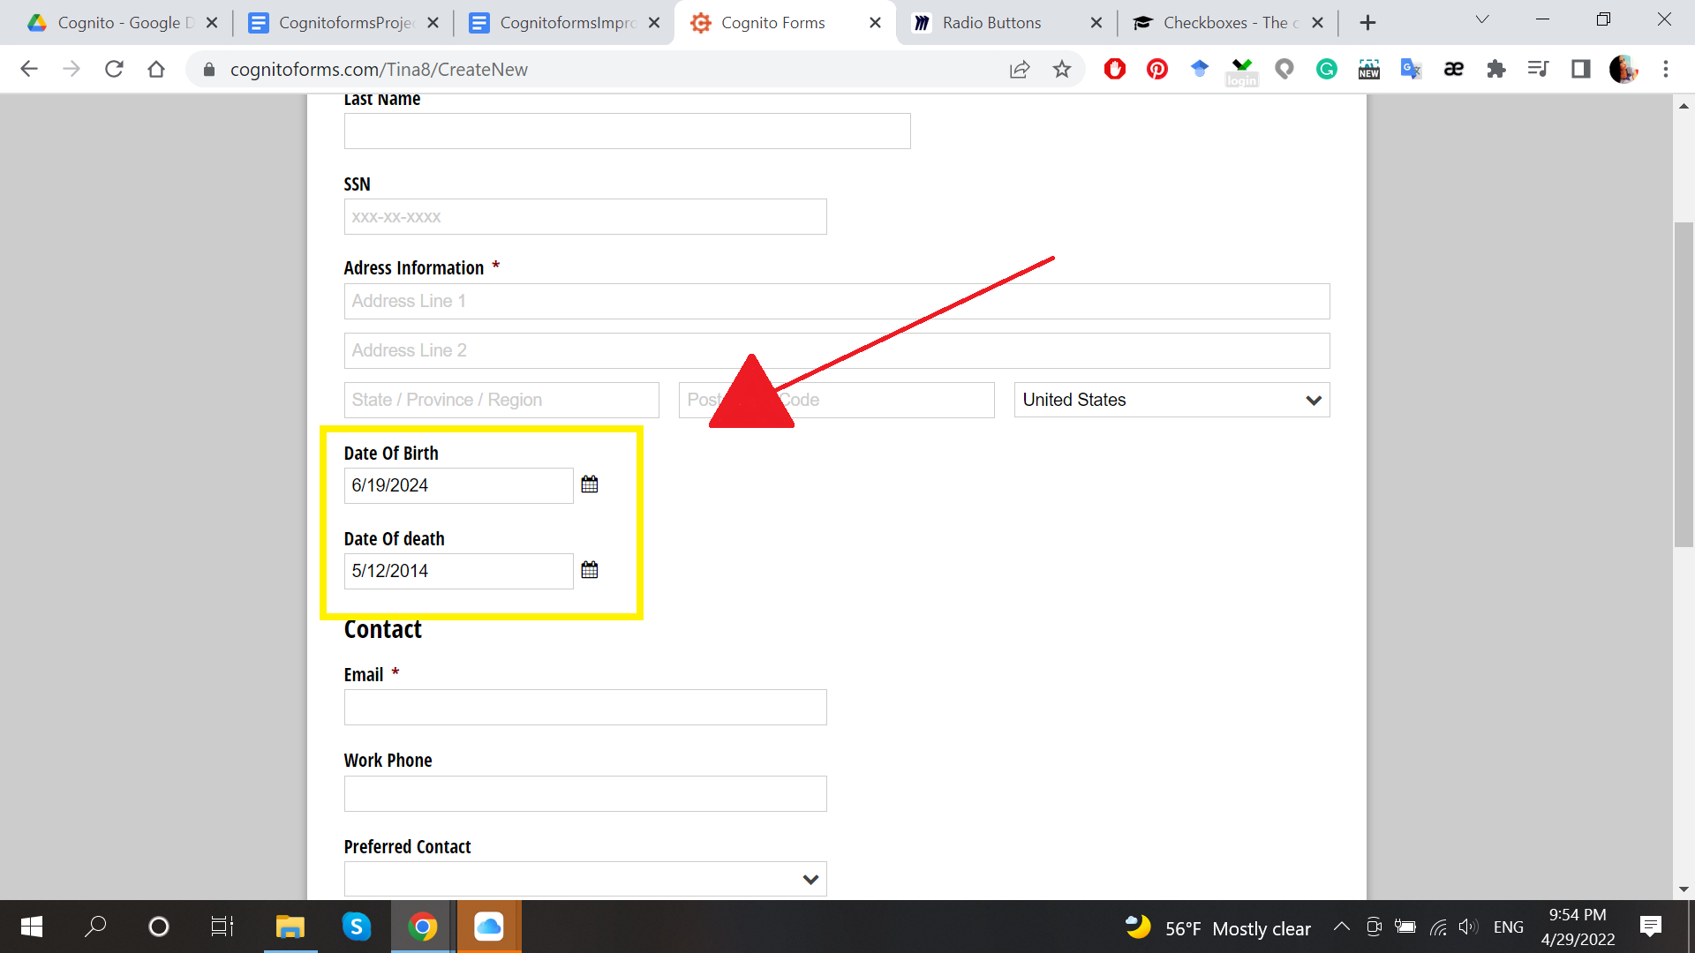

1. The field “Home Number” could have limitations in numbers to 50 digits
2. The field “Marital Status” can be shown as a radio button group but the field “Health Behaviors” can be shown as a checkbox group