UI Test

1. The “Last Name” section needs to be changed to “Last Name \*” because that is a mandatory field. Picture below.

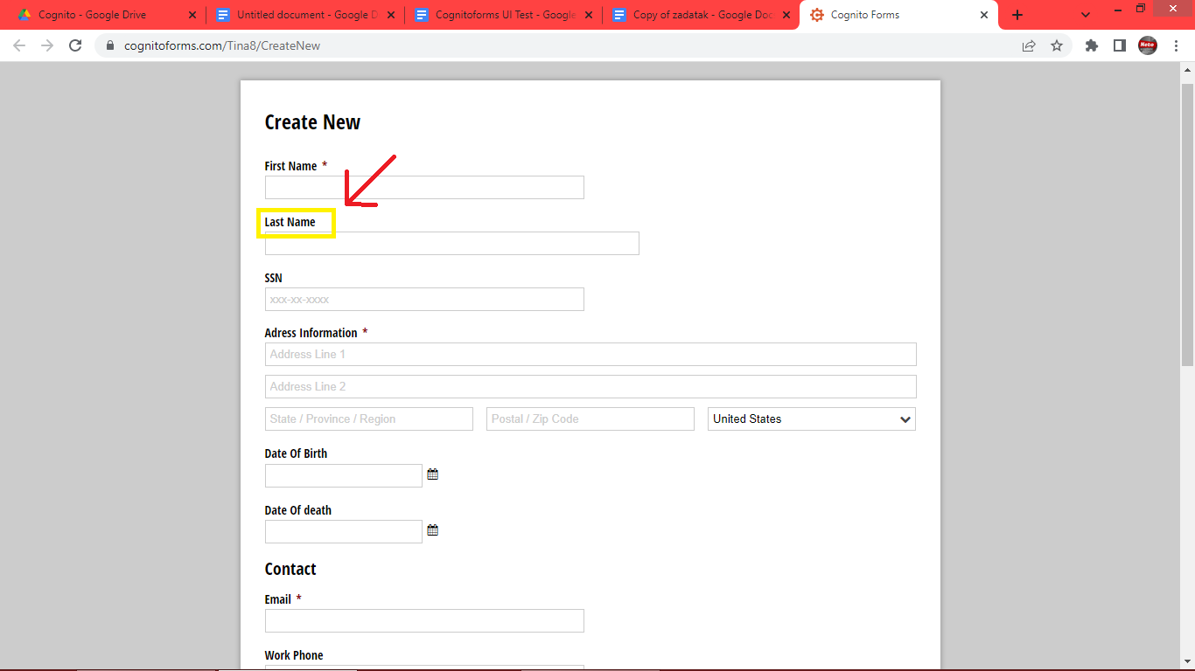

2. The section “Adress Information \*” needs to be changed to “Address Information \*”. Picture below.

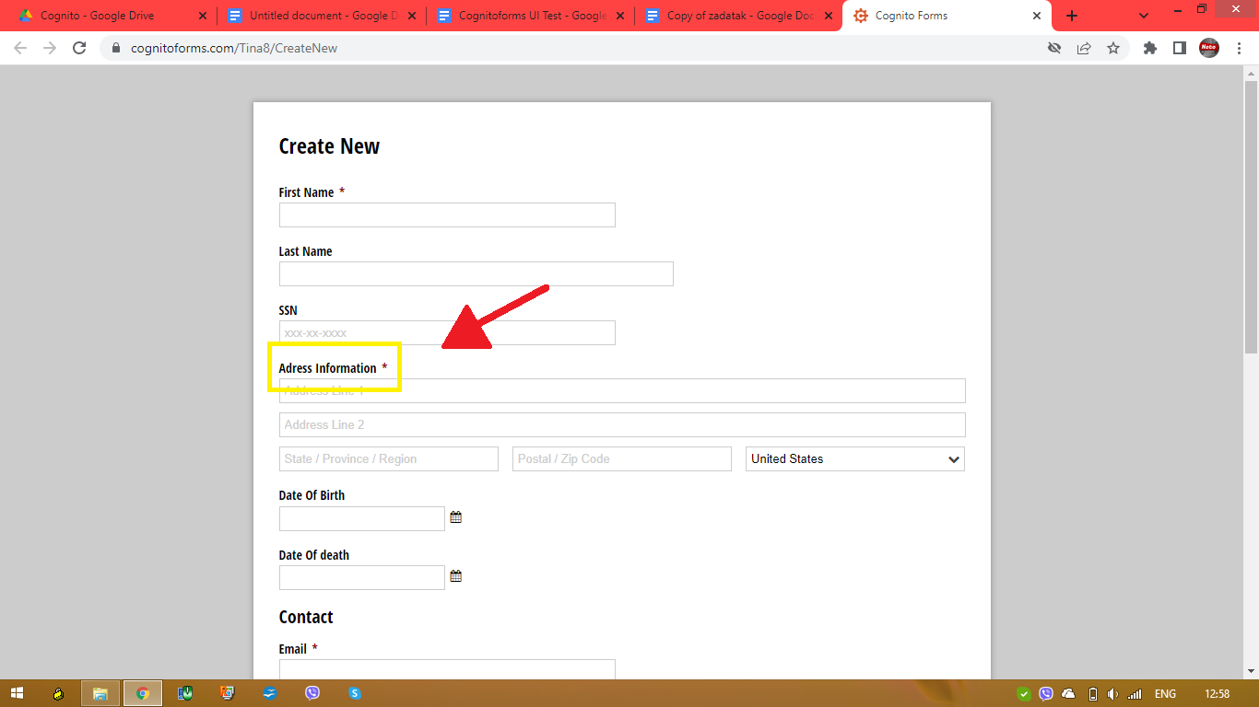

3. In date picker (calendar) under the field “Date Of Birth” it is not possible to choose a date before 01/01/2010 and it is possible to choose a date until 12/31/2030. Pictures below.

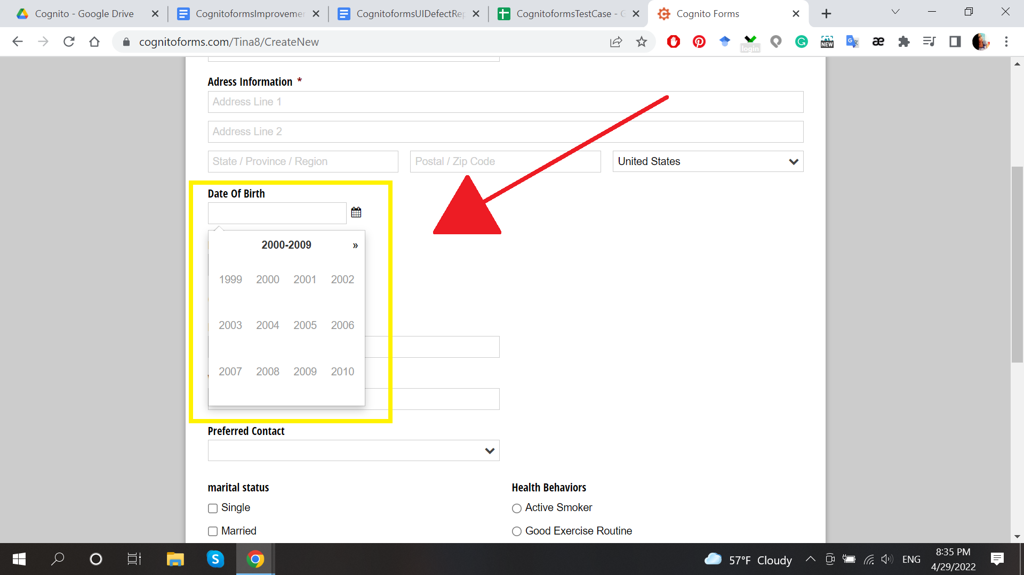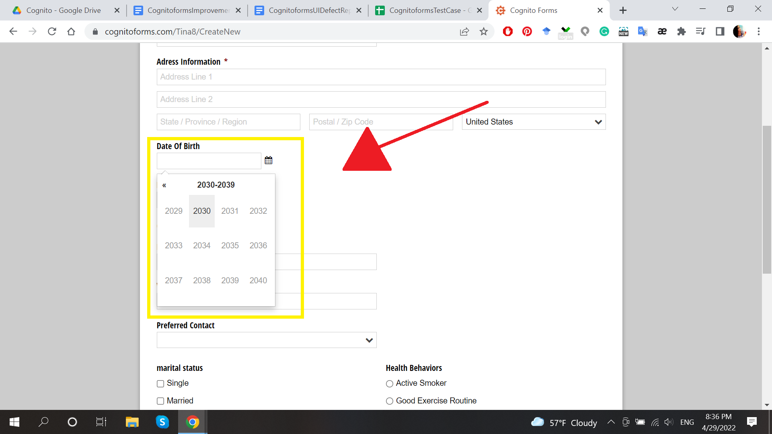

4. In date picker (calendar) under the field “Date Of Death” it is not possible to choose a date before 01/01/2010 and it is possible to choose a date until 12/31/2030. Pictures below.

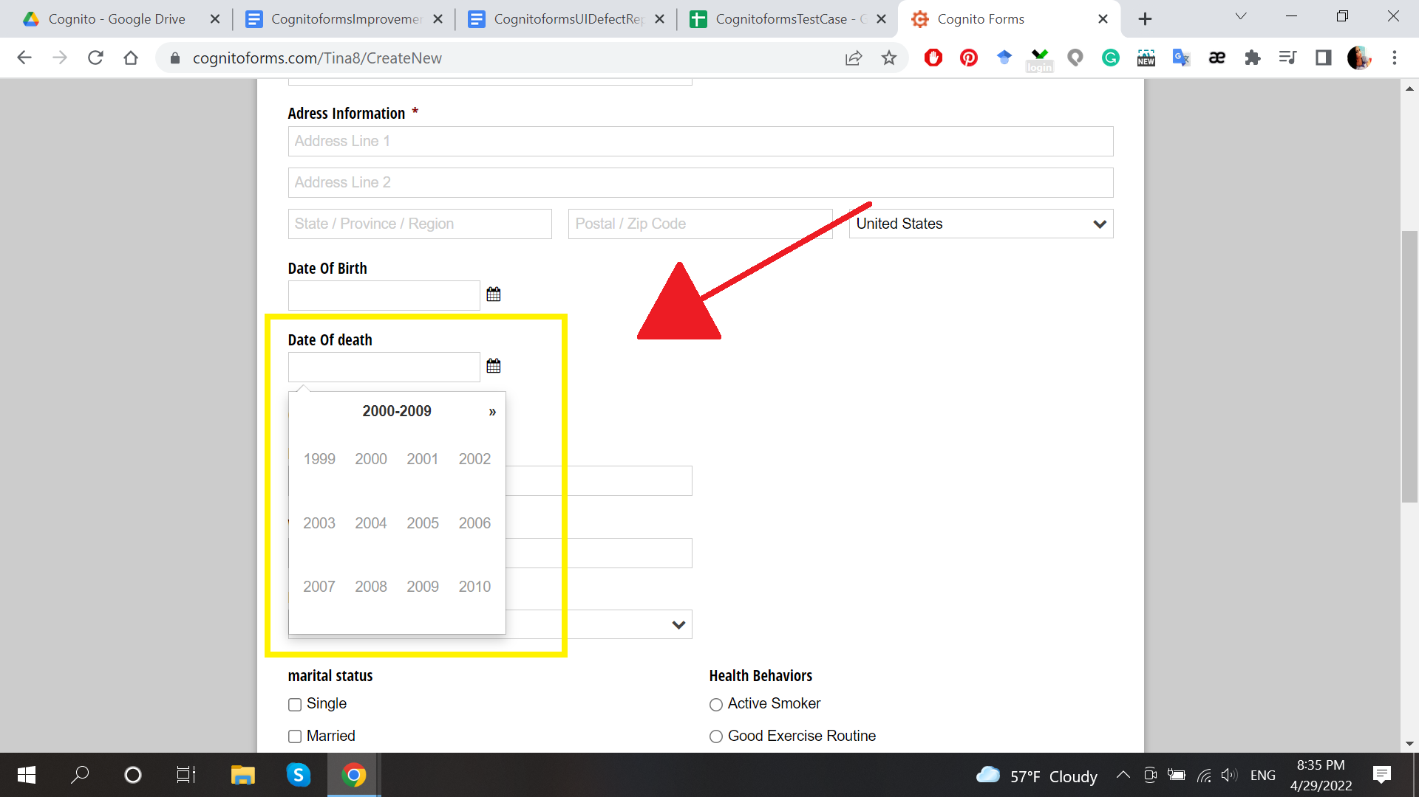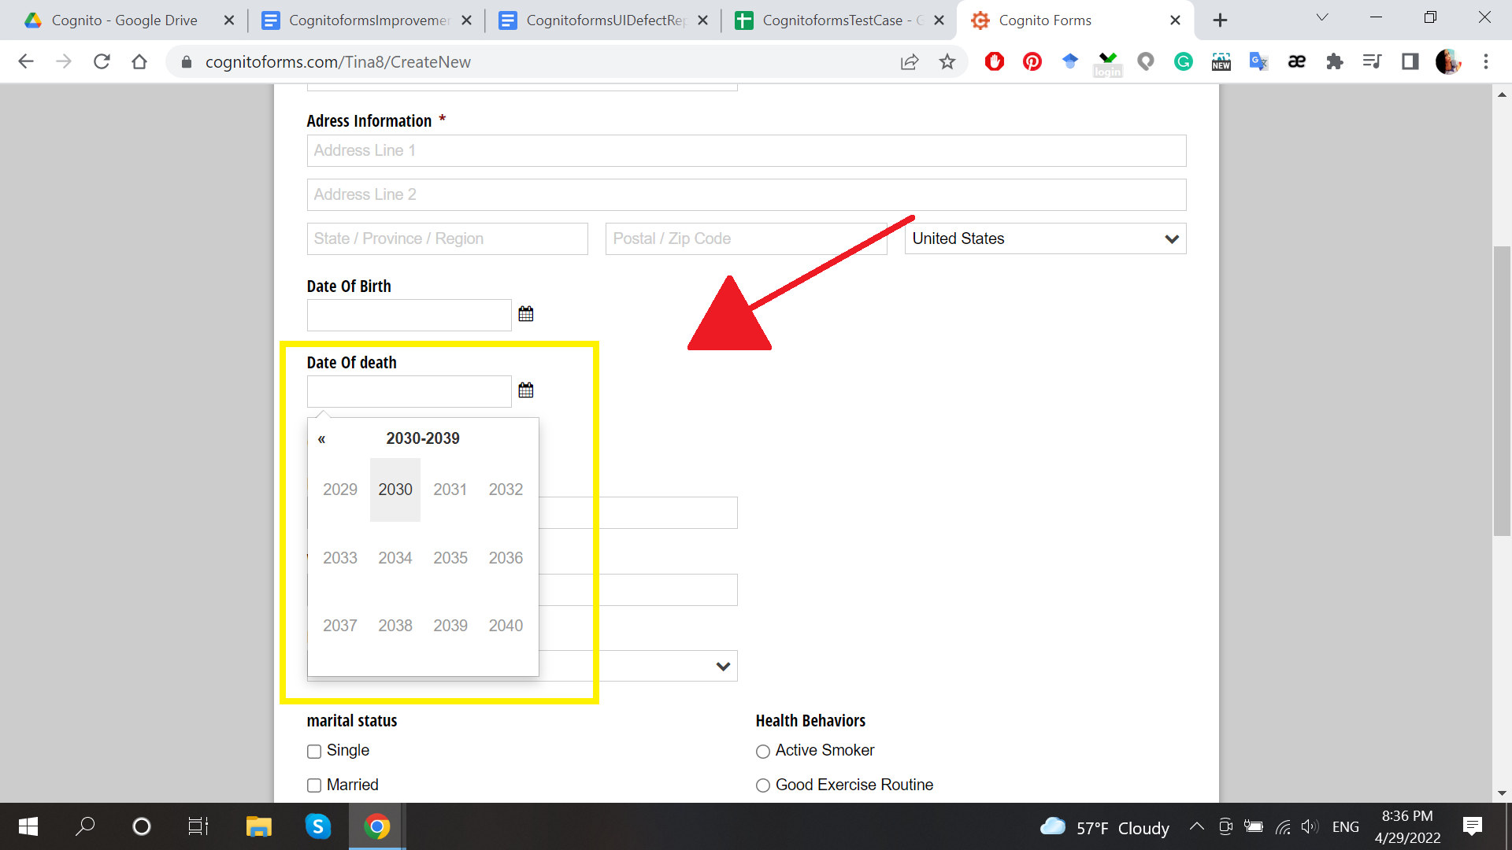

5. The “Date Of death” section needs to be changed to “Date Of Death”. The letter “D” must be a capital letter in the word Death. Picture below.

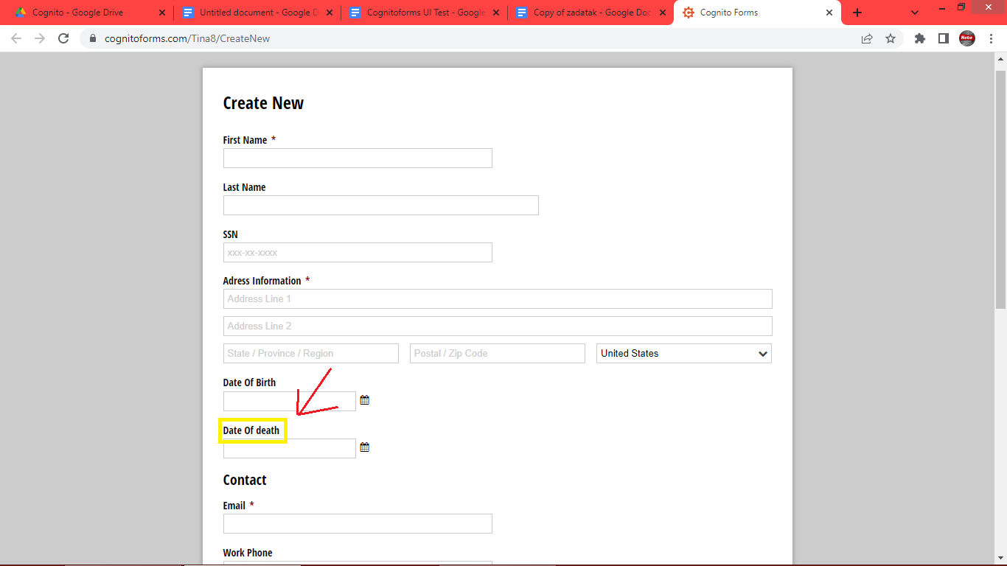

6. The section “Preferred Contact” field “Home Phone” is missing. Picture below.

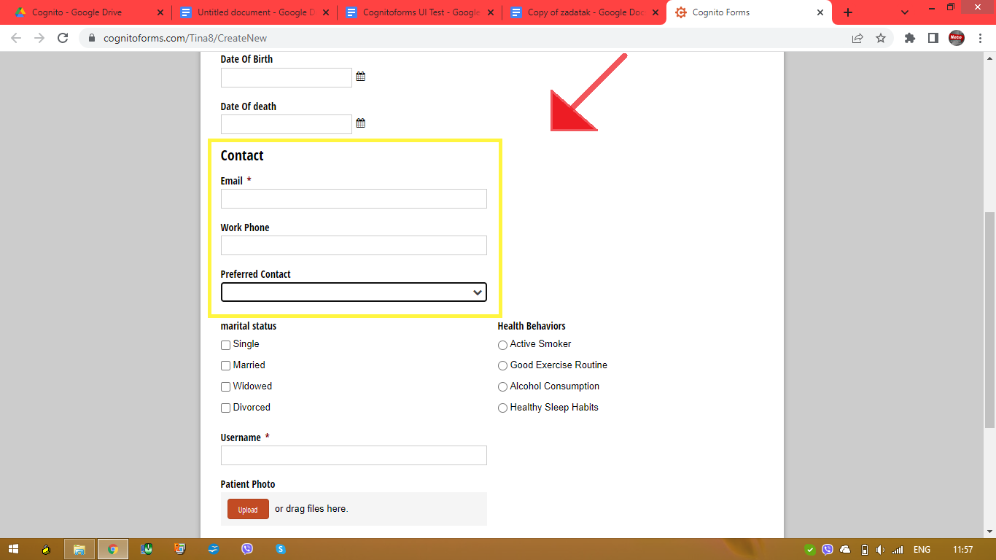

7. In the section “marital status” needs to be possible to tick just one option. The letter “M” for marital and the letter “S” for status needs to be capital letters. Picture below.

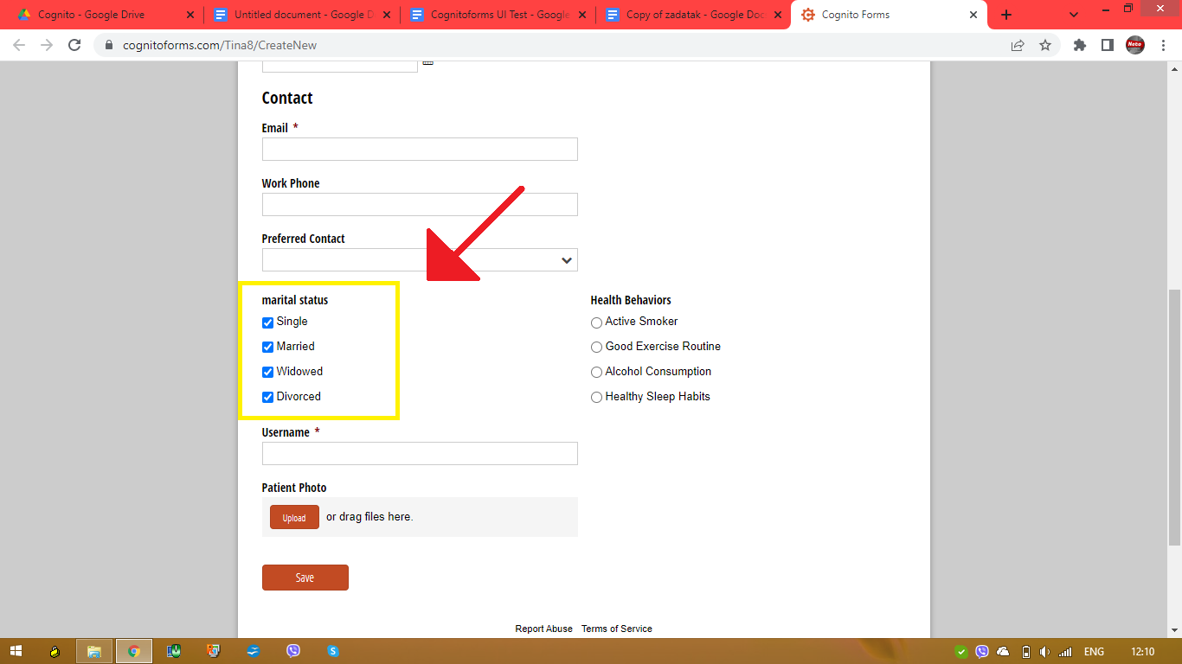

8. In the section “Health Behaviors” needs to be possible to tick more than one option and to can to remove a tick if you made a mistake. Picture below.

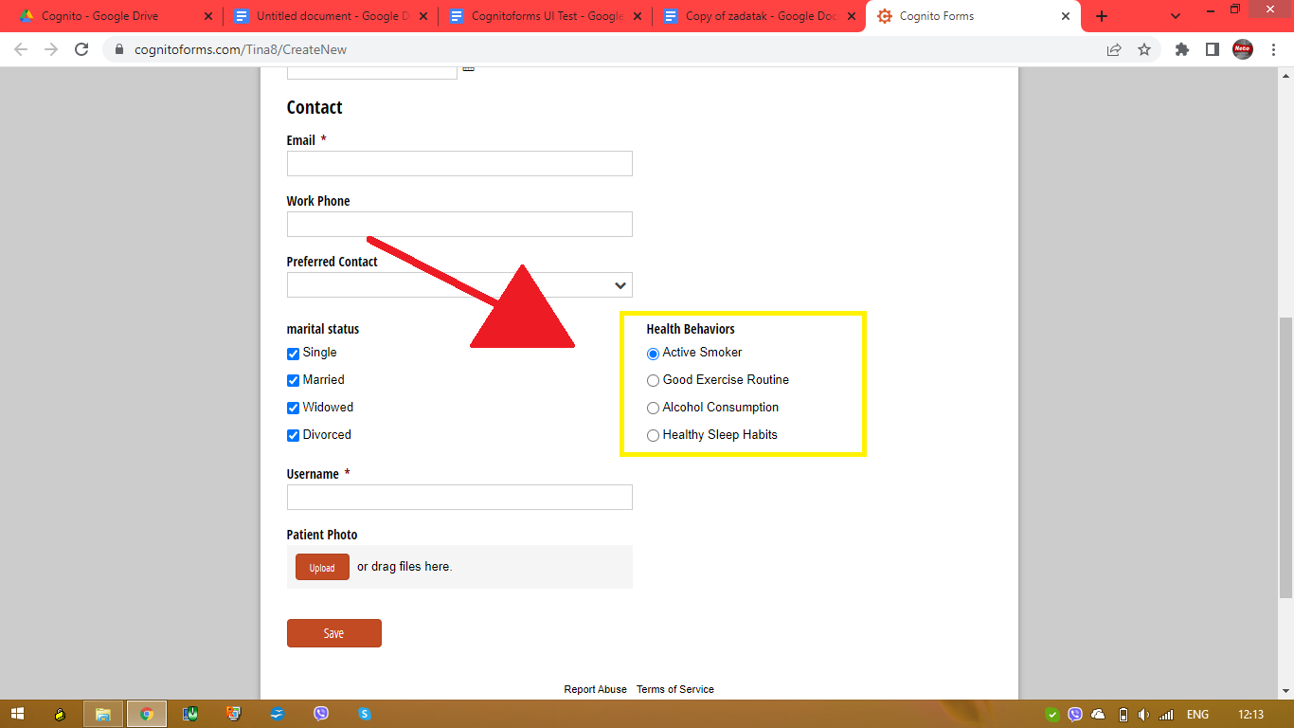

9. Error message for section “Last Name” needs to be changed from “Lastname is required” to “Last Name is required.”. Picture below.

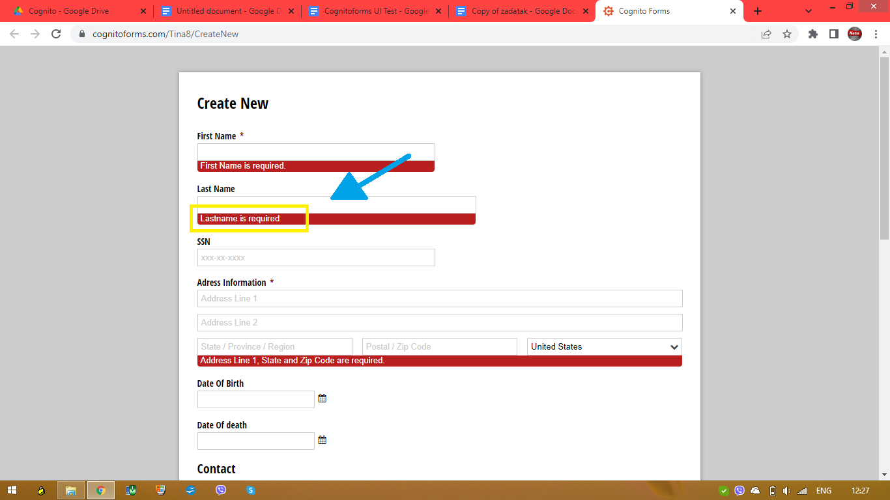

10. Error message for section “Adress Information” needs to be changed from “Address Line 1, State and Zip Code are required.” to “Address Line 1, State/Province/Region and Postal/Zip Code are required.” Picture below.

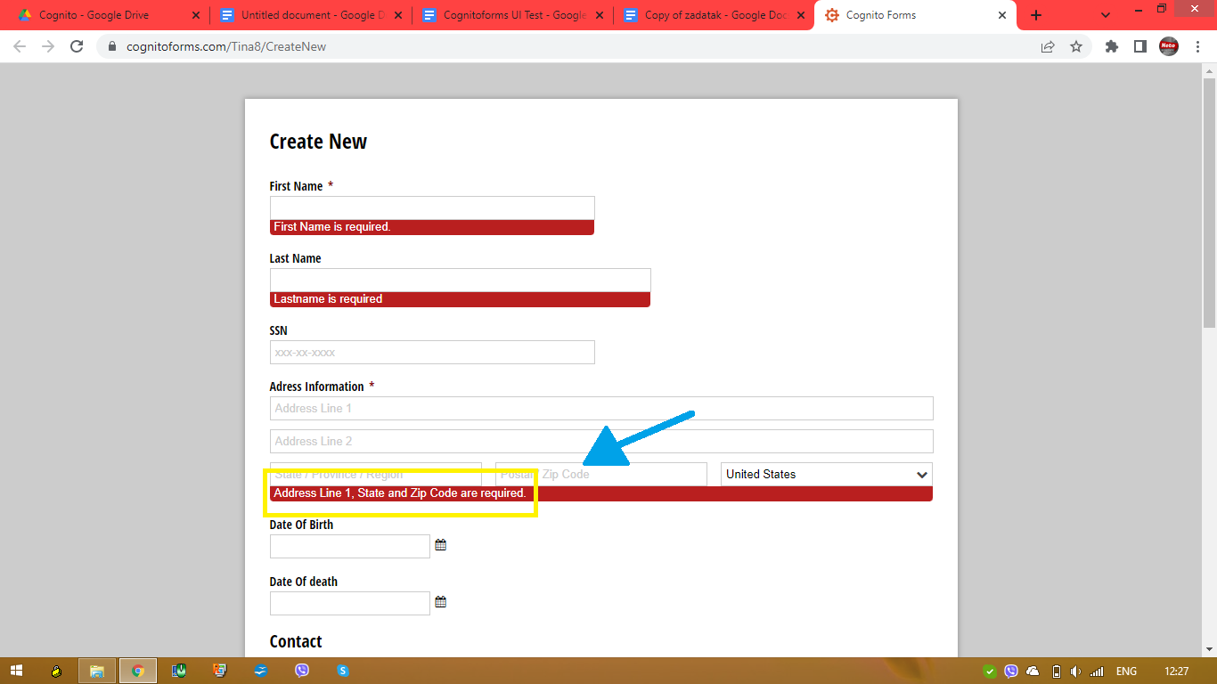

11. Under the section “Patient Photo” needs to be “Upload or drag a file here.” Picture below.

