Dropout Watch: Early Identification of At-Risk University Students Using Logistic Regression, Decision Tree, and Random Forest Classifiers
[INSERT MEMBER 1], [INSERT MEMBER 2], [INSERT MEMBER 3], [INSERT MEMBER 4], [INSERT MEMBER 5]
Group [INSERT GROUP NO.], Course [INSERT COURSE & SECTION]
National University, Philippines | Instructor: Dr. Armida P. Salazar
Emails: [INSERT]

Abstract—University dropout wastes students’ effort and institutional resources, yet advisors rarely know early which students need support. This study builds a supervised classifier that flags students at risk of dropping out. Using 10,000 student records with 15 predictors and a binary dropout label (23.5% positive), we performed exploratory data analysis (EDA), then compared exactly three traditional algorithms—Logistic Regression, Decision Tree, and Random Forest—under identical conditions: one stratified 80/20 split, the same five-fold cross-validation folds, the same leakage-safe preprocessing pipeline, and class-weighted learning. Because missing an at-risk student is the costlier error, dropout-class recall was the selection metric. Logistic Regression was selected (CV recall 0.755 ± 0.031, ROC AUC 0.822 ± 0.010). On the untouched test set it reached recall 0.760, precision 0.470, macro F1 0.697, and ROC AUC 0.820. The model is deployed in a Streamlit application as a screening aid for academic advisors.
Keywords—student dropout prediction, logistic regression, class imbalance, exploratory data analysis, Streamlit
I. INTRODUCTION
Student attrition is a long-standing concern in higher education. Foundational work frames dropout as the outcome of a student’s academic and social integration into the institution [1], which implies that academic performance, engagement, and personal circumstances carry early warning signals. Institutions that detect these signals early can direct tutoring, counseling, and financial support to the students who need them most.
The practical problem addressed here is: given a student’s current academic, behavioral, and background attributes, estimate whether the student is at risk of dropping out. The intended users are academic advisors and student-success staff, who would use the output to prioritize outreach, not to make final decisions about any student. Machine learning is appropriate because the signals are numerous, interact across variables, and are impractical to weigh by hand across thousands of students.
The task is a binary classification problem with a naturally imbalanced target, where simple accuracy is misleading and the costs of errors are unequal [2]. Our research objective is to determine which of three traditional algorithms—Logistic Regression, Decision Tree, and Random Forest—best identifies at-risk students under a fair, leakage-free experimental design, and to deliver the selected model in a usable application. The scope is limited to tabular supervised learning; neural networks, deep learning, and AutoML are excluded by project rules.
II. METHODS
A. Dataset and Ethics
The dataset (student_dropout_dataset_v3.csv) contains 10,000 student records and 19 columns: an identifier, 17 candidate predictors, and the binary target Dropout (1 = dropped out). The unit of analysis is one student. Source, license, and collection method: [INSERT SOURCE LINK, LICENSE/PERMISSION, AND COLLECTION METHOD] [3]. No names or contact details are present; the identifier is a sequential integer and is excluded from modeling. The group should state here whether the records are real institutional data (and the ethical approval or permission obtained) or synthetic data. A data dictionary is given in Appendix A.
B. EDA Procedure
EDA covered dimensions and types, missing values, duplicates, impossible values, univariate distributions, feature–target relationships (Pearson correlation for numeric variables and group-wise dropout rates for categorical ones), class balance, and outliers (1.5×IQR rule, followed by a judgment on whether values were errors or legitimate extremes). Every figure below is tied to a finding or a decision.
C. Preprocessing and Leakage Control
All transformations are inside a single scikit-learn Pipeline [4], so that they are fit only on training folds during cross-validation and on the training split for the final model: median imputation and standardization for 8 numeric predictors; most-frequent imputation and one-hot encoding (unknown categories ignored) for 7 categorical predictors. Student_ID was dropped as an identifier, and Semester_GPA and CGPA were dropped because they are nearly redundant with GPA (GPA–CGPA r = 0.96; Semester_GPA–CGPA r ≈ 1.00; see Section III-A). No rows were deleted. Class imbalance was handled with class_weight=“balanced” in all three models rather than resampling, so that the evaluation data keep their natural distribution.
D. Experimental Design
The data were split 80/20 with stratification on the target (8,000 training and 2,000 test records; random_state = 42). The data are not time-ordered, so a random split is appropriate. All tuning used five-fold stratified cross-validation inside the training set, with the same fold assignments for all three algorithms. The test set was used once, for the selected model only.
E. Algorithms and Tuning
Exactly three traditional algorithms were compared: (1) Logistic Regression, an interpretable linear model for binary outcomes [5]; (2) a CART Decision Tree, which captures nonlinear thresholds and interactions and is easily visualized [6]; and (3) a Random Forest, an ensemble of decorrelated trees that reduces variance [7]. Hyperparameters were tuned by grid search on cross-validated macro F1. We tuned on macro F1 rather than recall because maximizing recall alone can select degenerate settings that flag nearly every student. Grids and selected values are in Table I.
Table I
Hyperparameter grids and selected values
Model | Grid searched | Selected
Logistic Reg. | C {0.01, 0.1, 1, 10}; penalty {L1, L2}; liblinear | C = 0.01, L2
Decision Tree | max_depth {3, 5, 7, 10}; min_samples_leaf {2, 10, 30} | depth 5, leaf 30
Random Forest | 200 trees; max_depth {5, 10, None}; min_samples_leaf {5, 20} | depth None, leaf 5

F. Evaluation Metrics
The costs of the two error types are unequal. A false negative is an at-risk student who receives no support, while a false positive is an extra advising conversation for a student who would have stayed. We therefore selected dropout-class recall (sensitivity) as the primary metric and always report it alongside precision so that flagging everyone cannot look good. Supporting metrics for all models are accuracy, dropout-class precision, F1, macro F1, ROC AUC, and the confusion matrix, reported as mean ± standard deviation across folds. Precision–recall analysis is recommended for imbalanced data [8].
G. Software and Application
Experiments used Python 3.12 and scikit-learn 1.8.0 [4]. As a baseline, the group also ran an Orange workflow [9] with default settings on the full data set (Section III-D). The selected pipeline is saved with joblib and loaded by a Streamlit application [10] that accepts validated form inputs or a CSV upload.
III. RESULTS
A. EDA Findings
Data quality. There are no duplicate rows. Family_Income, Study_Hours_per_Day, and Stress_Index each have 500 missing values (5.0%) and Parental_Education has 511 (5.1%) (Fig. 1b). Missingness rates are about 5% in both outcome classes, which suggests it is unrelated to dropout; we therefore imputed using training-set statistics instead of dropping rows. All values lie in plausible ranges (age 17–29.6, GPA 0–4, attendance 38.2–100%, stress 1–10), so no impossible values were found.
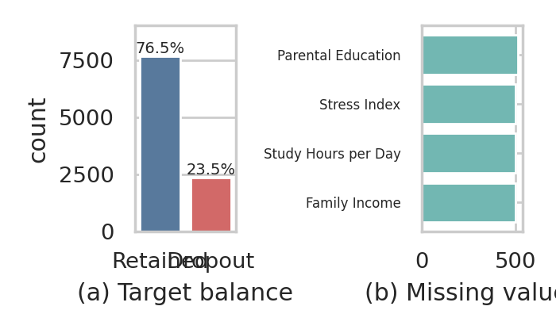
Fig. 1. (a) Class distribution: 23.5% of students dropped out. (b) Missing values by variable. Finding: the target is imbalanced, so accuracy alone is misleading, and class weighting plus recall-based evaluation are required.
Target balance. 76.5% of students were retained and 23.5% dropped out (Fig. 1a). A classifier that always predicts “retained” would score 76.5% accuracy while finding no at-risk students, which is why accuracy is not used for selection.
Key relationships. GPA is the strongest signal (r = −0.46 with Dropout); mean GPA is 2.58 for retained students and 1.43 for dropouts (Fig. 2). Stress_Index (r = +0.26), Attendance_Rate (−0.16), Study_Hours_per_Day (−0.09), and Assignment_Delay_Days (+0.08) follow. Age, Travel_Time, Family_Income, and the identifier are essentially uncorrelated with the target (|r| ≤ 0.03), and the identifier is excluded.
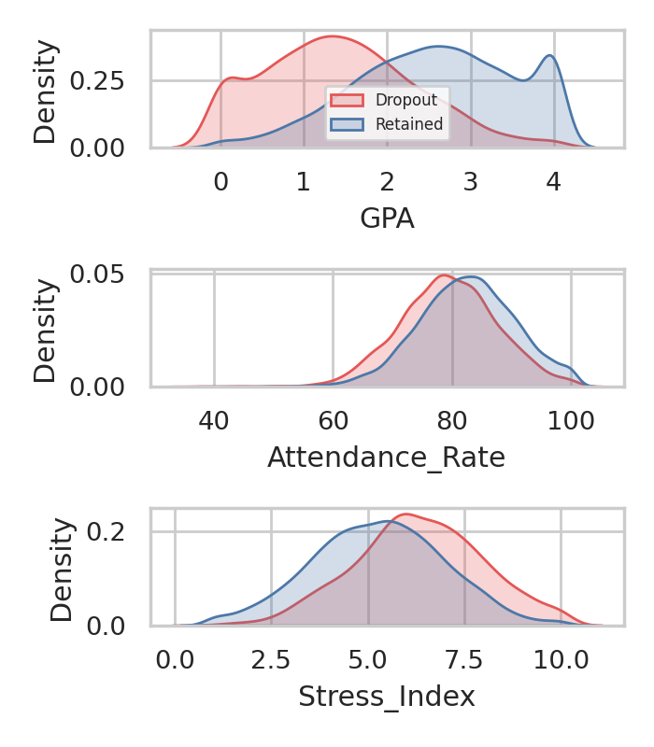
Fig. 2. Distributions of GPA, attendance rate, and stress index by outcome. Finding: dropouts cluster at lower GPA and attendance and higher stress, supporting a largely additive, monotonic relationship that a linear model can capture.
Collinearity. GPA, Semester_GPA, and CGPA are highly correlated (GPA–CGPA r = 0.96; Semester_GPA–CGPA r = 0.999; Fig. 3). Keeping all three would make Logistic Regression coefficients unstable without adding information, so only GPA was retained.
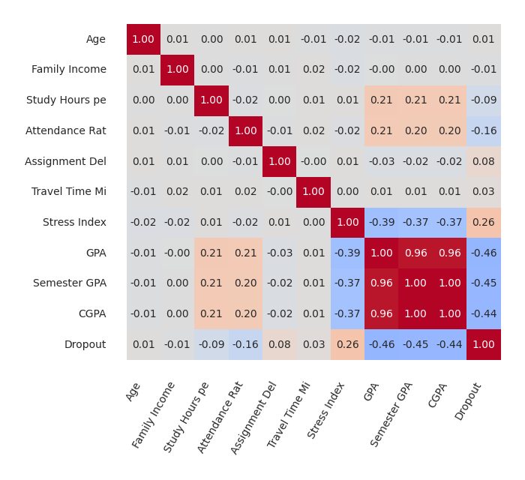
Fig. 3. Correlation matrix of numeric variables. Finding: the three GPA variables are near-duplicates; GPA is the most target-relevant, so Semester_GPA and CGPA are dropped.
Categorical variables. Dropout rates differ little across departments (23.0–24.0%), semesters (22.2–24.4%), and parental education (22.1–24.6%); larger gaps appear for part-time work (25.4% vs. 22.3%) and lack of internet access (28.4% vs. 22.9%) (Fig. 4). These variables are retained but are expected to contribute modestly.
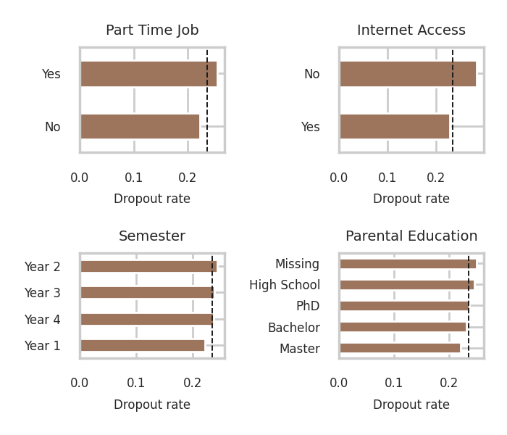
Fig. 4. Dropout rate by category; dashed line is the overall rate (23.5%). Finding: internet access and part-time work show the clearest differences; department and semester are close to the base rate.
Outliers. Family_Income has a hard floor at 25,000, shared by 3,668 records (36.7%), and a long right tail up to 316,601 (604 values above the 1.5×IQR fence) (Fig. 5). The floor looks like censoring or a data-generation artifact and is documented as a limitation. The high incomes are plausible extremes, not errors, so they were kept; standardization limits their influence on the linear model.
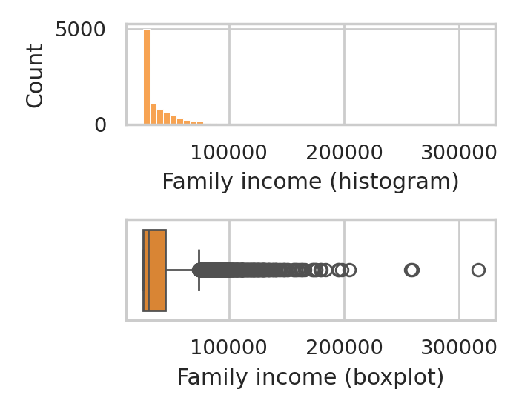
Fig. 5. Family income distribution and boxplot. Finding: a floor at 25,000 and a long right tail; extreme values are retained as legitimate.
B. Cross-Validation Comparison
Table II reports five-fold CV results on the training set, using the same folds and pipeline for every model, and Fig. 6 summarizes them. Logistic Regression had the highest dropout recall and ROC AUC. Random Forest had the highest macro F1, accuracy, and precision but a recall about 0.15 lower. The Decision Tree was lowest on AUC and macro F1 and had the most variable accuracy.
Table II
Five-fold CV results, mean ± SD (training set only)
Metric | Logistic Reg. | Decision Tree | Random Forest
Recall (dropout) | 0.755 ± 0.031 | 0.719 ± 0.032 | 0.601 ± 0.022
Precision (dropout) | 0.469 ± 0.007 | 0.457 ± 0.023 | 0.539 ± 0.005
F1 (dropout) | 0.578 ± 0.012 | 0.558 ± 0.012 | 0.569 ± 0.012
Macro F1 | 0.696 ± 0.007 | 0.682 ± 0.015 | 0.713 ± 0.007
ROC AUC | 0.822 ± 0.010 | 0.793 ± 0.006 | 0.810 ± 0.009
Accuracy | 0.741 ± 0.005 | 0.731 ± 0.020 | 0.785 ± 0.003

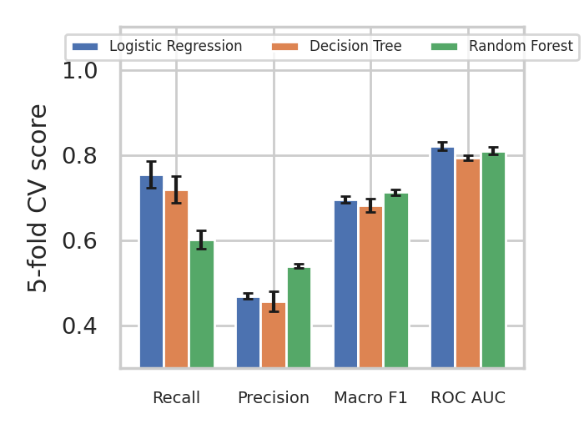
Fig. 6. Cross-validation comparison (mean ± SD). Logistic Regression leads on recall and ROC AUC; Random Forest leads on precision and macro F1.
C. Final Test Results
Logistic Regression was selected on cross-validated recall and then evaluated once on the 2,000 held-out records (Table III, Fig. 7). Test results are consistent with the CV estimates (recall 0.760 vs. 0.755; ROC AUC 0.820 vs. 0.822), which indicates no overfitting to the validation folds.
Table III
Held-out test results, Logistic Regression (evaluated once)
Metric | Test | CV mean
Recall (dropout) | 0.760 | 0.755
Precision (dropout) | 0.470 | 0.469
F1 (dropout) | 0.581 | 0.578
Macro F1 | 0.697 | 0.696
ROC AUC | 0.820 | 0.822
Accuracy | 0.742 | 0.741

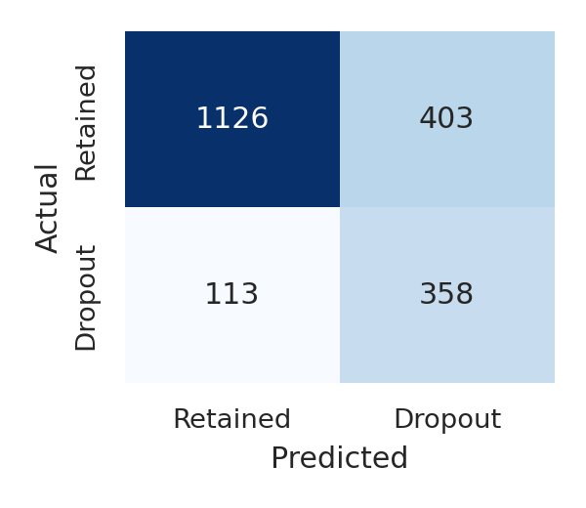
Fig. 7. Test confusion matrix (n = 2,000): 358 dropouts correctly flagged, 113 missed, 403 retained students flagged, and 1126 correctly cleared.
Of the 471 students who actually dropped out, 358 were flagged (76.0%). Of 1529 retained students, 403 (26.4%) were flagged unnecessarily. Fewer than half of flagged students (precision 0.470) go on to drop out.
Model interpretation. Standardized coefficients (Fig. 8) show GPA as the dominant protective factor (−1.08), followed by attendance (−0.24); stress (+0.30), assignment delays (+0.21), and travel time (+0.11) raise risk. The signs agree with the EDA. Categorical coefficients are small because of strong L2 regularization (C = 0.01).
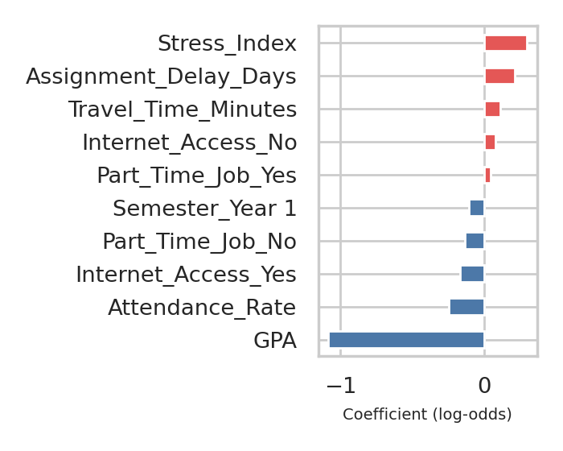
Fig. 8. Largest standardized coefficients of the selected Logistic Regression (red raises risk, blue lowers it).
D. Orange Baseline
To cross-check the pipeline, an Orange workflow [9] (Table IV) evaluated default Tree, Logistic Regression, and Random Forest learners by stratified five-fold cross-validation on all 10,000 records, with dropout as the target class. These runs were unweighted, untuned, and not held out, so they are a baseline, not the reported result. Their AUCs agree with ours (Logistic Regression 0.821 vs. 0.822; Tree 0.797 vs. 0.793). Dropout recall under defaults was only 0.37–0.41, so about 60% of dropouts were missed, which supports the use of class weighting.
Table IV
Orange baseline (defaults, 5-fold CV, target = dropout)
Model | AUC | CA | F1 | Prec. | Recall | MCC
Tree | 0.797 | 0.797 | 0.464 | 0.612 | 0.373 | 0.364
Logistic Reg. | 0.821 | 0.810 | 0.501 | 0.655 | 0.405 | 0.408
Random Forest | 0.778 | 0.794 | 0.476 | 0.592 | 0.398 | 0.364

E. Application Evidence
The Streamlit application loads the saved pipeline, identifies the model in use, lists each input with its units, rejects out-of-range numeric entries through bounded fields, validates uploaded CSV columns and category values with readable error messages, and shows the dropout probability and a flag at a 0.5 threshold. Deployed URL: [INSERT URL]. Repository: [INSERT LINK]. Screenshots and the test log (valid, invalid, and boundary inputs) are placed in Appendix B.
IV. DISCUSSION
Why Logistic Regression performed best on the primary metric. The EDA shows that risk rises roughly monotonically as GPA and attendance fall and stress rises, which is the kind of additive structure a regularized linear model captures efficiently. Random Forest and the Decision Tree can fit interactions, but the data show no strong evidence of them, and several variables (age, travel time, department) are close to noise, which lets flexible models fit chance patterns; this is a likely explanation, not one we tested directly.
The gap between models must be read with the fold variability in mind. Logistic Regression’s recall advantage over Random Forest (0.755 vs. 0.601) is large relative to the fold SDs (≤ 0.031). Its recall advantage over the Decision Tree (0.755 vs. 0.719) is about the size of one SD, so that ranking is not conclusive on recall alone; the stronger evidence against the Tree is ROC AUC (0.822 vs. 0.793, SD ≈ 0.006–0.010).
Tradeoffs. Random Forest is more accurate (0.785) and more precise (0.539) and so flags fewer students unnecessarily, but it misses roughly 40% of dropouts in cross-validation. If counselling capacity were severely limited, its higher precision could justify the choice, and a different threshold on Logistic Regression could also trade recall for precision. We chose Logistic Regression because the costlier error is a missed at-risk student and because its coefficients can be explained to advisors, who are more likely to trust and act on a transparent model. Training and prediction are also fast enough for a lightweight web application.
Errors. On the test set, 24.0% of dropouts were missed and 26.4% of retained students were flagged. Because precision is below 0.5, a flag should be treated as a prompt for a supportive conversation, never as a conclusion about a student.
V. CONCLUSION AND RECOMMENDATIONS
Among the three algorithms compared, Logistic Regression best met the objective of finding at-risk students, with cross-validated recall of 0.755 and held-out recall of 0.760 at precision 0.470. It is deployed as a simple, interpretable screening tool.
Limitations. (1) Data provenance and generalizability: [INSERT whether records are real or synthetic and from which institution]; results may not transfer to other populations. (2) Timing: GPA may be recorded close to or after the dropout event; the group should confirm that it is available early enough for the intended use, as otherwise it leaks the outcome. (3) Family_Income is floored at 25,000 for 36.7% of records. (4) The 0.5 threshold was not tuned. (5) Cross-sectional data cannot support causal claims. (6) Gender, income, and parental education are inputs, so a fairness audit across groups is needed before real use. (7) Selection history: an earlier iteration selected on macro F1, which favored Random Forest; the selection criterion was changed to recall on cost grounds, and the group had already seen Random Forest’s test score at that time. We disclose this for transparency.
Recommendations. Tune the decision threshold with precision–recall analysis [8] and expected intervention cost; validate on a later cohort with a chronological split; add engagement features such as LMS activity and financial holds; calibrate probabilities; audit performance by gender, income band, and department; and monitor the deployed model for drift.
REFERENCES
[1] V. Tinto, “Dropout from higher education: A theoretical synthesis of recent research,” Rev. Educ. Res., vol. 45, no. 1, pp. 89–125, 1975.
[2] H. He and E. A. Garcia, “Learning from imbalanced data,” IEEE Trans. Knowl. Data Eng., vol. 21, no. 9, pp. 1263–1284, Sep. 2009.
[3] [INSERT DATASET CITATION: author/organization, “student_dropout_dataset_v3,” source, year, URL, accessed date.]
[4] F. Pedregosa et al., “Scikit-learn: Machine learning in Python,” J. Mach. Learn. Res., vol. 12, pp. 2825–2830, 2011.
[5] D. W. Hosmer, S. Lemeshow, and R. X. Sturdivant, Applied Logistic Regression, 3rd ed. Hoboken, NJ, USA: Wiley, 2013.
[6] L. Breiman, J. H. Friedman, R. A. Olshen, and C. J. Stone, Classification and Regression Trees. Belmont, CA, USA: Wadsworth, 1984.
[7] L. Breiman, “Random forests,” Mach. Learn., vol. 45, no. 1, pp. 5–32, 2001.
[8] T. Saito and M. Rehmsmeier, “The precision-recall plot is more informative than the ROC plot when evaluating binary classifiers on imbalanced datasets,” PLoS ONE, vol. 10, no. 3, Art. no. e0118432, 2015.
[9] J. Demšar et al., “Orange: Data mining toolbox in Python,” J. Mach. Learn. Res., vol. 14, pp. 2349–2353, 2013.
[10] Streamlit Inc., “Streamlit documentation.” [Online]. Available: https://docs.streamlit.io (accessed Oct. 11, 2026).

Appendix A. Data Dictionary
Table A1
Variables in student_dropout_dataset_v3.csv (10,000 rows)
Variable | Type | Definition / units
Student_ID | Integer | Sequential identifier (excluded)
Age | Numeric | Years
Gender | Categorical | Female, Male
Family_Income | Numeric | Family income (floor 25,000; currency per source) [INSERT unit]
Internet_Access | Categorical | Yes, No
Study_Hours_per_Day | Numeric | Hours per day
Attendance_Rate | Numeric | % of classes attended
Assignment_Delay_Days | Integer | Days assignments are late (0–8 observed)
Travel_Time_Minutes | Numeric | Minutes (5–74.9 observed)
Part_Time_Job | Categorical | Yes, No
Scholarship | Categorical | Yes, No
Stress_Index | Numeric | 1 (low) to 10 (high)
GPA | Numeric | 0.0–4.0 scale
Semester_GPA | Numeric | Semester GPA (excluded, near-duplicate)
CGPA | Numeric | Cumulative GPA (excluded, near-duplicate)
Semester | Categorical | Year 1–Year 4
Department | Categorical | Arts, Business, CS, Engineering, Science
Parental_Education | Categorical | High School, Bachelor, Master, PhD
Dropout | Binary target | 1 = dropped out, 0 = retained

Appendix B. Sample Inputs and Outputs, and Application Test Log
Unlisted fields use the baseline profile: Age 21, Female, income 38,000, internet Yes, 4.0 study hours, attendance 82%, 2 delay days, 30 min travel, no part-time job, no scholarship, stress 5.5, GPA 2.5, Year 2, CS, Bachelor. Probabilities come from the saved final model.
Table B1
Sample predictions from the saved Logistic Regression pipeline
Profile | Changes from baseline | P(dropout) | Flag (≥0.5)
A (typical) | none | 0.337 | Not flagged
B (low risk) | GPA=3.6; Attendance_Rate=95; Stress_Index=3; Assignment_Delay_Days=0; Study_Hours_per_Day=6 | 0.048 | Not flagged
C (high risk) | GPA=1.2; Attendance_Rate=60; Stress_Index=8.5; Assignment_Delay_Days=5; Part_Time_Job=Yes; Internet_Access=No | 0.938 | At risk
D (boundary: GPA 0.0) | GPA=0 | 0.867 | At risk
E (boundary: GPA 4.0, att 100) | GPA=4; Attendance_Rate=100 | 0.061 | Not flagged

Table B2
Application test log (group to complete after running the deployed app)
Test case | Expected behavior | Observed
Valid form input | Probability and flag displayed | [INSERT]
GPA = 0.0 / 4.0 (boundary) | Accepted; prediction displayed | [INSERT]
Attendance = 101 (invalid) | Field rejects value | [INSERT]
CSV with missing column | Readable error listing missing columns | [INSERT]
CSV with unknown category | Readable error naming the column | [INSERT]
Missing optional values in CSV | Imputed; prediction displayed | [INSERT]
Screenshots | Form, result, and error screens | [INSERT FIGURES]

Appendix C. Group Contribution Record
Table C1
Member contributions (to be completed and confirmed by all members)
Member | Assigned responsibility | Actual contribution | Confirmed
[INSERT] | [e.g., EDA] | [INSERT] | [ ]
[INSERT] | [e.g., modeling] | [INSERT] | [ ]
[INSERT] | [e.g., Streamlit app] | [INSERT] | [ ]
[INSERT] | [e.g., paper] | [INSERT] | [ ]
[INSERT] | [e.g., documentation] | [INSERT] | [ ]

Appendix D. Ownership and Authorship Declaration
[INSERT the signed Ownership and Authorship Declaration (PDF) here. It must be signed by Dr. Armida P. Salazar and all student group members.]

