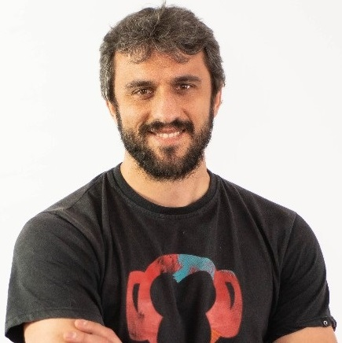
Ciro Iván
Full Stack Software Engineer | AI-Assisted Development
• ivan-ciro@outlook.com • +34 694 212 763 • València, Spain
• https://linkedin.com/in/ciroivandev • https://github.com/k1r0s

SUMMARY
Full-Stack Engineer with 10+ years of experience building scalable web & mobile applications, user-facing features, and conversion-focused digital products in fast-paced startup and product environments. Strong expertise across frontend and backend development, product experimentation, UI optimization, and AIassisted engineering workflows. Experienced collaborating closely with product, growth, and design teams to rapidly ship features, improve user journeys, and maintain high standards of code quality and reliability. Passionate about pragmatic engineering, clean implementation, experimentation, and using AI tools responsibly to improve development velocity and product quality.

SKILLS
• Language: JavaScript, TypeScript, Python, PHP, Ruby, Swift, Go, Java, Kotlin, C/C++, C#

• Backend: Ruby on Rails, Django, Flask, Node.js, Express.js, Next.js, REST APIs, FastAPI, .NET, .NET Core, .NET Framework, ASP.Net, Spring Boot, Hibernate, GraphQL, Laravel, Apollo, Remix, MicroServices, Entity Framework, LINQ

• Database: MySQL, PostgreSQL, SQL server Express, MongoDB, Oracle, JDBC, Redis, Prisma, NoSQL, Aurora, DynamoDB

• Growth Engineering: A/B Testing, Conversion Funnels, Experimentation

• Practices: Agile/Scrum, Clean Code, CI/CD, Pragmatic Engineering, webMCP, SEO, Elasticsearch

WORK EXPERIENCE
CTO / Principal Backend Engineer 11/2023 – 06/2025
Autónomo València, Spain

Co-Founder / Full-Stack Engineer 10/2022 – 11/2023
Einabit Valencian Community, Spain

Lead Full-Stack Developer 01/2021 – 09/2022
Trucksters València, Spain

Lead MERN Stack Developer 01/2018 – 01/2021
Dribo València, Spain

Lead Frontend Developer 9/2017-7/2018
QMENTA.Inc Barcelona, Spain

Senior Frentend Developer 06/2017-09/2017
Vueling Alicanta, Spain

Senior Frentend Developer 03/2017-06/2017
Entradas a tu alcance Alicanta, Spain

Lead Backend Developer 06/2016-03/2017
Jitrix Software & Design Alicanta, Spain

Full-Stack Developer 09/2015 – 06/2016
Gfi España Alicanta, Spain

Python Backend Developer 04/2015 – 09/2015
Everis Alicanta, Spain
• Built and maintained scalable web applications using C#, .NET, Azure-based services, user-facing systems, and conversion-focused frontend experiences

EDUCATION
B.S. in Systems Engineering 2013-2015
Escuela Tecnológica Instituto Técnico Bogotá, Colombia

Advanced Technician in Multiplatform Application Development, Web Application Development 2012 – 2013
CIFP Batoi Valencia, Spain

ADDITIONAL STRENGTHS
• Strong ownership mentality and startup mindset
• Comfortable using AI tools daily in engineering workflows
• Strong eye for code quality, QA and maintainability
• Product-focused and highly pragmatic engineering approach
• Excellent communication skills in remote-first environments

