Theory:
Histogram:
A histogram is a graphical representation that shows the distribution of pixel intensities in an
image. It displays the frequency of each intensity value on the horizontal axis and the number
of pixels with that intensity value on the vertical axis.

Histogram Equalization:
Histogram equalization is a technique used to enhance the contrast of an image by
redistributing the intensity values. It stretches the histogram of an image to cover the full range
of intensity values, resulting in a more balanced and visually appealing image.

Histogram Matching:
Histogram matching is a process of transforming an image to match the histogram of a
reference image. It is used to transfer the characteristics of the reference image's hi

Flowchart:
The flowchart for the program will consist of the following steps:

Load the input image.
Generate and display the histogram of the image.
Apply histogram equalization to enhance the contrast.
Generate and display the histogram of the equalized image.
Load the reference image for histogram matching.
Perform histogram matching between the input image and reference image.
Generate and display the histogram of the matched image.
Display the original image, equalized image, and matched image side by side.
Save the equalized and matched images (optional).

Program
Now, let's see the Python program that implements histogram generation, histogram
equalization, and histogram matching:

import cv2
import numpy as np
import matplotlib.pyplot as plt
def generate_histogram(image):
# Calculate the histogram of the image
histogram = cv2.calcHist([image], [0], None, [256], [0, 256])
return histogram
def perform_histogram_equalization(image):
# Convert image to grayscale
gray_image = cv2.cvtColor(image, cv2.COLOR_BGR2GRAY)

# Apply histogram equalization
equalized_image = cv2.equalizeHist(gray_image)
return equalized_image

def perform_histogram_matching(input_image, reference_image):
# Convert images to grayscale
gray_input = cv2.cvtColor(input_image, cv2.COLOR_BGR2GRAY)
gray_reference = cv2.cvtColor(reference_image, cv2.COLOR_BGR2GRAY)

# Calculate histograms
input_hist = generate_histogram(gray_input)
reference_hist = generate_histogram(gray_reference)

# Perform histogram matching
matched_image = cv2.matchHistograms(gray_input, gray_reference,
method=cv2.HISTCMP_HELLINGER)
return matched_image

# Load the input image
input_path = 'input_image.jpg'
input_image = cv2.imread(input_path)

# Generate and display the histogram of the input image
input_hist = generate_histogram(input_image)
plt.plot(input_hist)
plt.title("Input Image Histogram")
plt.xlabel("Intensity")
plt.ylabel("Frequency")
plt.show()

# Perform histogram equalization
equalized_image = perform_histogram_equalization(input_image)

# Generate and display the histogram of the equalized image
equalized_hist = generate_histogram(equalized_image)
plt.plot(equalized_hist)
plt.title("Equalized Image Histogram")
plt.xlabel("Intensity")
plt.ylabel("Frequency")
plt.show()

# Load the reference image for histogram matching
reference_path = 'reference_image.jpg'
reference_image = cv2.imread(reference_path)

# Perform histogram matching
matched_image = perform_histogram_matching(input_image, reference_image)

# Generate and display the histogram of the matched image
matched_hist = generate_histogram(matched_image)
plt.plot(matched_hist)
plt.title("Matched Image Histogram")
plt.xlabel("Intensity")
plt.ylabel("Frequency")
plt.show()

# Display the original image, equalized image, and matched image side by side
combined_image = np.hstack((input_image, equalized_image, matched_image))
cv2.imshow("Original | Equalized | Matched", combined_image)
cv2.waitKey(0)

# Save the equalized and matched images (optional)
equalized_path = 'equalized_image.jpg'
matched_path = 'matched_image.jpg'
cv2.imwrite(equalized_path, equalized_image)
cv2.imwrite(matched_path, matched_image)
print(f"Equalized image saved at: {equalized_path}")
print(f"Matched image saved at: {matched_path}")

Explanation:

We import the required modules, including cv2 for image processing, numpy for array
operations, and matplotlib.pyplot for plotting the histogram.
The generate_histogram function takes an image as input and calculates its histogram using the
cv2.calcHist function.
The perform_histogram_equalization function converts the image to grayscale, applies
histogram equalization using cv2.equalizeHist, and returns the equalized image.
The perform_histogram_matching function performs histogram matching between the input
image and the reference image using cv2.matchHistograms with the
cv2.HISTCMP_HELLINGER method.
In the main part of the program, we load the input image using cv2.imread.
We generate and display the histogram of the input image using the generate_histogram
function and matplotlib.pyplot.plot.
Histogram equalization is performed using the perform_histogram_equalization function, and
the equalized image is stored in the equalized_image variable.
We generate and display the histogram of the equalized image using the same process as step
6.
The reference image is loaded for histogram matching.
Histogram matching is performed using the perform_histogram_matching function, and the
matched image is stored in the matched_image variable.
We generate and display the histogram of the matched image using the same process as step 6.
The original image, equalized image, and matched image are displayed side by side using
cv2.imshow and np.hstack.
The equalized and matched images are saved to files using cv2.imwrite.
You can replace the input_path and reference_path variables with the paths to your input andreference images, respectively.
Remember to have OpenCV and matplotlib installed (pip install opencv-python matplotlib)
before running this program.

Expected Output:
Histogram plots of the input image, equalized image, and matched image will be displayed in
separate windows.
A combined image window will appear showing the original image, equalized image, and
matched image side by side.
The equalized image and matched image will be saved to separate files, and their paths will be
printed as output.
Note: The program assumes that the input image and reference image are in JPEG format, but
you can modify the code to support other formats if needed.

Histogram Equalization:

import cv2
import matplotlib.pyplot as plt

# Load the image
image_path = '/Users/tousifkhan/Desktop/SEM5/DSIP_PRACT/Experiments/Experiment_8/image.png'
# Replace with the path to your image
image = cv2.imread(image_path, cv2.IMREAD_GRAYSCALE)

# Calculate the histogram
histogram = cv2.calcHist([image], [0], None, [256], [0, 256])

# Plot the histogram
plt.figure(figsize=(8, 6))
plt.title('Histogram')
plt.xlabel('Pixel Value')
plt.ylabel('Frequency')
plt.plot(histogram)
plt.xlim([0, 256])
plt.grid(True)
plt.show()

# Perform histogram equalization
equalized_image = cv2.equalizeHist(image)

# Display the original and equalized images
plt.figure(figsize=(10, 5))
plt.subplot(1, 2, 1)
plt.title('Original Image')
plt.imshow(image, cmap='gray')
plt.axis('off')

plt.subplot(1, 2, 2)
plt.title('Equalized Image')
plt.imshow(equalized_image, cmap='gray')
plt.axis('off')

# Calculate the histogram
histogram = cv2.calcHist([equalized_image], [0], None, [256], [0, 256])

# Plot the histogram
plt.figure(figsize=(8, 6))
plt.title('Histogram')
plt.xlabel('Pixel Value')
plt.ylabel('Frequency')
plt.plot(histogram)
plt.xlim([0, 256])
plt.grid(True)
plt.show()

plt.tight_layout()
plt.show()

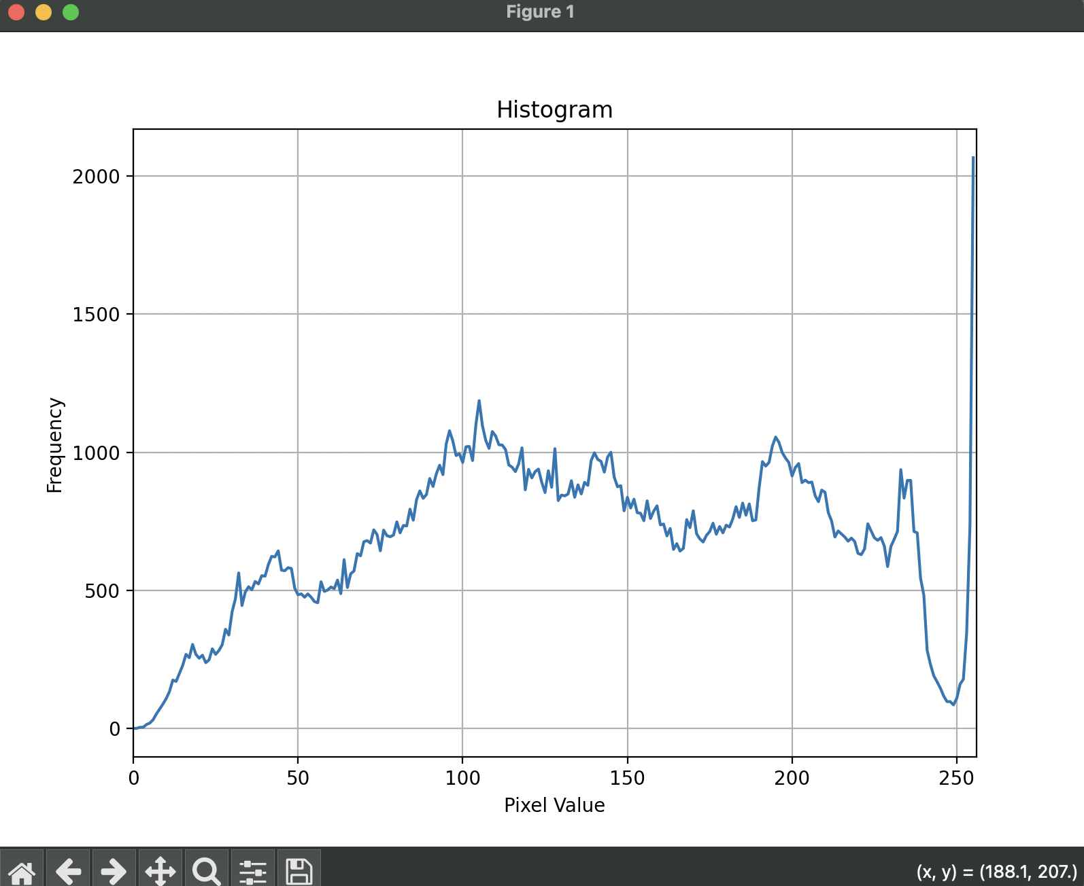

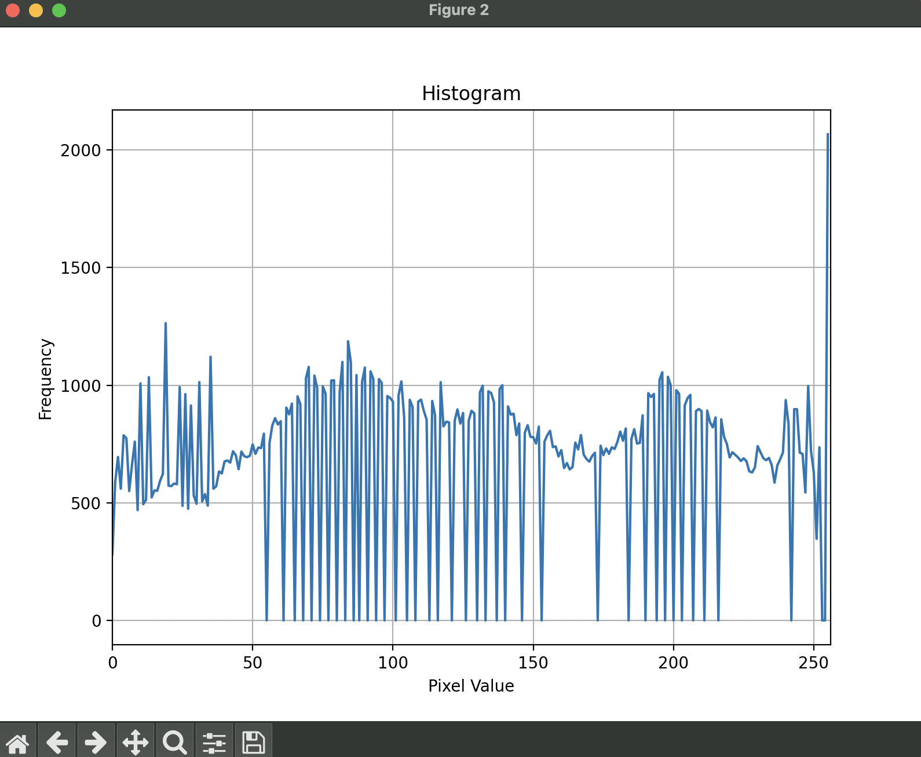

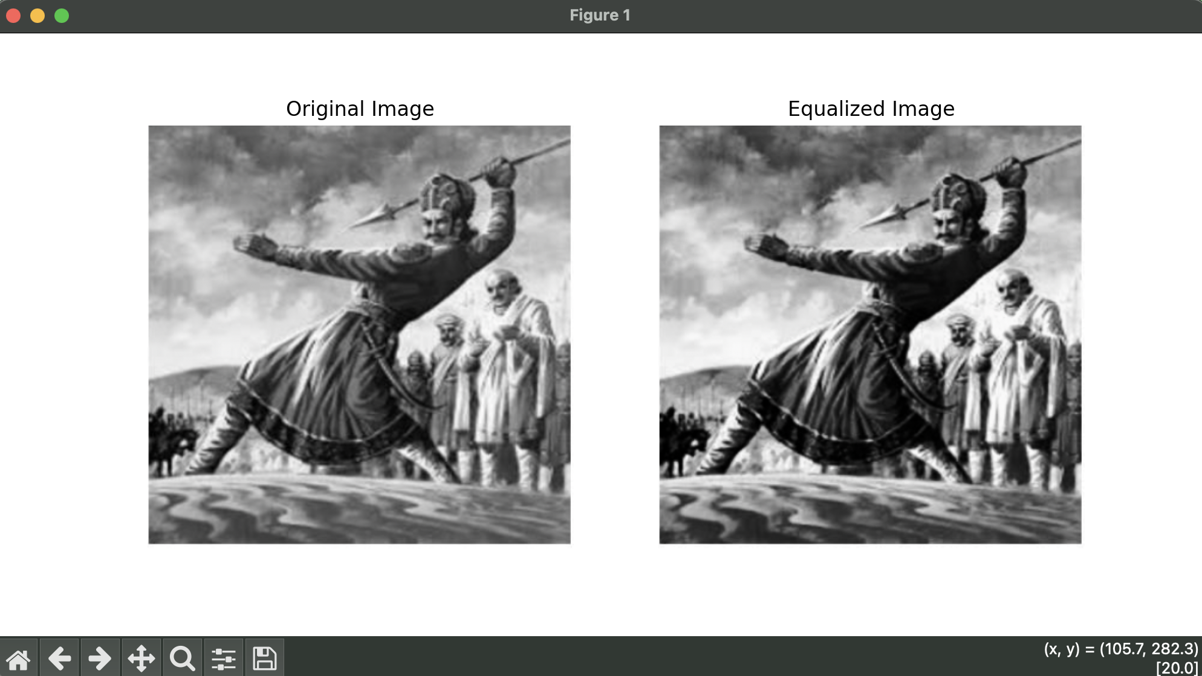

Histogram Matching:

import cv2
import numpy as np
from matplotlib import pyplot as plt

# Load the source and reference images
source_path = '/Users/tousifkhan/Desktop/SEM5/DSIP_PRACT/Experiments/Experiment_8/image.png'
reference_path = '/Users/tousifkhan/Desktop/SEM5/DSIP_PRACT/Experiments/Experiment_8/Reference.png'
source_image = cv2.imread(source_path, cv2.IMREAD_GRAYSCALE)
reference_image = cv2.imread(reference_path, cv2.IMREAD_GRAYSCALE)

# Calculate histograms for the source and reference images
source_hist = cv2.calcHist([source_image], [0], None, [256], [0, 256])
reference_hist = cv2.calcHist([reference_image], [0], None, [256], [0, 256])

# Normalize histograms to have sum equal to 1
source_hist /= source_hist.sum()
reference_hist /= reference_hist.sum()

# Calculate cumulative distribution functions (CDF) for histograms
source_cdf = source_hist.cumsum()
reference_cdf = reference_hist.cumsum()

# Perform histogram matching by mapping source CDF to reference CDF
mapping = np.interp(source_cdf, reference_cdf, range(256))
matched_image = mapping[source_image]

# Convert to uint8 data type
matched_image = matched_image.astype(np.uint8)

# Display the images using Matplotlib
plt.figure(figsize=(12, 6))

plt.subplot(131)
plt.title('Source Image')
plt.imshow(source_image, cmap='gray')
plt.axis('off')

plt.subplot(132)
plt.title('Reference Image')
plt.imshow(reference_image, cmap='gray')
plt.axis('off')

plt.subplot(133)
plt.title('Matched Image')
plt.imshow(matched_image, cmap='gray')
plt.axis('off')

plt.tight_layout()

plt.show()

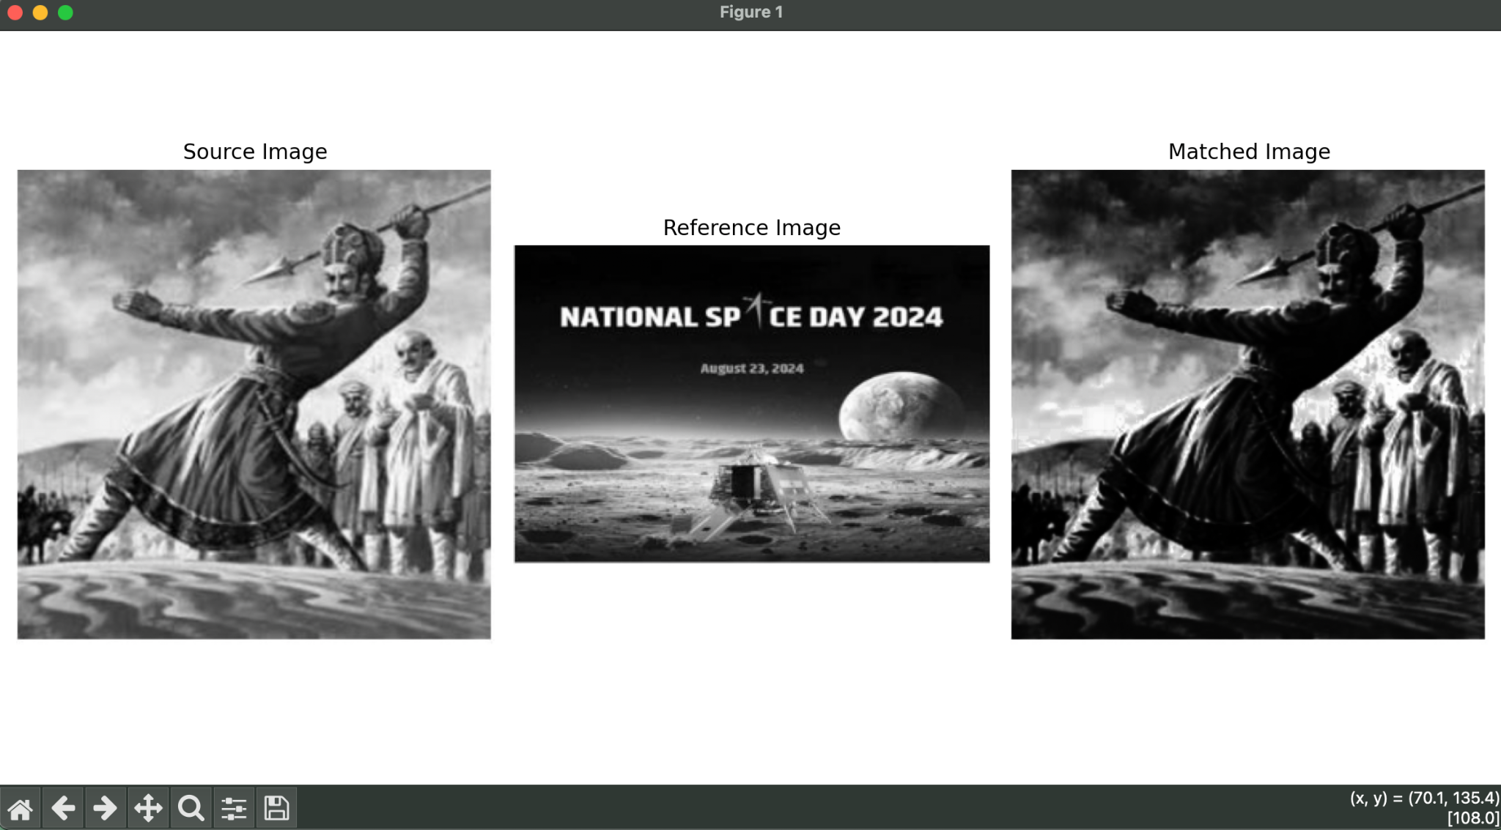

GITHUB LINK:-

https://github.com/SlockAhuja/DSIP.git

