AIM: Design Butterworth and Chebyshev filter using bilinear transformation method.

Theory: The bilinear transformation method is commonly used to design analog filters and then convert them into digital filters. This method maps the analog frequency response to the digital frequency response using a bilinear transformation.

The Butterworth and Chebyshev filters are two commonly used filter types. The Butterworth filter has a maximally flat frequency response in the passband, while the Chebyshev filter allows for a sharper transition between the passband and the stopband at the expense of ripples in either the passband or stopband.

Program:
import numpy as np
import matplotlib.pyplot as plt
from scipy.signal import butter, bilinear, freqz, cheby1
def design_butterworth_filter(filter_order, cutoff_frequency, sampling_frequency):
# Design the analog Butterworth filter
analog_b, analog_a = butter(filter_order, cutoff_frequency, analog=True, btype=&#39;low&#39;)
# Perform the bilinear transformation
digital_b, digital_a = bilinear(analog_b, analog_a, sampling_frequency)
return digital_b, digital_a
def design_chebyshev_filter(filter_order, cutoff_frequency, sampling_frequency, ripple):
# Design the analog Chebyshev filter
analog_b, analog_a = cheby1(filter_order, ripple, cutoff_frequency, analog=True, btype=&#39;low&#39;)
# Perform the bilinear transformation
digital_b, digital_a = bilinear(analog_b, analog_a, sampling_frequency)
return digital_b, digital_a
def plot_filter_response(digital_b, digital_a, sampling_frequency):
# Compute the frequency response of the filter
frequency, magnitude_response = freqz(digital_b, digital_a, fs=sampling_frequency)
# Plot the magnitude response
plt.figure(figsize=(10, 6))
plt.plot(frequency, np.abs(magnitude_response))
plt.title(&#39;Filter Magnitude Response&#39;)
plt.xlabel(&#39;Frequency (Hz)&#39;)
plt.ylabel(&#39;Magnitude&#39;)
plt.grid(True)
plt.show()
# Compute the impulse response of the filter
_, impulse_response = freqz(digital_b, digital_a, fs=sampling_frequency, worN=4096)
# Plot the impulse response
plt.figure(figsize=(10, 6))
plt.plot(impulse_response)

Marwadi University
Faculty of Engineering and Technology
Department of Information and Communication Technology

plt.title(&#39;Filter Impulse Response&#39;)
plt.xlabel(&#39;Samples&#39;)
plt.ylabel(&#39;Amplitude&#39;)
plt.grid(True)
plt.show()
# Specify the desired filter specifications
filter_order = 4 # Filter order
cutoff_frequency = 1000 # Cutoff frequency in Hz
sampling_frequency = 8000 # Sampling frequency in Hz
ripple = 0.5 # Ripple factor for Chebyshev filter
# Design the Butterworth filter
digital_b, digital_a = design_butterworth_filter(filter_order, cutoff_frequency, sampling_frequency)
# Plot the Butterworth filter&#39;s magnitude response and impulse response
plot_filter_response(digital_b, digital_a, sampling_frequency)
# Design the Chebyshev filter
digital_b, digital_a = design_chebyshev_filter(filter_order, cutoff_frequency, sampling_frequency,
ripple)
# Plot the Chebyshev filter&#39;s magnitude response and impulse response
plot_filter_response(digital_b, digital_a, sampling_frequency)
# Save the filter coefficients (optional)
filter_path = &#39;filter_coefficients.txt&#39;
np.savetxt(filter_path, np.vstack((digital_b, digital_a)), delimiter=&#39;,&#39;)
print(f&quot;Filter coefficients saved at: {filter_path}&quot;)

Code:-
import numpy as np
import matplotlib.pyplot as plt
from scipy.signal import butter, bilinear, freqz, cheby1

def design_butterworth_filter(filter_order, cutoff_frequency, sampling_frequency):
# Design the analog Butterworth filter
analog_b, analog_a = butter(filter_order, cutoff_frequency, analog=True, btype='low')
# Perform the bilinear transformation
digital_b, digital_a = bilinear(analog_b, analog_a, sampling_frequency)
return digital_b, digital_a

def design_chebyshev_filter(filter_order, cutoff_frequency, sampling_frequency, ripple):
# Design the analog Chebyshev filter
analog_b, analog_a = cheby1(filter_order, ripple, cutoff_frequency, analog=True, btype='low')
# Perform the bilinear transformation
digital_b, digital_a = bilinear(analog_b, analog_a, sampling_frequency)
return digital_b, digital_a

def plot_filter_response(digital_b, digital_a, sampling_frequency):
# Compute the frequency response of the filter
frequency, magnitude_response = freqz(digital_b, digital_a, fs=sampling_frequency)

# Plot the magnitude response
plt.figure(figsize=(10, 6))
plt.plot(frequency, np.abs(magnitude_response))
plt.title('Filter Magnitude Response')
plt.xlabel('Frequency (Hz)')
plt.ylabel('Magnitude')
plt.grid(True)
plt.show()

# Compute the impulse response of the filter
_, impulse_response = freqz(digital_b, digital_a, fs=sampling_frequency, worN=4096)

# Plot the impulse response
plt.figure(figsize=(10, 6))
plt.plot(impulse_response)
plt.title('Filter Impulse Response')
plt.xlabel('Samples')
plt.ylabel('Amplitude')
plt.grid(True)
plt.show()

# Specify the desired filter specifications
filter_order = 4 # Filter order
cutoff_frequency = 1000 # Cutoff frequency in Hz
sampling_frequency = 8000 # Sampling frequency in Hz
ripple = 0.5 # Ripple factor for Chebyshev filter

# Design the Butterworth filter
digital_b, digital_a = design_butterworth_filter(filter_order, cutoff_frequency, sampling_frequency)

# Plot the Butterworth filter's magnitude response and impulse response
plot_filter_response(digital_b, digital_a, sampling_frequency)

# Design the Chebyshev filter
digital_b, digital_a = design_chebyshev_filter(filter_order, cutoff_frequency, sampling_frequency, ripple)

# Plot the Chebyshev filter's magnitude response and impulse response
plot_filter_response(digital_b, digital_a, sampling_frequency)

# Save the filter coefficients (optional)
filter_path = 'filter_coefficients.txt'
np.savetxt(filter_path, np.vstack((digital_b, digital_a)), delimiter=',')
print(f"Filter coefficients saved at: {filter_path}")

Output:
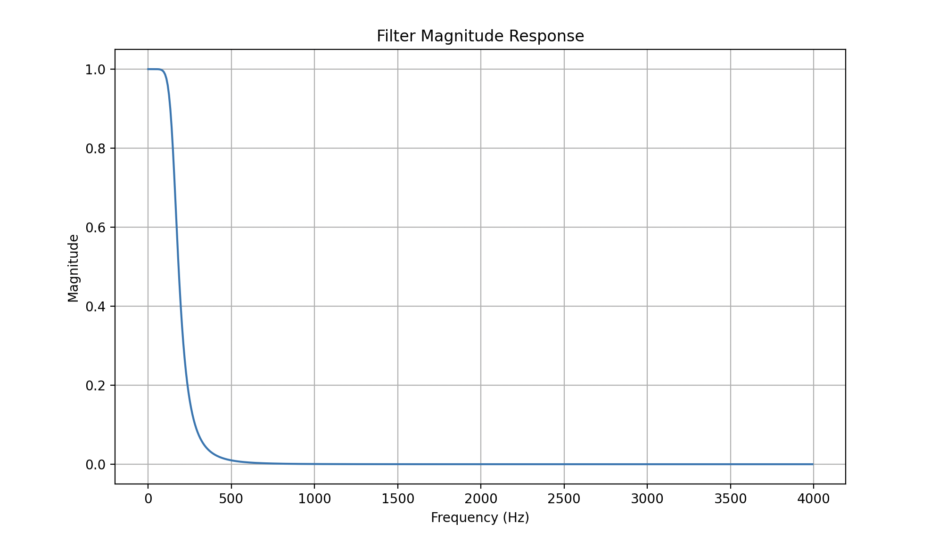
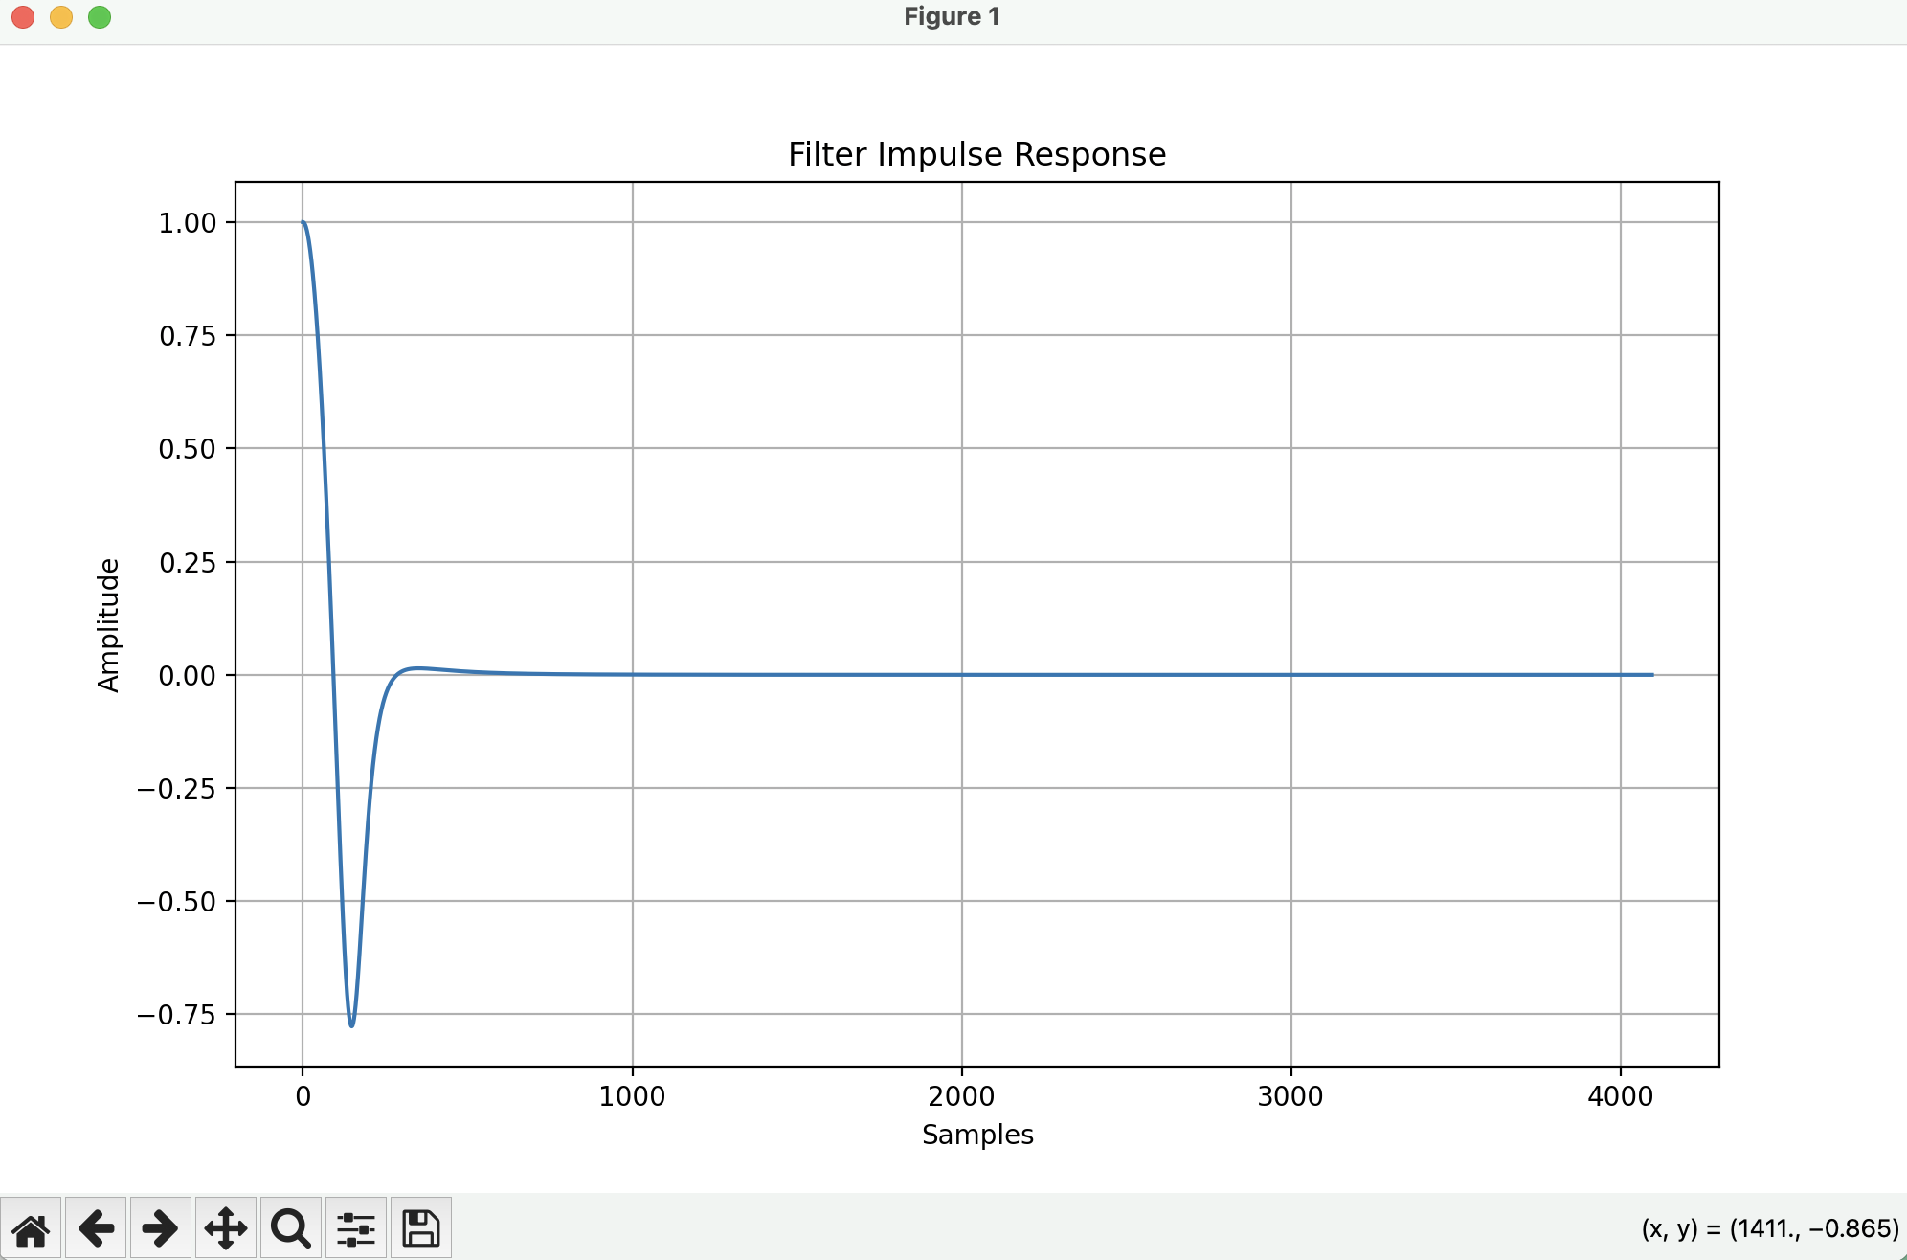

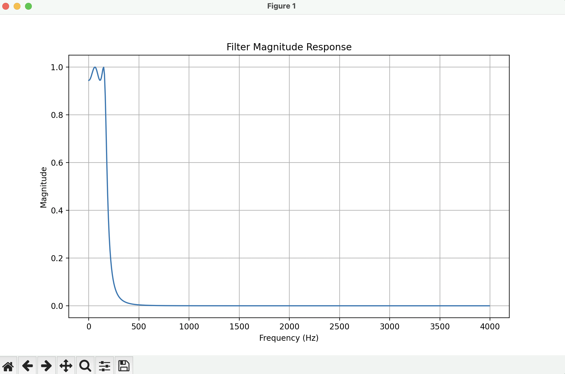

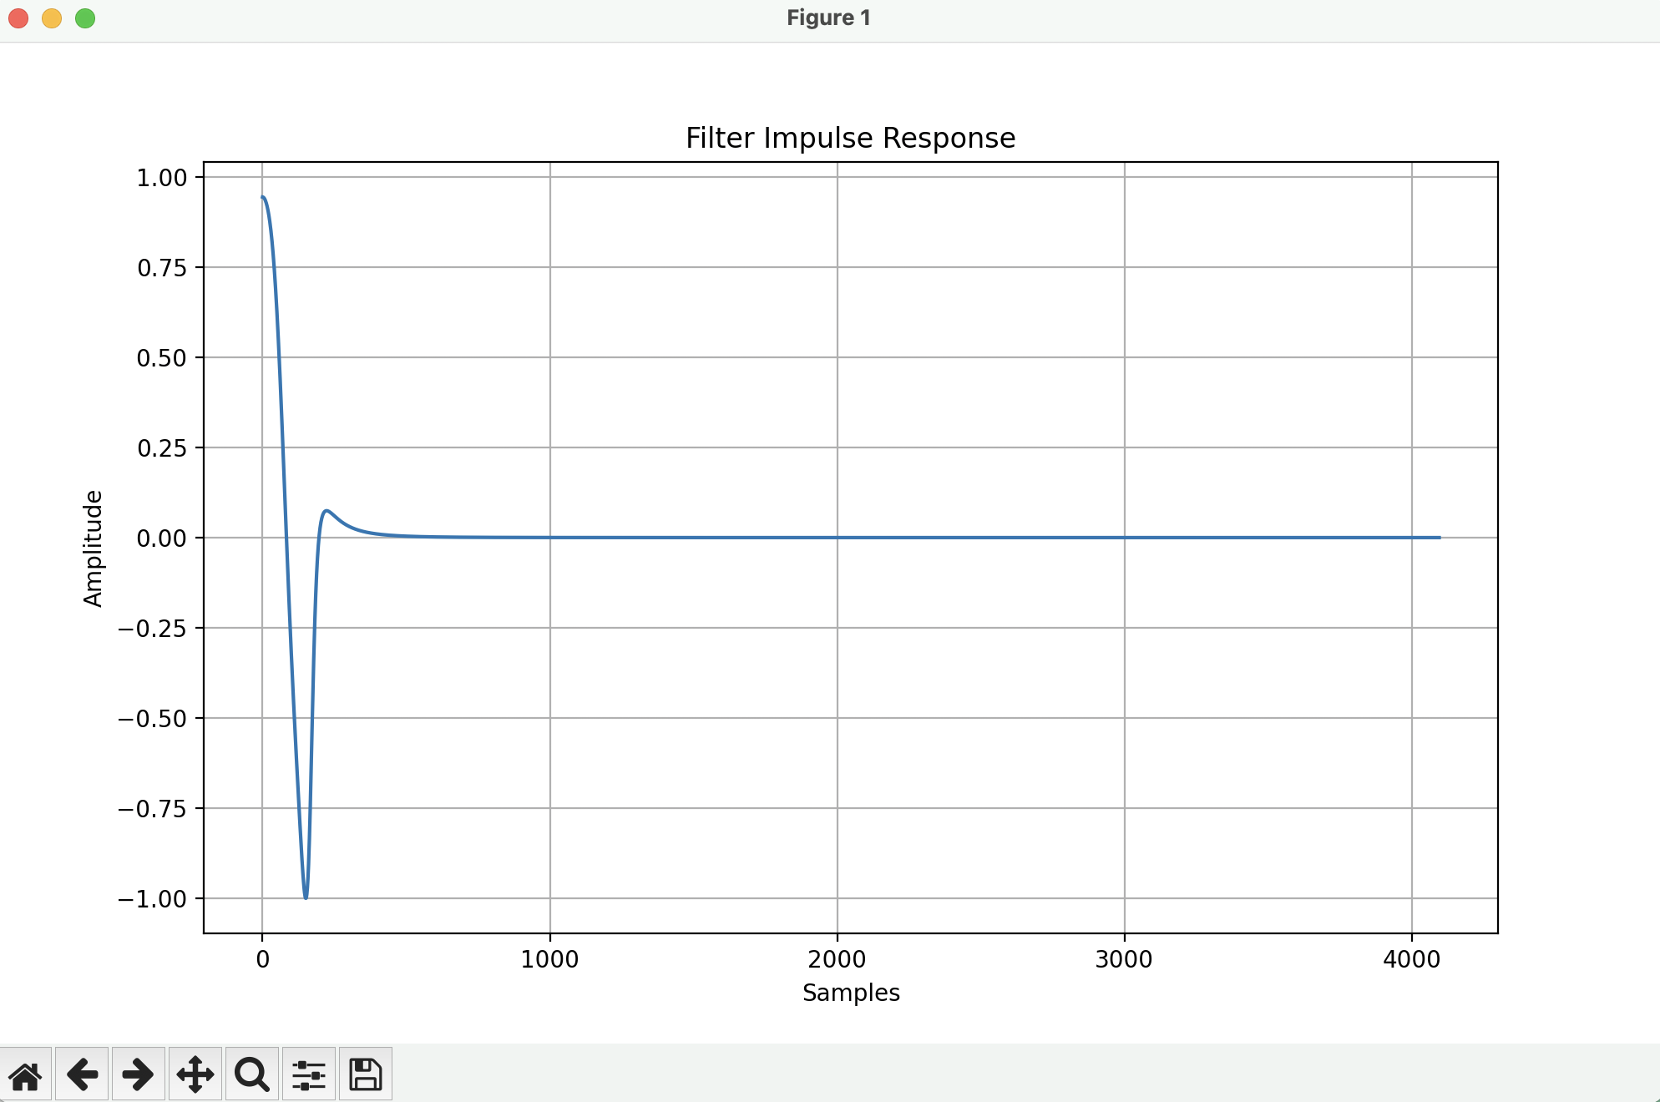

Conclusion:
In this experiment, Butterworth and Chebyshev digital filters were successfully designed from analog prototypes using the bilinear transformation method, effectively mapping the specified cutoff and sampling frequencies from the analog to the digital domain without aliasing. The generated plots validated the theoretical properties of both filter types: the Butterworth filter exhibited a maximally flat passband ideal for smooth, distortion-free signal processing, while the Chebyshev filter achieved a sharper transition between the passband and stopband by introducing a controlled ripple factor. Finally, the successful computation of their impulse responses and the export of the digital filter coefficients to a text file demonstrated that these filters are fully functional and ready for practical implementation in digital signal processing systems.

GITHUB LINK:-

https://github.com/SlockAhuja/DSIP.git

