Code:-

import numpy as np
import matplotlib.pyplot as plt

# ============================================================
# INPUT SIGNAL
# ============================================================

signal = np.array([1, 2, 3, 4, 5, 6, 7, 8])

# Number of samples
N = len(signal)

# Sample indices
n = np.arange(N)

# ============================================================
# FFT
# ============================================================

fft_result = np.fft.fft(signal)

# Real and imaginary parts
fft_real = np.real(fft_result)
fft_imag = np.imag(fft_result)

# Magnitude and phase
magnitude_spectrum = np.abs(fft_result)
phase_spectrum = np.angle(fft_result)

# ============================================================
# IFFT
# ============================================================

reconstructed_signal = np.real(np.fft.ifft(fft_result))

# ============================================================
# PRINT RESULTS
# ============================================================

print("=" * 60)
print(" FFT ANALYSIS")
print("=" * 60)

print("\nOriginal Signal:")
print(signal)

print("\nFFT Result:")
for i, value in enumerate(fft_result):
print(
f"X[{i}] = "
f"{value.real:.2f} "
f"{'+' if value.imag >= 0 else '-'} "
f"j{abs(value.imag):.2f}"
)

print("\nMagnitude Spectrum:")
print(np.round(magnitude_spectrum, 2))

print("\nPhase Spectrum (radians):")
print(np.round(phase_spectrum, 2))

print("\nReconstructed Signal using IFFT:")
print(np.round(reconstructed_signal, 2))

# ============================================================
# PLOTTING
# ============================================================

fig, axes = plt.subplots(
6, 1,
figsize=(12, 18)
)

# ============================================================
# 1. ORIGINAL SIGNAL
# ============================================================

axes[0].stem(
n,
signal,
linefmt='C0-',
markerfmt='C0o',
basefmt=' '
)

axes[0].set_title(
"1. Original Discrete-Time Signal",
fontsize=13,
fontweight='bold'
)

axes[0].set_xlabel("Sample Index (n)")
axes[0].set_ylabel("Amplitude")
axes[0].set_xticks(n)
axes[0].grid(True, alpha=0.3)

# Data labels
for i, value in enumerate(signal):
axes[0].annotate(
f"{value}",
(i, value),
xytext=(0, 8),
textcoords="offset points",
ha="center",
fontsize=9
)

# ============================================================
# 2. FFT - REAL AND IMAGINARY PARTS
# ============================================================

axes[1].stem(
n,
fft_real,
linefmt='C0-',
markerfmt='C0o',
basefmt=' ',
label='Real Part'
)

axes[1].stem(
n,
fft_imag,
linefmt='C1-',
markerfmt='C1s',
basefmt=' ',
label='Imaginary Part'
)

axes[1].axhline(
0,
linewidth=0.8
)

axes[1].set_title(
"2. FFT - Real and Imaginary Components",
fontsize=13,
fontweight='bold'
)

axes[1].set_xlabel("Frequency Index (k)")
axes[1].set_ylabel("Amplitude")
axes[1].set_xticks(n)

axes[1].legend(
loc='upper right'
)

axes[1].grid(True, alpha=0.3)

# ------------------------------------------------------------
# REAL DATA LABELS
# ------------------------------------------------------------

for i, value in enumerate(fft_real):

# Put real values above/below depending on sign
offset = 10 if value >= 0 else -18

axes[1].annotate(
f"R={value:.2f}",
(i, value),
xytext=(0, offset),
textcoords="offset points",
ha="center",
fontsize=8,
fontweight="bold"
)

# ------------------------------------------------------------
# IMAGINARY DATA LABELS
# ------------------------------------------------------------

for i, value in enumerate(fft_imag):

# Put imaginary labels opposite the real labels
if value >= 0:
offset = 22
else:
offset = -30

axes[1].annotate(
f"I={value:.2f}",
(i, value),
xytext=(0, offset),
textcoords="offset points",
ha="center",
fontsize=8,
fontweight="bold"
)

# ============================================================
# 3. MAGNITUDE SPECTRUM
# ============================================================

axes[2].stem(
n,
magnitude_spectrum,
linefmt='C2-',
markerfmt='C2o',
basefmt=' '
)

axes[2].set_title(
"3. FFT Magnitude Spectrum",
fontsize=13,
fontweight='bold'
)

axes[2].set_xlabel("Frequency Index (k)")
axes[2].set_ylabel("|X[k]|")
axes[2].set_xticks(n)

axes[2].grid(True, alpha=0.3)

# Magnitude values
for i, value in enumerate(magnitude_spectrum):
axes[2].annotate(
f"{value:.2f}",
(i, value),
xytext=(0, 8),
textcoords="offset points",
ha="center",
fontsize=9
)

Output:-

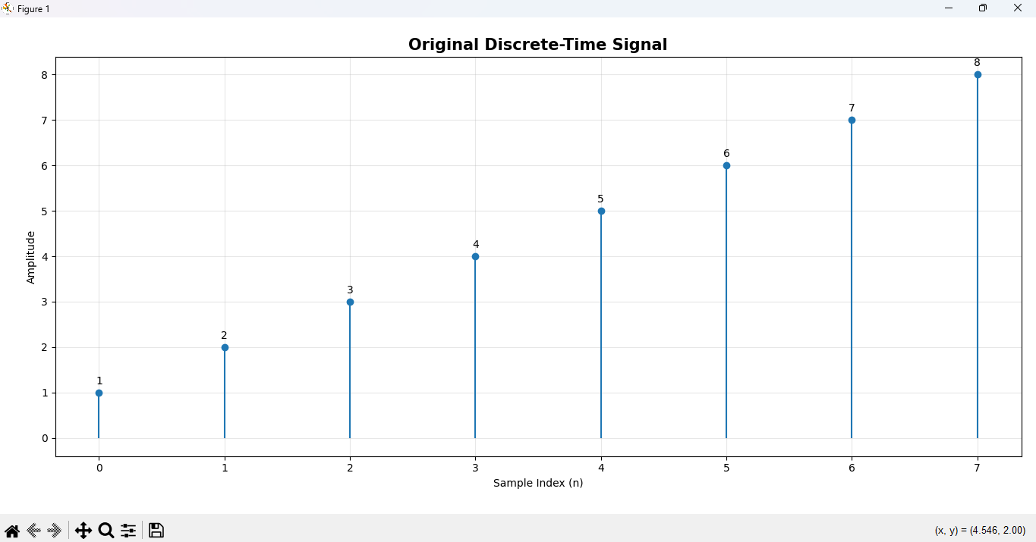
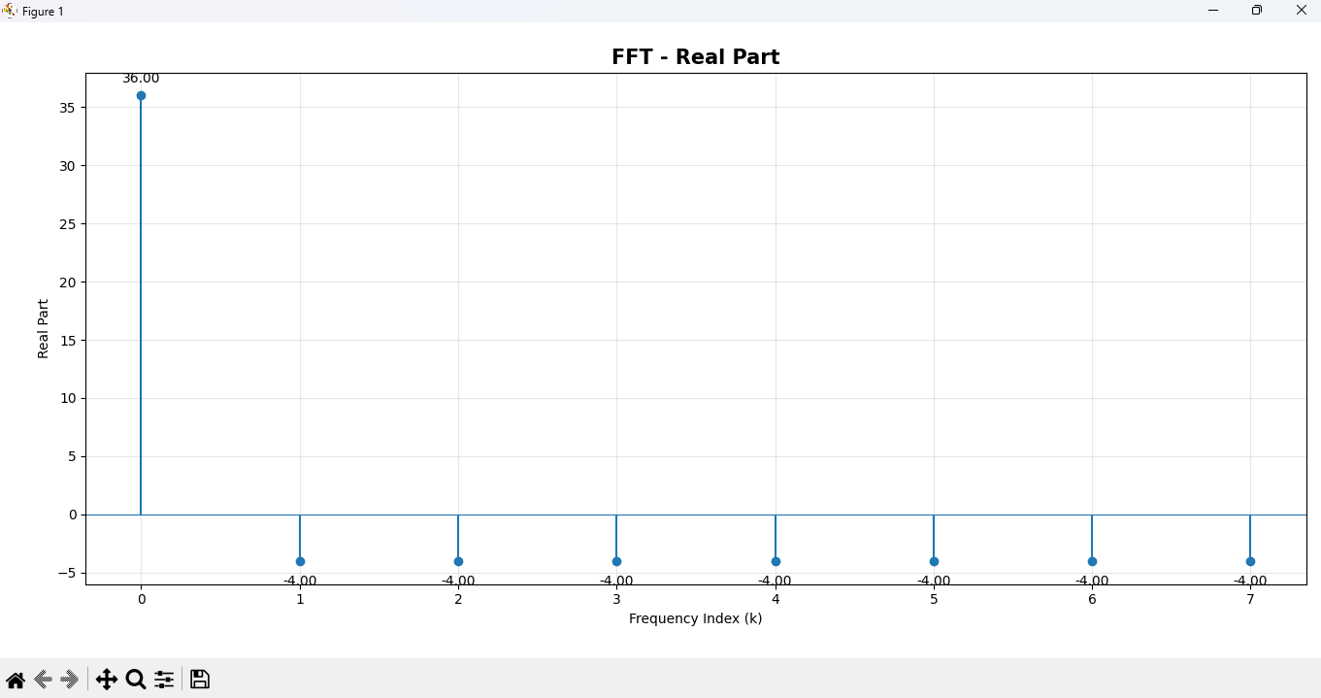

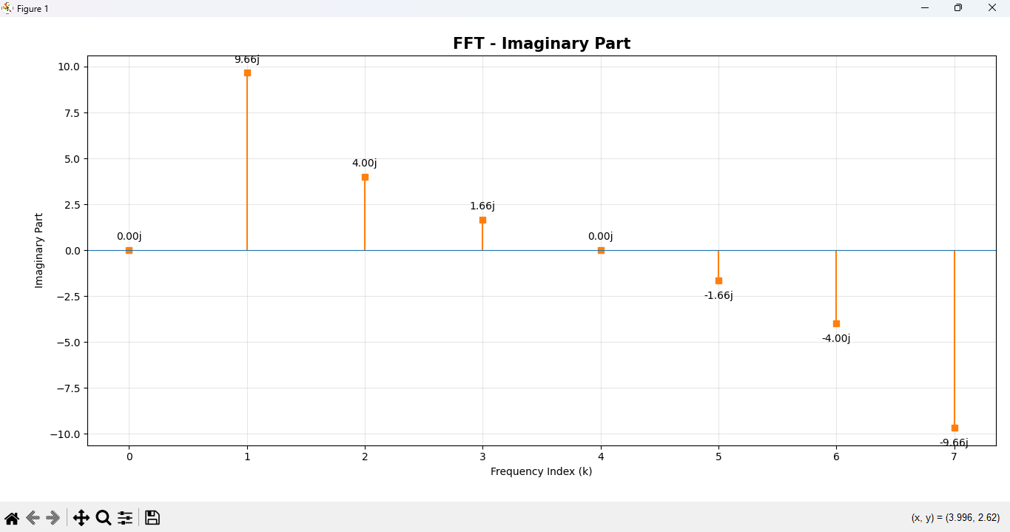

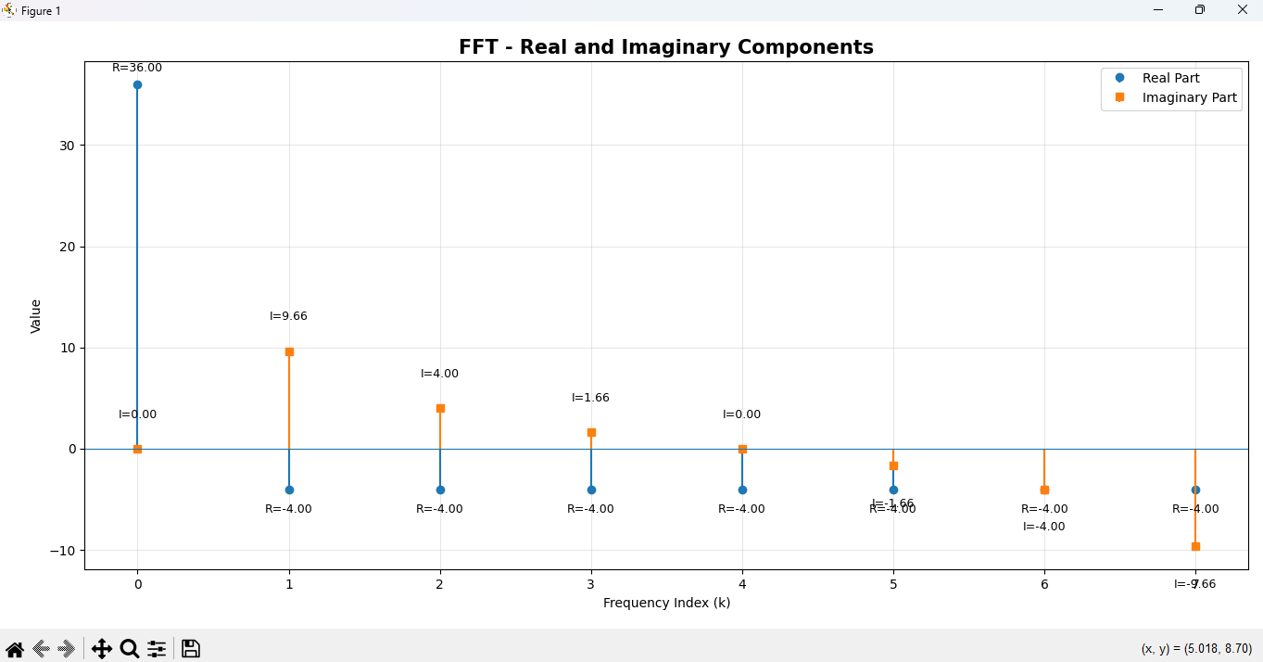

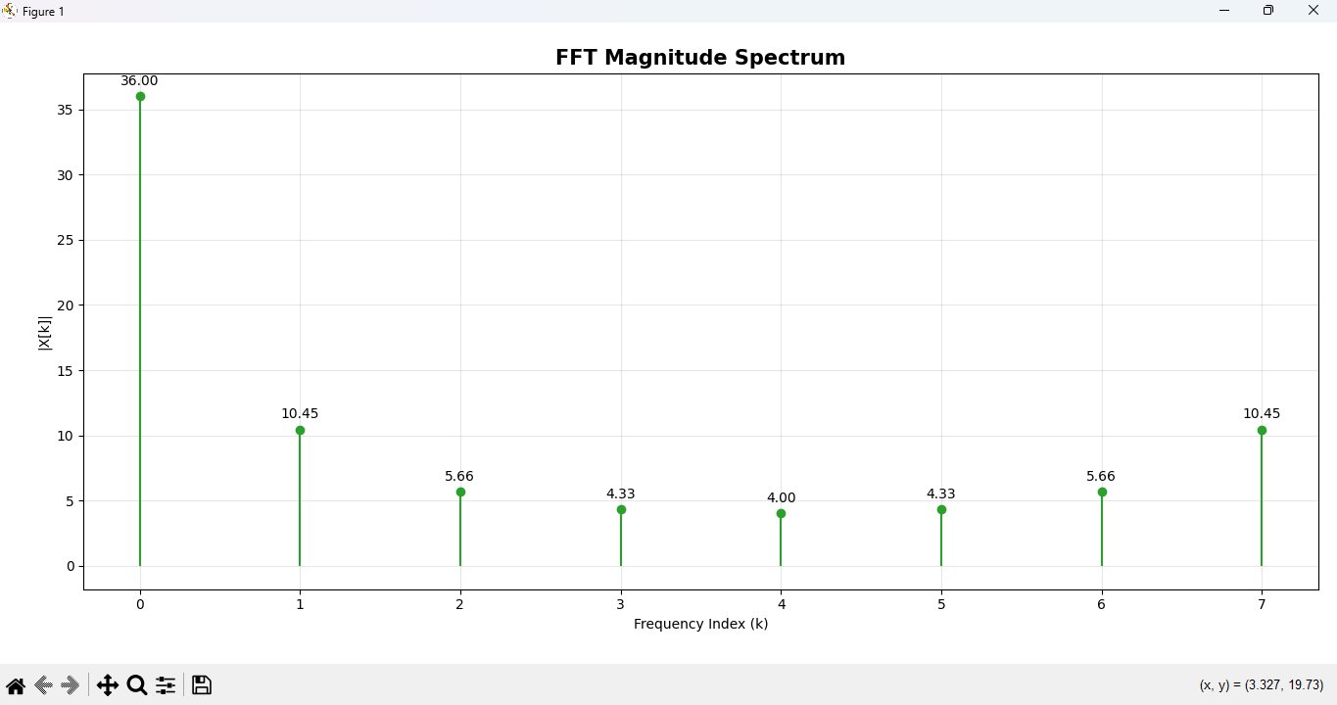

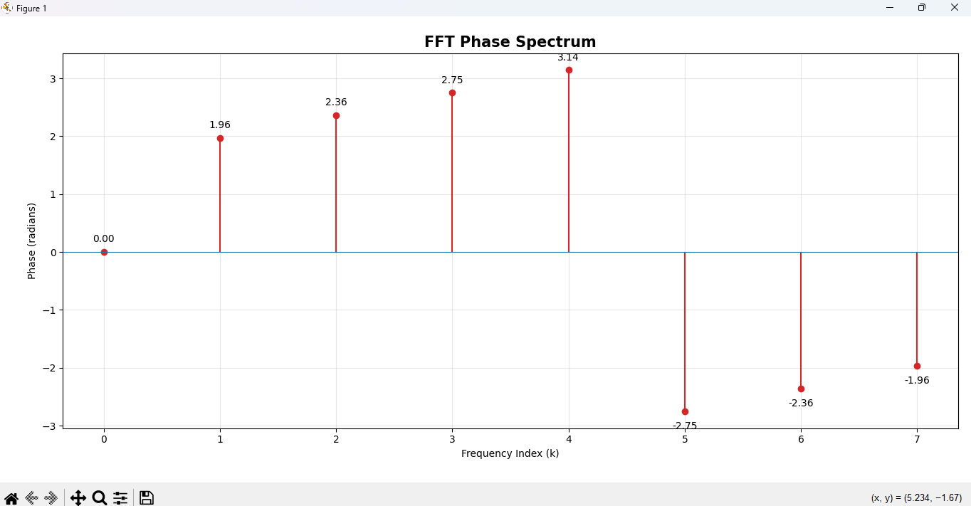

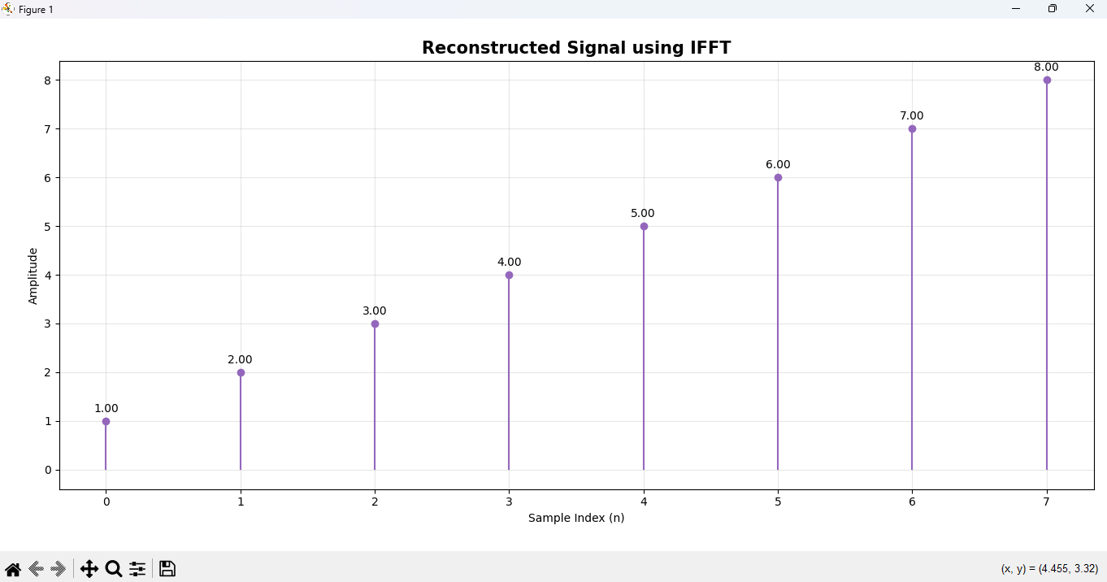

GitHub:-https://github.com/SlockAhuja/DSIP

