write a python program to simulate smoothening and sharpening operation on image
using spatial filter.

import cv2
import numpy as np
import matplotlib.pyplot as plt

# Load the image
image = cv2.imread('/Users/tousifkhan/Desktop/SEM5/DSIP_PRACT/Experiments/Experiment_9/trees.png') # Note: Update path for your Mac

# Convert BGR to RGB for correct color rendering in Matplotlib
image_rgb = cv2.cvtColor(image, cv2.COLOR_BGR2RGB)

# Define the Gaussian kernel for smoothing
kernel_size = (5, 5)
sigma = 1.5
gaussian_kernel = cv2.getGaussianKernel(kernel_size[0], sigma)
gaussian_kernel = np.outer(gaussian_kernel, gaussian_kernel)

# Apply Gaussian smoothing
smoothed_image = cv2.filter2D(image_rgb, -1, gaussian_kernel)

# Define a sharpening kernel
sharpening_kernel = np.array([[-1, -1, -1],
[-1, 9, -1],
[-1, -1, -1]])

# Apply sharpening
sharpened_image = cv2.filter2D(image_rgb, -1, sharpening_kernel)

# Plot using Matplotlib
plt.figure(figsize=(12, 4))

plt.subplot(1, 3, 1)
plt.title('Original')
plt.imshow(image_rgb)
plt.axis('off')

plt.subplot(1, 3, 2)
plt.title('Smoothed')
plt.imshow(smoothed_image)
plt.axis('off')

plt.subplot(1, 3, 3)
plt.title('Sharpened')
plt.imshow(sharpened_image)
plt.axis('off')

plt.tight_layout()
plt.show()

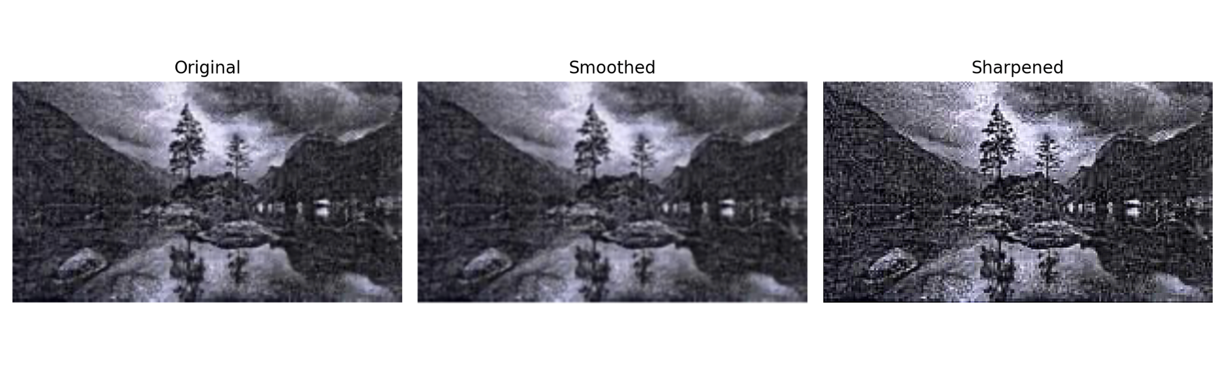

write a python program to simulate smoothening using Averaging linear filters

import cv2
import numpy as np
import matplotlib.pyplot as plt

# Load the image
image = cv2.imread('/Users/tousifkhan/Desktop/SEM5/DSIP_PRACT/Experiments/Experiment_9/trees.png')

# Convert BGR (OpenCV default) to RGB (Matplotlib default)
image_rgb = cv2.cvtColor(image, cv2.COLOR_BGR2RGB)

# Define the size of the Averaging filter kernel
kernel_size = (5, 5) # You can adjust the size based on the desired smoothing level

# Create the Averaging filter kernel
kernel = np.ones(kernel_size, dtype=np.float32) / (kernel_size[0] * kernel_size[1])

# Apply the Averaging filter for smoothing
smoothed_image = cv2.filter2D(image_rgb, -1, kernel)

# Display the original and smoothed images side by side using Matplotlib
plt.figure(figsize=(10, 5))

plt.subplot(1, 2, 1)
plt.title('Original Image')
plt.imshow(image_rgb)
plt.axis('off')

plt.subplot(1, 2, 2)
plt.title('Smoothed Image (Averaging Filter)')
plt.imshow(smoothed_image)
plt.axis('off')

plt.tight_layout()
plt.show()

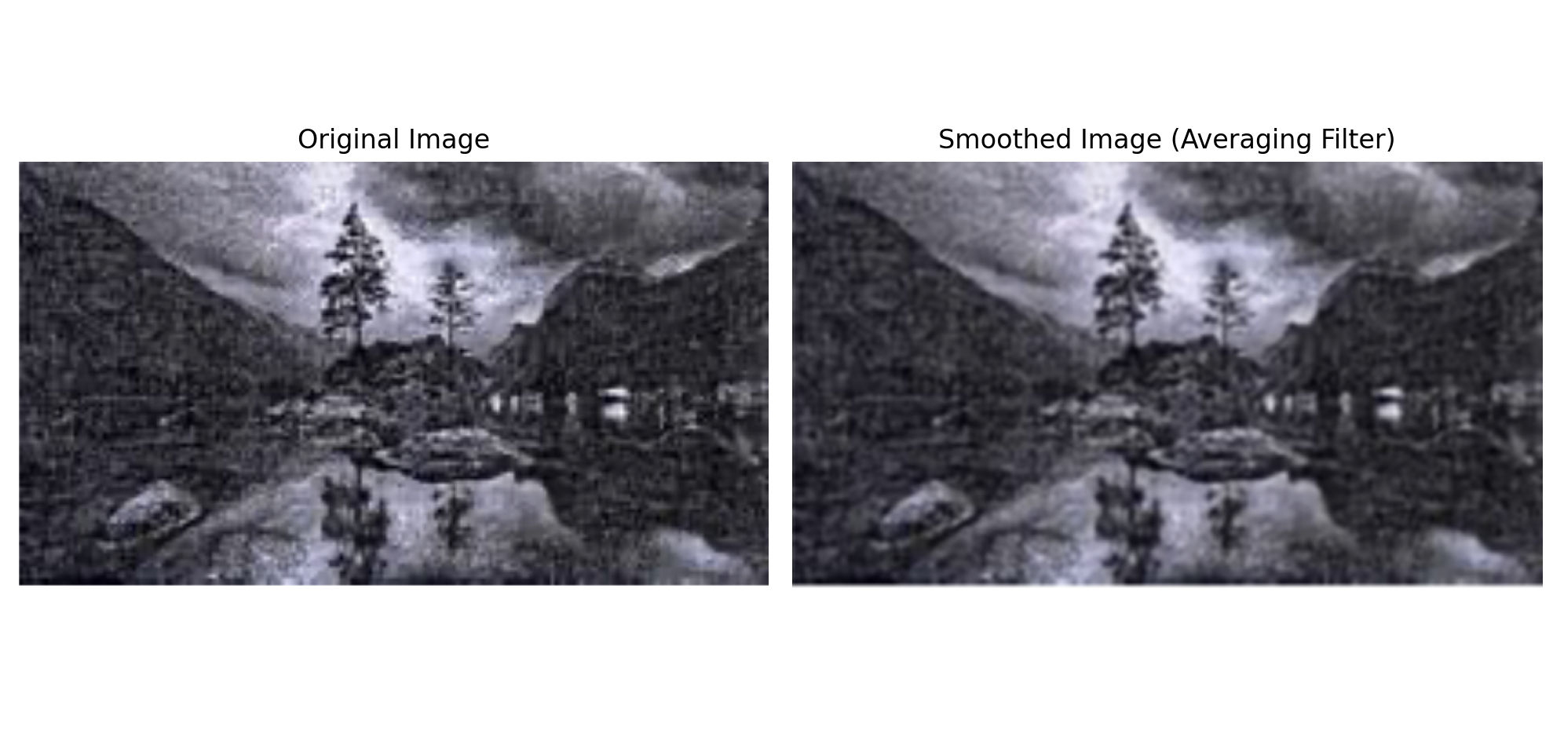

write a python program to simulate smoothening using median filters

import cv2
import numpy as np
import matplotlib.pyplot as plt

# Load the image
image = cv2.imread('/Users/tousifkhan/Desktop/SEM5/DSIP_PRACT/Experiments/Experiment_9/trees.png')

# Convert BGR (OpenCV default) to RGB for Matplotlib
image_rgb = cv2.cvtColor(image, cv2.COLOR_BGR2RGB)

# Define the size of the median filter kernel (should be an odd number)
kernel_size = 5 # You can adjust the size based on the desired smoothing level

# Apply the Median filter for smoothing
smoothed_image = cv2.medianBlur(image_rgb, kernel_size)

# Display the original and smoothed images using Matplotlib
plt.figure(figsize=(10, 5))

plt.subplot(1, 2, 1)
plt.title('Original Image')
plt.imshow(image_rgb)
plt.axis('off')

plt.subplot(1, 2, 2)
plt.title('Smoothed Image (Median Filter)')
plt.imshow(smoothed_image)
plt.axis('off')

plt.tight_layout()
plt.show()

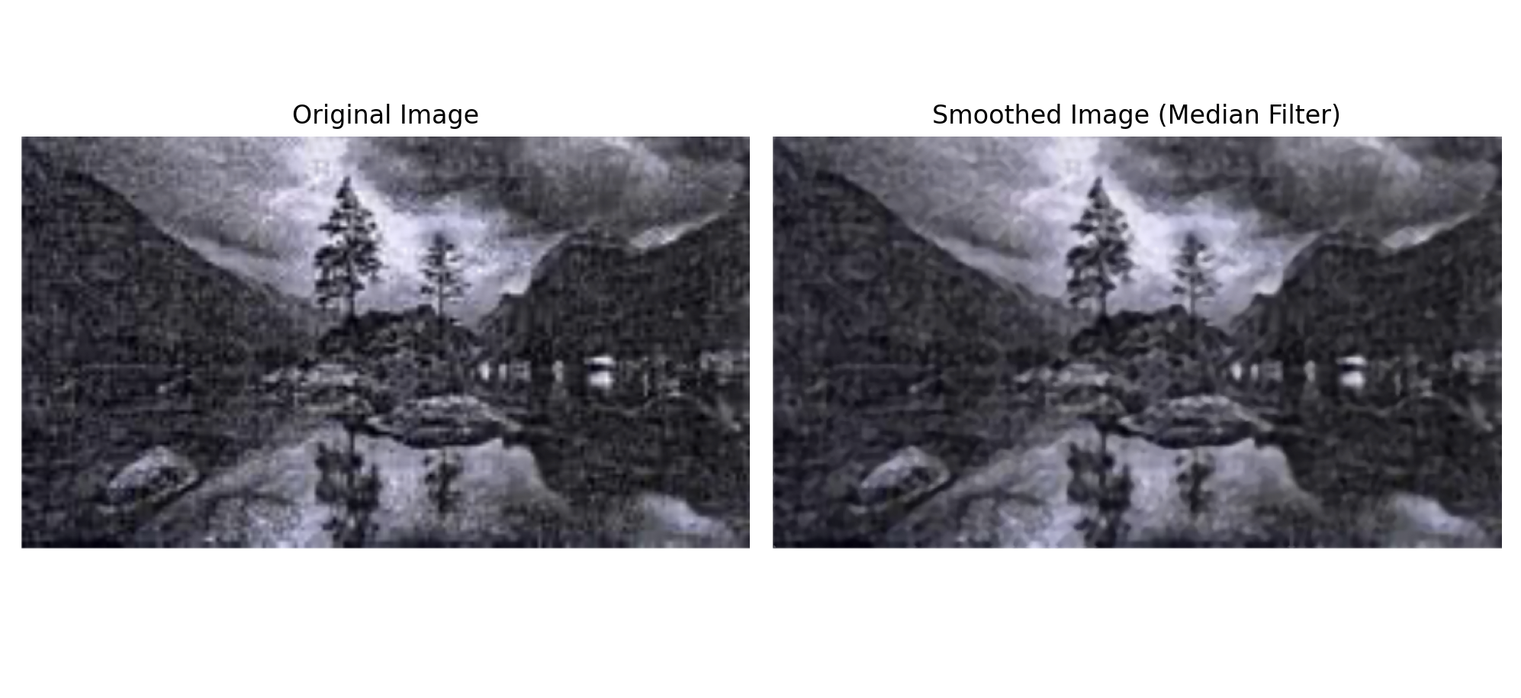

write a python program to simulate sharpening using spatial high pass filters

import cv2
import numpy as np
import matplotlib.pyplot as plt

# Load the image
image = cv2.imread('/Users/tousifkhan/Desktop/SEM5/DSIP_PRACT/Experiments/Experiment_9/trees.png')

# Convert BGR to RGB for Matplotlib
image_rgb = cv2.cvtColor(image, cv2.COLOR_BGR2RGB)

# Apply Gaussian smoothing to reduce noise
blurred_image = cv2.GaussianBlur(image_rgb, (5, 5), 0)

# Create a Laplacian kernel for sharpening
laplacian_kernel = np.array([[0, -1, 0],
[-1, 5, -1],
[0, -1, 0]], dtype=np.float32)

# Apply the Laplacian filter for sharpening
sharpened_image = cv2.filter2D(blurred_image, -1, laplacian_kernel)

# Display the original, blurred, and sharpened images using Matplotlib
plt.figure(figsize=(15, 5))

plt.subplot(1, 3, 1)
plt.title('Original Image')
plt.imshow(image_rgb)
plt.axis('off')

plt.subplot(1, 3, 2)
plt.title('Blurred Image (Gaussian)')
plt.imshow(blurred_image)
plt.axis('off')

plt.subplot(1, 3, 3)
plt.title('Sharpened Image (Laplacian)')
plt.imshow(sharpened_image)
plt.axis('off')

plt.tight_layout()
plt.show()

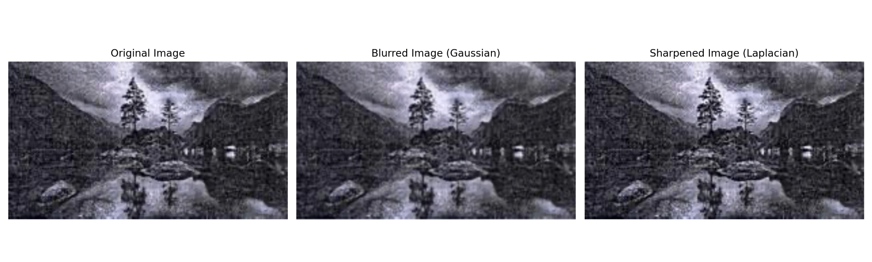

GITHUB LINK:-

https://github.com/SlockAhuja/DSIP.git

