ACTIVITY 1
Generate a consistent aviation visual with more than one AI image tool
━━━━━━━━━━━━━━━━━━━━━━━━━━━━━━━━
ACTIVITY 1 | Create the same aviation scene using different tools

PROMPT
Create a photorealistic image of a female airline customer-service executive at a modern international airport check-in counter. She wears a professional navy-blue uniform and faces the camera. Soft natural light enters from camera-left, while passengers and terminal details remain gently blurred in the background. Use realistic skin texture, natural facial features, polished commercial photography, shallow depth of field, and a 16:9 composition. Avoid airline logos and clearly readable text.

TOOL 1 • CHATGPT
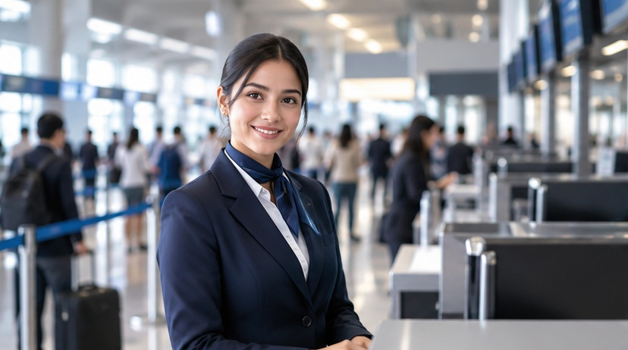
New visual generated for the revised activity layout.
TOOL 2 • GEMINI

ACTIVITY 2
A quick visual-accent comparison of the two generated outputs
━━━━━━━━━━━━━━━━━━━━━━━━━━━━━━━━
ACTIVITY 2 | Observe the model’s visual accent


Alternative airport-service visual used in the revised document.
Evaluation criterion | Tool 1 – Gemini | Tool 2 – ChatGPT
AI tool | Gemini | ChatGPT
Prompt adherence | Mostly followed | Mostly followed
Realistic human face | Yes | Yes
Natural skin texture | Mostly natural | Very natural
Eyes & hands | Eyes correct; hands mostly correct | Eyes correct; hands mostly correct
Airport setting | Realistic | Realistic
Camera-left lighting | Yes | Yes
Professional uniform | Yes | Yes
Unwanted text / logos | Some readable check-in/background signage | No obvious readable text or airline logo
AI-generated appearance | Slightly: smooth face, hands and artificial text | Slightly: polished face and background
Overall observation | Strong airport-service realism | More polished commercial realism

ANALYSIS
What the visual comparison tells us
━━━━━━━━━━━━━━━━━━━━━━━━━━━━━━━━
ACTIVITY 2 | Analysis questions

1. Which tool followed the prompt more accurately? ChatGPT matched the requested composition more closely: a professional female airline executive, navy-blue uniform, camera-left lighting, modern airport setting, and no obvious readable airline branding.
2. Which image looked more realistic? The ChatGPT output appeared slightly more natural overall, particularly in facial detail, skin texture, lighting, and background depth.
3. What differences were visible in the lighting? Both visuals used bright, soft illumination from the camera-left side. Gemini distributed the light more evenly, while ChatGPT created softer highlights and shadows.
4. Were there distorted eyes, hands, or facial features? No major facial distortion was noticeable. Gemini’s hands looked a little less natural, while ChatGPT’s hands were partly concealed by the counter and therefore appeared more controlled.
5. Which visual would suit an airline website? The ChatGPT version is more suitable for a general airline website because its presentation is clean and commercial, while avoiding obvious readable text and airline logos.
6. What is the visual accent of each model? Gemini emphasizes a formal airport-service scene with a clear full-body composition and detailed terminal surroundings. ChatGPT emphasizes polished commercial realism, with stronger attention to the executive’s face, skin texture, and shallow depth of field.

ACTIVITY 3
Testing whether spatial instructions change the direction of light
━━━━━━━━━━━━━━━━━━━━━━━━━━━━━━━━
ACTIVITY 3 | Test spatial instructions

PROMPT A — CAMERA-LEFT
Create a photorealistic airport ground-staff executive standing beside a check-in counter. Soft morning light must enter from camera-left and illuminate the left side of the scene. The executive holds a tablet, with a modern airport terminal softly blurred behind her. Use professional photography, realistic facial features, a 16:9 composition, no logos, and no clearly readable text.


Revised Camera-Left visual.
PROMPT B — CAMERA-RIGHT
Create a photorealistic airport ground-staff executive beside a check-in counter. Soft morning light must enter from camera-right and illuminate the right side of the scene. The executive holds a tablet, while a modern airport background remains softly out of focus. Use professional photography, realistic facial features, a 16:9 composition, no logos, and no clearly readable text.

OBSERVATION
Checking whether the spatial instructions were respected
━━━━━━━━━━━━━━━━━━━━━━━━━━━━━━━━
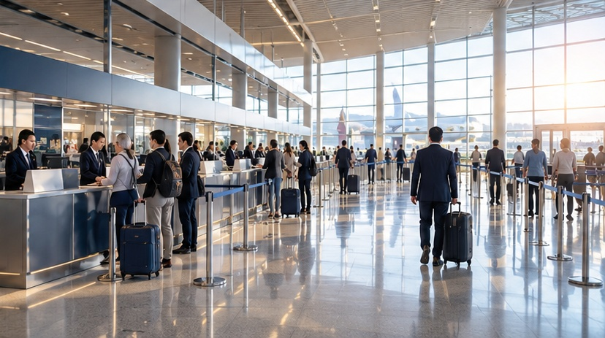
Revised Camera-Right visual.
Question | Observation
Did the lighting direction change? | Yes. The direction changes from camera-left in the first visual to camera-right in the second.
Was camera-left followed correctly? | Yes. Soft light enters from the left side and illuminates the left portion of the scene.
Was camera-right followed correctly? | Yes. Bright morning light enters from the right and illuminates the right side of the image.
Did the background remain consistent? | Yes. Both visuals retain a modern airport check-in environment with counters, passengers, glass surfaces, and a softly blurred terminal.
Did the person’s appearance change? | The subject remains visually consistent: professional navy-blue uniform, neat hairstyle, tablet, and a polished airport-service appearance.
Which instruction was ignored, if any? | The main spatial instructions were followed. Some distant screens contain indistinct visual elements, but no clearly readable text or visible airline logo is prominent.

Key takeaway: The activity demonstrates how prompt wording—especially spatial terms such as camera-left and camera-right—can influence lighting and composition in AI-generated aviation visuals.

