**Mutual Fund Comparison: Pharmaceuticals Portfolio, Gold Portfolio, & Blue-Chip Growth**

Sydney Long

This analysis compares three distinct mutual funds focused on pharmaceuticals, gold, and blue-chip growth sectors. The objective is to evaluate their historical annual return performance and overall risk levels. By examining key descriptive statistics over a 10-year period, the analysis aims to identify differences in volatility, consistency, and return potential across the three fund categories.

|  |  |  |  |  |  |
| --- | --- | --- | --- | --- | --- |
| *Pharmaceuticals Portfolio* | | *Gold Portfolio* | | *Blue Chip Growth* | |
|  |  |  |  |  |  |
| Mean | 11.974 | Mean | -1.078 | Mean | 17.936 |
| Standard Error | 5.43347141 | Standard Error | 9.64117937 | Standard Error | 8.76390441 |
| Median | 10.88 | Median | -9.47 | Median | 18.655 |
| Mode | #N/A | Mode | #N/A | Mode | #N/A |
| Standard Deviation | 17.182145 | Standard Deviation | 30.488086 | Standard Deviation | 27.713899 |
| Sample Variance | 295.22611 | Sample Variance | 929.52339 | Sample Variance | 768.06020 |
| Kurtosis | -0.0214368 | Kurtosis | -0.5717294 | Kurtosis | 1.0372561 |
| Skewness | 0.09248926 | Skewness | 0.14921825 | Skewness | -0.5412599 |
| Range | 57.63 | Range | 98.69 | Range | 100.69 |
| Minimum | -16.27 | Minimum | -51.41 | Minimum | -38.46 |
| Maximum | 41.36 | Maximum | 47.28 | Maximum | 62.23 |
| Sum | 119.74 | Sum | -10.78 | Sum | 179.36 |
| Count | 10 | Count | 10 | Count | 10 |
| Confidence Level(95.0%) | 12.2913663 | Confidence Level(95.0%) | 21.809863 | Confidence Level(95.0%) | 19.825329 |
| Lower | Upper | Lower | Upper | Lower | Upper |
| -0.3173663 | 24.265366 | -22.887863 | 20.731863 | -1.8893291 | 37.761329 |

Ten years of annual return data were analyzed for each mutual fund. The following tables highlight important performance statistics.

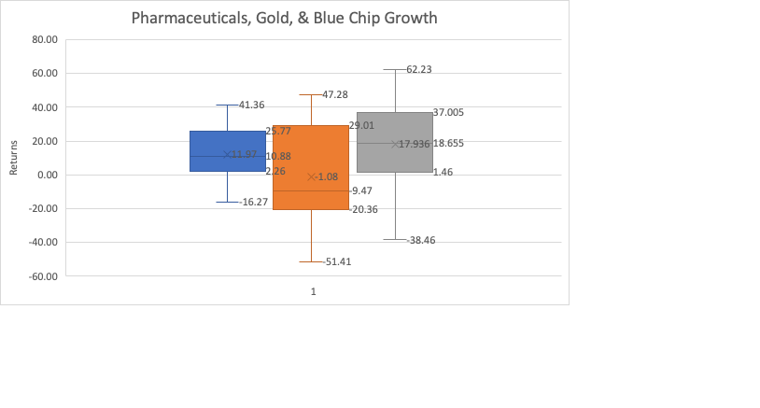

The Gold Portfolio exhibits the highest standard deviation (30.488%), indicating greater volatility compared to the Blue Chip Growth (27.714%) and Pharmaceuticals (17.182%) portfolios. It also has the smallest upper confidence limit (20.732) and the widest range of potential outcomes, with a lower limit of -22.888 and a minimum return of -51.41%. These figures suggest a higher degree of uncertainty and risk, making it the least favorable option for risk-averse investors in this analysis.

The Pharmaceuticals Portfolio delivers an average annual return of 11.974%, falling between the Gold and Blue Chip Growth portfolios. Its median return of 10.88% reinforces this middle-ground position. Notably, it has the lowest standard deviation, suggesting more stable performance over time. With a narrower range of returns (minimum of -16.27%, maximum of 41.36%), this fund may appeal to those seeking moderate returns with lower volatility.

The Blue Chip Growth Portfolio shows the highest average (17.936%) and median (18.655%) returns over the 10-year period. While its standard deviation (27.714%) indicates some volatility, it is lower than that of the Gold Portfolio. This combination of high returns and moderate risk suggests that the Blue Chip Growth option may be the most attractive in terms of return potential, based on this historical data.

*\* This analysis is for educational purposes only and does not reflect real investments or financial recommendations. The data used is hypothetical and was created to demonstrate statistical comparison methods.*