Report – Comparing Annual Returns

Sydney Long

Two high growth industries have been observed for their reward and risk on investment. I have compared the Fidelity Technology Portfolio and Fidelity Health Care Services industries to determine their appropriateness on client investment. The hypothesis test statistics are shown below.

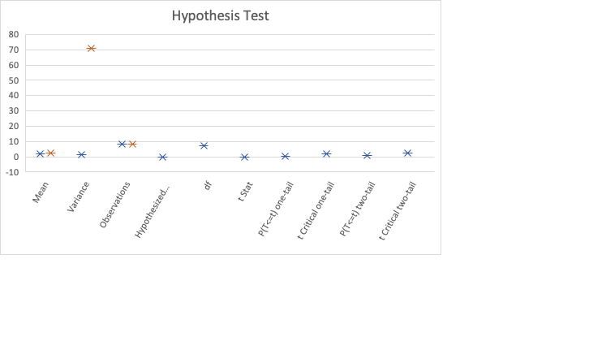

When reviewing this hypothesis test it is apparent that the observe value (1.89) is less than the critical value (2.36). This would mean that we fail to reject the null hypothesis. Also, the p value is also less than the alpha value indicating that these results are statistically significant. I have also observed the range of these two variables by using the following box and whisker plots below.

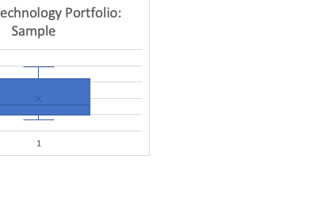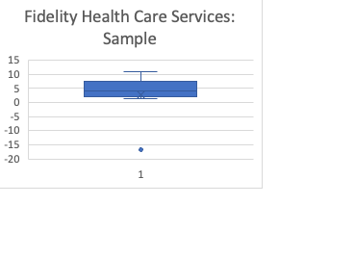

The range for the technology portfolio industry is at 3.22. The range for healthcare services industry is at 27.85. Healthcare also poses an outlier of -16.83 which tracks due to the high positive kurtosis of 5.34. This tells us that the Health Care Services industry is much more volatile and has a wider range of returns. Health Care Services has a higher standard deviation of 8.42 with Technology Portfolio sitting much lower at 1.26. This also indicates that there is more risk involved when investing in health care services than Technology portfolio.

The line plot above reiterates the volatility of the healthcare industry. While there is less risk with investing in the Technology Portfolio fund, it also has the potential to provide lower overall returns with its mean being 2.02. Healthcare services provides the potential to result in higher overall returns with its mean being 2.66. If the investor has a goal of assuming more risk with the opportunity to achieve higher returns, the healthcare industry would be a good option. If the investor is more conservative and would like to prioritize lower risk for possibly income generated from long term holding (dividends/interest) instead of investment gains, the technology industry may be a better option.