**PYTHON PROGRAMMING ON RASPBERRY PI - by Andre Petrov**

RUNNING LOG

|  |  |  |
| --- | --- | --- |
| **DATE** | **ACTION** | **COMMENT** |
|  |  |  |
| 20.10.2017 | Uploaded activity log file to Git |  |
| 20.10.2017 | Updated running log here |  |
| 20.10.2017 | Uploaded activity log file to Git |  |
| 20.10.2017 | Deleted some unrelated text |  |
| 20.10.2017 | Uploaded activity log file to Git |  |
|  |  |  |
|  |  |  |
|  |  |  |
|  |  |  |

The following steps were taken to test Adeept’ s wiring kit and Python code on Raspberry Pi.

**1. Created local Git working directory ‘adeept’, initialised it and cloned Addept repo from GitHub.**

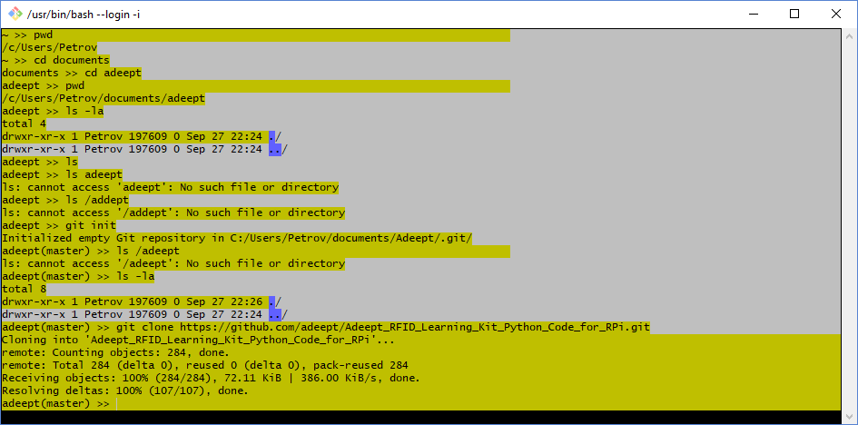

**=============================**

1. **Opened a new Python project called ‘adeept’ in Eclipse IDE on Windows and created a working environment using files cloned from GitHub**

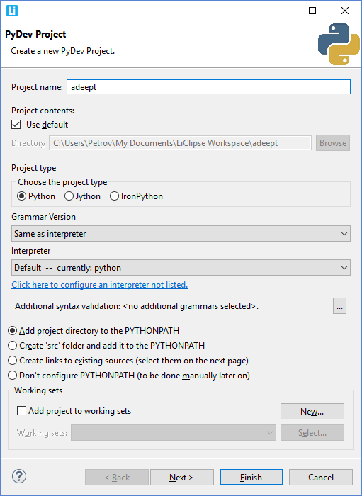

**=============================**

**3. Downloaded Git to Raspberry Pi**

*Sudo apt-get install git*

*Git init*

Directory set at **/home/pi/.git**

|  |  |  |
| --- | --- | --- |
| **20171009_211714** | **20171009_211837** |  |

**=============================**

**4. Downloaded Adeept’s Python code to RPi**

*$ git clone https://github.com/adeept/Adeept\_RFID\_Learning\_Kit\_Python\_Code\_for\_RPi.git*

**=============================**

1. **Installed WiringPI on RPi - C code library (Did not really need to…)**

*git clone git://git.drogon.net/wiringPi*

*Cloning into 'wiringPi'...*

*remote: Counting objects: 1151, done.*

*remote: Compressing objects: 100% (957/957), done.*

*remote: Total 1151 (delta 804), reused 212 (delta 142)*

*Receiving objects: 100% (1151/1151), 364.87 KiB | 200.00 KiB/s, done.*

*Resolving deltas: 100% (804/804), done.*

***Install wiringPi:***

Step 1 : Get the source code

*$ git clone git://git.drogon.net/wiringPi*

*git clone git://git.drogon.net/wiringPi*

*Cloning into 'wiringPi'...*

*remote: Counting objects: 1151, done.*

*remote: Compressing objects: 100% (957/957), done.*

*remote: Total 1151 (delta 804), reused 212 (delta 142)*

*Receiving objects: 100% (1151/1151), 364.87 KiB | 200.00 KiB/s, done.*

*Resolving deltas: 100% (804/804), done.*

Step 2 : Compile and install

*$ cd wiringPi*

*$ git pull origin*

*$ sudo ./build*

Step 3: Checking whether GPIO was installed

*pi@raspberrypi:~/WiringPi $ sudo gpio -v*

gpio version: 2.44

Copyright (c) 2012-2017 Gordon Henderson

This is free software with ABSOLUTELY NO WARRANTY.

For details type: gpio -warranty

Raspberry Pi Details:

Type: Pi 3, Revision: 02, Memory: 1024MB, Maker: Sony

\* Device tree is enabled.

\*--> Raspberry Pi 3 Model B Rev 1.2

\* This Raspberry Pi supports user-level GPIO access.

**6. Install Python on RPI**

<https://www.raspberrypi.org/documentation/linux/software/python.md>

<<<Python 3 already installed on RPI>>

**=============================**

**7. Install Eclipse IDE on RPi**

$ *sudo apt-get install eclipse*

SUCCESS ! BUT MAY NEED TO CHANGE OpenJDK to Java 8 JDK

|  |
| --- |
| 20171008_174718 |

**=============================**

**8. Install Vim editor on RPi**

*git clone <https://github.com/vim/vim.git>*

*sudo apt-get install vim-gnome*

|  |  |  |  |
| --- | --- | --- | --- |
| 20171009_220319 | 20171009_220937 | 20171009_221502 |  |

<<<Not using it really, launching Eclipse to work with Python code on RPi>>>

1. **Download Adeept code to RPi**

*git clone https://github.com/adeept/Adeept\_RFID\_Learning\_Kit\_Python\_Code\_for\_RPi*

|  |  |  |
| --- | --- | --- |
| 20171013_095611 |  |  |

**10. Build circuits and run code on RPi via VNC**

|  |  |  |  |  |
| --- | --- | --- | --- | --- |
| **20171009_223206** | **20171009_235325** | **20171010_161314** | **20171010_210836** |  |
|  |  |  |  |  |
| **20171010_211425** | **20171010_224726** | **20171010_230604** | **20171012_122402** |  |
| **20171011_091704** | **20171011_083158** | **20171012_134842** | **20171012_155733** |  |
|  |  |  |  |  |
| **20171012_165231** | **20171012_194743** | **20171014_183655** |  |  |
|  |  |  |  |  |

1. **Encountered problems / issues with Adeept code and kit**

*11.1 Lesson 19 - RFID*

<<PROBLEM - when running Read.py it tries to import MFRC522…..

#!/usr/bin/env python

# -\*- coding: utf8 -\*-

import RPi.GPIO as GPIO

import MFRC522

import signal

…...

>>>>>>>Following that, MFRC tries to import spi

#!/usr/bin/env python

# -\*- coding: utf8 -\*-

import RPi.GPIO as GPIO

import spi

import signal

import time

….

>>>RFID kit contains a folder named SPI-PY

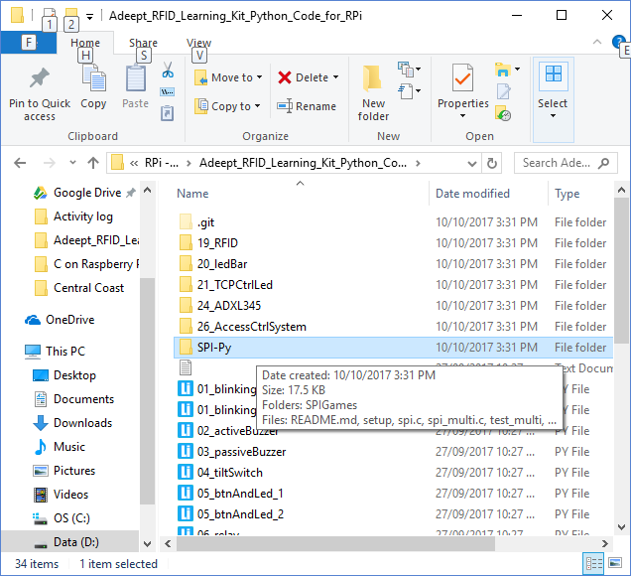

>>>> MFRC522 gives an error:

Traceback (most recent call last):

File "/home/pi/workspace/Adeept/19\_RFID/MFRC522-python/Read.py", line 5, in <module>

import MFRC522

File "/home/pi/workspace/Adeept/19\_RFID/MFRC522-python/MFRC522.py", line 5, in <module>

import spi

ImportError: No module named 'spi'

|  |  |  |
| --- | --- | --- |
| 20171012_214053 | 20171012_214058 | 20171013_131452 |

|  |  |  |
| --- | --- | --- |
| 20171013_132346 | 20171013_133208 |  |

>>> solution - Code is written in Python 2 but I was trying to run it in IDE running Python 3.6.2

|  |  |  |
| --- | --- | --- |
| pip3_install_spi |  |  |

**Lesson 20**

Issues with code

|  |  |  |
| --- | --- | --- |
| 20171012_214053 | integer error |  |
|  |  |  |

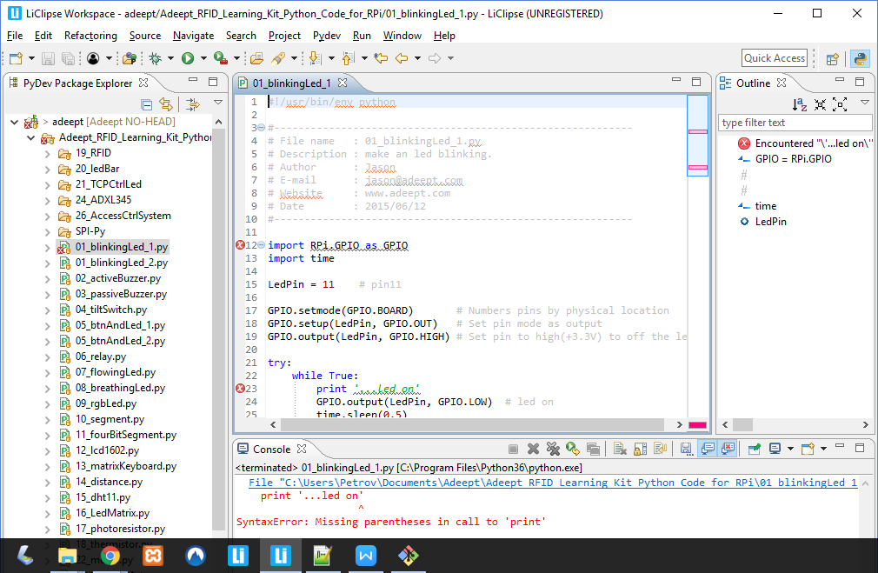

>>> Missing parenthesis in call to print

>>>float object cannot be interpreted as integer

>>> solution - Code is written in Python 2 but I was trying to run it in IDE running Python 3.6.2

==========END OF LOG AS 20.10.2017=================================