## **Deliverable 2: Case Study – Football Inventory Management System**

### **Project Title: Football Inventory Management System**

### **Theme: Sports**

### **Use Case: Inventory (Item – Categories)**

### **Overview:**

The Football Inventory Management System is a web-based application built using Django that allows football teams to manage their gear and equipment. The system tracks items such as footballs, jerseys, boots, cones, and more, organized into categories like match gear, training equipment, and accessories. It supports multiple user roles: Managers, Coaches, and Players.

### **Users and Roles:**

1. **Manager**
   1. Manages all inventory.
   2. Approves or rejects item requests from users.
   3. Adds or edits items and categories.
2. **Coach**
   1. Views inventory stock levels.
   2. Requests items for training sessions or matches.
3. **Player**
   1. Browses available items.
   2. Requests gear for personal use.

### **Use Case Scenarios:**

1. **Adding a New Item**  
    A manager logs into the system and adds a new set of football boots under the category “Match Equipment.”
2. **Requesting Gear**  
    A coach views available training cones and submits a request to use them for a practice session.
3. **Approving a Request**  
    The manager sees the coach’s request and approves it, updating the inventory accordingly.
4. **Viewing Categories**  
    A player filters gear by category to find items they’re allowed to request, like jerseys and water bottles.
5. **Stock Level Monitoring**  
    The manager checks item quantities and flags low-stock items for reordering.

#### **Actors & Use Cases**

* **Manager**
  + Add/Edit Items
  + Approve/Reject Requests
  + View Inventory
  + Manage Categories
* **Coach**
  + Request Items
  + View Inventory
  + View Request Status
* **Player**
  + View Items
  + Request Items
  + View Request Status

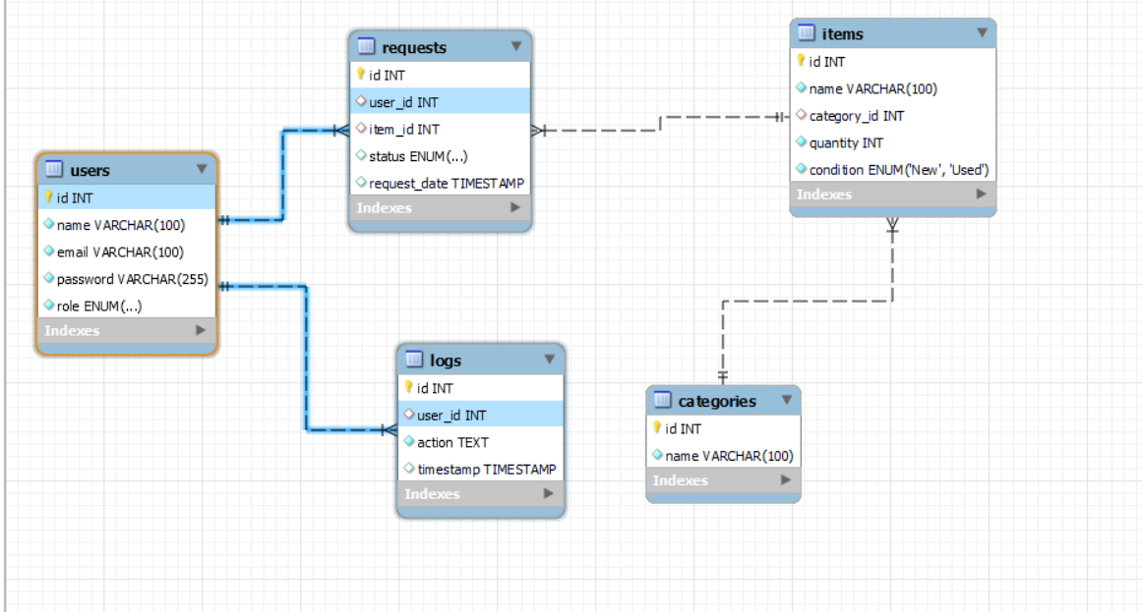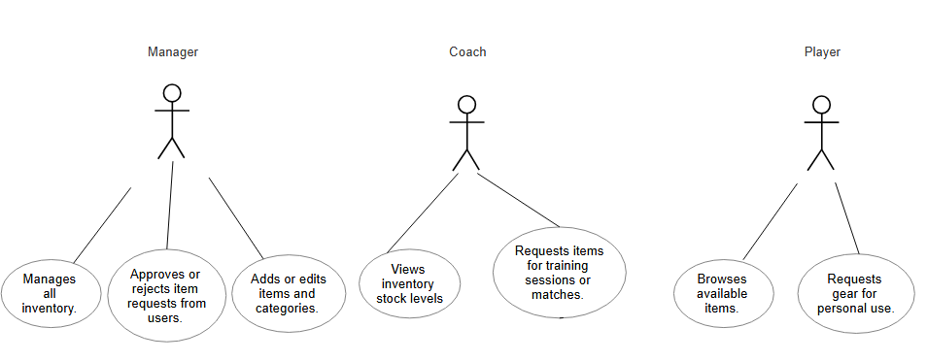



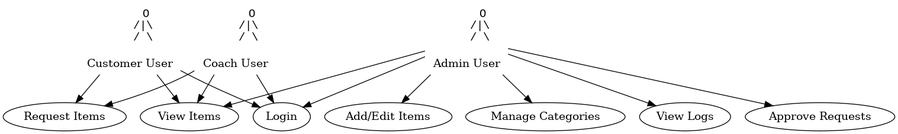

This diagram illustrates individual user interactions with the system including login, viewing inventory, item

requests, and admin-specific functionalities like approval, logging, and item management.

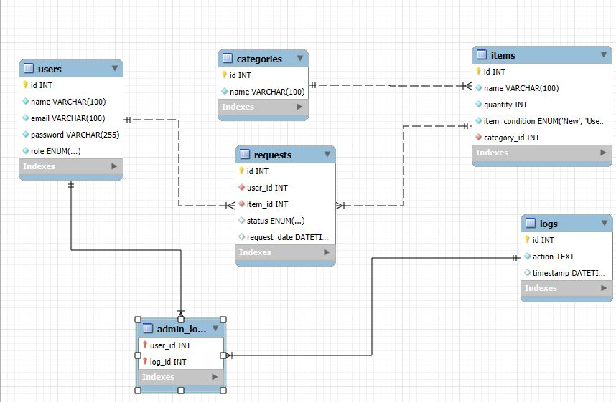

ERD Explanation:

- users: Stores all system users, with roles (Admin, Coach, Customer).

- categories: Item categories (e.g., Training, Match Day).

- items: Equipment entries linked to categories.

- requests: Tracks item requests, linked to users and items.

- logs: Admin activity logs.

- admin_logs: Join table linking admins to logs (many-to-many).