ICT & Infra S2 M/S week 11: IDS & IPS, part A

Class: I02
Student numbers:
Student names: Mihai Glodici

Date: Feb 2020
Version 1.2

Introduction
In this practicum you will learn the basics of IDS. You will configure Snort IDS on your VM, learn the basics of IDS rules, FP and FN rates.
How to deliver your assignments?
Fill in this document with required information about your group. Answer questions and upload the document to your GIT repository at most one week after the assignment is given.

Assignment 1: Deploying an Ubuntu VM and installing Snort.
Difficulty: . Estimated time: 30 minutes.
Create (Deploy) an Ubuntu virtual machine (VM) from the most recent Ubuntu Template Templ_Ubuntu18 Lubuntu from SecLab ( use your OE2XXX account ):
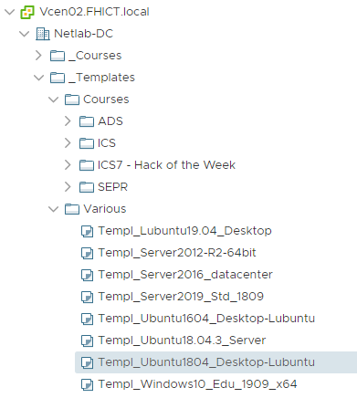
Figure 1. Choose the latest Ubuntu template.
Connect you virtual machine to any VLAN network with DHCP server.
Now start the VM you just created and log in with account: “student”, password: “student”.
Open a LXTerminal screen at your VM.
Find out the network adapter name in your Ubuntu system and determine the ip address of this adapter received from your DHCP service in your network by typing the following command in terminal:
$ sudo ifconfig
You have to configure which ip-range snort should monitor. That is the entire IP-range of the private VLAN where you placed the sensor.

Write down the name and ip-address of your network adapter, network range in your private LAN
Now we update the system and install snort by using the Ubuntu package manager apt from the command line as follows:
$ sudo apt update
$ sudo apt upgrade
$ sudo apt install snort
You will be asked for the network adapter name
You will be asked for the network IP address and/or range

Assignment 2: Configuring snort.
Difficulty: . Estimated time: 30 minutes.
Snort configuration files can be found in the following directory:
/etc/snort/
There are two very important configuration files:
snort.debian.conf
snort.conf
From snort.debian.conf the config items are passed to snort as command line parameters when starting via the standard Ubuntu service. These parameters overrule settings given in snort.conf (!)
Display the contents of snort.debian.conf:
$sudo cat /etc/snort/snort.debian.conf
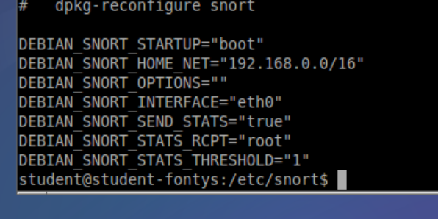

Check whether the name of the network adapter matches the previously noted name and whether the ip-range matches that of your private VLAN.
If needed, you can edit the contents of the text file, for example with the command-line editor nano or vi (m).

Assignment 3. Snort preparation.
Difficulty: . Estimated time: 45 minutes.
We are almost there. snort is set by default for a binary logging format and we do not want that for now. We will adjust this, but first we make a backup of the original file for safety reasons:
$ cd /etc/snort
$ sudo cp snort.conf snort.conf.orig
Now edit the snort.conf file:
$ sudo nano snort.conf
And look for the section “output plugins”:
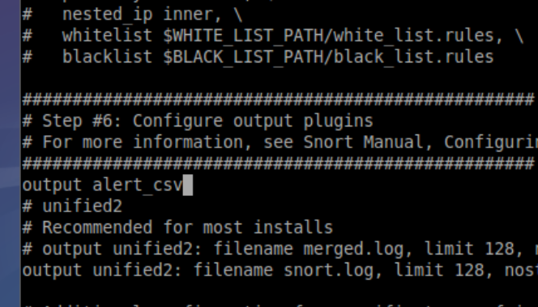
In the original file there is no line containing output alert_csv so you have to add that as in the above example. Do not forget to save the changed configuration file!
From now on snort will save logging in a CSV (Comma Separated Values) text format.
Logging will be written to the following file:
/var/log/snort/alert.csv
Now we will verify the section where detection rules are defined. Go to:
Here you do not see the detection rules themselves, but relevant rules files are 'included'. The names of the rules files indicate what they are meant for:
'#' means commented out so these lines are not read when snort starts. This way you can 'turn off' rule files that you do not need in your network without having to completely remove them.
In the local.rules file you will later add your own rules that apply specifically to your network.

Assignment 4. Snort first test by building a simple rule
Difficulty: . Estimated time: 45 minutes.
Activate your modified snort configuration by running:
$ sudo service snort restart
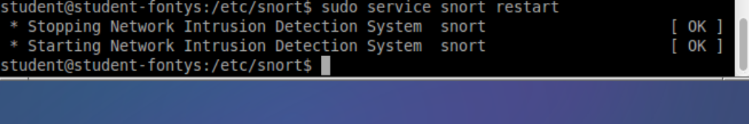
Now check if in the logging directory the file /var/log/snort/alert.csv exists (probably 0 bytes).
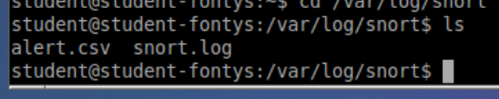cd
Add the following test rule in the local.rules file that can recognize ping packets within the network:
alert icmp any any -> any any (msg: "TEST works because we detect a ping packet”; sid:9000001; rev:1)
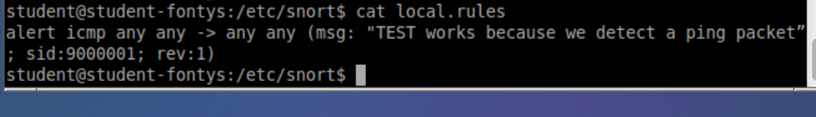
Activate your modified snort configuration by running:
$ sudo service snort restart
Note: from now on, do this every time after modifying the configuration.
To see what snort logs we use the command tail (tail of a file). For example, tail -5 <filename> returns the last 5 lines of that file. With the -f (flush) option you continuously view the last written line of a file. We will use this to track our logging 'live' on the screen:
$ tail -f /var/log/snort/alert.csv
Now, ping this VM from another machine ( your Windows PC ). If all goes well, you will now receive snort notifications (alerts) because your new test rule will be triggered.
Provide a screenshot of these notifications in alert.csv
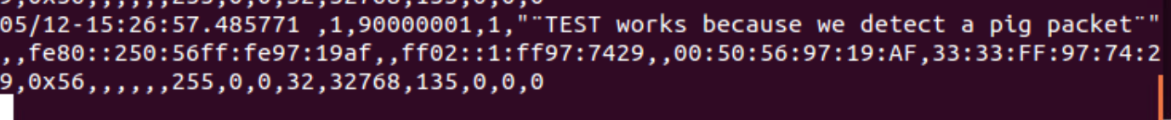
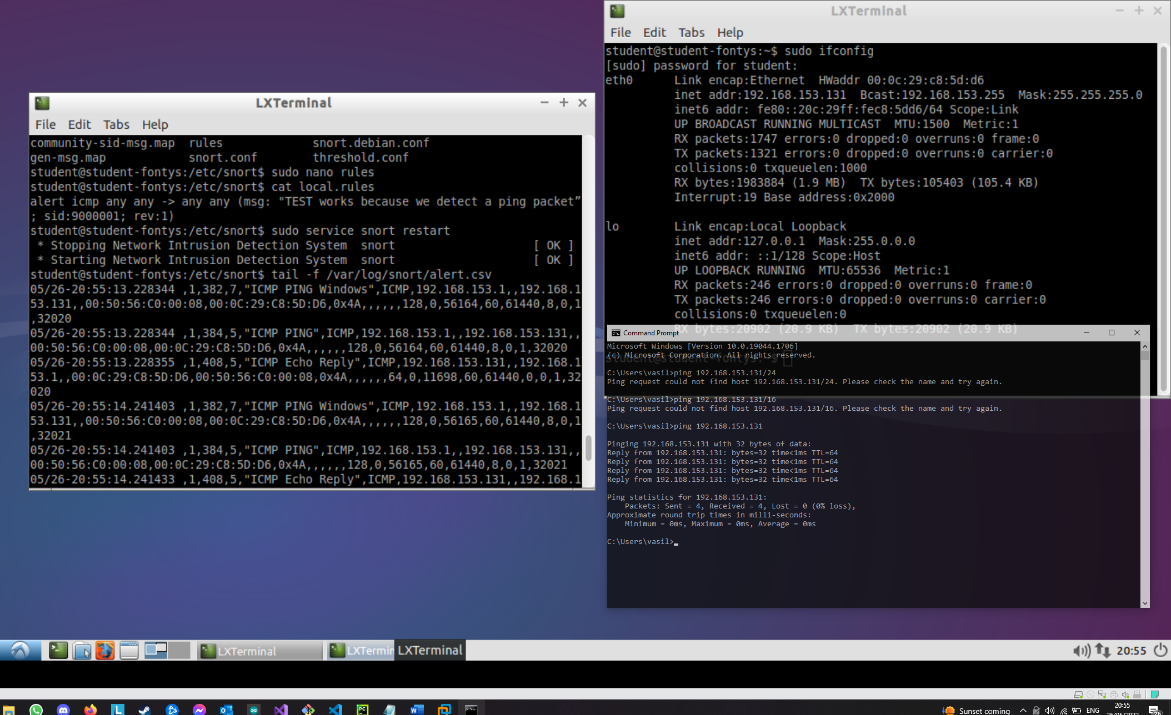
Question: Is this test alert False Positives or False Negative? Why?
Provide your explanation to this question
This is a true positive because the rule does what it’s supposed to, detect ICMP pings. It even detects that I pinged from a Windows machine, and which IP and MAC address.

Assignment 5. Snort tests with for malicious/suspicious activities
Difficulty: . Estimated time: 240 minutes.
Check the lecture slides and “SNORTOLOGY 101 THE ANATOMY OF A SNORT RULE” manual to learn about the Snort rules options.
You may also examine the snort manual link: http://manual-snort-org.s3-website-us-east-1.amazonaws.com/node27.html.
  - Try different combinations as:
Alert tcp $EXTERNAL_NET any -> $HOME_NET 443 (msg: “OMG! Someone visited the web server!!!”; classtype:web-application-attack; sid 12345; rev:1;)
Alert tcp $EXTERNAL_NET any -> $HOME_NET 80 (msg: “OMG! Someone visited the web server!!!”; classtype:web-application-attack; sid 12346; rev:1;)
Alert tcp $EXTERNAL_NET any -> any any (msg: “OMG! A TCP packet!!!”; classtype:not-suspicious; sid 12347; rev:1;)
Alert tcp $EXTERNAL_NET any -> any any (msg: “No Worries! This a just a test rule.”; content:”CanaryTweet”; nocase; classtype:not-suspicious; sid 12347; rev:1;)
…
Any other examples here… to demonstrate catching suspicious/malicious activities…
Provide your scenarios, screenshots, explanations to the requests above.
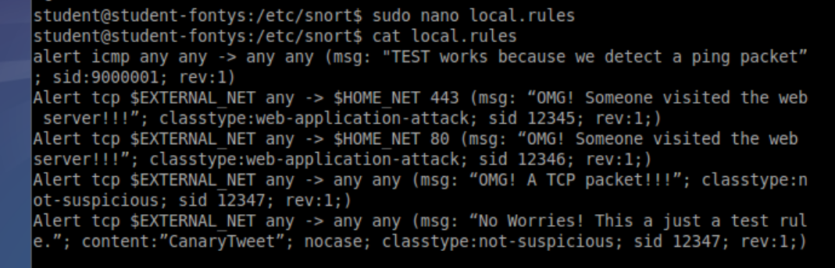

Question: How can you define your Snort rules hence False/Positive or False/Negative rates of your IDS will remain as low as possible?
!!!Using less rules that only target specific types of attacks, like DDOS/password cracking/Sql Injections should return the least amount False Positives/False Negatives. Also, the processing load will not be as difficult to process with less rules.
By using various rule options you can arrow down the behavior it detects resulting is a higher true positive rate but could in some cases lead to a false negative

  - (Bonus assignment) Create your own malicious scenarios. You may re-use some DoS attacks demonstrated during S1 Infrastructure (TCP SYN flooding, DNS DoS).
Setup these attacks on your Windows or Linux machine in InfraLab. Migrate this Snort VM to your InfraLab environment.
Define your own Snort rule to catch this malicious attack. Think about a specific pattern for detection of this attack but keeping FP and FN as low as possible.
Provide your scenarios, screenshots, explanations to the requests above.

