Final Project Midpoint Check-in
INFO 5368-030 Practical Applications in Machine Learning
Project information. Team CourtVision: Toby, David, Andrew, Javi, Isaiah, and Darian. Project title: Predicting NBA Draft Likelihood from NCAA Player Statistics (2009-2021). GitHub repository: https://github.com/Slope881213/PAML-Final-Project.
Work completed so far. We set up the shared GitHub repository and uploaded the data-processing notebook, EDA notebook, cleaned train/validation/test CSV files, and completed MLP files and outputs. The dataset uses a time-aware split: 2009-2018 train, 2019-2020 validation, and 2021 test. The target is three-class draft status: undrafted, first round, or second round.
Offline experiments done thus far. The MLP portion is complete as a from-scratch one-hidden-layer neural network using NumPy/Pandas only. It uses train-only scaling, one-hot encoding, softmax output, weighted cross-entropy, manual backpropagation, mini-batch gradient descent, L2 regularization, and early stopping. The best model used 16 hidden units, ReLU, learning rate 0.01, and L2 0.001. Validation results were macro-F1 0.6239 and multiclass AUROC 0.9828. Test results were macro-F1 0.4830, multiclass AUROC 0.9590, drafted-any recall 0.6800, precision 0.3542, and AUROC 0.9635. Placeholder: add final KNN and logistic regression metrics after upload.
Online experiments and website development done thus far. The planned Streamlit app will let users select or enter an NCAA player profile and view probabilities for undrafted, first round, and second round outcomes. Planned pages are Introduction, Data Overview, Draft Projection, What-if Simulator, and Model Evaluation. The MLP artifacts already include saved weights, preprocessing metadata, and an inference script for backend integration. A UI screenshot is uploaded in the repository. Placeholder: add exact run instructions after the app files are uploaded.
Scope revision. The main revision is that the deployed target is explicitly three-class draft status rather than only binary drafted/not drafted. We will still report a drafted-any view as a secondary metric, but accuracy will not be the headline metric because class imbalance makes an all-undrafted classifier look strong.
Remaining work and path to completion. The team still needs comparable logistic regression and KNN results on the same splits, the uploaded Streamlit app files, exact run instructions, and the final model-comparison table and member contributions.

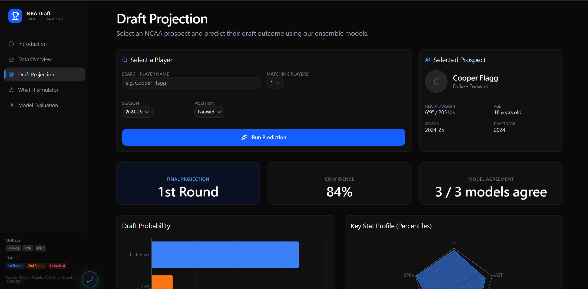
Figure 1. Current draft projection interface screenshot.

