**HW1**

Shen Wei

**OS version:**

Linux version 4.4.0-18362-Microsoft (Microsoft@Microsoft.com) (gcc version 5.4.0 (GCC) ) #1049-Microsoft Thu Aug 14 12:01:00 PST 2020

**bash version:**

GNU bash, version 5.0.17(1)-release (x86_64-pc-linux-gnu)

Copyright (C) 2019 Free Software Foundation, Inc.

**python version:** Python 3.8.2

**github url:** https://github.com/Slotair-bocca/HW1

# Linux operating system and memory hierarchy

**1.**

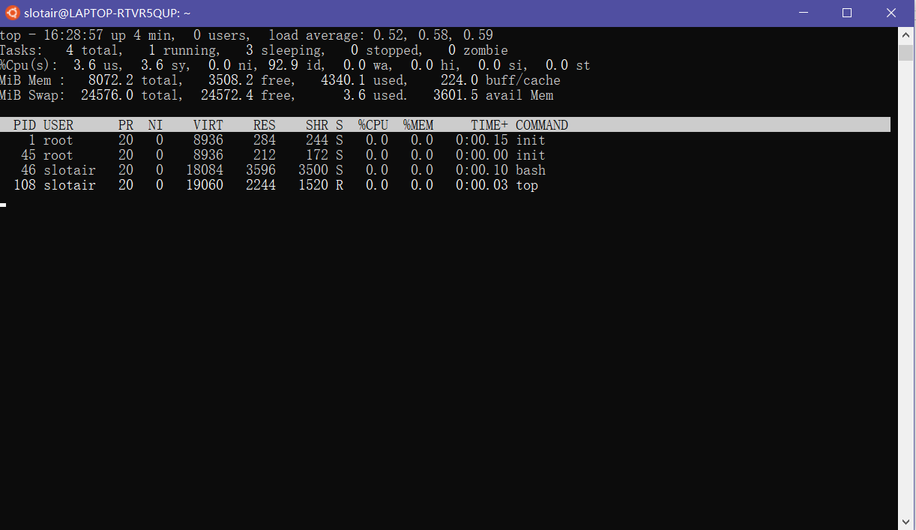

**2.**

commands：cat /proc/meminfo

# Get memory information

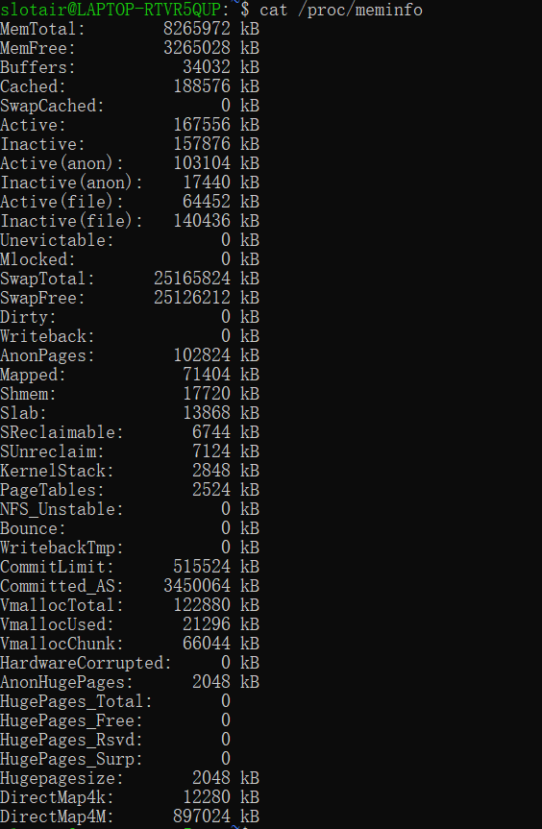

**3.**

output：

.

├── bin -> usr/bin

├── boot

├── dev

│   ├── block

│   ├── fd -> /proc/self/fd

│   ├── kmsg

│   ├── lxss

│   ├── null

│   ├── ptmx

│   ├── pts

│   │   └── ptmx

│   ├── random

│   ├── shm -> /run/shm

│   ├── stderr -> /proc/self/fd/2

# Bash script

#!/bin/bash

mkdir ouput

cd output

i=1

while(( $i<=100 ))

do

number=$i

filename="DDM"$number

mkdir filename

cd filename

touch time_till_now.txt

echo $"nanoseconds since 1970-01-01 00:00:00 UTC:\n<" > time_till_now.txt

echo -n ($date) '>' >> time_till_now.txt

cd ./..

let "i++"

done

# Regular expression

**1，**

import re

path='D:/blocklist.xml'

files=[]

with open(path,'r') as f:

files=f.read()

result=re.findall('<.*blockID="[i|g]\d+" id=".*".*?>', files)

for i in result:

print(i)

**2，**

import re

path='D:/blocklist.xml'

files=[]

with open(path,'r') as f:

files=f.read()

result=re.findall('<.*blockID="[i|g]\d+" id=".*\@.*".*?>', files)

for i in result:

if '\\' in i or '/' in i or '^' in i:

continue

else:

print(i)