RIG Team

The URS file shows the requirements to run a functioning setup as defined by the RIG team

RIG Team URS

Contents

Objective 2

Product 2

Scope 2

Client installation requirements 2

# Objective

RIG team is currently working on an application that would help a client to maintain and monitor their company’s environment through the usage of a three-part location-based application.

Within this file a detailed description of the minimum requirements needed to establish a functional running work environment for the client.

# Product

the product will consist of first a layout of the server setup and its required installations, second the application that will help monitor the environment, third the hosting of the website alongside the database to hold all records, fourth and last the monitoring devices placed in the warehouses for safety surveillance.

# Scope

The parameters that define the project are the connections between three locations and storing the data into a database for later usage.

Given that location 1 would be the main office hosting the server that will carry the website and database connections, while location 2 and 3 are the warehouse locations which will contain a part of the application that will handle the monitoring and updates for the current inventory to the database.

The application will have the following limitation:

Access for customers as users on the website, access for employees as users to the system, access for administrators to maintain and monitor the whole layout and outputs.

# Client installation requirements

1. Server running windows server 2019 with Hyper-V installed to host the secondary systems.
2. python 3 library.
3. CentOS installed on one of the Hyper-V machines.
4. pfSense installed on a Hyper-V machine alongside CentOS.
5. Ubuntu OS running IDS or pfSense running IDS if needed.
6. employee’s client machines running windows 10.
7. Raspberry-pi machines running apache hosting the website to send updates to server.

# Project personas

Here we will cover the three potential users of such application to help clarify the target audience and the potential this application has for the client requesting it.

## Persona 1 (Customer)

Steven

18

Student

Details:

Steven is a fresh university student, currently studying design for a future career in game designing. First thing that matters for Steven is that his computer setup is at its highest peak of performance. To not suffer any lagging or delays in work performance he needs to update his setup frequently, this means that the newest parts and price range updates are important for him. As a loyal customer to the client company he keeps an eye on the website once in a while.

Goals:

Steven would like to be able to see the prices for each part available, new updates and/or comparisons to other deals are a plus for him to save money off.

## Persona 2 (Employee)

Diana

25

Warehouse Supervisor

Details:

Diana is a hard worker at here firm being place in a managerial position by her current employer was a great step forward in advancing her career. Some of Diana’s responsibilities are to monitor the safety hazards of the warehouse and being alerted in case of an emergency.

Second part of her work description is responsibility for the products available on shelfs and keeping the stocks as accurate on the floor as they are in the company’s system.

Goal:

To make a branch of the main company’s application connected to the warehouse would help with keeping it updated at an hourly base rather than when an employee is available to manually update it or by sending the number the main office to update the records.

## Persona 3 (Administrator)

Sandeep

43

Vice president

Details:

Sandeep has been working in a managerial position for the last 10 years, lately he has managed to advance closer to his dream job being a CEO of a company.

Through his years of work and experience he learned the value of the ability to monitor every aspect of his company from one location in a form of statistical values, plus the productivity levels show faster if all workload is documented in one forum in the company allowing the ease of evaluation.

This ease of evaluation is an added bonus when it comes to decisions such what should come next and what updates are crucial for the firm in its current situation.

Goals:

Sandeep would always go for the work environment that improves the workload and tracing in his company, making any new suggestions an object to read about and evaluate it for either adding it to the company or not.

# Product vision

# Gantt

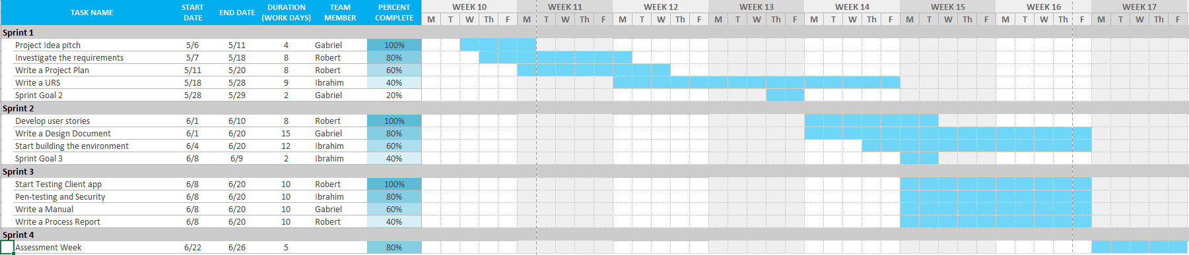

# Wireframes & GUI

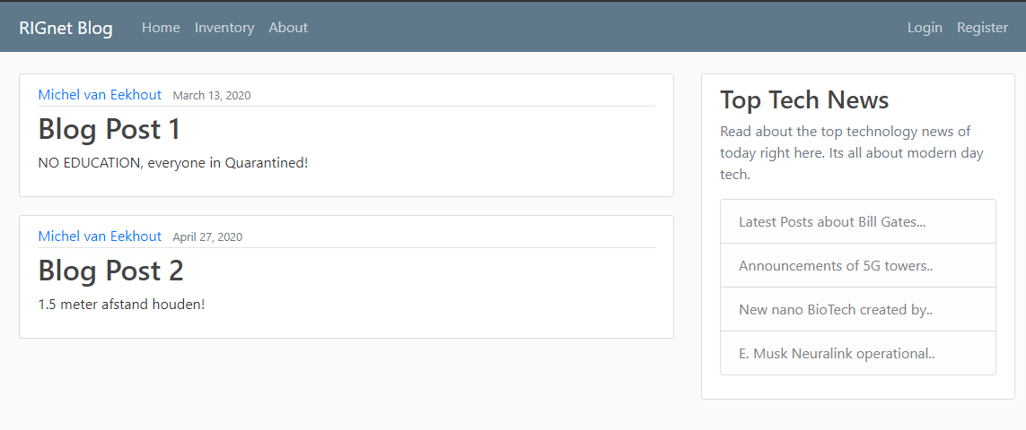

Figure This is the home page wireframe of the main website

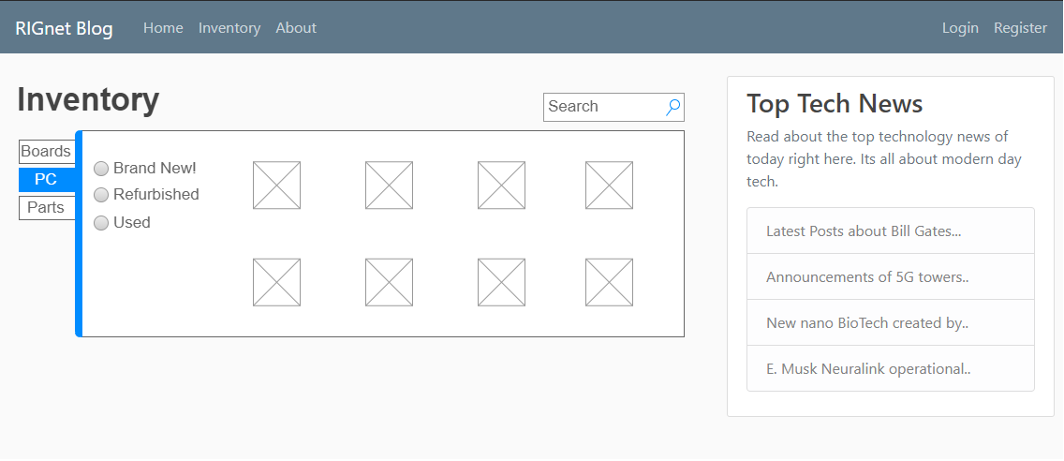

Figure This is the inventory page wireframe of the main website

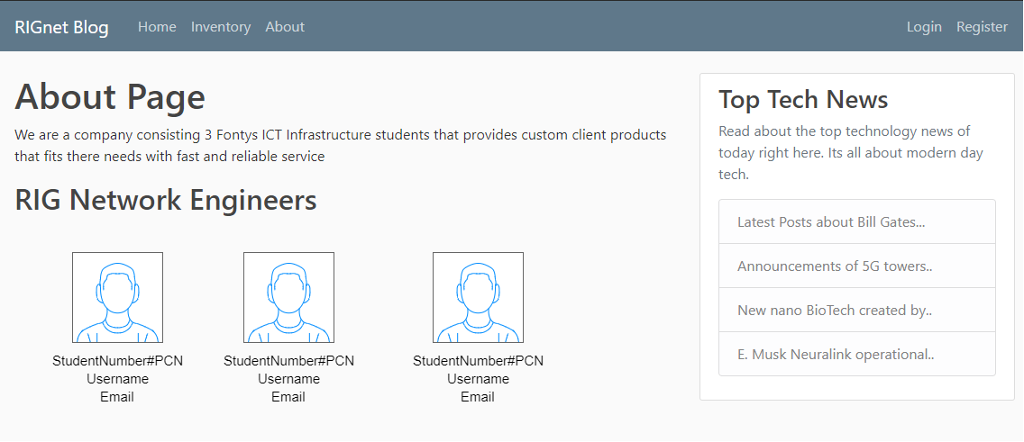

Figure This is the about page wireframe of the main website

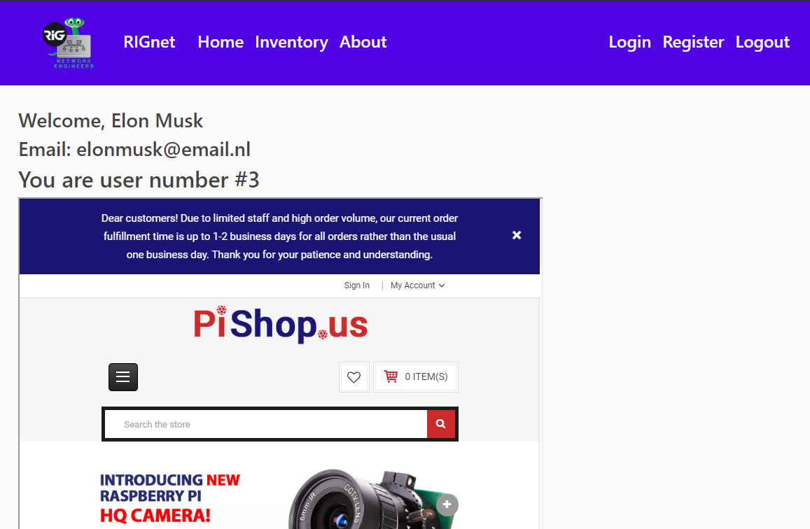

Figure This is the home page GUI of the main website

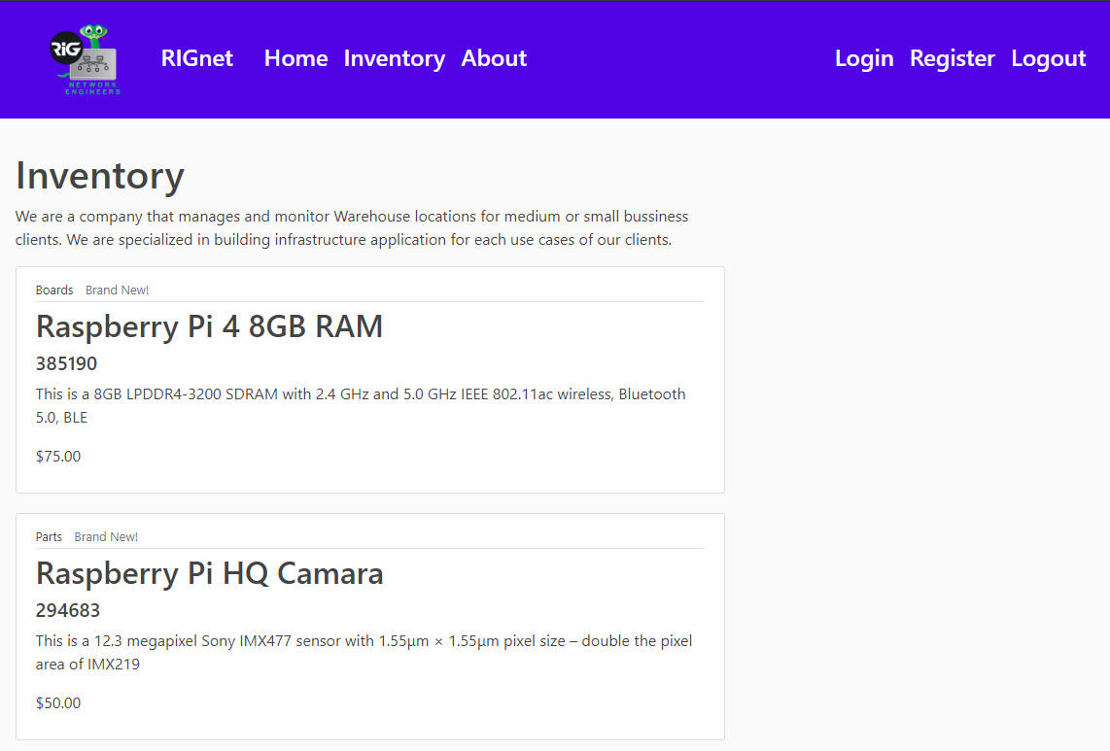

Figure This is the inventory page GUI of the main website

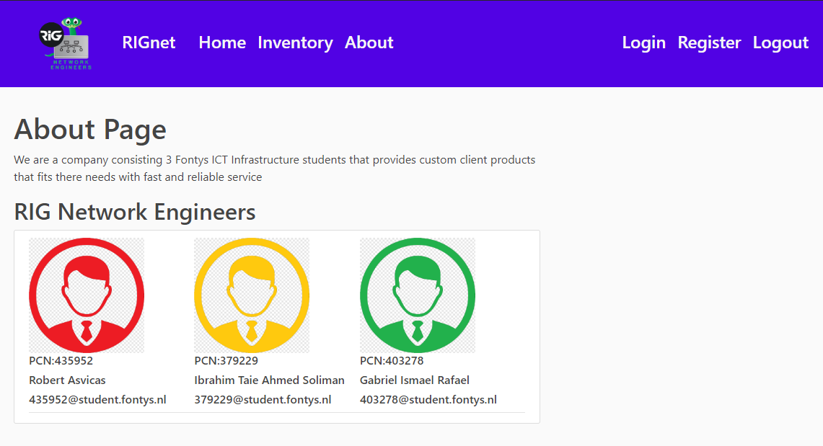

Figure This is the about page GUI of the main website

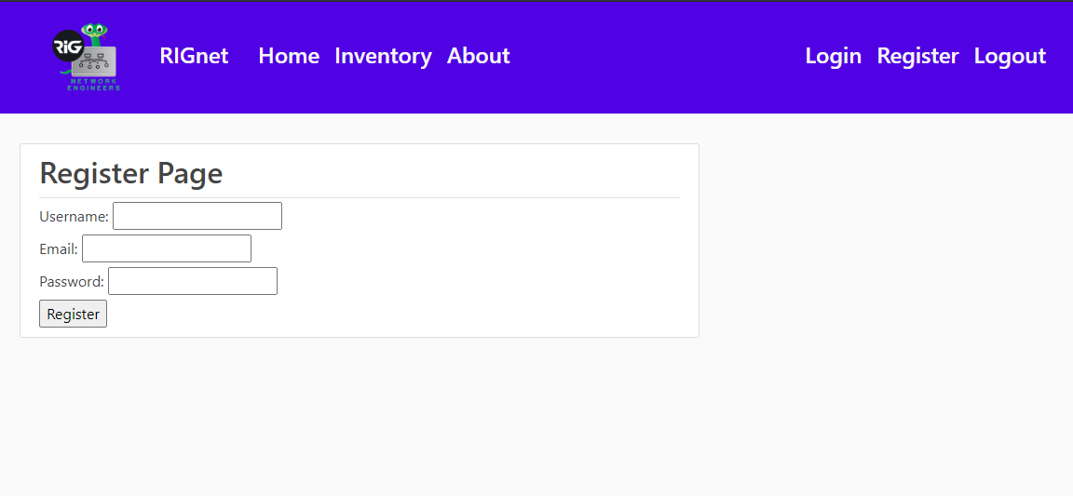

Figure This is the register page GUI of the main website

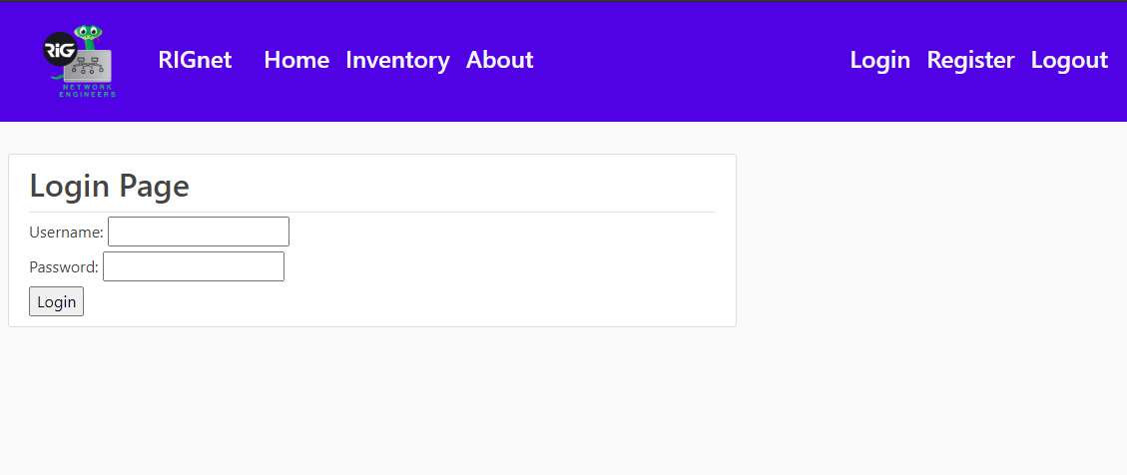

Figure This is the login page GUI of the main website