**计算机网络 第一章 作业**

**姓名：崔玉峰**

**学号：201600301079**

**班级： 2016级4班**

1. What is the principal difference between connectionless communication and connection-oriented communication? Give one example of a protocol that uses (i) connectionless communication; (ii) connection-oriented communication.

面向连接通信：服务用户首先必须建立一个连接，然后使用该连接传输数据，最后释放该连接。

无连接通信：不需要建立连接，每个报文都携带了完整的目标地址

无连接通讯： UDP  
 面向连接的通讯：TCP

1. What does ‘‘negotiation’’ mean when discussing network protocols? Give an example.

协商意味着通信双方遵守相同的网络协议，通信双方通过协商可以确认相同的协议内容，双方只要遵守相同的内容即可完成通信，比如IP协议，如何定义每个人的地址。

1. How long was a bit in the original 802.3 standard in meters? Use a transmission speed of 10 Mbps and assume the propagation speed in coax is 2/3 the speed of light in vacuum.

同轴电缆的传播速度 = 200000000m/s

10Mbps的传输速率传一位的时间是 =1/10485760 = 9.5*10^-8 s

因此：

一位的长度为 = 200000000* 9.5*10^-8=19.07m

1. The ping program allows you to send a test packet to a given location and see how long it takes to get there and back. Try using ping to see how long it takes to get from your location to several known locations. From these data, plot the one-way transit time over the Internet as a function of distance. It is best to use universities since the location of their servers is known very accurately. For example, berkeley.edu is in Berkeley, California; mit.edu is in Cambridge, Massachusetts; vu.nl is in Amsterdam; The Netherlands;www.usyd.edu.au is in Sydney, Australia; and www.uct.ac.za is in Cape Town, South Africa.

分别通过ping命令执行：

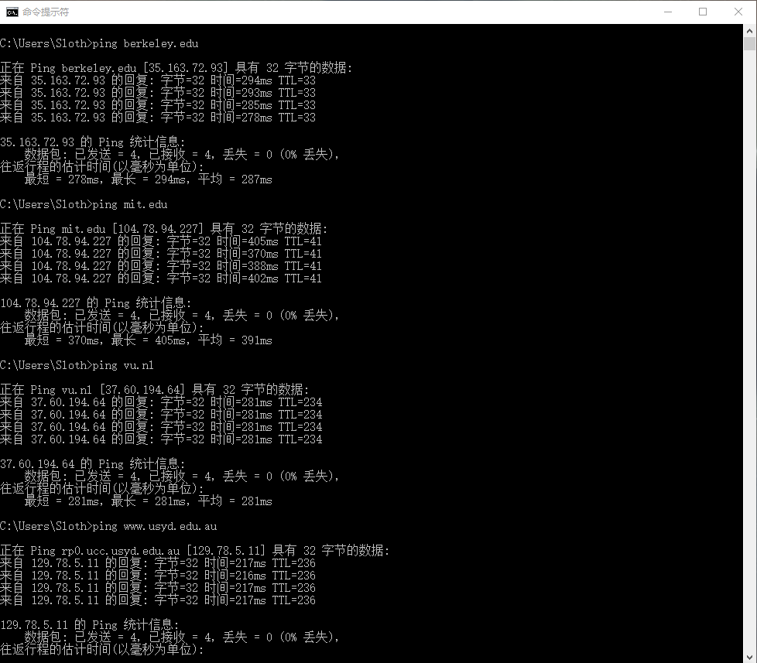

berkeley.edu Berkeley, California 287ms

mit.edu Cambridge, Massachusetts 391ms

vu.nl Amsterdam 281ms

[www.usyd.edu.au](http://www.usyd.edu.au) Sydney, Australia 216ms

[www.uct.ac.za](http://www.uct.ac.za) Cape Town, South Africa 请求超时