1. The following data fragment occurs in the middle of a data stream for which the byte- stuffing algorithm described in the text is used: A B ESC C ESC FLAG FLAG D. What is the output after stuffing?

FLAG A B ESC ESC C ESC ESC ESC FLAG ESC FLAG D FLAG

1. What is the remainder obtained by dividing x^7+x^5+1 by the generator polynomial x^3+I?

CRC 算法

帧：x^7+x^5+1 -> 10100001

生成项：x^3+I -> 1001

10100001 / 1001 = 10110111 .... 111

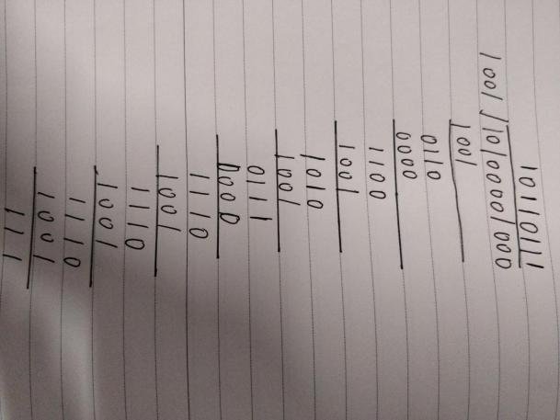

余数：111 -> x^2+x+1

1. A bit stream 10011101 is transmitted using the standard CRC method described in the text. The generator polynomial is x^3+1 Show the actual bit string transmitted. Suppose the third bit from the left is inverted during transmission. Show that this error is detected at the receiver's end. Given an example of bit errors in the bit string transmitted this will not be detected by the receiver

CRC 算法 帧：10011101 生成项：1001

10011101000 / 1001 = 10001100....100

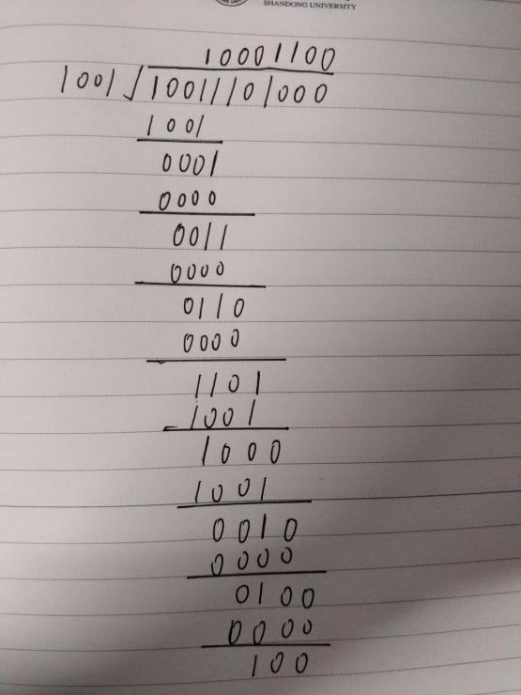

发出的帧为10011101100

左边第三位发生反转则接受到的帧为 10111101100 ，

10111101000/1001 = 10101000....000

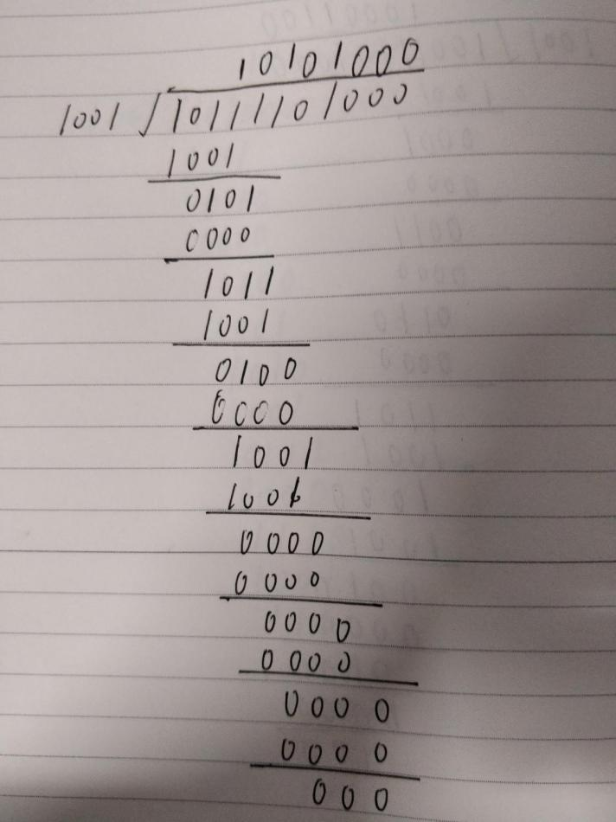

000与100不同所以可以确定错误

1. Image a sliding window protocol using so many bits for frequency numbers that wraparound never occurs 。What relations must hold among the four windows edges and the window size, which is constant and the same for both the sender and the receiver?

设S1为发送者窗口上边缘 ，S2为发送者窗口下边缘

R1为接收者窗口上边缘， R2为接收者窗口下边缘。

Size 为窗口大小

则它们之间的关系有

0<S2 - S1<=Size

0<R2-R1 <= Size

S1 <=R1<=S2