1. The wireless LANs that we studied used protocols such as CSMA/CA and RTS/CTS instead of using CSMA/CD. Under what condition, if any, would it be possible to use CSMA/CD instead?

在无线局域网的情况下存在暴露站和隐藏站问题，所以并不能使用CSMA/CD.协议。除非当局域网中任意一个站的范围都能覆盖到其他的所有站的时候 CSMA/CD协议才能被使用。

1. Sketch the Manchester and Differentiated Manchester encodings on a classical Ethernet for the bit stream 0001110101.

曼彻斯特编码：

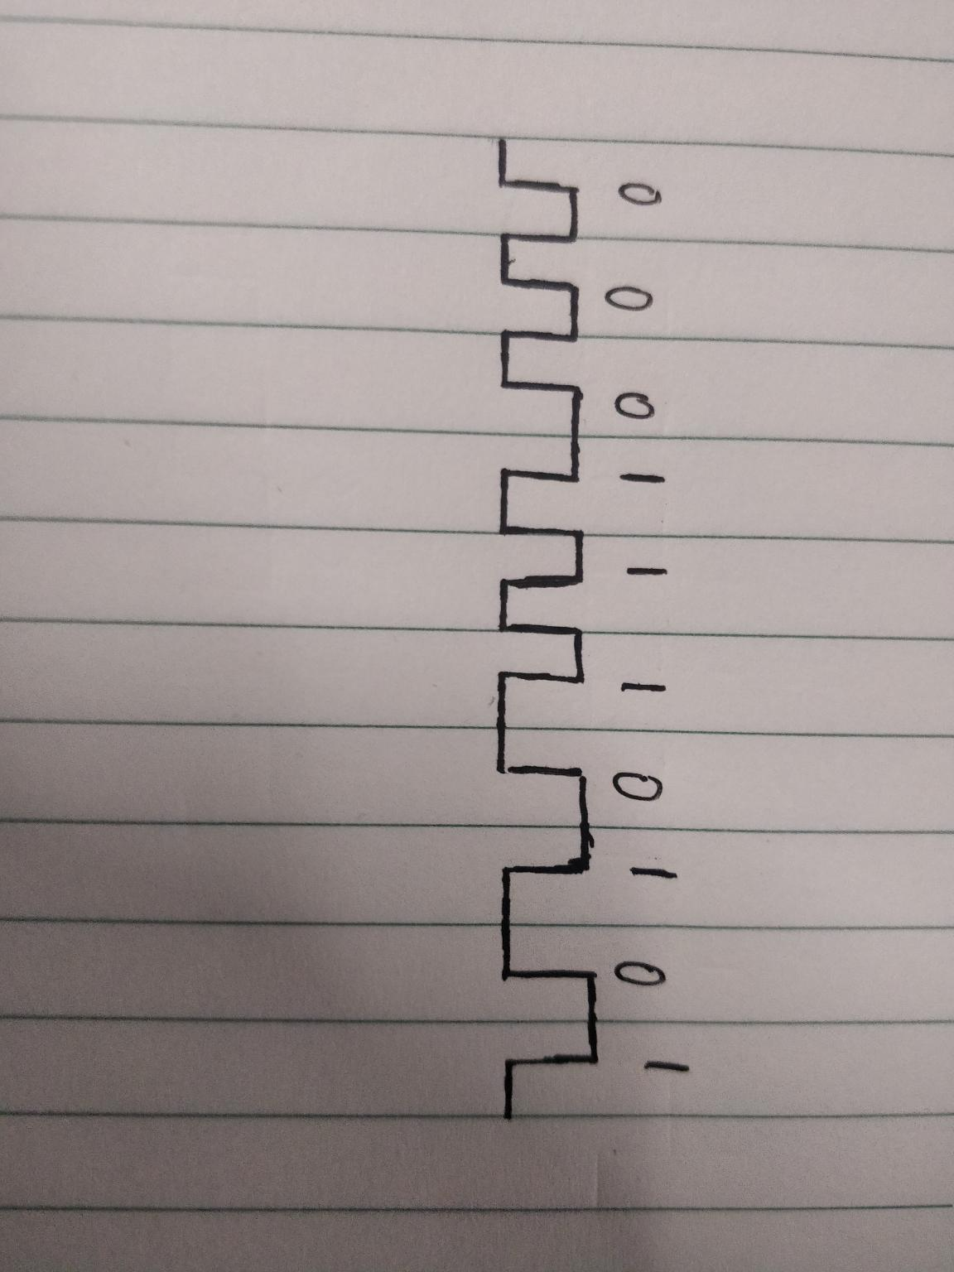

差分曼彻斯特编码：

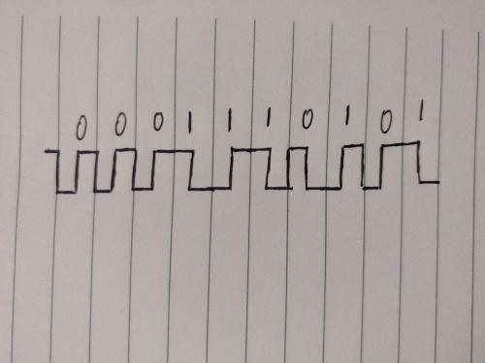

1. Consider building a CSMA/CD network running at 1 Gbps over a 1-km cable with no repeaters. The signal speed is 200,000km/sec. What is the minimum frame size?

帧往返一次的时间为 ：

2\* 1 /200,000 =0.00001 s

应该保证发送的帧的时间应该大于这个时间。

最小帧长:

0.00001 \* 1000000000 = 10000bit

10000bit = 1250Byte

最小帧长应该为1250个字节